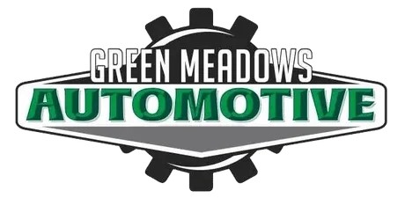

Classic Vehicle repair information

We value your classic vehicle and are thrilled you have chosen us to take care of your investment. We would like you to read through this so that we set reasonable expectations to get your vehicle properly diagnosed, repaired and back to you as soon as possible.

⦁ We are a small shop with a team that can accommodate most older vehicles. We currently bill at $185.00 per hour and will bill you hourly as most repairs on these vehicles are unable to be quoted like modern vehicles. Our best effort will be put forward to ensure your money is well spent and your concerns are corrected in a timely manner.

⦁ You must make an appointment with us, have your vehicle insured and it must have a top or cover with/on it in case it must be stored outside before dropping off.

⦁ Most of these vehicles are 30+ years old and have had many hands on them over the years. Some of these vehicles can be Rest of World (ROW) vehicles, not built to North American Standards (NAS). This causes delays in diagnostics due to lack of information and sometimes the vehicles have been built or repaired at a lower standard than you will receive at Green Meadows Automotive.

⦁ These problems usually take more time to figure out, but be certain that we will get your vehicle repaired and it will not sit here for an extended period of time. You will be kept up to date on the progress of your vehicle and feel free to stop by at any time.

⦁ Once your vehicle is diagnosed, the parts search, order and delivery process may take 5-10 business days and sometimes more if the parts must be imported. We have NO control over this.

⦁ You will be given a quote to the best of our abilities, but this is subject to change once the repair has started due to age and condition of the vehicle.

⦁ Signing this document acknowledges that you understand what is covered on this form and have agreed to the work being performed with in these guidelines