
The Willow Branch
September/October 2021
Office Hours: Monday, Wednesday, Friday and Saturday 9:00 am – 2:00 pm

The official Newsletter of the Willow Run RV Condominium Association

Board of Directors
President: Dan Christianson
Vice President: Judy Fallon
Secretary: Robert Van Hook
Treasurer: Joel Templeman
Maintenance: Neil Berkowitz
A message from the President

The View from My Campsite

As I sit to write this article, September and fall are right around the corner. Where has the summer gone?
Just a friendly reminder to have all the necessary forms into the office and make sure we have your correct address and email.

We still have a few activities this summer so keep watch to the website, Facebook, the office and bulletin boards. Safe travels to those leaving the area and we look forward to seeing everyone next spring.

Dan Christianson - Willow Run Board


From the desk of Robb Van Hook:
New Year Activity Schedule
As we come closer to the end of the season, we on the Board would like to ensure that next year’s activities run as smoothly as possible. To that end, we kindly ask that residents who would like to plan an activity use a new Activity Request form. Forms will be available for pick up at the office and clubhouse. These can be dropped off at the office or with any board member. The goal of using a more formal request process is to make sure the Board is aware of any activities (so we can answer any questions that arise), prevent conflicting events from being scheduled for the same time, and allow proper time to publicize any events. The form can also be used to schedule ongoing weekly activities. Please have requests into the office by September 15th for next year’s major events so they can be included on the calendar.
Thanks, Robb Van Hook, Secretary

From the desk of Judy Fallon

Permits-get your permits
Please obtain your permits for campers, boats, and trailers.
Fall packets- can’t stress enough the importance of the Association having your legal address. Also, for Walworth County. You have the option to download the fall packet from the website. Please complete the “opt out form” so we can save on the ever-increasing postage costs. Thank you
Newsletter- the board would like to thank Sharon for all her time putting together our most fabulous newsletter. Thank you also to all the contributors to the newsletter that make it so valuable.
Volunteers- the Board would like to thank all of the folks who put together and helped run our events. What a great summer!!
Thanks for reading!!
Judy
Judy Fallon – Vice President


This Photo by Unknown Author is licensed under CC BY-ND
From the desk of: Joel Templeman, Treasurer

Dues Payments can now be paid through PayPal
The comment section NEEDS to include the following information, or the payment will be rejected:
- Lot #
- Unit owners name
- Month(s) payment is for
Select sending to “Friends and Family”. This allows for a non-business transfer and will not incur a fee.
All payment due dates and late fees remain the same.
Email joeltempleman@yahoo.com with any questions.

Off-season unit sales
If you are selling a unit after the office closes October 15th, paperwork should be submitted to joeltempleman@yahoo.com . Please remember that we require 14 days before closing for processing. Fees of $50 for less than 14 days and $100 for less than 7 days will be assessed and collected prior to signing the closing documents.
From the desk of: Ed Plante
A word of praise and thanks go to our lifeguards: I would like to thank all the lifeguards we had on staff for the 2021 camping season. We continue to have a phenomenal team working for us. They keep the pool and swimmers safe. What a crew. When you see the lifeguards, please thank them in person.
Thank you, Cye, for the cleaning of the pool, clubhouse and bathrooms. Thanks for all you do! Also, I would like to send a big thanks to:

- Glen Knudsen for keeping the clubhouse sign current so we know what’s going on in the park.
- To everyone who helped with the pork chop and chicken dinner.
- To Betty Ulbert and her crew for keeping our park in beautiful flowers.
- To Jim Sobel and his ground crew for keeping our grounds beautiful and to
- Nate Stowal for his effort to keep our beaches in tip top shape.
- To Jim Ulbert for his years of dedication to Willow Run, his expert leadership and for the effort to teach me everything he knows……You will be missed!
And finally, to Sharon Bibro for her work on the newsletter.
One last final thought: There will be dumpsters coming on the Labor Day weekend for your convenience. Please fill the dumpsters in the gated area first!! And please pay attention to the “do not fill above this line” warning. Also, please, please do not put hot coals in the dumpster. We have had serious dumpster fires  September/October Hoppinings
This Photo by Unknown Author is licensed under CC BY-SA
EVENTS-----EVENTS-------EVENTS
This is what we have been waiting for!!! The following have been confirmed.
- September 3rd. Paddle Boat Parade: see blurb
- September 4th. Pancake Breakfast – 8:00 am – 10:00 am
- September 4th. Bingo – 7:30 pm
- September 5th. Golf Cart Races (playground parking lot) TBD
- September 5th. Parking Lot movie TBD evening
- September 8th. Card making class - clubhouse
- September 11th. German Fest (see blurb)
- September 15th. Ladies Lunch (11:45 in the parking lot)
- September 25th. Kids Halloween Part (see blurb)
- October 9th. Board Meeting (if needed). 10:00 am
Join us for the Willow Run Paddle Boat Parade!
Friday, September 3rd.
Light up your boat and your favorite drink and join us for a lake parade. Paddle boaters can start docking up from 6:30 – 7:00 pm at lot 181-179 for corn hole games and paddle shots. The parade will start at dusk. Don’t have a paddle boat? Come watch the parade by the playground parking lot. Our season is nearly ending, so let’s light up the lake one more time!

Ralph and Kim Smith

 Men’s Club Breakfast Club
This Photo by Unknown Author is licensed under CC BY-NC-ND

Saturday, September 4th. 2021 8 am – 10 am Cost: $5.00
Menu: Pancakes, eggs, sausage, orange juice, coffee and fruit cup.


This Photo by Unknown Author is licensed under CC BY-NC-ND
Have you noticed how expensive greeting cards have become? Some are as high as $8.99. If you want to learn to make your own simple cards, join me on September 8th. for a card making and stamping class.
You will leave with 4 cards (you choose the sentiments) and a cute cookie/candy bag. The cost is $10.00 and includes all the supplies you will need to finish these projects. All you need to bring is yourself. Sign up is required to ensure we have enough supplies for everyone. Watch for the sign-up sheet in the club house. Class begins at 1:00 pm in the club house and you can stay as long as you need to complete your projects. If you have any questions, please call me at 414-881-3909.
Jill Deschaine Lot 248

German Feast: September 11, 2021
2:30PM till 8:00PM
Yes, it’s Back…...German Fest 2021
This will be an outdoor event with food, games, liquid refreshments, contests, costume judging, and a dunk tank and much, much more. Did I mention music and dancing…………?

Games will include Mug Hoisting, Hammerschlagen, serving tray obstacle course, and sauerkraut eating.
We will also have games for the children

Food will include brats, hot dogs, sauerkraut, German potato salad, chips, and German Strudel for dessert.

Yes…there will be raffles……..50/50 and raffles for beautiful gift baskets and a raffle for a summer sausage stick. Proceeds will be used toward New Playground Equipment

Meal ticket will be $10.00. Tickets should be available on or about Sept 1st in the office, or from Dan at Lot 127


Willow Runs Last of the season Ladies Dinner.

Our last Ladies Lunch is Wed, Sept 15th......We have reservations at the American Cafe just over the border in Richmond, Ill. We will meet at the clubhouse at 11:45 and plan to leave by 12:00 sharp. Sign-up sheet will go up later today. The added advantage is that you can do wine and spirit shopping after lunch. Hope we get a good turnout for the last lunch of the 2021 season.

Lynn Decker Lot 149

This Photo by Unknown Author is licensed under CC BY-NC-ND
Kids Trick or Treating
September 25th. 2:00 pm

- Costume Contest
- Hayrides
- Trick or Treating
Start lining up at 1:45 pm. Costume judging at 2:00 pm



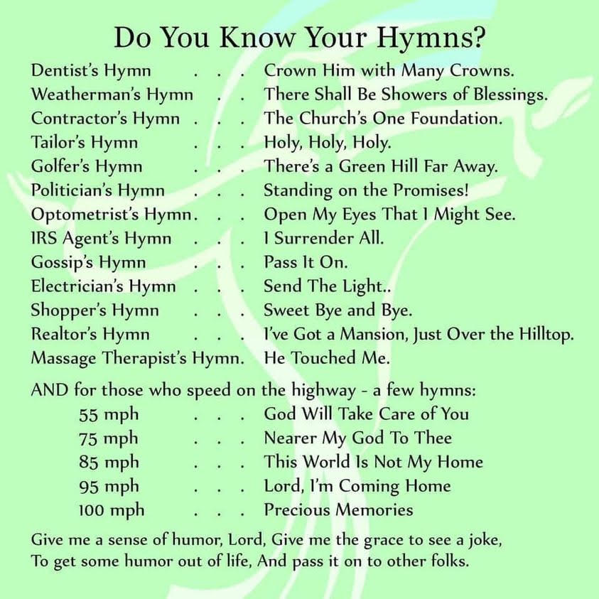

A Pessimist sees a dark tunnel
An Optimist sees light at the end of the tunnel
A Realist sees a freight train
The Engineer sees 3 idiots standing on the tracks. It’s all a matter of perspective!!

That’s all folks! Have a safe winter! See you in Spring
This Photo by Unknown Author is licensed under CC BY-NC-ND

Tentative Weekly Game Schedule (Subject to change)
Monday Water Exercise 10:00 am
Monday Texas Hold’em 7:00 pm
Tuesday Men’s Volunteer Program (Free Coffee) 9:00 am
Tuesday Wacky Water Ball 10:00 am – Noon
Tuesday Cards 1:00 pm
Tuesday Dominos (Mexican Train) 6:00 pm
Wednesday Water Exercise 10:00 am
Wednesday Game Night 6:30 pm
Thursday Wacky Water Ball 10:00 am - Noon
Thursday Game Night 6:30 pm
Friday Water Exercise 10:00 am

Please Note: The brush pile (behind the office) is for brush only. Please do not put any lumber
on the brush pile.

Thank You
Ed Plante

 HELP - Volunteers Needed
This Photo by Unknown Author is licensed under CC BY-NC-ND

Volunteers are needed for the day of the German Fest for help with various activities. We also need volunteers to donate gift baskets for the special raffle. If you are interested in working or donating a gift basket, please call or text Lauri Sobel at 815-245-2454. Thank you in advance for your generosity.

The German Fest committee also thanks you in advance.

