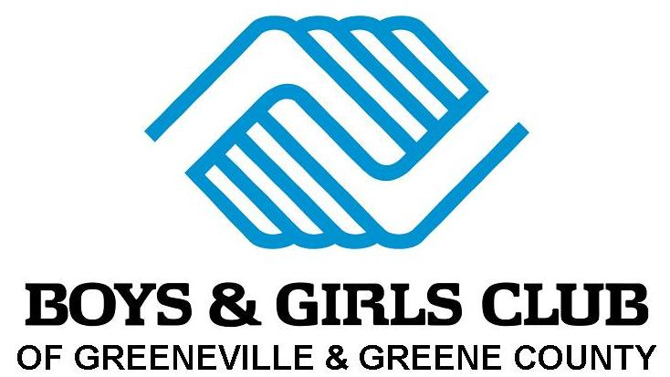

2026 Boys & Girls Club Schedule of Events

Schedule subject to changes, please check the Boys & Girls Club website & Facebook page for changes.

January 2026
1st – Closed for New Year’s Day
2nd, 5th, & 6th - City and County Schools Out for Christmas Break (Club Open: 7:30 am-5:30 pm)
9th – Law Enforcement Appreciation Day
13th & 15th – Holston Medical Group will be visiting the Club
19th - Martin Luther King, Jr. Day (City and County Schools Out, Club Open: 7:30 am-5:30 pm)
20th - Holston Home Grocery Distribution

February 2026
1st – Summer Program Registration Opens
6th – Give Kids a Smile Day
6th – BGC Super Bowl Party
13th- Valentine’s Day Party
13th, 16th - City & County Schools Out for President’s Day (Club Open: 7:30 am-5:30 pm)
17th – Mardi Gras Party
21st – Day 4 Kids

March 2026
2nd - 6th - Read Across America Week activities in local schools and at the Boys & Girls Club
16th – ^{20th} - Spring Break for City and County Schools (Club Open: 7:30 am-5:30 pm)
17th - St. Patrick’s Day Party

April 2026
2nd- BGC Easter Egg Hunt
3rd - Club Closed for Good Friday
20th - 26th - National Volunteer Week
22nd -Earth Day

May 2026
1st - Deadline to Register for Summer Program (fees all must be paid in full)
1st - Football League & Cheerleading Registration Begins
4th- Star Wars Day
5th – (City & County Schools Out, Club Open 7:30-5:30)
5th - Cinco de Mayo Party, 4:30 pm
20th - Last day of school for County/City
21st – First Day of Summer Program
25th - Club Closed for Memorial Day

June 2026
11th - Bob Kesling Boys & Girls Club Celebrity Golf Ball Drop
12th - Bob Kesling Boys & Girls Club Celebrity Golf Classic
25th to 1st - National Boys & Girls Club Week Activities
Weekly Swimming at Hardin Park will take place on Tuesdays for ages 10 & up.
Weekly Swimming at Hardin Park will take place on Wednesdays for ages 5-9.

July 2026
1st - End of National Boys & Girls Club Week

August 2026
6th – Last Day of Summer Program
7th – First Day of After School Program
8th Celebrity Auction
17th – National Nonprofit Day
29th – (City and County Schools Out, Club Open: 7:30 am-5:30 pm)

September 2026
3rd & 4th - (City and County Schools Out, Club Open: 7:30 am-5:30 pm)
5th – International Day of Charity
7th - Club Closed for Labor Day, City and County Schools Out
11th - National Day of Service and Remembrance

October 2026
12th -16th – Fall Break (City and County Schools Out, Club Open: 7:30 am-5:30 pm)
22nd – Lights on After School
29th – BGC Halloween Party

November 2026
3rd - (City and County Schools Out, Club Open: 7:30 am-5:30 pm)
11th - Veterans Day program
15th - America Recycles Day
19th – BGC Thanksgiving Dinner
25th - (City and County Schools Out, Club Open: 7:30 am-5:30 pm)
26th - 27th - Club Closed for Thanksgiving

December 2026
15th – BGC Christmas Party
17th - Open 10:00 AM – 5:30 PM
18th, 21st, 22nd, & 23rd - (City and County Schools Out, Club Open: 7:30 am-5:30 pm)
24th - 1st - Club Closed for Christmas Break

Schedule subject to change, notices will be posted on our Facebook page, website and at the Club.

For more information on Boys & Girls Club Events and Activities
visit our website and social media sites.

Please check out our Club’s website at www.ggcbgc.org

BGCA national sites at www.bgca.org & www.bgca.net.

 Like us on Facebook www.facebook.com/BGCGreeneville

 Follow us on Pinterest www.pinterest.com/bgcgreeneville

 Follow us on Instagram www.Instagram.com/bgc_greeneville

 Follow us on TikTok @bgcgtn

