
Pringle Street Surgery
Welcomes You
DURING YOUR APPOINTMENT:

The doctor or nurse will ask you some more questions and may want to examine you. This might include: listening to your chest with a stethoscope, checking your blood pressure or looking inside your mouth or eyes with a small torch. The doctor will explain what they are doing and why they are doing it.






Telephone number: 01254 360105
Pringle Street Surgery
216-218 Pringle Street, Blackburn BB1 1SB

3
What to do if you are worried:

After this, the doctor might give you advice or prescribe medicine.

If you are feeling very unwell and you are very worried please call 999.

If you have any questions, you can ask them. If you find it hard to understand, you can ask for them to explain in a different way.
Welcome to your GP Surgery
The doctor might want you to go to a hospital or see a different doctor. This is so they can keep you healthy.

At Pringle Street Surgery, we have a lot of people who work together to help keep you healthy. These include: receptionists, pharmacists, nurses and doctors. This a short leaflet that tells you what to expect when you have an appointment.


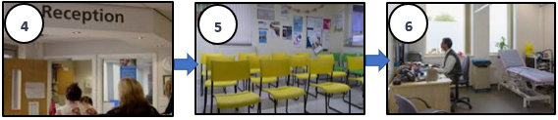



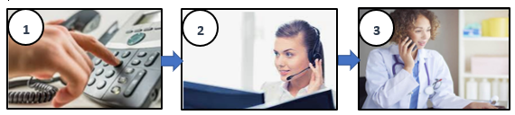


If you are feeling ill and would like to talk to a doctor or nurse please call this number: 01254 360105
You will then speak to one of our receptionists. They may ask you some questions. This is so they can help make sure you get to speak to the right doctor or nurse at the right time.
After you have talked to the receptionist, you may be asked to come into surgery for an appointment. They will tell you what day and time to come in.
Please make sure your telephone number and address are up to date.

You can make appointments on the phone, in-person or online via the NHS app.
You can bring a carer or family member with you to help you. You will then sit down and wait. The doctor or nurse will call you into their room.

When you arrive at the surgery, first you will speak to someone at our reception desk. They will ask you your name and date of birth and let the doctor know you have arrived.
Let the receptionist know if you have any extra needs and what we can do to help you.
This might be a leaflet that is easier to read, in bigger writing or a hearing loop in your appointment. We will try our best to help you.

HOW TO MAKE AN APPOINTMENT:
YOUR VISIT TO THE DOCTOR’S:
1
2

