13th Annual Southeastern Showdown
Georgia Junior High School Rodeo Association
Perry, Georgia
November 6, 7 and 8, 2026

T-SHIRTS –

There will not be a vendor on site selling shirts. They will be preordered and there is a form on our website www.ghsra.com under the SESD tab for junior high school. HIGH SCHOOL AND JUNIOR HIGH SHIRTS ARE DIFFERENT, SO MAKE SURE YOU ARE ORDERING THE RIGHT SHIRTS. Deadline for shirt orders is Monday October 19, 2026 at NOON and if you are mailing in a check or money order the deadline to receive payment is Friday October 23, 2026.

Shirts are available in Youth and Adult sizes. Depending on availability, Youth sizes might be a different color than the Adult sizes as well as some types may not be available in Youth sizes. We will have Short Sleeve, Long Sleeve (adult sizes only) and Hoodies.

Make sure that you are using the correct link for what you want to order or you may wind up with the wrong t-shirts.

ORDERS WILL BE AVAILABLE FOR PICKUP STARING FRIDAY AFTERNOON JUST OUTSIDE THE RODEO OFFICE IN PERDUE AREANA.

ALL ORDERS MUST BE PICKED UP BY THE END OF THE FIRST GO ROUND (SATURDAY
AFTERNOON).

SHOULD THE GJHSRA HAVE TO CANCEL THIS EVENT, WE WILL SHIP T SHIRT ORDERS TO
YOUR STATE. NO REFUNDS WILL BE GIVEN.

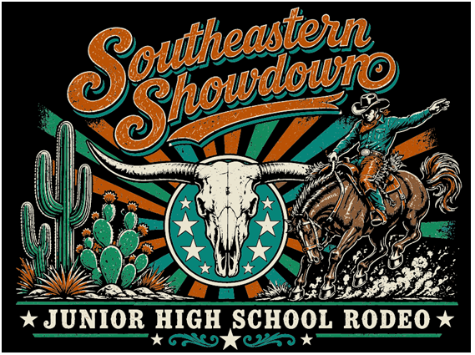

If you have any questions or problems, please contact:

Christine Miller
636-699-7155

