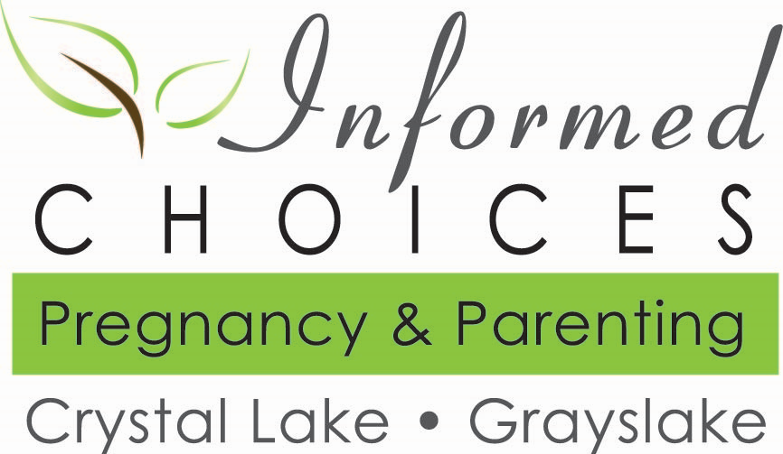

**Staff Job Description for the Position of:**

**Part Time Nurse**

Revised: 07-12-19 **edited 4.21.2025**

1. The employment relationship described above is at-will for both parties, and can be terminated at any time and for any reason whatsoever by either party, subject to any restrictions contained in an employment contract if applicable. No oral promises have been made to the employee contrary to what is contained in this Job Description.

**EMPLOYEE ACCEPTANCE**

I hereby certify that I have read and understood the contents of this Job Description and agree to abide by the terms specified herein.

Signed:______________________ Print Name:___________________ Date __/__/___014 **- DRAFT**

**OBJECTIVES:**

The Part Time Nurse (PTN) provides support and care to the Informed Choices (IC) Pregnancy Center clients by maintaining professional standards of care in conformity with the ANA (American Nurses Association) Code of Ethics. This role affirms the value of unborn life by compassionately supporting women with truth and dignity as they navigate pregnancy decisions. The PTN works in conjunction with the Nurse Manager (NM) and volunteer advocates to assure that clients are receiving the best medical, nursing, and psychosocial care.

**RESPONSIBILITIES:**

The position of PTN encompasses a variety of responsibilities, including but not limited to, the following:

1. Assure that the client feels welcome upon her arrival for her appointment.
2. Perform urine pregnancy tests.
3. Perform ultrasound examinations.
4. Reinforce the humanity of the unborn child with the client.
5. Provide client education according to Informed Choices Policies and Procedures.
6. Assure that infection control guidelines and procedures are followed.
7. Complete necessary client forms, including Pregnancy Verification Letter and medical service logs.
8. Comply with all medical, as well as general Center procedures, policies, and practices.

**QUALIFICATIONS:**

The PTN must meet the following qualifications:

1. Hold a current Registered Nurse’s License from and is in good standing with the State of Illinois.
2. Be a committed Christian who demonstrates a personal relationship with Jesus Christ as her Savior and Lord.
3. Express full agreement with the Informed Choices Statement of Faith, Statement of Principal, Mission Statement, Articles of Incorporation, and By-laws.
4. Be actively involved in a local church.
5. Possess an awareness of the Biblical perspective on life and issues involved in crisis pregnancies; maintaining a firm stand against abortion.
6. Possess a full understanding and demonstrate compliance with the policies and procedures of the center.
7. Be dependable, stable, and capable of following through on commitments.
8. Have a sincere desire to reach out to abortion-vulnerable and abortion-minded women.
9. Maintain a consistent life-affirming philosophy and would never refer or advise a woman to have an abortion. (When a situation arises where a woman’s life is at risk, consistent with sound medical practice the PTN should advocate taking measures to preserve her life, while maximizing the probability that both the woman and her child can be saved.)
10. Respects confidentiality.

**REPORTS TO:**

The PTN reports directly to the Nurse Manager (NM).

**SUPERVISES:**

The PTN supervises center volunteers/lay counselors when present during ultrasound examinations and assists with quality control of pregnancy tests.

**COMPENSATION:**

The PTN is a Part Time - Hourly (Non-Exempt) position. Compensation shall be as delineated in the IC Personnel Policies and Procedures document.