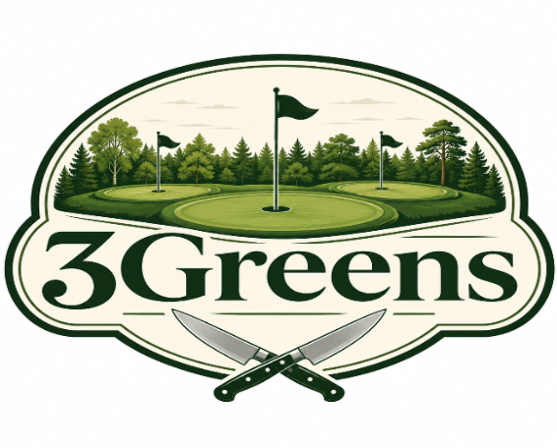

Shared Plates & Bites
Poutine Fries- Gravy, Cheddar Cheese & Scallion $8
Loaded Tots- Queso Blanco, Bacon, Sour Cream, Scallion $12
Bone-in (8) & Boneless Wings (8)- Choice of 1 Sauce: Served w/ Carrots, Celery and Ranch OR Bleu Cheese $15
Sauces: Lemon-Pepper (Dry Rub), Cajun (Dry Rub), Ancho-BBQ, Honey BBQ, Buffalo, Parmesan-Garlic, Nashville Hot Honey Mustard, Mango-Habanero
Fish N Fries- Only Available Thursday & Friday 2 Pieces of Cod, House Tartar Sauce w/ Fries $14 (Add another Piece for $4)
Onion Ring Tower- Fresh Made Onion Rings, Comeback Sauce $10
Chips N Dip- Served with Salsa and Queso Blanco $9
Chicken Tender Basket- 3 Hand Battered Strips Served with Fries and Choice of Sauce $15

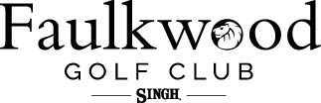

Salads (Add Chicken $5)
House - Spring mix, Onion, Carrot, Radish, Cherry Tomato w/ White Balsamic Vinaigrette $9
Caesar- Romaine, House Caesar, Crostini, Parmesan & Lemon Zest $11
Caprese- Spring Mix, Tomatoes, Fresh Mozzarella, Basil, Balsamic Glaze & Olive Oil $13
Wraps (All Wraps include Kettle chips)
Substitute Fries for $3
Caesar- Chicken, Romaine, Caesar, Lemon, Parmesan $13
Caprese- Chicken, Tomato, Fresh Mozzarella, Basil, Balsamic, Spring Mix & Olive Oil $14
Chicken Pesto - Chicken, Pesto, Fresh Mozzarella, Tomatoes & Spring Mix $13
Buffalo Chicken- Fried Chicken, Buffalo Sauce, Cheddar, Onion, Spring Mix & Carrots $12
Chicken, Bacon, Ranch- Romaine, Tomato, Onion & Cheddar $12
Quesadilla- Chicken, 3 cheese blend melted in a Flour Tortilla w/ Salsa & Sour Cream $11 (Roasted Veggies +$3)
Handhelds & Burgers (GF option) (All handhelds and Burgers include kettle chips)
Substitute Fries for $3
B.L.T.A- Bacon, Lettuce, Tomato, Avocado on Sourdough $13
Nashville Chicken- Nashville Hot Sauce, Pickles, Swiss on Brioche Bun $15
3 GREENS Club- Ham, Turkey, Bacon, Swiss, American, Tomato, Spring Mix & Mayo on Sourdough $14
The Reuben- Corned Beef, Sauerkraut, 1000 Island, Swiss on Rye $16
Turkey Reuben- Turkey, Apple Slaw, 1000 Island, Swiss on Rye $15
3 GREENS Burger- Choice of Cheese, Spring Mix, Tomato, Onion on Brioche $12 (Add ons: Pickles, $1 Jalapenos, $1 Pickled Red $1 Onions, $2 Caramelized Onions, $2 Bacon, $2 Avocado)
Mushroom & Swiss Burger-Mushroom Medley, Swiss & Spring Mix $14
Southwest Burger- Pepper Jack, Chipotle Aioli, Avocado, Spring Mix, Tomato on Brioche $15
Patty Melt- Swiss, Caramelized Onion, 1000 Island on Rye $15
Chef B’s Sliders- 3 Sliders, American, Pickles, Steak Sauce on Brioche $12
Sauces:
Ancho-BBQ, Honey BBQ, Buffalo, Chipotle Aioli, Comeback Sauce, Berry Chipotle, Nashville Hot, Honey Mustard, Mango-Habanero, Parm-Garlic, Steak Sauce
Dressings:
White Balsamic Vinaigrette (House made), Caesar (House-made), Honey Mustard, Ranch, Pesto (House-made), Olive Oil & Balsamic, Bleu Cheese, 1000 Island, Honey Mustard, Italian
Pizzas (GF +$2)
(Available in Regular or Thin Crust)
The Yooper- Pizza sauce, 4 cheese Blend, Oregano, Olive Oil $13
The Brooklyn- Pizza Sauce, Mozzarella, Large Pepperoni, Parmesan & Oregano $14
The Pittsburgh- Mushroom Crema, Mozzarella & Fontina, Mushroom Medley, Basil Oil, Parmesan $15
The Italian - Pizza sauce, Mozzarella, Parmesan, Sausage & Fennel $15
The Hollywood- Pizza sauce, Cherry Tomato, Mozzarella, Basil, Balsamic & Olive Oil $15
Build Your Own (BYO) Starting at $12
Pizza Sauce with Fresh Mozzarella
Toppings (3 Max): Protein $2 Each, Veggies $1 Each
Pepperoni, Bacon, Chicken, Sausage, Ham, Tomato, Mushroom Medley, Onion, Jalapeno, Pineapple, Pickled Red Onion, Bell Pepper, Banana Pepper, Basil, Garlic & Balsamic
Sides:
Roasted Vegetable Medley $3
Apple Slaw $3
French Fries $4
Tater Tots $4
Side Salad $4
Onion Rings $5

*Notice: Ask your server about menu items that are cooked to order or served raw
Consuming raw or undercooked meats, poultry, seafood, shellfish or eggs may increase your risk of food borne illness.

