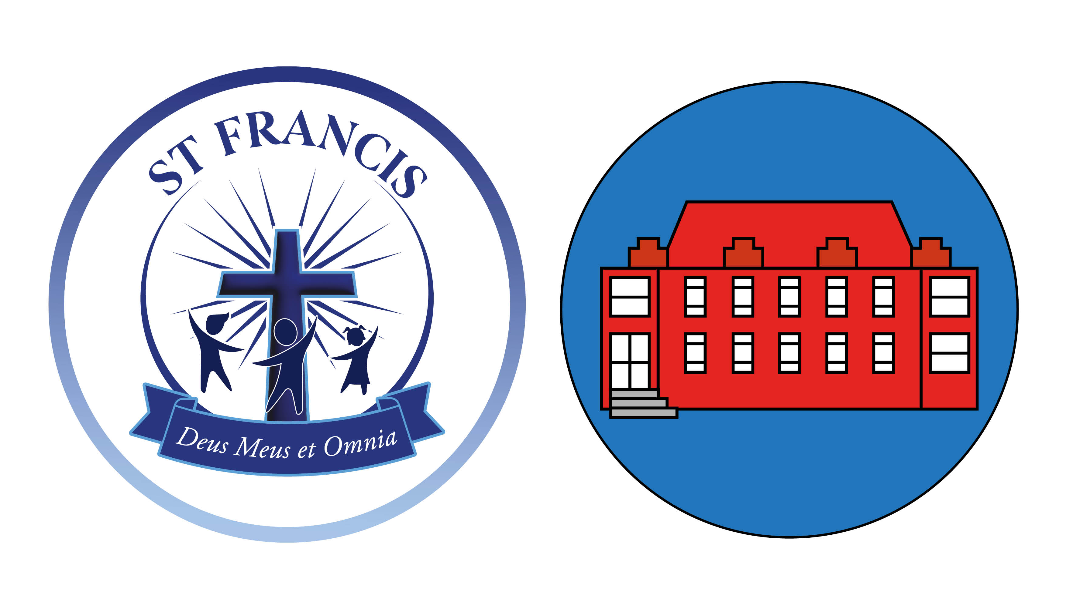
St. Gerard’s Catholic Primary School
Park Nook
Doncaster Road
Thrybergh
Rotherham
S65 4AE

Headteacher: Mrs B Baxter
Email: office@stgerardsprimary.org

Tel: (01709) 850568

29th September 2025
Dear Parents and Carers
We have some exciting news to share about our school's catering! After the October half-term break, we'll be transitioning to a new catering partner, Caterlink.
Our last day with our current provider will be Friday, October 24th. Caterlink will officially begin serving delicious and nutritious meals on Monday, November 3rd, the first day back after October half term.
Caterlink is an outstanding school caterer that's passionate about using fresh, locally sourced ingredients to create high-quality meals. They offer a wide variety of options that we're sure our students will love!
The price for a main school meal for this academic year will be £3.00, this price will be the same for all schools within St Francis CMAT. You can also rest assured that the way you pay for meals will not change.
We want to assure you that the safety of your children is our priority. All dietary and allergy information currently recorded on Arbor will be securely shared with Caterlink before their official start date. Please do not hesitate to contact school if you have any questions or concerns.
To make this a smooth transition, please continue to keep your child’s lunch account topped up. All existing credit will automatically transfer to their new Caterlink account on October 25th, 2025.
We're confident this change will have a positive impact on our students' health and well-being, and we can't wait for them to experience the new menu. If you have any questions, please don't hesitate to contact the school office.
Thank you for your continued support as we make this exciting change!

