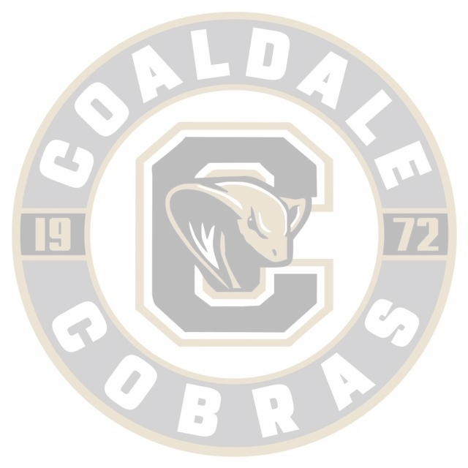
Coaldale Minor Hockey Association

Guidelines

(Revised JUNE 2025)
Note to CMHA President

These guidelines have been developed to support the Coaldale Minor Hockey Association (CMHA) Board in making informed decisions and to help new board members understand their roles and responsibilities. It is the responsibility of the President to ensure a current copy of these guidelines is available at each CMHA Board meeting and to oversee their regular review and updates.

Section 1 | Coaldale Minor Hockey Association |  | 6
1.1 | Description |  | 6
1.2 | Mission Statement |  | 6
1.3 | Divisions and Age Groups |  | 6
Section 2 | Coaldale Minor Hockey Association Board |  | 7
2.1 | Board Meetings |  | 7
 | 2.1.1 | Schedule | 7
 | 2.1.2 | Agenda | 7
 | 2.1.3 | Reporting | 7
 | 2.1.4 | Attendance | 7
2.2 | Signing Authority |  | 8
2.3 | Correspondence |  | 8
2.4 | Purchasing Policy and Procedure |  | 8
2.5 | Annual General Meeting (AGM) |  | 8
2.6 | First Board Meeting after AGM |  | 8
2.7 | CMHA Board Positions |  | 9
2.8 | Travel Expenses |  | 9
2.9 | Communication between Board Members |  | 9
Section 3 | Registration Guidelines |  | 10
3.1 | Registration |  | 10
 | 3.1.1 | Payment | 10
 | 3.1.2 | Transfer to Other Associations | 11
 | 3.1.3 | Goaltender Discount | 11
 | 3.1.4 | Multiplayer Discount | 11
3.2 | Late Registration |  | 11
3.3 | Refunds |  | 11
 | 3.3.1 | Refund for Player Withdrawal | 11
 | 3.3.2 | Refund for Injured Player | 12
3.4 | Insurance |  | 12
 | 3.4.1 | Non Sanctioned Event Liability | 12
Section 4 | Code of Conduct |  | 13
4.1 | Code of Conduct - Player, Parent/Guardian, Coach |  | 13
 | 4.1.1 | Breach of Code of Conduct | 13
4.2 | Education |  | 13
Section 5 | Team Size, Player Movement |  | 14
5.1 | U5 |  | 14
5.2 | U7 (formerly Initiation) |  | 14
 | 5.2.1 | U7 (4 Year Old) | 14
5.3 | U9 (formerly Novice) |  | 14
5.4 | U11(formerly Atom) |  | 14
5.5 | U13 (formerly Pee Wee) |  | 14
5.6 | U15 (formerly Bantam) |  | 14
5.7 | U18 (formerly Midget) |  | 14
5.8 | Player Movement Policy |  | 15
5.9 | Release of Players Due to Team Numbers |  | 16
5.10 | Amalgamating Teams |  | 16
5.11 | Dividing Player Numbers within a Division |  | 16
Section 6 | Team Guidelines |  | 17
6.1 | Team Sponsors |  | 17
6.2 | Team Apparel |  | 17
6.3 | Jerseys |  | 17
6.4 | Fundraising |  | 17
 | 6.4..1 | 50/50 | 17
 | 6.4.2 | Progressive 50/50 | 17
6.5 | Provincials |  | 18
6.6 | Team Funds |  | 18
6.7 | Referee Payments |  | 18
6.8 | Loans |  | 18
Section 7 | Coach Guidelines |  | 19
7.1 | Coaches Meeting |  | 19
7.2 | Ice Time |  | 19
7.3 | Safety |  | 19
7.4 | Coach Selection |  | 19
7.5 | Requirements |  | 19
7.6 | Mentorship |  | 20
Section 8 | Player Guidelines |  | 21
8.1 | Driving |  | 21
8.2 | Two Teams |  | 21
8.3 | Protective Equipment |  | 21
8.4 | Releasing of Players to Elite |  | 21
8.5 | Goaltending |  | 21
8.6 | U18 Tryouts |  | 21
Section 9 | Equipment Guidelines |  | 22
9.1 | Equipment and Damages |  | 22
9.2 | Jerseys and Goalie Equipment |  | 22
9.3 | Equipment Deposit |  | 22
Section 10 | Referee Guidelines |  | 23
10.1 | Number of Games |  | 23
10.2 | Conflict of Interest |  | 23
10.3 | Referee Equipment |  | 23
10.4 | Referee Clinic Fees |  | 23
Section 11 | Complaints & Discipline Guidelines |  | 24
11.1 | Player and Parent Behaviour Expectations |  | 24
 | 11.1.1 | Code of Conduct | 24
11.2 | Types of Infractions |  | 24
11.3 | Complaints |  | 25
 | 11.3.1 | Making a Complaint | 25
 | 11.3.2 | Complaint Handling Procedure | 25
11.4 | Discipline Committee |  | 26
11.5 | Discipline Process |  | 26
 | 11.5.1 | Handling Infractions | 26
 | 11.5.2 | Discipline Sanctions | 27
11.6 | Specific Policies |  | 27
 | 11.6.1 | CMHA Coach Discipline Policy | 27
 | 11.6.2 | Player Attendance Policy | 27
11.7 | Appeal Process |  | 28
11.8 | Final Provisions |  | 28
 | 11.8.1 | Reinstatement | 28
 | 11.8.2 | Confidentiality | 29
 | 11.8.3 | Consistency | 29
 | 11.8.4 | Conflict of Interest | 29
Sections 12 | Appendices |  | 30
 | Appendix A - Purchasing Policy |  | 30
 | Appendix B - Letter of Acknowledgement |  | 31
 | Appendix C - Code of Conduct - Parent & Guardian |  | 32
 | Appendix D - Code of Conduct - Coach |  | 34
 | Appendix E - Code of conduct - Player |  | 36
 | Appendix F - Communication Flow Chart |  | 38

SECTION 1: COALDALE MINOR HOCKEY ASSOCIATION

1.1 Description

The Coaldale Minor Hockey Association (CMHA or Association) is a registered society in the Province of Alberta and is the local organizing body for minor hockey within Zone 5 of Hockey Alberta (HA) and Central Alberta Hockey League (CAHL). Coaldale Minor Hockey Association operates under the rules and regulations as set forth by Central Alberta Hockey League (CAHL), Hockey Alberta (HA), and Hockey Canada (HC).

1.2 Mission Statement
The Coaldale Minor Hockey Association is dedicated to organizing and advancing hockey for the youth of Coaldale and the surrounding areas. Through the efforts of our members and volunteers, we are committed to fostering fair play, teamwork, skill development, and positive life skills in a safe and respectful environment.
Core Values
- Commitment – Dedicated to the game, teammates, and coaches.
- Development – Focused on enhancing individual skills, team strategies, and the growth of coaches and officials.
- Fun – Emphasizing that hockey is a game meant to be enjoyable and engaging.
- Passion – Driven to improve, uphold fair play, and ensure healthy, safe competition.
- Respect – Valuing the game, its officials, opponents, coaches, and teammates.
(Revised September 2024)
1.3 Divisions / Age Groups
- U7 (5 & 6 year old before Dec 31 of current season)
- U9 (7 & 8 year old before Dec 31 of current season)
- U11 (9 & 10 year old before Dec 31 of current season)
- U13 (11 & 12 year old before Dec 31 of current season)
- U15 (13 & 14 year old before Dec 31 of current season)
- U18 (15,16 & 17 years old before Dec 31 of current season)

(Revised July 2020)
SECTION 2: CMHA BOARD
2.1 Board Meetings
2.1.1 Board Meeting Schedule
Regular Board meetings will typically be held monthly. Meetings in May, June, July and January are optional at the discretion of the Board. Meetings are held on the Second Tuesday of the month at the Coaldale Sportsplex. When said Tuesday should fall on a statutory holiday, then another agreeable date shall be found. Regular meeting dates of the Board should be set and published on the CMHA Calendar (website) one week in advance. Dates of annual events and meetings such as the AGM should be set at the first meeting of the Board after being elected and published on the CMHA Calendar (website).
(Revised September 2024)
2.1.2 Board Meeting Agenda
All meetings shall follow an agenda as prepared by the Secretary and distributed to the Board Members before the meeting. Normally the President will chair the meeting; in his absence the Vice President will act as Chairperson. The agenda should include a report from each director and board position. Any CMHA member wishing to speak at these meetings must inform the President for it to be added to the agenda.
The first half hour of Board meetings will be open to any visitor/visitors or concerned coaches or parents.
2.1.3 Board Meeting Reporting
All Board members must submit a written report to the Secretary and a copy of the same to the President the Thursday before the actual meeting date. These reports must be submitted by email and if not submitted then that person is omitted from the Agenda of the next meeting and should not be permitted to present anything unless they ask for it to be added to the Agenda prior to the Agenda being approved by the Board at the beginning of the meeting. This way the President can ensure that each member is held accountable to be diligent in preparing for the meetings and respectful of everyone else’s time.

The Secretary, once (s)he has received the reports from all members, should send out an email, to all Board members, which contains the following:
- The Agenda for the next meeting.
- The minutes of the previous meeting.
- Copies of all reports that have been submitted for the next meeting.

2.1.4 Board Meeting Attendance

Any board member having three (3) unexcused absences to regularly scheduled monthly meetings may be subject to removal by the Board with a 50% +1 vote. The removed member will be notified by the President within 48 hours of the vote via email and all Board members will be copied.
2.2 Signing Authority
- All cheques will require two signatures.
- Two members of the Board of Directors (Treasurer and President) shall have the signing authority.
- Signing authority will be reviewed and updated at the bank at the commencement of each new season.
(Revised September 2024)
2.3 Board Correspondence
The Secretary of the Association should be responsible for all correspondence of the Corporation. This means that he/she maintains a record of all documentation that is signed and sent out on behalf of the CMHA regardless of who signs it, a copy should be provided to the Secretary for document control for future reference. Any correspondence received by CMHA without a written signature will be mentioned, but not discussed, then destroyed.

2.4 Purchasing Policy and Procedure
From time to time the Coaldale Minor Hockey Association (CMHA) needs to make purchases on behalf of the board and its members. All purchases made on behalf of the Board must be made with the best interests of the Association in mind and therefore the purchasing policy and procedure has been created and approved by the CMHA board. The purchasing policy is to be followed for all purchases in excess of $1000. This policy can be found in Appendix A of this document.
(Revised 2018)
2.5 Annual General Meeting (AGM)

The AGM is to be held on the 4th Tuesday of March in accordance with CMHA Bylaws (Section 9 AGM). Notice of the AGM should be given to CMHA members at least 4 weeks in advance of the meeting through email and on the CMHA website. As per the CMHA bylaws, a minimum of 5 directors should be elected every year at the AGM. Directors are elected to a 2 year term. Nominations for directors should be made at least 1 week prior to the AGM so that nominees can be posted on the CMHA website. Nominations can be taken from the floor at the AGM.

2.6 First Board Meeting after the AGM

As stated in the CMHA Bylaws “The Board of Directors are elected for a two (2) year term. The new directors' term of office shall begin with a board meeting within one month of the annual meeting. All the previous years board members are to attend this meeting. The previous years board members are to give a brief report on their duties for the various offices they held. They will also provide the board with any materials or resources helpful to the person assuming their position. Once this has been completed the current directors shall form their board for the upcoming term. All offices shall be filled and the board is ready to operate CMHA for the upcoming year.”
2.7 CMHA Board Positions
Position descriptions for President, Vice President, Secretary and Treasurer are in the CMHA bylaws. All other Director positions descriptions are written down and stored in Google Drive.
CMHA Board will have a maximum of 15 voting board members. In order to serve in the role of President, a board member must have already served a full 2 year term on the CMHA Board.
(Revised February 2022).
2.8 Travel Expenses
Anyone traveling to the annual Hockey Alberta or other approved conferences, training, and other meetings will be reimbursed for direct out of pocket expenses, which include accommodation, travel and meals.
- League representative travel expenses to meetings will be reimbursed at a rate of $0.50/km (CAHL rate 2018).
(Revised September 2024)
2.9 Communicating Situations or Issues Amongst Board Members

When dealing with issues or situations that affect other board members' portfolios, the affected board members as well as board executives need to be made aware of the issue or situation. This should be done by inclusion in emails so that there is a record of the exchange.

(Revised February 2019)

SECTION 3: REGISTRATION GUIDELINES
3.1 Registration
- All registration is completed online through TeamSnap.
- Registration opens June 1 and closes September 1. Any registrations received after this date must contact the CMHA Administrator and will be placed on a waitlist. Placement from the waitlist will depend on available space within the appropriate division.
- Players trying out for Elite Hockey (AAA/AA) who intend to return to CMHA if released must still register by September. Any registrations received after this date must contact the CMHA Administrator and will be placed on a waitlist. Placement from the waitlist will depend on available space within the appropriate division.
- For all divisions, must parents register their player in the division that corresponded with their birth year, regardless of their player’s skill level.
- A minimum of 12-15 players must be registered for U5 in order to have a season. If the minimum number of players is not met, the CMHA Board will determine whether players will be moved up to the U7 Division or released to other associations. Full refunds will be issued to any players who are released or who choose not to play as a result.
- Junior/U18 Overage Players Registrations
  - U18 OA player registration will only be considered if U18 team numbers allow for additional player(s) and/or Goalies.
  - CMHA will follow Hockey Alberta - Process for Overage Player and CAHL Overage Guidelines in CAHL Game Regulation Manual (Section 9. K.1).
  - Registration will only be allowed after September 1, if numbers allow and will be pending approval from CMHA Board, CAHL and HA.
- Players wanting to play in a different age division (up/down) please refer to the player movement guideline.
3.1.1 Payments
- A $100 deposit per registrant is required at the time of registration. The remaining balance must be paid in full by September 15. Alternatively, families may choose to pay the full registration fee at the time of registration.
- Payment can be through Teamsnap via credit card, cash and e transfer will also be accepted.
- Creative payment options may be considered, at the discretion of the Executive Officers of CMHA. Parents are to email CMHA Administrator with requests if needed.

(Revised September 2024)
3.1.2 Transfers to Other Associations
In Hockey Alberta, player transfers between Minor Hockey Associations (MHAs) typically require written permission from the player's current association and may involve a formal Player Movement application. The Player Movement Form must be completed and submitted to the CMHA Administrator for review and signature by the CMHA President. CMHA reserves the right to deny any player movement request to another association.
If a player’s request is denied by CMHA, they have the right to appeal the decision directly to Hockey Alberta.
3.1.3 Goaltender Discount
Full time goalies in U13, U15 and U18 will get a $300 refund on registration fees once the season has begun and the goaltender situation is set. A full time goalie is a goalie that dresses as a goalie every game. If a player plays half the games as goalie and half as a player, they will get a 50% refund.
(Approved March 2019, Revised September 2024)
3.1.4 Multiplayer Discount
Any family who registers 3 or more players with CMHA will receive a 10% discount on all registration fees (Early Bird Fees ONLY).
(Approved September 2024)
3.2 Late Registration
The registration deadline is September 1. Registrations received after this date must contact the CMHA Administrator and will be placed on a waitlist. Placement from the waitlist is subject to space availability within the appropriate division. Exceptions may be granted on a case-by-case basis.
Registrations submitted after July 15 will be subject to a $100 late fee.
If approved by the CMHA Board, players registering between December 31 and January 10 of the current season will be charged 60% of the full registration fee for their age division
3.3 Refunds
3.3.1 Refund for Player Withdrawal
If a CMHA Minor Hockey League (CAHL or City League) player chooses to quit hockey prior to the player’s first league game, that player will be reimbursed all of his/her registration fee excluding a $30 administration cost; if he/she quits after the first league game but before December 31st of the year, he/she is reimbursed 40% of the registration fee; if he/she quits December 31st or after, there is no reimbursement.

If a CMHA Pond Hockey player chooses to quit the program before October 31, that player will be reimbursed all of his/her registration fee excluding a $30 administration cost; if he/she quits after October 31 but before December 31st of the year, he/she is reimbursed 40% of the registration fee; if he/she quits December 31st or after, there is no reimbursement.
3.3.2 Refund for Injured Player
When a player suffers a serious injury that prevents him/her from practicing and playing, and where the injury is verified by a doctor, the following refund schedule may apply:
- The player will be refunded 33% (less Hockey Alberta (HA) registration) for every 60 consecutive days that the player is unable to play or practice.
- All rebates will be minus the cost of registering the player with HA.
- All doctor recommendations must clearly include the date at which the player is able to return to practice and/or play in a game
- When there is a full roster of players (i.e. 17 skaters and two goalies or 18 skaters and one goalie), the Board may release the injured player in order to make room for a healthy player.
- The player or his parents must apply, in writing, to the Board for the refund before the end of May 1st of the season in which the player was injured
3.4 Insurance
CMHA will pay for the Hockey Alberta endorsed insurance policy for players, coaches, managers, and officials in our Association. A reimbursement will be given by CHMA with proof of receipt if a member has paid twice. For insurance reasons, all players, officials and coaches must be registered with CMHA before being able to participate in any CMHA on-ice activity

3.4.1 Non Sanctioned Event Liability
This non-sanctioned event liability policy applies only to parent and sibling games organized by individual teams for fun. It does not apply to CMHA teams participating in games against non-Hockey Canada sanctioned teams.
Please note that CMHA strictly prohibits its teams from competing against non-sanctioned teams under any circumstances.
If a team wishes to host a parents-and-siblings game as part of an ice event, every participant must complete a liability waiver. This waiver acknowledges that CMHA insurance does not cover these types of events, and any incidents or injuries that occur are the sole responsibility of the participating individuals and not CMHA.

SECTION 4: CODE OF CONDUCT

4.1 Code of Conduct
The CMHA Code of Conduct for Parents/Guardians, Players, and Coaches is outlined in Appendix C, D & E of this document.
The Parents/Guardians Code of Conduct is acknowledged and signed during the registration process through TeamSnap. The Player Code of Conduct will be reviewed with all players by their coaching staff at the beginning of the season. The Coaches Code of Conduct will be reviewed during the Coaches Meeting held prior to the start of the season.
4.1.1 Breach of Code of Conduct
For breaches of the Code of Conduct, please refer to Section 11: Complaint and Discipline Guidelines.
4.2 Education
The CMHA will promote awareness of all forms of abuse and neglect within the game by providing educational materials and programs, which are made available through Hockey Alberta for participants, parents, volunteers, and staff members.

SECTION 5: TEAM MAKEUP, PLAYER MOVEMENT & GOALIE GUIDELINE

5.1 U5
- Min 12-15 players need to be registered to operate each season
  - If minimum number cannot be reached players will be reimbursed and released to alternate associations

5.2 U7
- Min 8 players with a Max 15 players per team
- Goaltenders must rotate with each child encouraged to play at least once

5.2.1 U7 (4 year old rule)
- Players can skate un-assisted and Parents must be willing to be a team volunteer (coach, manager, treasurer etc.).
- If there is no U5 program - 4 year olds will only be considered if U7 numbers allow and the CMHA Board approves them to register
5.3 U9
- Minimum 12 players with a Max 15 players per team
- Goaltenders can rotate with each child encouraged to play at least once

5.4 U11
- Minimum 11 players per team
- Goaltenders can rotate with each child encouraged to play at least once make opportunity for all who want to be a goalie can participate

5.5 U13
- Minimum 11 players per team
- Goaltenders may specialize at the division

5.6 U15
- Minimum 14 players per team
- Goaltenders may specialize at the position

5.7 U18
- Minimum 14 players per team
- Goaltenders may specialize at the position

5.8 Player Movement

Player movement may be implemented by the CMHA Board to adjust the number of players at an age level or for a team. Player movement is NOT permitted for the purpose of accelerating a player based on their abilities. Player movement may also be permitted for special circumstances as determined by the CMHA board and will be dealt with on a case by case basis. Procedure for player movement (in order as written):

- Player Movement to satisfy minimum roster numbers
  - Players will only be moved in the event the teams won’t meet the minimum number of players to roster a team.
  - In the event that there are too many players for 1 team, but not enough for 2 teams and there are no other players to draw from other associations, then player movement to fill positions for the team will be permitted. Moving a player down will only be permitted to facilitate the goalie position or because of a safety issue.
  - Once it has been determined a team will need players to be moved up or down in order to meet roster number minimum requirements, the board director responsible for that team will work with the coach and organize tryouts.
  - Players younger than the age group they would move to will try out for the B team if there are two teams. Players moving up, have to be in their second year of the age group they are supposed to play for.
  - Players older than the age group they would move to will try out for the team needing players if there are two teams. Players moving down, have to be in their first year of the age group they are supposed to play for and fall within all the required criteria for an overage player within Hockey Alberta’s Regulations. (Ref. Hockey Alberta Regulations; Player Registration 2.1)
  - The coach and Director of the age group requesting players will set up 2 practices for the players to try out. The tryout will be open to all players in their second year for those that would be moving up a level, and all players in their first year for those who would be moving down a level.
  - Players/parent’s that are notified must reply with their intent to try out 48 hours before the first scheduled try out to the director, coach, and administrator. Tryouts and player selection must be completed before September 30th. Player selection must be submitted to the administrator and director of that age group.
  - The coach of the team the players are trying out for would make the final
selection based on the tryouts, the coach is responsible for contacting the
families of the selected players. The coach will also contact their board director for that level and notify them of the selection.
  - The new roster and the player movement will have to fall within guidelines
for player movement with Hockey Alberta and the new roster will be subject to approval from Hockey Alberta.
  - The new roster will have to be approved by the league that the team will be playing in, ie. CAHL.

- Requests for a player movement outside of team size can be applied for in writing from a legal guardian outlining reasons for movement to be submitted to the board no later than September 1st.
  - Requests can be applied for in writing from a legal guardian and must outline reasons for movement to be submitted to the board no later than September 1st.
  - Request for player movement to be reviewed by CMHA Board.
  - Player movement to fall in line with Hockey Alberta and CAHL guidelines for player movement before board approval.

- Final approval for any Player Movement by CMHA Board no later than Sept. 30th.
(Revised September 2021)

5.9 Release of Players Due to Team Numbers
In an instance where team min or max cannot be reached, CMHA will accept players from/release players to other associations with a priority given to proximity.
5.10 Amalgamating Teams
If there is an amalgamation of community teams, the parents of the teams directly involved will be consulted before the first tiering round game.

5.11 Dividing Player Numbers in a Division

Players will be divided up according to the following rules:

- If over half of players (or over a third of players if there will be 3 teams) want to play on the “A” team, then there will be tryouts.
- Team numbers must meet minimum numbers as outlined in guidelines 5.1 to 5.6
- Divide team numbers as evenly as possible. If due to numbers teams cannot be even then then Coaches will decide team numbers based on Team Selection Process

(Revised February 2019)

SECTION 6: TEAM GUIDELINES

6.1 Team Sponsors
CMHA teams that receive sponsored jerseys are encouraged to provide their sponsor(s) with a team photo as a token of appreciation.
(Revised July 2020)
6.2 Team Apparel
Teams may purchase apparel from any local business; however, all items must comply with the CMHA Logo Policy.
(Revised September 2024)
6.3 Jerseys
No alterations are permitted to CMHA-issued jerseys. However, U5 and U7 Timbits and U11 (Atomic) jerseys may be customized with player names or other modifications, as these jerseys are kept by the players at the end of the season
(Revised June 2025)
6.4 Fundraising
Any team fundraising outside of home tournaments must be approved by the CMHA Board. Teams are required to submit a formal request to the CMHA Fundraising Coordinator, who will present it at the next scheduled Board meeting. Teams conducting approved fundraisers are fully responsible for organizing and managing the activity.
(Revised June 2025)
6.4.1 50/50 Raffles
When running 50/50 raffles at games, teams must use the format provided by the CMHA. CMHA will provide teams with a form that needs to be filled out for each 50/50 raffle (this is so that the CMHA is compliant with AGLC rules). This form, approved by the AGLC, will contain the following information: CMHA gaming license number, date of sales, winners name, earnings from sales, signature of winner and signature of seller.

(Revised 2018)

6.4.2 Progressive 50/50 Raffles

Any team or tournament committee wishing to host a Progressive 50/50 raffle must obtain approval from the CMHA Board. Requests should be submitted to the CMHA Fundraising Director, who will present them at the next scheduled Board meeting. This process ensures proper reporting to the AGLC. Upon approval, the CMHA Administrator will apply for and set up the Progressive 50/50 raffle through the appropriate online platform.

(Revised June 2025)
6.5 Provincials
CMHA will donate $300.00 to any teams participating in Provincial Tournaments. If the location exceeds 500 km one-way, that team shall receive $1000.00. Any fundraising efforts by the team are to be done under the jurisdiction of CMHA.
6.6 Team Funds
Proceeds of 50/50 and home tournaments will go to the home team and is to be used for tournament registrations and/or other expenses. Teams are not to spend in excess of what is needed for the team to function. It is expected that any extra fundraising money generated by CMHA teams not used by year end be returned to CMHA.
6.7 Referee Payments

CMHA will directly pay officials for all League (Tiering, Regular Season, Playoff) Games as well as all Tournament Games. Any exhibition games other than ones listed above will be invoiced to teams from CMHA and they can e-transfer cmhacobra@gmail.com. Teams will need to budget for these additional game costs and make sure there is enough money in their team account to cover these fees.

(Revised September 2024)

6.8 Loans
The CMHA Board will not issue any loans to CMHA teams

SECTION 7: COACH GUIDELINES

7.1 Coach Meeting
CMHA will at minimum conduct one meeting with coaches at the beginning of the season. At this time the coach's guidelines and code of conduct will be reviewed.
7.2 Ice Time
Coaches are expected to discuss their own philosophy regarding fair play at the beginning of each season, to ensure all players and parents understand what the expectations are for the year.
Please note however that fair play is NOT equal ice. Equal ice is defined as equal ice-time every game to the best ability of the coach. Throughout the course of a game, situations will arise which may result in the coach choosing to support line consistency and a specific line of players may have to be adjusted.
Overall, it is expected that by the end of the year, every player will have played in all situations (such as power play and penalty kill) and ice time would be fair in comparison to their peers. We are a development-focused association, and coaches are required to adhere to Coaldale Minor Hockey philosophies and regulations surrounding equitable ice time.
(Revised June 2025)
7.3 Safety
The Hockey Alberta safety program is compulsory for all CMHA teams. One coach from each team must have this certification in order to be on the bench.
7.4 Coach Selection
Head coaches will be selected by the CMHA Board. Assistant coaches and managers will not be appointed until after the teams have been selected. The CMHA Board must approve all assistant coaches and managers. Where possible, CMHA will have the head coach in place for each team no later than the August CMHA Board meeting of that year. All coaches are to apply at time of registration.

7.5 Coach Requirements
All coaches must have proper Hockey Alberta qualifications before commencement of the regular season. As of 2017, all coaching requirements must be completed by November 15.
All coaches, trainers and on ice/on bench help must complete the Respect in Sport Activity Leader program before the regular season. All coaches, trainers and on ice/on bench help must get a criminal record check (CRC) done by December 15th. The CRC needs to be updated every 2 years.

7.6 Coach Mentorship
Coaches are required to coach one practice up a level and one practice down a level before Christmas. (eg. A U9 coach will be required to run a U7 practice with the U7 coaches and run a U11 practice with the U11 Coaches before the Christmas break)
(Approved Feb 2019, Revised July 2020)

SECTION 8: PLAYER GUIDELINES

6.1 Driving
Players with their drivers licence are permitted to drive to practice and home games being played at the Coaldale Arena. Players are NOT permitted to drive to out of town games. A parent or guardian must drive a player to all out of town games.
6.2 Two Teams
No player will be registered on 2 teams unless the 2 teams are affiliated under Hockey Alberta (HA) rules of registration. Then the approval of the district league governor is also needed.
6.3 Protective Equipment
Protective equipment is to be worn by ALL CMHA players while on the ice as set down in HA rules. As well, ALL spare goaltenders and injured players on the bench that are registered in CMHA must wear full hockey gear.
6.4 Releasing of Players to Junior A, AA, AAA etc.
CMHA will grant releases for Junior A, AA, and AAA team tryouts. A release will only be granted at or near the beginning of the tryout process. Players who fail to make the team at the level they are trying out at MUST come back to CMHA. Releases to Junior B will be dealt with on an individual basis.
6.5 Goaltending
Whenever we have more than 2 goalies per team at any level, tryouts will be required. The goalie that fails to make the cut will be accommodated on a case by case basis. Movement into another hockey association may be required.
6.6 U18 Tryouts
Numbers may warrant tryouts and cuts at the U18 level due to the maximum number of players per team (Section 5.6).
(Revised July 2020)

SECTION 9: EQUIPMENT GUIDELINES

9.1 Equipment Damage
Any players or coaches found having caused willful damage to Town or CMHA property ( at home or away ) will be disciplined by CMHA with possible fines and/or suspensions.
9.2 Jerseys and Goalie Equipment
- Jerseys and goalie equipment, once designated to teams, becomes the responsibility of the coach and manager.
- They must ensure that it is not used for off-ice purposes.
- All equipment must be turned in to the Equipment Manager at the end of the CMHA season.
- Equipment is for use by CMHA players only during the hockey season. There will be a $250 deposit required by an individual if equipment is used out of season ( eg. Summer Hockey )
- Goalie equipment for CMHA players will be provided up to and including the U11 and U13 levels.
9.3 Equipment Deposit
Locker combos, first aid kits etc. will be in each team locker and issued to each Head Coach and Team Manager.
(Revised June 2025)

SECTION 10: REFEREE GUIDELINES

10.1 Number of Games
Referees are to receive an equal amount of games, where possible, throughout the year.
10.2 Conflict of Interest
To ensure fair play and maintain the integrity of our games, we discourage having Head Referees and players in the same game who are related. If this situation is unavoidable, it is the responsibility of the team's Coach and Manager to inform the opposing team of the relationship. Additionally, they must document this in the scorebook, with both teams signing off on the notation.
(Revised September 2024)
10.3 Referee Equipment
Referees are to supply their own shirts, pants, crest and armbands.
10.4 Referee Training Fees
- CMHA will pay 100% of the referee course and provide the rulebook for any CMHA player or parent who takes the refereeing course and attains a passing grade, after they have refereed 5 games in the CMHA system.

(Revised September 2024)

Section 11: CMHA COMPLAINT & DISCIPLINE GUIDELINES

11.1 Player and Parent Behavior Expectations
Coaldale Minor Hockey aims to ensure all members—players, parents, coaches, officials, and spectators—conduct themselves in a respectful, fair, and safe manner. This policy outlines the expectations, reporting process, disciplinary procedures, and consequences for inappropriate behavior. Please note that Coaldale Minor Hockey Association can only issue disciplinary action for conduct that occurs within its defined scope. Incidents that take place outside of CMHA-sanctioned events will not be reviewed or acted upon by the CMHA Board.
This policy applies to:
- All Coaldale Minor Hockey Association sanctioned events, including: games, practices, tournaments, meetings, dryland and social team events.
- All members and participants including players, parents, coaches, volunteers, officials, and spectators.

11.1.1 Code of Conduct
The CMHA Player and Parent Code of Conduct applies to every player and parent members. See Code of Conducts Section 3.

11.2 Types of Infractions

Minor Infractions: Single incidents with no safety concerns. Examples:

Disrespectful behavior or language

Unsportsmanlike conduct

Being late or missing events without cause

Breach of social media guidelines

Major Infractions: More serious or repeated behavior, or actions that involve safety or harm. Examples:

Bullying, harassment, or abuse

Repeated misconduct or violations

Substance use by minors at events

Physical violence or threats

Vandalism or theft

Hybrid Infractions: Incidents that may be escalated based on severity or frequency, such as:

Three or more minor infractions

Minor infractions involving hate speech or targeted harassment

11.3 Complaints
11.3.1 Making a Complaint
Any CMHA member may report an infraction. All complaints must be submitted in writing—either by email or letter (or using a formal complaint form, if implemented)—within ten (10) business days of becoming aware of the alleged incident.
Complaints must follow the Communication Flow Chart ,(see Appendix F) including the mandatory 24-hour cooling-off period, before being formally submitted. Complaints may be directed to the Team Manager, Coach, or submitted directly to the Divisional Director. Anonymous complaints will not be accepted.
Each complaint must be submitted individually and in writing. Please note that phone calls, text messages, informal emails, or verbal conversations will not be accepted as official complaints unless accompanied by a formal written submission in the proper format.
11.3.2 Complaint Handling Procedure
Once a formal complaint is received, it will be acknowledged in writing—either by email or letter—using Hockey Alberta’s Complaint Acknowledgement Form (see Appendix B). This acknowledgment will be issued by the Divisional Director, Secretary, or Administrator. The complaint will then be brought forward for review at the next scheduled CMHA Board meeting.
If the complaint is deemed urgent or safety-related, a special board meeting may be called. This determination will be made by the Divisional Director in consultation with the Executive of the Board.
At the scheduled meeting, if the Board concludes that further review is necessary, the complaint will be referred to the Discipline Committee for investigation. The committee will conduct its review in alignment with Hockey Alberta’s "Guide to Effective Conduct Management," available on the Hockey Alberta website under the Game and Conduct Management section.
Following the Board’s or Discipline Committees decision, a formal response letter will be emailed to the member who submitted the complaint and to the members involved . Once these letter(s) are sent and acknowledged, the matter will be considered closed.
Please note that the CMHA Board and Discipline Committee will not disclose any details regarding disciplinary actions or outcomes related to another member, even to the individual who submitted the initial complaint.
If the member is not satisfied with the outcome or consequences, they may:
- Submit a new written complaint with additional context or concerns, or
- File an written appeal following CMHA’s established appeal process
(Revised June 2025)
11.4 Discipline Committee
- A three member discipline committee is to be selected from the CMHA membership.
- The discipline committee is responsible for investigating complaints , as well as reporting its findings to the CMHA Board along with its recommended disciplinary action. If a complaint is deemed to be a conflict of interest for the Committee or the complaint is deemed to be a sensitive matter, a neutral party should be used for the investigation. This neutral party could be someone from another Minor Hockey Association or from Hockey Alberta. Complaints deemed to be criminal should be turned over to the police.
- HA’s “Guide to Effective Conduct Management” can be found on HA’s website under the “Game and Conduct Management” tab. This guide should be used by the Discipline Committee in its investigation of complaints and throughout the entire disciplinary process.

The Discipline Committee will:
- Determine whether to investigate the complaint.
- Conduct interviews or gather written statements as needed.
- Deliver a conclusion and, if applicable, issue sanctions.
- Keep all records confidential, unless required by law or external authorities.

11.5 Discipline Process
11.5.1 Handling Infractions
Minor infractions may be addressed at the team level by the Coach or Team Manager and must be reported to the Divisional Director to ensure proper documentation.
Major or hybrid infractions must be reported directly to the Divisional Director via the complaint process to bring forth to the board for review. The Board will determine whether a complaint should be addressed by the team’s coaching staff or referred to the Discipline Committee for further review. If the matter is directed back to the coaching staff, the Board may provide guidance and recommendations to help support a resolution.

11.5.2 Discipline Sanctions
Sanctions may include, but are not limited to:
- Verbal or written warnings
- Required apology or training (e.g., Respect in Sport)
- Suspension from events or team activities
- Removal of team privileges or roles
- Expulsion from Coaldale Minor Hockey
- Reporting to Hockey Alberta, Hockey Canada, or legal authorities
*The CMHA Board reserves the right to make all final decisions concerning its members, including any disciplinary actions or sanctions imposed.

11.6 Specific Policies

11.6.1 CMHA Coach Discipline Policy

When a coach in the CMHA has been abusive towards a referee or other game official, that coach will be subject to the following:
- First Offense: Verbal conversation with the Referee-in-Chief.
- Second Offense: Written documentation within CMHA, suspension for 1 - 3 games with the possibility of escalation to Hockey Alberta for further action.
- Third Offense: One-month suspension from all team activities, including games, practices, and off-ice events.
(Revised 2017)
11.6.2 CMHA Player Attendance Policy
This policy is designed to cultivate a positive, respectful, and dedicated team environment. It provides clear guidelines and fair consequences regarding attendance at team events and behavior expectations, fostering team integrity, accountability, and sportsmanship.
Includes: Practices and Games ONLY.
Notification Procedures:
Players must notify the coach or team manager as soon as possible—ideally at least 24 hours in advance—if they cannot attend a team event, except in emergencies.
Excused Absences May Include:
- Medical appointments or illness
- Family emergencies
- Pre-approved academic obligations
- Other significant reasons, at the coach’s discretion
Unexcused Absences Include:
- Absence without prior notice
- Avoidable scheduling conflicts
- Non-emergency personal reasons
Consequences:
- 1st Offense: Verbal warning; additional conditioning or makeup session
- 2nd Offense: Written warning; one-game suspension
- 3rd Offense: Two-game suspension and mandatory meeting with the coach
*Players who miss more than 75% of practices and games by December 15 will be removed from CMHA with no refund.

11.7 Appeal Process
Members and Participants have the right to appeal any disciplinary action taken against them.
To appeal Minor Infractions:
- Submit a written appeal to the Coach, Team Manager and Divisional Director within 48 hours of receiving the disciplinary notice.
- The coach will review the appeal and may meet with the player to discuss it.
- A final decision will be communicated within 72 hours of the appeal meeting.
To appeal Major/Hybrid Infractions:
- Submit a written appeal to the Divisional Director, Secretary or Administrator within 48 hours of receiving the disciplinary notice.
- The CMHA Board will review the appeal and may meet with the members involved to discuss it.
- A final decision will be communicated within 72 hours of the appeal meeting.

11.8 Final Provisions

11.8.1 Reinstatement
Members and Participants who are suspended or disciplined must fully complete their sanction. To be reinstated for full participation, they must also demonstrate improved behavior and a renewed commitment to the values and expectations of CMHA.

11.8.2 Confidentiality
Disciplinary matters will be handled confidentially to respect the privacy of all involved. All complaints and investigations will remain confidential unless disclosure is necessary for legal or safety reasons.

11.8.3 Consistency in Discipline
All disciplinary actions will be reviewed by the same individual or committee to ensure consistent application.

11.8.4 Conflict of Interest
The Association President and Discipline Committee members will assess suspensions but will recuse themselves from any situation where a conflict of interest arises.
(Approved September 2024)
*Coaldale Minor Hockey Association reserves the right to report serious infractions to Hockey Alberta, law enforcement, or child protection services as needed.

APPENDIX A: PURCHASING POLICY
All Purchases to be made on behalf of CHMA are to be brought to the Board attention either via a monthly report or as new business or round table discussion in ADVANCE of the purchases being made whenever possible.
All purchases in excess of $1000.00 shall be placed on the next Meeting Agenda and voted on. Purchases less than $1000.00 shall be noted into the minutes. The Purchaser does not need a vote, simply the notation into the Meeting minutes.
In the event that CMHA needs to expend an amount greater than $1000.00 then the party responsible for the purchases shall obtain 3 written quotes for the purchase whenever possible and follow the procedures set forth below.
(It is understood that some products and services are sole source items and only available from a limited number of vendors and suppliers. In this case a detailed description of product sourcing shall be provided by purchasing at board meeting and recorded in the minutes)
All written quotes shall be provided to the secretary for entrance into the monthly meeting minutes and kept as a matter of course.
Whenever large or multi year commitments are required the Board is encouraged to look for proposals and not just bids with prices so that the knowledge of the Vendors can be considered.
The Board should encourage Electronic (email) submissions so that proposals can be easily tracked and reviewed by all who need to and all submission times and vendors may be accurately traced and identified.
If a product or service (with a value in excess of $1000.00) is to be donated or delivered at a greatly reduced price it is the Board’s decision to determine if the Purchasing Procedure needs to be followed.
Recognition of reduced services or donations should be recognized on the website, the monthly meeting minutes and the monthly newsletter so that further donations may be encouraged.
All Board members are required to make purchases that are in the best interest of the members of CMHA. Purchases that are made from existing members of the Board are to follow the procedures prior to making the purchase.
(Revised 2018)
APPENDIX B: HOCKEY ALBERTA COMPLAINT ACKNOWLEDGMENT FORM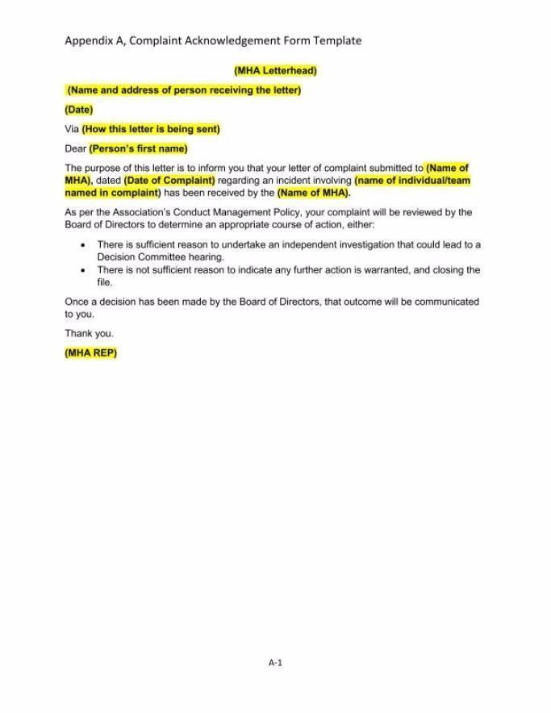
APPENDIX C: CMHA PARENT CODE OF CONDUCT
As a parent or guardian involved in Coaldale Minor Hockey, I agree to uphold the following standards of conduct to promote a safe, respectful, and positive hockey environment:

Respect and Responsibility
- I will respect and adhere to the policies, rules, and values set forth by Hockey Canada, Hockey Alberta, CAHL, Coaldale Minor Hockey Association (CMHA), and my child’s team.
- I will respect the rules of the game, opponents, officials, and their decisions.
- I will treat everyone fairly and respectfully, regardless of gender, place of origin, race, sexual orientation, religion, political beliefs, or economic status.
- I will respect the dignity of all athletes, coaches, and officials. I understand that any form of harassment, bullying, or abuse—verbal, physical, or emotional—is unacceptable.

Conduct and Communication
- I will maintain self-control at all times and demonstrate respectful behavior on and off the ice.
- I will not condone or participate in hazing, inappropriate behavior, or actions that demean or isolate others.
- I will refrain from public criticism of players, coaches, officials, or other parents.
- I will not use profanity, insults, harassment, or offensive language toward any participant, coach, official, or spectator.
- I will direct any feedback or concerns through the appropriate channels in a respectful and constructive manner.

Commitment and Support
- I will attend games and practices as often as reasonably possible and notify the coach or team manager in advance if my child will be absent.
- I will ensure my child arrives on time and prepared for games and practices.
- I will support all players on the team, not just my own child.
- I will encourage my child and others to play hard, have fun, and show good sportsmanship—win or lose.

Safety and Sportsmanship
- I will prioritize the safety and well-being of all athletes, coaches, officials, and spectators.
- I will not advocate for or condone the use of alcohol, recreational or mind-altering drugs, or performance-enhancing substances.
- I will respect all facilities—home and away—and behave responsibly while attending events.
- I will not use any recording devices in dressing rooms, recognizing the need for privacy and respect.
- I will promote and model teamwork, sportsmanship, and a positive attitude at all times.

Game Environment
- I will respect the authority and judgment of referees, timekeepers, and officials, even if I disagree with their decisions.
- I will not argue with or mistreat referees, coaches, or other volunteers.
- I will help my child understand that mistakes are part of learning and that effort, growth, and character matter more than winning.
- I will encourage my child to love the game for the joy of playing, not just the result.

Final Commitment
- I will not force my child to play or push them beyond their comfort or interest.
- I will do my part to foster a welcoming, respectful, and development-focused environment that reflects the values of Coaldale Minor Hockey Association.

Acknowledgement
I have read and understand the above Parent Code of Conduct and agree to abide by its principles. I acknowledge that any violation of this Code may result in a review by the CMHA Board and/or Discipline Committee and may lead to disciplinary actions, including suspension or removal from Coaldale Minor Hockey.

APPENDIX D: CMHA COACH CODE OF CONDUCT
All coaches must read, sign, and return this form to their Division Director or CMHA Administrator prior to the first game of the season.
As a coach with Coaldale Minor Hockey Association (CMHA), I understand the responsibility I hold as a leader and role model. I agree to uphold the following standards to promote safety, respect, and development for all players.

Respect and Responsibility
- I will respect and uphold the rules, policies, and values of Hockey Canada, Hockey Alberta, CAHL, LMHA, and Coaldale Minor Hockey.
- I will treat all players, parents, coaches, officials, and volunteers with respect regardless of gender, background, race, sexual orientation, religion, political belief, or economic status.
- I will lead by example in promoting fair play, inclusion, and respect on and off the ice.
- I will respect the decisions of game officials and timekeepers, even in disagreement.

Conduct and Integrity
- I will always demonstrate professionalism, sportsmanship, and composure, and will act as a positive role model for my players.
- I will not engage in harassment, bullying, or abusive behavior in any form—verbal, physical, or emotional—toward players, parents, officials, or others.
- I will not use or condone the use of alcohol, mind-altering substances, or performance-enhancing drugs at any hockey-related event.
- I will avoid public criticism of players, parents, referees, or opposing teams.
- I will address concerns privately, respectfully, and through the proper channels.

Player Development and Fair Play
- I will ensure a safe, inclusive, and positive team environment, focused on skill development and enjoyment of the game.
- I will provide all players with opportunities to grow and contribute, respecting the CMHA Fair Play Philosophy and striving for fairness over the course of the season.
- I will communicate clearly with players and parents about expectations, discipline, roles, and opportunities.
- I will use teachable moments during practices and games to promote learning and personal development.
- I will encourage and recognize effort, improvement, and teamwork above individual success.

Accountability and Commitment
- I will arrive prepared and on time for all practices, games, and team functions.
- I will ensure players are supervised at all times and maintain a safe dressing room environment, including adherence to CMHA’s electronic device and recording policy.
- I will keep accurate records and promptly report absences, injuries, incidents, or disciplinary matters to the appropriate Division Director or CMHA contact.
- I will complete all required coaching certifications and maintain them in good standing, including Respect in Sport – Activity Leader.

Team and Community Representation
- I will represent CMHA in a manner that upholds the reputation and values of the Association.
- I will support the broader hockey community and help foster a respectful atmosphere at all games, both home and away.
- I will collaborate with parents, officials, volunteers, and CMHA representatives in the best interest of the players and the team.

Acknowledgement
I have read and understand the above Coach Code of Conduct and agree to abide by these principles. I understand that any breach of this Code may result in review by the CMHA Board and/or Discipline Committee and could result in disciplinary action, suspension, or removal from my coaching role.

APPENDIX E: CMHA PLAYER CODE OF CONDUCT
All players must read, sign, and return this form to their Coach or Team Manager by October 5th in order to participate in games.
As a player with Coaldale Minor Hockey Association (CMHA), I agree to uphold the following standards of conduct on and off the ice:

Respect and Responsibility
- I will respect and follow the policies, rules, and values set by Hockey Canada, Hockey Alberta, CAHL, CMHA, and my team.
- I will respect the rules of the game, my opponents, and the decisions of officials.
- I will treat all individuals fairly regardless of gender, place of origin, race, sexual orientation, religion, political beliefs, or economic status.
- I will respect the dignity of my teammates and others. I understand that any form of harassment, bullying, or abuse is completely unacceptable.

Conduct and Sportsmanship
- I will maintain self-control at all times, including during emotional or competitive situations.
- I will not participate in or condone hazing or any degrading or isolating behavior toward other players.
- I will not advocate for or use alcohol, recreational drugs, or banned performance-enhancing substances.
- I will refrain from public criticism of other athletes, coaches, or officials.
- I will not use offensive, profane, or insulting language toward teammates, coaches, opponents, or officials.
- I will strive to display high personal standards and represent CMHA positively on and off the ice.

Commitment and Team Expectations
- I will attend games and practices as regularly as possible and inform the Coach or Team Manager ahead of time if I will be absent.
- I will arrive on time and be prepared for all team activities.
- I will participate in a manner that promotes the safety and enjoyment of all athletes, coaches, and officials.
- I will respect the facilities and other user groups, whether at home or away.
- I will not record audio or video inside dressing rooms using personal devices.

Attitude and Effort
- I will always demonstrate sportsmanship, teamwork, and a positive attitude.
- I will respect the spirit and rules of the game and encourage my teammates to do the same.
- I will show respect for the judgment and authority of referees, timekeepers, and officials.
- I will treat both opponents and officials with respect in both victory and defeat.
- I will accept my teammates’ abilities and support them in their development.
- I will accept defeat gracefully and always love the game more than the prize.

Acknowledgement
I have read and understand the above Player Code of Conduct and agree to abide by its principles. I acknowledge that any violation of this Code may result in a review by the CMHA Board and/or Discipline Committee and may lead to disciplinary actions, including suspension or removal from Coaldale Minor Hockey.

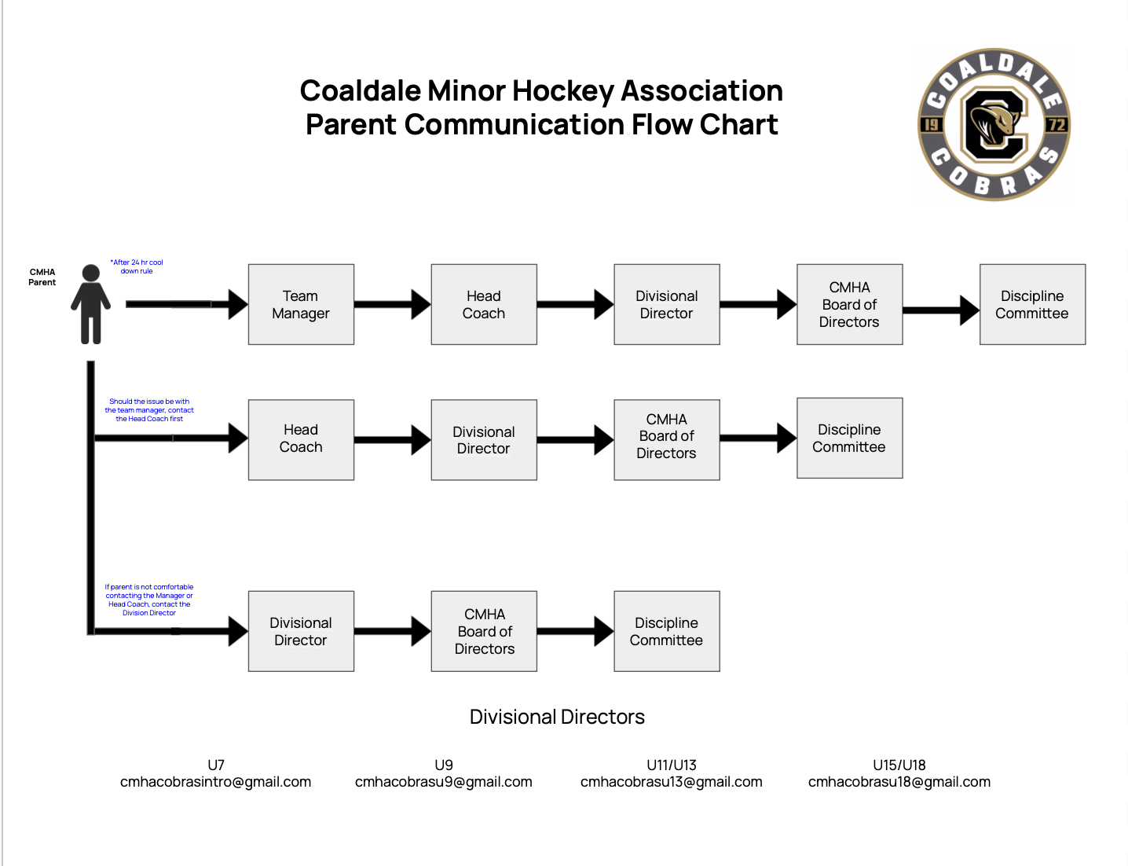
APPENDIX F: CMHA COMMUNICATION FLOW CHART

