Our Saviour Parish Capital Campaign
The Building & Grounds Committee is excited to hear the Our Saviour Parish Capital Campaign has been approved by the Bishop. As part of our committee’s work, we have been assessing our buildings over the past 2-3 years identifying deferred maintenance and needed small capital improvements for the Church, Parish Administrative Offices, School and Rectory. We are excited this campaign will provide the funding needed to accomplish the identified work. Today we are sharing with you a high level overview of projected costs and priorities for identified projects associated with the four campus buildings. In the coming weeks we will provide detailed scopes of work and associated costs for each of the buildings. This overview is not set in stone; it will be fluid and flexible as we gain insight from our parishioners.
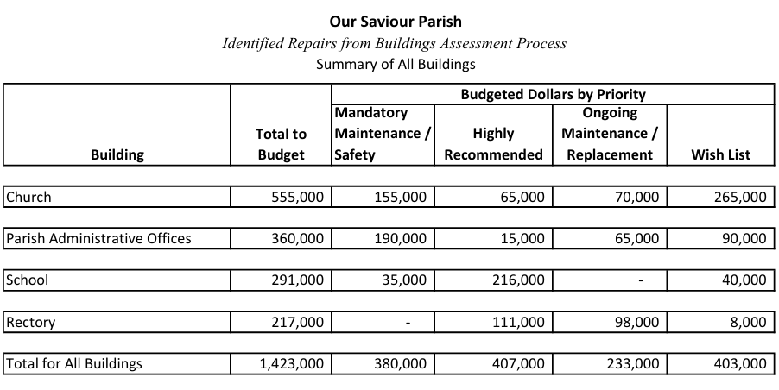
Look for additional information in future Church Bulletins; however, if you have a comment or concern to share feel free to contact:
Ray DePauw 773-465-6177
Marilyn Lunnemann 314-560-4149
Jerome Themig 217-438-4204

