Common Website Mistakes Small Business Owners Make — And How to Fix Them

Chances are, you’re here because you saw my “Website Mistakes” series on social media and you wanted to nab a nifty checklist for yourself – how to solve the problems you’re seeing (or, if you haven’t created your website yet, how to prevent the problems before they start).
That’s okay! It’s great that you’re here, taking initiative. Like I tell my clients:
You can’t be an expert in absolutely everything.

It’s all right if you don’t know everything there is to know about web copy. And it’s all right if you’ve made some (or all!) of the mistakes on the list. You don’t know what you don’t know, and the important thing is that you’re here to try to fix it.
First, let’s talk about what your website should be doing for you:
- Establishing (or reinforcing) your expertise and credibility
- Helping you build relationships with both current and prospective clients
- Giving you a space you own to host all your content – you won’t have to worry about any social media shutdowns

In essence, your website should be THE spot for your messaging. And when you’re happy with it, you’re confident sending prospective clients to it. When you’re confident sending clients to your website, or using it to host funnels, you’re going to be getting warm (or hot) leads coming right to your proverbial front door.
You want your website to be doing a lot of heavy lifting for you. And when it’s crafted well, it can. So, let’s talk about these common problems and how you can fix them!
(And if you want to skip ahead, the checklist I promised is at the end. But you’ll want to read the info I’m giving you – it’s good, I promise 😊)

Leading With Solutions, Not Problems
For a lot of people, this seems counterintuitive. You WANT to tell people exactly what you do, right? You want them to know, in detail, all the services you offer.
But stop for a minute and think. When you have, for example, a plumbing issue, you search “emergency plumbers near me,” or “fix plumbing clog fast,” something that relates directly to your specific problem. The sites that grab your attention are the ones that talk directly about your issue, and THEN about how they can solve it.
So how can you relate this to your website? Well…
- Ask yourself – why is a customer coming to you? Write down all the reasons your desired clients are searching for you.
- Put yourself in the client’s shoes and answer the question: “What’s in it for me?” Why would they choose you over everyone else? Write those reasons down.
- Now ask yourself these questions to target your messaging:
  - What do you do?
  - Why do you do it?
  - Why would someone care?
Putting this info together will give you a good idea of your ideal customer profile, and the problems they’re facing. Once you know that, you can structure your website content to address their issues and provide targeted solutions that show you understand their problems.
Let me give you an example from my own website!
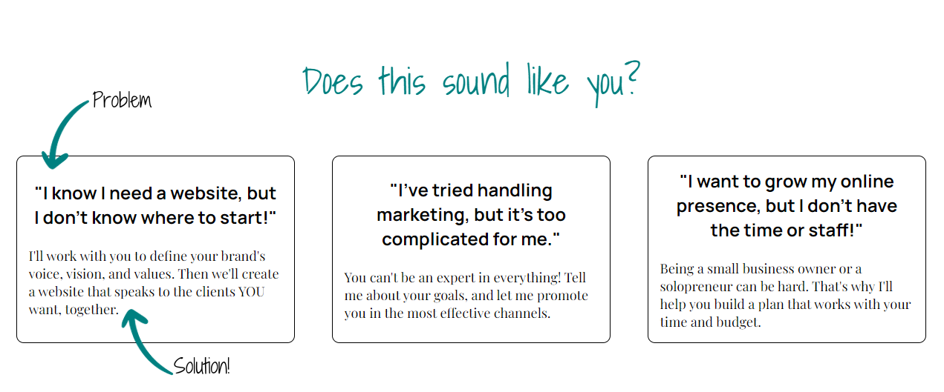
When a potential client comes to my site, they see statements they may have been making – either out loud or to themselves. Immediately, they feel identified with, and the targeted solution continues to address the issue while providing a brief description of how I can help. Because I’ve made that connection with them and shown them I understand their issue, they’re more likely to continue reading and exploring the site to see exactly what I can do for them. You can do the same thing if you follow the steps I’ve given you!

Overlooking the Importance of Proofreading
Honestly, this one is HUGE. There are so many websites out there with spelling and grammar errors. And unfortunately, there’s still the perception that errors=unprofessionalism.
No one’s asking you to be a world-class writer, or even to be that great a writer. If you can say what needs to be said in language that connects with your ideal customer, that’s all you need.
Well, that and someone to read over what you’ve written to make sure there’s no mistakes. After all, even the best of the best in the writing world have editors and proofreaders to clean up their work!

So how can you make sure your work is up to par? Well…
- Hire someone – you can hire a professional to proofread and edit your website copy. If neither you nor anyone on your team have any experience with web copy, this is probably your best option.
- Use grammar and spelling tools – tools like Grammarly and Hemingway Editor can help scan your content for spelling and grammar errors; Grammarly’s paid options can also help with more advanced recommendations, but be aware that these apps don’t always offer the best or most correct options.
- Beta test or “soft launch” – do a small launch of your website to a group you trust; friends, family, or coworkers are a good option. They can go through the site and check for any odd phrases, spelling and grammar issues, and more. This is a great choice if you can’t pay for a professional editor, and helps you catch errors before potential clients do!

Ignoring the Importance of First Impressions
I covered this a little bit in my posts, but it’s important to remember: you only have 20 seconds, MAX to grab someone’s attention, especially when you’re trying to connect with people who have never visited your website before. Most website visitors bail within 3-5 seconds if they’re not seeing what they need to see. Your website must pass that threshold to make sure you’re keeping your ideal client right where you want them.
So how can you do this?
- Don’t ignore your home page: a lot of attention goes into landing pages, but your home page is where most of the people coming from organic search are likely to end up. It’s also where your general links on social media/your newsletter/etc are likely to lead.
- Make your potential customer the hero! What does that mean? It means:
  - Set up your customer with a catchy headline that calls to their pain points and makes them go “hey, that’s me!”
  - Make sure you include effective CTAs (we’ll talk more about this later!)
  - Engage with your ideal customer on a human level – make them curious enough to keep reading
- Make sure your website is mobile-optimized! Over half of all internet users do so primarily or completely from mobile devices like phones and tablets. Plus, search engines (like Google) rank mobile-friendly websites higher in organic search results!
- Get fresh eyes on your copy: Not sure if you’re hitting the mark? Reach out to a friend or (even better) a former or current client to give your new website copy a read-over. See if they have the reaction you want… and if they don’t, figure out how to get it!

Getting Over-complicated and Losing Personality
If you work in an industry that has a lot of industry-specific language, or if you’re primarily targeting other businesses, it can be easy to get caught up in the idea of “professionalism.”
The thing is, even in a business-to-business setting, you're still talking to people. And it can be off-putting for people to open a website that's full of jargon or overly formal language and terminology.
So how can you avoid this?
- Imagine your ideal customer is sitting across from you. How would you talk to them?
- Write down what you’d say to them if they were right there – or record a few sales calls to see how you engage.
- Translate that to your website! Try to be simple, approachable, and personable, even if you’re in a profession that requires more formal language (like a lawyer or accountant).

Leaving out the Most Important Thing – CTAs!
You’ve gotten to this point! You’ve crafted website copy that speaks to your ideal customer, you’ve made them the hero of the story, you’ve gotten them to stay and learn more about you through compelling, client-focused copy. They’re ready to hire you and…

Oops. There’s no easy way for them to contact you, book a consultation, or give you a call. There’s no “click here to schedule an appointment,” or “call now for your free quote.”
They leave, disappointed that they can’t get ahold of you.
CTAs (Calls-To-Action) are vital if you want customers to actually follow through. People want their experience to be as easy as possible; they don’t want to have to hunt for your phone number or wade through a contact page. And even if WE think something is easy, our customers might not.
So…
- Make sure you’ve got at least one CTA on every page. It can be something as simple as a “Call now!” or “Contact Us” that leads directly to your contact page (or opens up an email for them to send). If you want to guide them to your services page, something like “See Our Services” can be a good option.
- Got a long landing page? Writing a complex sales letter? Put your CTAs strategically through your content! Have a “buy now” button, or a “book your appointment” option. Don’t miss those opportunities to connect!

The Checklist
I know some of you skimmed through all that info and just want the easy-to-use checklist I promised you. Well – here it is!

Lead With Solutions, Not Problems
- Ask yourself – why is a customer coming to you? Write down all the reasons your desired clients are searching for you.
- Put yourself in the client’s shoes and answer the question: “What’s in it for me?” Why would they choose you over everyone else? Write those reasons down.
- Now ask yourself these questions to target your messaging:
  - What do you do?
  - Why do you do it?
  - Why would someone care?

Overlooking The Importance of Proofreading
- Hire someone – you can hire a professional to proofread and edit your website copy. If neither you nor anyone on your team have any experience with web copy, this is probably your best option.
- Use grammar and spelling tools – tools like Grammarly and Hemingway Editor can help scan your content for spelling and grammar errors; Grammarly’s paid options can also help with more advanced recommendations but be aware that these apps don’t always offer the best or most correct options.
- Beta test or “soft launch” – do a small launch of your website to a group you trust; friends, family, or coworkers are a good option. They can go through the site and check for any odd phrases, spelling and grammar issues, and more. This is a great choice if you can’t pay for a professional editor, and helps you catch errors before potential clients do!

Ignoring The Importance of First Impressions
- Don’t ignore your home page: a lot of attention goes into landing pages, but your home page is where most of the people coming from organic search are likely to end up. It’s also where your general links on social media/your newsletter/etc are likely to lead.
- Make your potential customer the hero! What does that mean? It means:
  - Set up your customer with a catchy headline that calls to their pain points and makes them go “hey, that’s me!”
  - Make sure you include effective CTAs (we’ll talk more about this later!)
  - Engage with your ideal customer on a human level – make them curious enough to keep reading.
- Make sure your website is mobile-optimized! Over half of all internet users do so primarily or completely from mobile devices like phones and tablets. Plus, search engines (like Google) rank mobile-friendly websites higher in organic search results!
- Get fresh eyes on your copy: Not sure if you’re hitting the mark? Reach out to a friend or (even better) a former or current client to give your new website copy a read-over. See if they have the reaction you want… and if they don’t, figure out how to get it!

Getting Over-Complicated and Losing Personality
- Imagine your ideal customer is sitting across from you. How would you talk to them?
- Write down what you’d say to them if they were right there – or record a few sales calls to see how you engage.
- Translate that to your website! Try to be simple, approachable, and personable, even if you’re in a profession that requires more formal language (like a lawyer or accountant).

Leaving Out the Most Important Thing – CTAs!
- Make sure you’ve got at least one CTA on every page. It can be something as simple as a “Call now!” or “Contact Us” that leads directly to your contact page (or opens up an email for them to send). If you want to guide them to your services page, something like “See Our Services” can be a good option.
- Got a long landing page? Writing a complex sales letter? Put your CTAs strategically through your content! Have a “buy now” button, or a “book your appointment” option. Don’t miss those opportunities to connect!

And there you have it! A comprehensive guide to 5 website mistakes small businesses make and how to fix them.
If you’re interested in learning more, or need help getting your website up and running, feel free to book a consultation with me. I’d love to chat and see how I can help you make your online presence the absolute best it can be!

