BAACIO Shop volunteer guidelines
- Who can volunteer for the shop - any paid up member of BAACIO, any trustee
- What required - carry out sales, record sales, bank any cash taken with in 2 days of sale. Update stock boards in the shop. Record volunteer hours.
- Additional help – would be helpful to carry out regular stock takes.
- Hrs required – 1-2 hrs Feb to November (key months April to Sept).
Requirements – ideally require 2-6 volunteers that would be willing to open the shop at regular times to suit their schedule. Ideally between April – September, maybe 2 hours a week. If you wish to use the SumUp App, this needs to be set up by the secretary. Shop shut Dec and Jan for stock take and end of year review.
Guidelines
Post on board when shop will be open.
Record any sales in the shop book (see example) record required
- Date
- Initials
- Quantity
- Item
- £ value and if cash or card transaction
Cash payments : If cash taken please cash up at the end of the day (ensure the cash taken adds up to the cash you have) and bank at Lloyds bank or at a post office, send a picture of the receipt to the treasurer and put the original in the metal box in the shop (Cristina’s box), please put your name on the slip.
Card payments : If you wish to use card transactions you can either download the SumUp app on your phone (set up required by Secretary) or you can use the shop mobile (when we get one) or you can message the Secretary or Treasurer who will be able to send you a link for payment.
BACS payment ; we also offer members to pay using BACS , please record in book and use the slips in the shop to record plot number, what sold (description and quantity and value ), date, value, and ask them to put their mobile number on it. Then take a photo of slip, ask for member to carry out transaction and send a screen shot to treasurer or to member doing the transaction (member to then send to treasurer). This way treasurer can check the bank as it should show with in 24 hrs if not we need to contact the member.
BACS slip sample
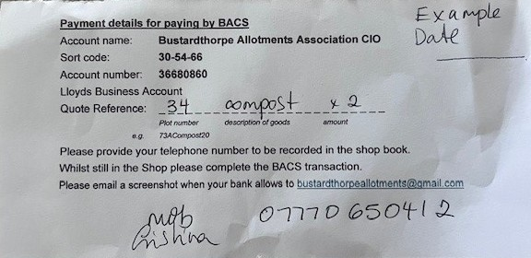
Pls Record following:
- plot number
- item description
- quantity
- value
- date
- mobile number of plot holder
If stock is required from one of the store container refer to the List of keys by the key lock and access the stock.
After sales, please update the stock board (for example if posts sold then update the post board). For posts, tin sheets, compost and geotex.
If we are running low on any items, please advise the secretary.
Keep a register of who has a shop key. Advise the secretary.
Please lock up when you leave the shop. Any concerns or issues pls contact email BAACIO. or message. Thank you.
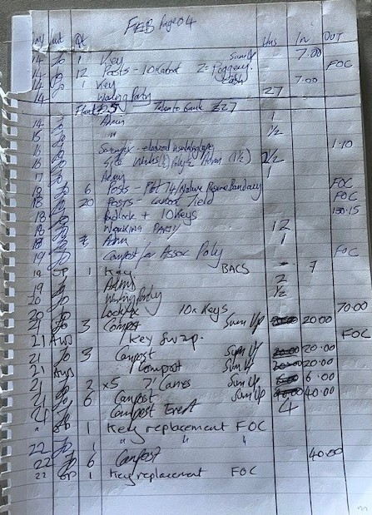
Pls Record following:
- Date of transaction
- Initial of person doing transaction
- quantity
- item description
- volunteer hrs
- IN - sales value (note if cash or card or bacs)
- OUT – expense
If item used for site maintenance pls record FOC
Recommend
Jan & Dec – shop shut for stock take and maintenance
April – Sept – busy time in shop
Nov – sell of any old stock have sale 15-30 Nov
Dec – review prices and update prices for following year (amend website, poster inside and out and item price tags)

Any issues pls contact Secretary or Treasurer. Thank you for your support. If you have any ideas on how to improve shop and stock management pls share with trustees.

CRG.26.2.26

