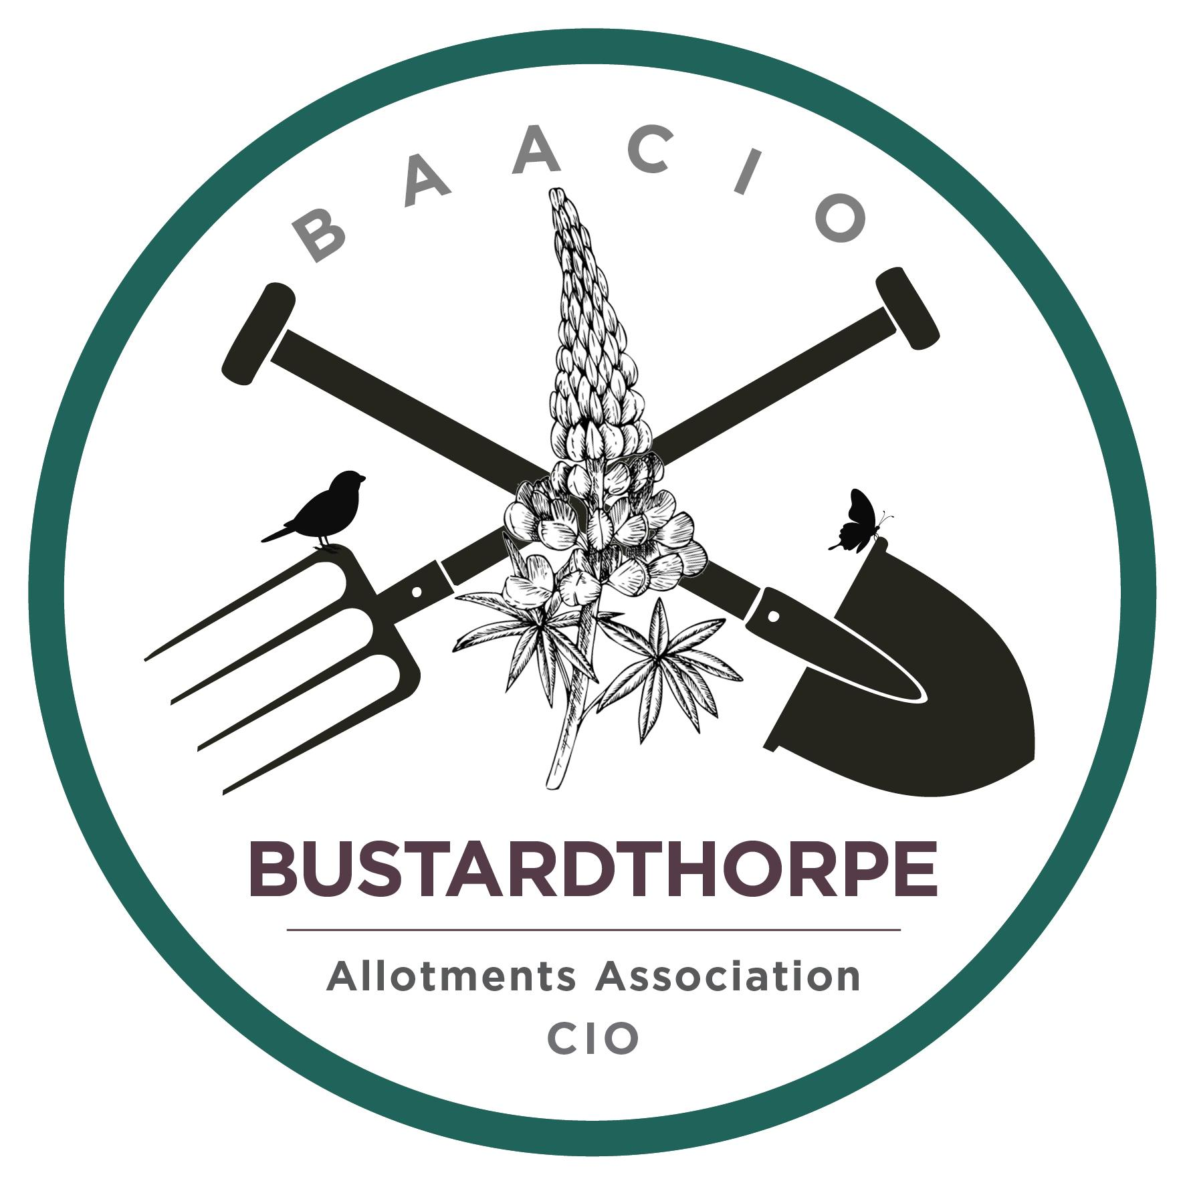 | Bustardthorpe Allotments Association  Charitable Incorporated Organisation  Registered Charity No: 1211930  Bishopthorpe Road, York, YO23 2QA

Rubbish on plots
Please do not bring rubbish on to plots.
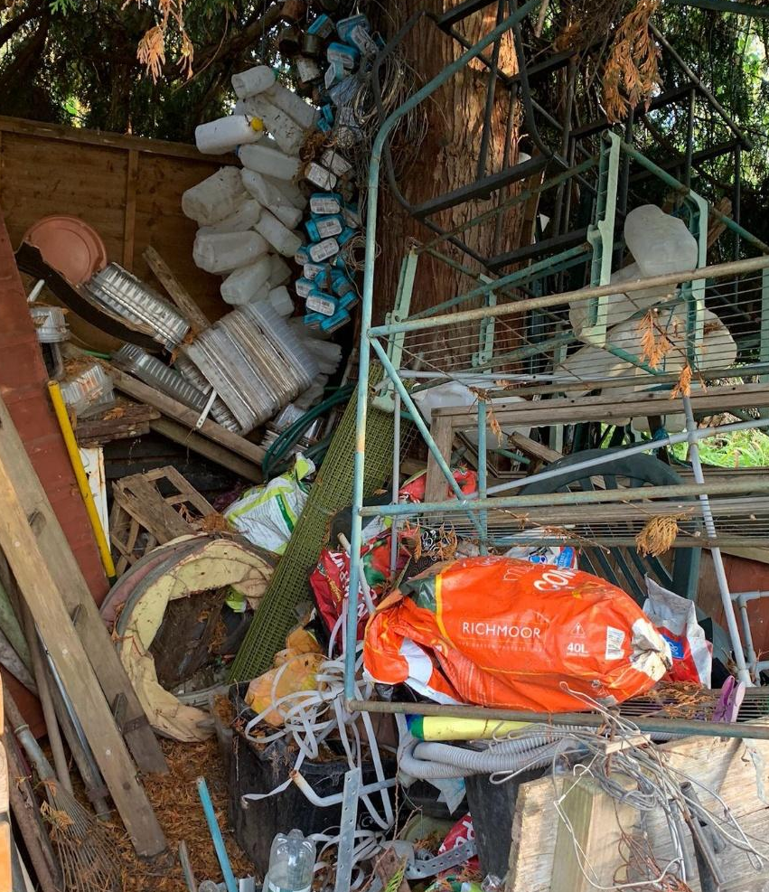 | Unless something is going to be quickly used for a useful purpose on the plot, it should not be there. You risk losing your tenancy.  In addition, bonfires are only for disposing of material from your plot that cannot be composted. Material must not be brought on site to burn.  Any items brought to your plot must be used within the next 6 months or you risk being sent a Warning of Termination letter.

All rubbish must be removed from your plot and Bustardthorpe site.

Plant pots can be recycled at Vertigrow Garden Centre, Malton Road, YO32 9TL.

Do not dump it in any area in and around the shop. This includes wood.

The only exception is items that another plotholder might be able to use. These can be left on the donations table outside the shop after permission has been sought from a committee member and on the strict understanding that if the items are not taken within a week you immediately remove them from site.

Relevant Tenancy Agreement clause:
5 Tenants responsibilities include:
5.8 Must not fly-tip rubbish on any part of the site including directly outside their plot. Plot holders are responsible for the removal from the Bustardthorpe site of all rubbish from their Allotment Garden.
5.15 Must take all reasonable steps to minimise the presence of pests such as rats and rabbits on their plots by maintaining the integrity of boundaries, turning over compost heaps and keeping the plot tidy, free of rubbish and weed free.

