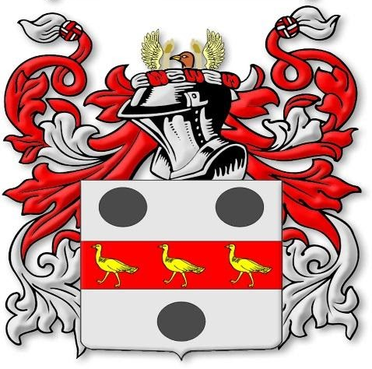 | Bustardthorpe Allotments Association  Charitable Incorporated Organisation  Registered Charity No: 1211930  Bishopthorpe Road, York, YO23 2QA
Ponds Policy
Ponds on allotments may be permitted if they improve bio-diversity, however this is not the primary purpose of having an allotment, which is vegetable/ fruit/ flower growing. Ponds can be hazardous for young children and for some wildlife and the safety steps set out in this policy must be taken.

What kind of pond could I have?
- A pond can be any shape, but the maximum dimensions are: 1metre x 1.5 metres x 60cms depth (3 feet 6 inches x 5 feet x 2 feet deep). This makes sure that the pond isn’t too big for any given plot size. It also means that there is less displaced soil to spread around the rest of the plot.
- The pond must have sloped or stepped sides to enable wildlife such as hedgehogs or frogs to get out safely. Stepped duckboards or planks also work well.
- Steep sided containers such as tanks or bathtubs are NOT permitted: they are known to be dangerous for small children and animals. If there is already such container on the plot it’ll need to be filled in and planted up, the Trustees will advise about this. Pre-formed pond liners are OK provided they meet the size criteria above.
- Raised ponds, constructed above ground level are NOT permitted, these do not serve a primary wildlife purpose
- Only rainwater is to be used to fill ponds.
- The Wildlife Trust website offers advice on how to build a pond https://www.wildlifetrusts.org/actions/how-build-pond

What can I do with a pond?
- Encourage a wider range of wildlife: insects, frogs and toads are all great for gardening and are important in the food chain. https://www.wildlifetrusts.org/habitats/freshwater/ponds
- Fish are NOT permitted in ponds.

Pond safety: this is important as small children can drown in even a few centimetres/inches of water.
- The plot must be locked when no-one is working it.
- If another plotholder has to cross the plot with a pond to access their own plot, they should be made aware of the potential hazards.
- Grow plants around the steeper sides of the pond to discourage curious children.
- The plotholder is responsible for ensuring the safety of children, dogs and any potentially vulnerable people visiting the plot, and must consider their needs when proposing or maintaining the pond.
- Fencing around ponds or the use of a sturdy grille mesh covering on locked plots is at the plot holders discretion.

I’d like a pond, how do I apply?
- Email the trustees at bustardthorpeallotments@gmail.com with the following information:
  - location on the plot (preferably on a plan);
  - if others have access through the plot, if so potentially whom;
  - the reason for wanting a pond;
  - materials and method to be used to construct the pond;
  - dimensions (surface dimensions and depth);
  - what are you planning to put in the pond;
  - how are you intending to accommodate any pond safety considerations;
  - what is the ongoing plan for looking after the pond.

The decision making process
- Trustee/s will visit the plot with the plot holder to discuss and give permission (or not). The Trustees’ decision on this is final.
- You’ll be sent a confirmation email for the record.
- Once the pond is dug out, the Trustee/s will visit again to make sure everything is being done properly.
- As part of routine plot monitoring, the pond will be kept under review.
- When you vacate your plot, the Trustees may ask for the pond to be filled in, which would need to be done before you finally vacate.

Existing ponds (as at 1 May 2025)
- Existing ponds may be retained as is unless the pond is a bathtub or similar steep sided container (see above)
- The pond MUST comply with the pond safety requirements set out above, and MUST be filled in when the plot is vacated if asked by the Trustees.

PLEASE NOTE: any proposed pond that is to be located on an unlocked communal area will only be permitted on a unanimous vote of Trustees who will impose relevant additional terms. If permitted, the Trustees undertake direct management and will make any related decisions at regular Trustee meetings.

Adopted May 2025: review May 2027.

