BAACIO how to set up and join an online meeting
Currently we are using Microsoft teams, as you don’t need to have a Microsoft account to log in however we considered others and preference may change.
- Zoom : you need a zoom account to set up but any email to log, but only 45 mins free
- Google Meets: you need a gmail account to set up and log in , 1 hr free meeting
- Microsoft Teams: you need a Microsoft account to set up , but don’t need one to access so any email can log in, 1 hr free meeting. Max attendees 100.
Meeting info required before you start
- Meeting name i.e. Trustee Meeting March 2026
- Date and time and duration (30-60 mins max)
- Invite list (emails required for each preferable) or send them the link once created
- Agenda – key point to be discussed at this meeting only 1-2 items
Setting up a meeting
Open Microsoft teams app , calendar will be showing click on “new meeting” (top right). Complete boxes see sample below, then click send on top right. This will send invite to all and show up in your calendar.
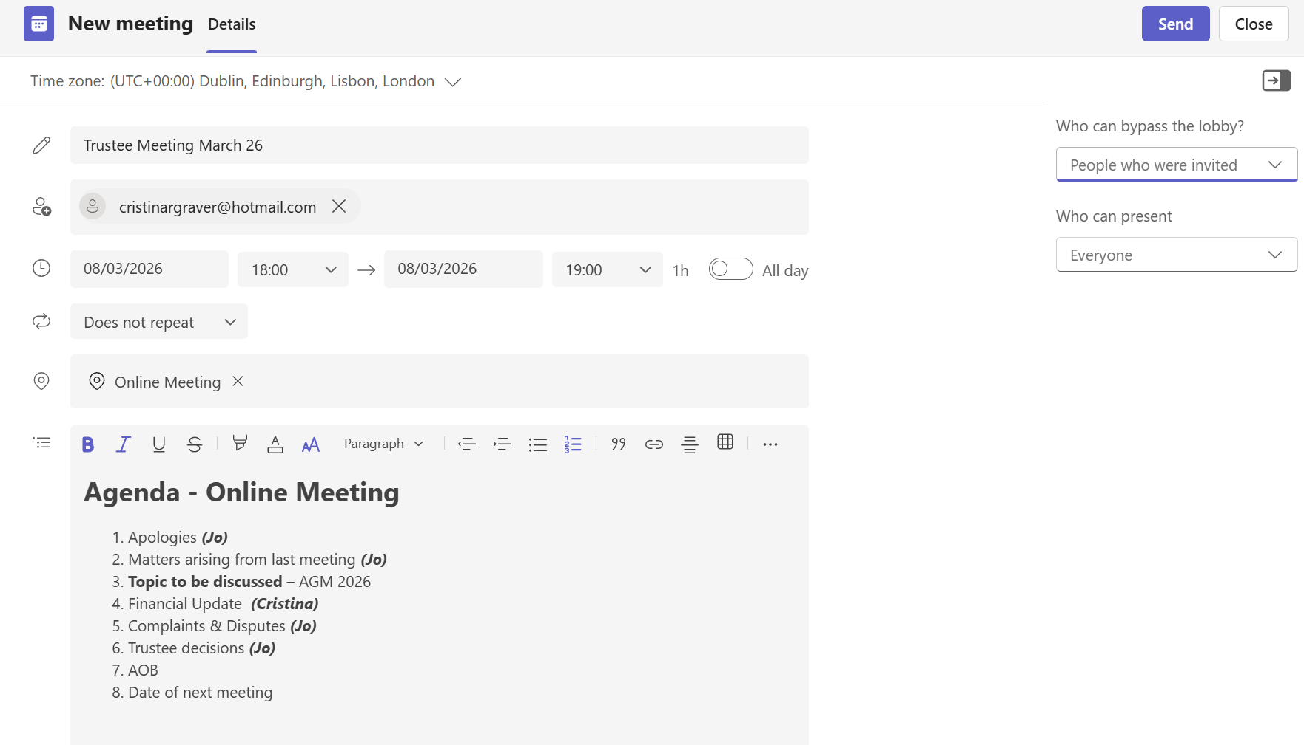
You will then see a meeting created box (See below) , you can use the link here to invite people whose email you don’t have. You can change date, time, invitee at any time and it will update invite to all. If you scroll down the invite you have all the log in details should you wish to copy and send an invite to additional people. Or
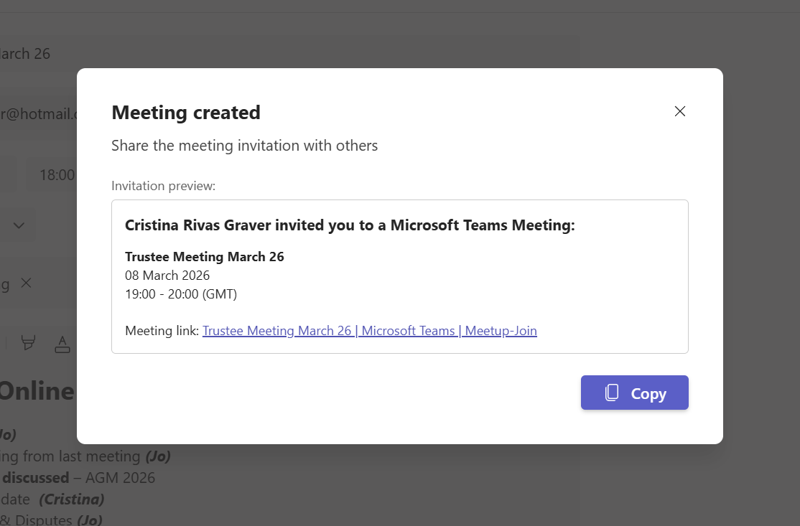
Joining a meeting
Invitees will get an email invite, they don’t need Microsoft to join but it is often better if they download the teams app. They can choose to accept or decline, once accepted the email disappears but the meeting should appear in their calendar. To join the meeting they just need to click join and then wait to be let in by the organiser, the organiser can see who is waiting to join and needs to click on the tick to allow them to join. Ensure all have microphone and video on. If AGM we would recommend to mute all participants and advise they can see and hear but can not contribute, they can email questions up to 48 hrs after the meeting to be included in the AGM minutes. Also that not responsible for any technical issues and limit so first come first served.
Once meeting live
Recording a meeting – we can record meeting (top right button) pls let all meeting attendees know, a message will also pop up to all attendees. Once recording finished, a copy of the recording is available in the chat for a limited time. If used to record AGM, make sure you save the file.
Timer – a timer can be set as there is a limit of 60 mins minute time. Top left.
Sharing screen – there is various options to share information (such as images, lists, spreadsheets) see top right options.
At the end of the meeting you are given a choice to email all participants if you wish (if recorded the video file is shared for a limited time) – we should test this out .
Link to further information.
How to Set up, Schedule and Join a Microsoft Teams meeting
CRG.26.2.26

