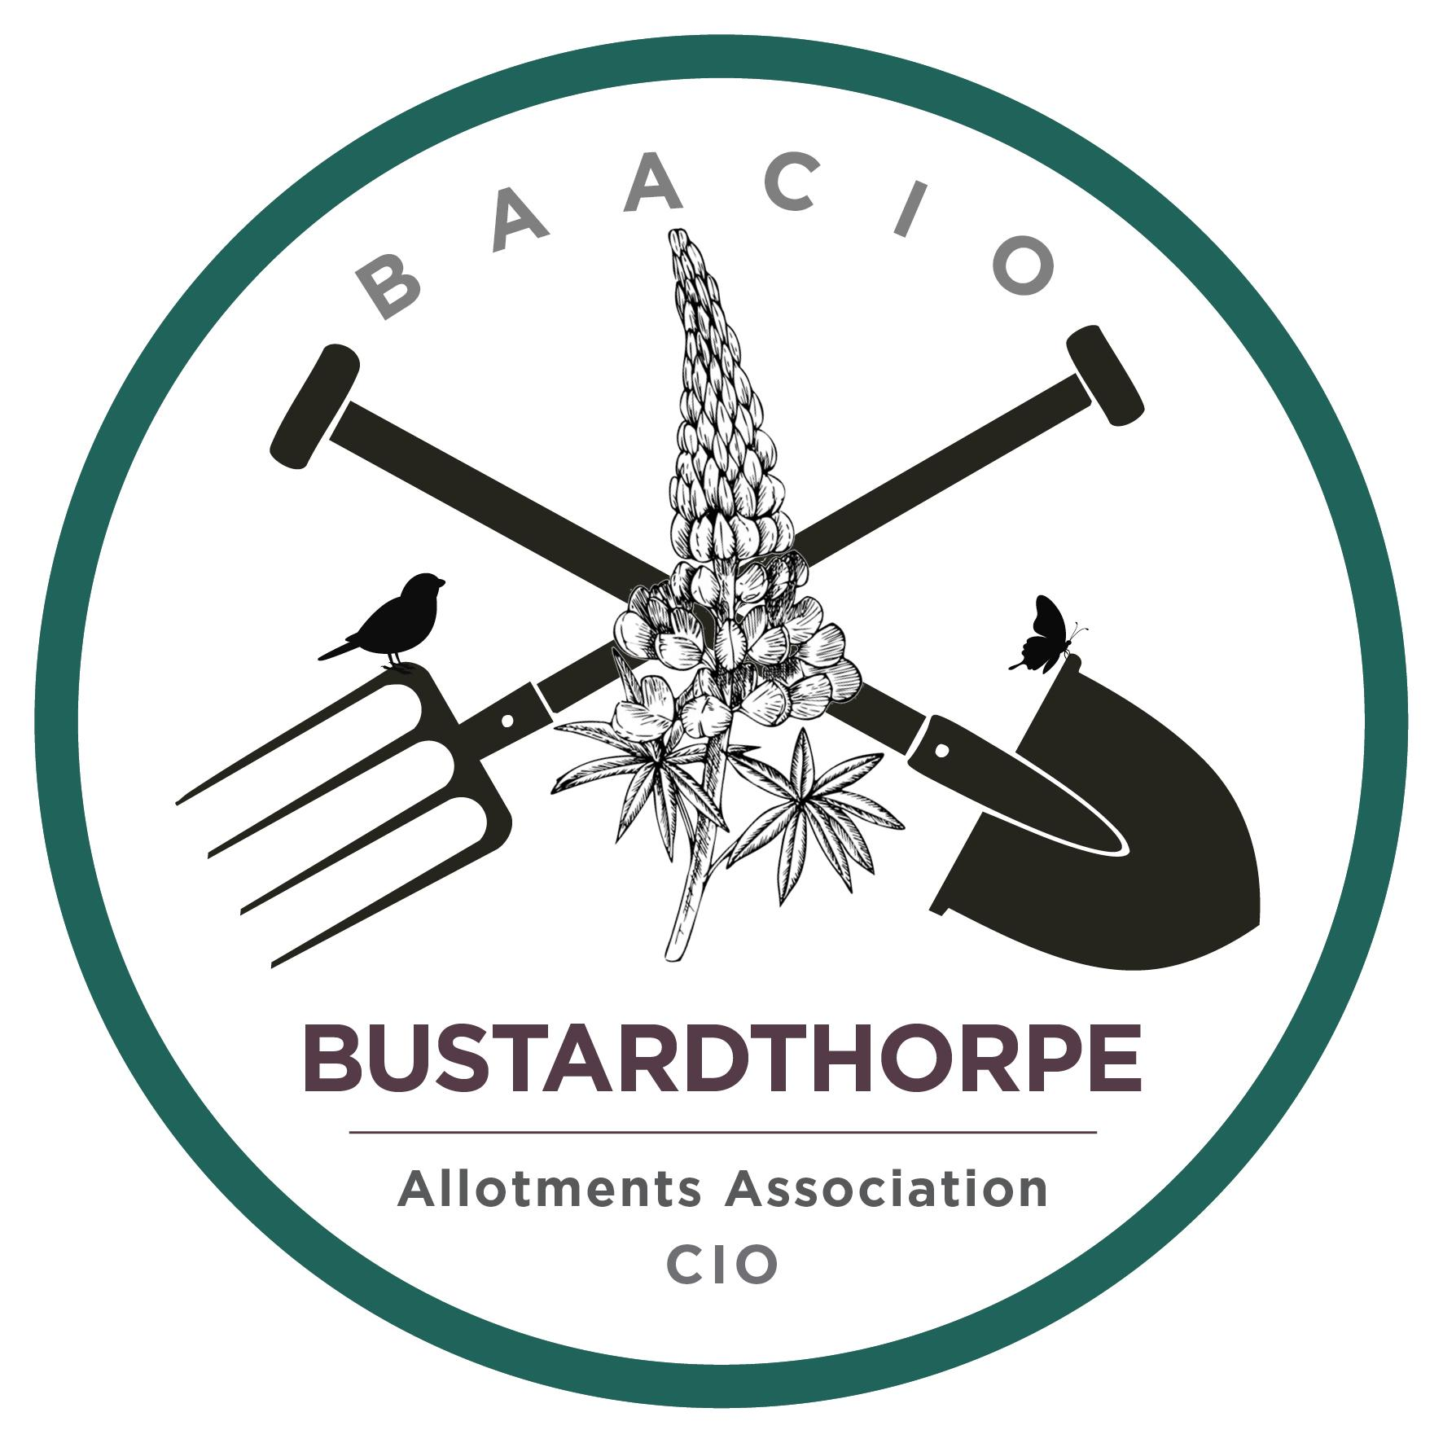 | Bustardthorpe Allotments Association  Charitable Incorporated Organisation  Registered Charity No: 1211930  Bishopthorpe Road, York, YO23 2QA

Keeping rats at bay
The brown rat (Rattus norvegicus) is a very common pest and lives wherever humans live, particularly in urban areas. It is probably impossible/unrealistic to suggest that rats can be excluded from a whole allotment site. As a consequence, measures to remove rats, by translocation or destruction are impractical in the longer term.
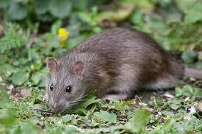
Many allotment plotholders will have been aware of rats on their plot, e.g. by seeing holes in compost bins or occasionally signs, mainly over winter, such as chewed holes, oval shaped faeces and even items as big as gloves moved in the shed. However, it’s quite rare to see a rat.
What all plotholders should try to do is to take measures to discourage rats from coming to their plots, and hence to the allotments as a whole. Discouraging rats at the allotment site is everybody’s responsibility. Please follow the 10-point advice below to help prevent them making your plot their home.
- Turn the contents of your compost bin regularly (at least twice per year). This not only disturbs any rats that have taken up residence but also aerates your compost heap which speeds up the process of digestion and reduces the amount of methane (a greenhouse gas) your heap emits.
- Plastic compost bins should be given a small gauge wire mesh lining at the base or can be placed on paving slabs to prevent rats from burrowing in underneath.
- Regularly kick your compost bin to ensure it is not a peaceful place for rats to sleep and check they are not taking up residence in your greenhouse.
- No household waste. Never put meat, dairy, bones, cooked foods or other inappropriate items in your compost bin. This will attract rats and make your bin smell.
- Harvest ripe fruit and vegetables promptly and take them home to enjoy (before somebody else eats them).
- Do not leave discarded fruit and vegetables on the ground; clear them away to your compost bin, as these are a source of food for rats and other pests.
- Keep your plot tidy and ensure that allotment gardens do not become overgrown or allow rubbish to build up e.g. timber, old carpet, stockpiled materials etc, as this provides cover for rats to live under (harbourage).
- Remember to thoroughly wash (and peel if appropriate) any food you harvest. Vegetables with signs of rat damage should be destroyed. Rats carry risk of Weil’s disease, Salmonella and Leptospirosis among other things and they urinate wherever they go.
- Sheds must be kept secure and not allow access to rats and mice. Regular checks should be made to ensure that rats are not living underneath sheds.
- Consider storing seeds, bulbs etc. in rodent proof containers.

