‘Staff’

Pastor: Fr. Chris Boutin
cboutin@mobarch.org

Deacon: Pat Pattberg
334-774-3449

Secretary: Jackie Oakes
Bookkeeper 334-774-6826
stjozark@gmail.com

Faith Formation:
Amber Williams
Amberamusowilliams@gmail.com

Parish Council:
Tana Reed- President
Andy Kraeger Sue Hayden
Bill Breeze Amber Williams
Maria Conaway Darcy Hamilton

Finance Council:
Rob Amuso – President
Johnathon Leazer
Matt Simechak

Gift Store: Harald Rambacher
Cindy & Ray Simmons

Penny’s Carolyn Thieme
Pantry: & many volunteers
(Food Pantry)
Backpack Blessing Ministry:
Janet Amuso & volunteers
Please contact the office for communication with council members or other ‘staff’
Sunday Mass  8:30am  Facebook live @ 8:30  Confessions  Sunday @ 8:00a Thursday @ 5:00p or by appointment | Stations  Friday’s during Lent @ 6:p  Mass  Thursday @ 5:30p | Office Hours  Tues. 10:00a-2:00p  Thurs. 10:00a-2:00p  (If calling outside of office hours, please leave a message.) | New, interested in joining or reconnecting?  Please call the office to schedule an appointment.
Week At a Glance

Sunday
8:00a: Reconciliation
8:30a: Mass
9:45a: Bible Study (FF Building)
9:45a: OCIA

Tuesday
7:00p: AA (closed meeting)

Thursday
5:00p: Reconciliation
5:30p: Mass

Friday
6:00p: Stations
7:00p: AA (closed meeting)

Sunday
8:00a: Reconciliation
8:30a: Mass
9:45a: Bible Study (FF Building)
9:45a: OCIA

Last Week’s Collections
General Collection - $3778
Catholic Relief Services - $200
St. Joseph’s Altar to S.O.S (Seminarians) $57

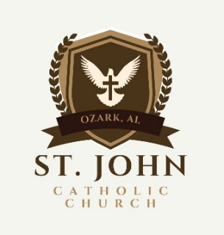
Today is the Fifth Sunday of Lent – March 22, 2026
Telephone: 334-774-6826 Email: stjozark@gmail.com
NEW Website: http://sjccozark.com/
FB: St. John the Evangelist Catholic Church – Ozark, AL
Mailing Address: P.O. Box 1008, Ozark, AL 36361
Address: 475 Camilla Ave., Ozark, AL 36360
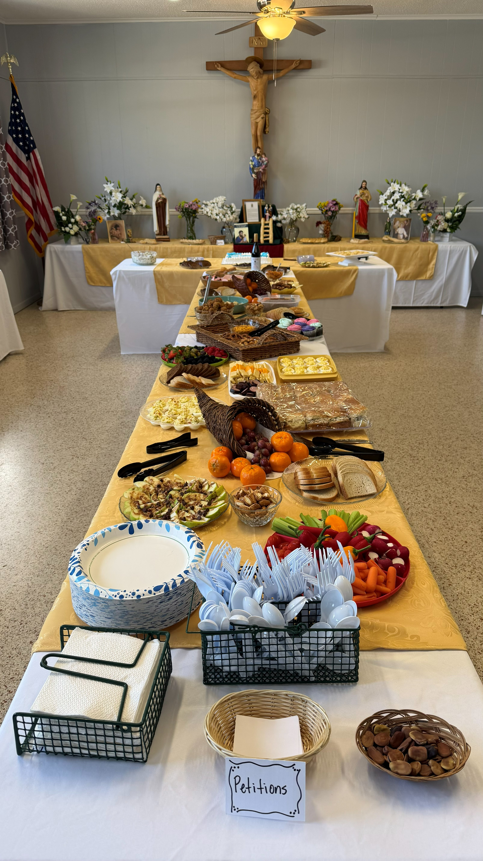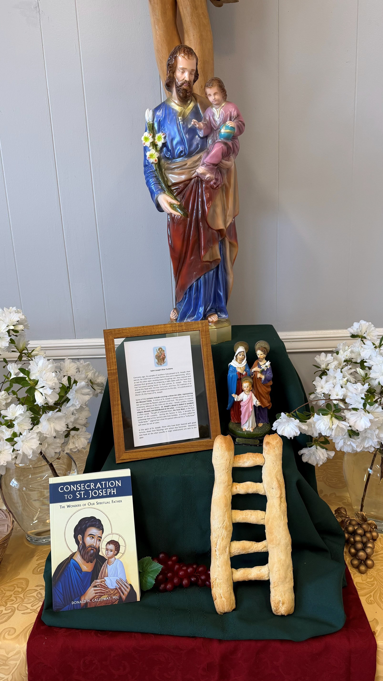

Thank you, ladies’ group & John R. for the clean-up
Beautiful and wonderful.
Thank you, Edna Wright and helpers
St. Joseph’s Altar 2026
Parish News

Ways to Give to St. John
sjccozark.com
and click “Menu” in upper R corner
“online giving”
Or

QR Code linked to our online giving
Or
Text to Tithe - Text GIVE to 334-633-0906

Holy Week Schedule

Palm Sunday – March 29- Mass 8:30a

Holy Thursday – April 2
Evening Mass of the Lord’s Supper – 7p
Night Watch before the Blessed Sacrament – 7:30p-10p

Good Friday – April 3 – Fast & Abstinence
Way of the Cross on the Hill - 12:00p
Mary’s Way of the Cross – 3:00p
Confessions – 6:00p
Liturgy of the Passion & Death of Our Lord – 7p

Holy Saturday Easter Vigil – April 4- 7:30p

Easter Sunday – April 5
Mass – 8:30a

St. Joseph’s Altar Thank you
Edna: “Thank you to all the people who helped set-up, clean up, brought food, etc. The food was delicious as usual. We had some new items on the menu which was great. Hope all enjoyed it. See you next year. Gracias”

Stations
Every Friday at 6:00p during Lent except for Good Friday

Way of the Cross on the Hill
Harald is looking for Helping hands for this year’s "Way of the Cross," our Annual Community Good Friday walk with Jesus!
Get up with Holy hill Church's.
We need some one to mark the way the day before and get the pictures out Good Friday morning, be there to hand out the handouts, (I will do my best to help out with all areas)
This year we start at St. John's 5 stations, go to Westview 5 stations. then to St. Michels 4 stations. Thank you!
Harald 334-733-6111.

Housebound and visitation
If you, or someone from the parish needs prayers or a visit with Holy Communion, please contact the office.

Gospel John 11:1-45
How does Pope Francis in this Angeles talk on the raising of Lazarus describe the beginning of our resurrection?
Jesus calls to us as he called to Lazarus in his tomb: “Come forth!” This call is addressed to every human person because we are all marked by death. Christ is not resigned to the sepulchers that we have constructed with our choices of evil and death, with our mistakes, our sins. [Jesus] invites us, almost orders us, to come out of the tombs into which our sins have plunged us. This is where our resurrection begins: when we decide to obey the command of Jesus to come into the light, to life; when the masks fall from our faces … and we rediscover the courage of our original faces, created in the image and likeness of God.
[ … the raising of Lazarus shows us that] there is no limit to the divine mercy, which is offered to everyone. … The Lord is always ready to roll away the tombstone of our sins, which separate us from him, the light of the living.]
Pope Francis, Angelus
April 6, 2014
Anne Osdieck
Excerpted from liturgy.slu.edu

