‘Staff’

Pastor: Fr. Chris Boutin
cboutin@mobarch.org

Deacon: Pat Pattberg
334-774-3449

Secretary: Jackie Oakes
Bookkeeper 334-774-6826
stjozark@gmail.com

Faith Formation:
Amber Williams
Amberamusowilliams@gmail.com

Parish Council:
Tana Reed- President
Andy Kraeger Sue Hayden
Bill Breeze Amber Williams
Maria Conaway Darcy Hamilton

Finance Council:
Rob Amuso – President
Johnathon Leazer
Matt Simechak

Gift Store: Harald Rambacher
Cindy & Ray Simmons

Penny’s Carolyn Thieme
Pantry: & many volunteers
(Food Pantry)
Backpack Blessing Ministry:
Janet Amuso & volunteers
Please contact the office for communication with council members or other ‘staff’
Sunday Mass  8:30am  Facebook live @ 8:30  Confessions  Sunday @ 8:00a Thursday @ 5:00p or by appointment | Stations  Friday’s during Lent @ 6:p  Mass  Thursday @ 5:30p | Office Hours  Tues. 10:00a-2:00p  Thurs. 10:00a-2:00p  (If calling outside of office hours, please leave a message.) | New, interested in joining or reconnecting?  Please call the office to schedule an appointment.
Week At a Glance

Sunday
8:00a: Reconciliation
8:30a: Mass
9:45a: Bible Study (FF Building)
9:45a: St. Joseph’s Altar

Tuesday
7:00p: AA (closed meeting)

Thursday
5:00p: Reconciliation
5:30p: Mass

Friday
6:00p: Stations
7:00p: AA (closed meeting)

Sunday
8:00a: Reconciliation
8:30a: Mass
9:45a: Bible Study (FF Building)
9:45a: OCIA
“Go wash in the Pool of Siloam” —which means sent. So he went and washed, and came back able to see. (Gospel)

Last Week’s Collections
General Collection - $3795
Building Fund - $185
Special Collection - $10

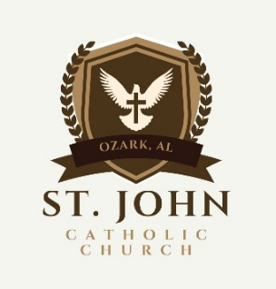
Today is the Fourth Sunday of Lent – March 15, 2026
Telephone: 334-774-6826 Email: stjozark@gmail.com
NEW Website: http://sjccozark.com/
FB: St. John the Evangelist Catholic Church – Ozark, AL
Mailing Address: P.O. Box 1008, Ozark, AL 36361
Address: 475 Camilla Ave., Ozark, AL 36360

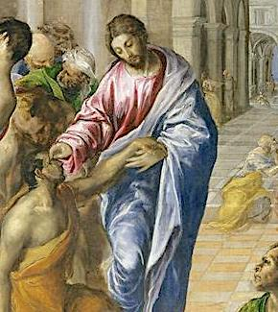

El Greco
Christ Healing he Blind Man, 1560
detail
liturgy.slu.edu
Parish News

Ways to Give to St. John
sjccozark.com
and click “Menu” in upper R corner
“online giving”
Or

QR Code linked to our online giving
Or
Text to Tithe - Text GIVE to 334-633-0906

Holy Week Schedule

Palm Sunday – March 29- Mass 8:30a

Holy Thursday – April 2
Evening Mass of the Lord’s Supper – 7p
Night Watch before the Blessed Sacrament – 7:30p-10p

Good Friday – April 3 – Fast & Abstinence
Way of the Cross on the Hill - 12:00p
Mary’s Way of the Cross – 3:00p
Confessions – 6:00p
Liturgy of the Passion & Death of Our Lord – 7p

Holy Saturday Easter Vigil – April 4- 7:30p

Easter Sunday – April 5
Mass – 8:30a

St. Joseph’s Altar
Mar. 15 after Mass
Everyone is welcome, please bring finger foods to share and enjoy fellowship

Stations
Every Friday at 6:00p during lent except for Good Friday

Way of the Cross on the Hill
Harald is looking for Helping hands for this year’s "Way of the Cross," our Annual Community Good Friday walk with Jesus!
Get up with Holy hill Church's.
We need some one to mark the way the day before and get the pictures out Good Friday morning, be there to hand out the handouts, (I will do my best to help out with all areas)
This year we start at St. John's 5 stations, go to Westview 5 stations. then to St. Michels 4 stations. Thank you!
Harald 334-733-6111.

Housebound and visitation
If you, or someone from the parish needs prayers or a visit with Holy Communion, please contact the office.

St. John by the Numbers for February

Building Fund
Beginning statement $18,824.64
Ending statement $19,240.88
Building Fund Collections $2560.00
Expenses $1195.54
(basketball stand & rim for FF, a/c filters, fire extinguishers check)

General Fund
Beginning statement $44,119.29
Ending statement $45,378.95
Collections $13,854.22
Contribution to crucifix $1000.00
Expenses $10,557.71

Catholic Foundation
Beginning statement $114,377.48

Ending statement $115,149.10

Penny’s Pantry by the #s

March 2026

142 families served
10 new families
39 veterans

68 (1-2) Households, 101 people
(61 seniors)
44 (3-4) Households, 156 people
27 (5-6) Households, 140 people
3 (7-8) Households, 22 people

147 children
141 adults
126 seniors
Total people served 414.

1-2 Household received 41# of food.
3-4 Households received 47# of food.
5+ Households received 61# of food.

Total of 6686# of food given to families this month.

