‘Staff’

Pastor: Fr. Chris Boutin
cboutin@mobarch.org

Deacon: Pat Pattberg
334-774-3449

Secretary: Jackie Oakes
Bookkeeper 334-774-6826
stjozark@gmail.com

Faith Formation:
Amber Williams
Amberamusowilliams@gmail.com

Parish Council:
Tana Reed- President
Andy Kraeger
Sue Hayden
Bill Breeze
Amber Williams
Maria Conaway
Darcy Hamilton

Finance Council:
Rob Amuso – President
Johnathon Leazer
Matt Simechak

Gift Store: Harald Rambacher
Cindy & Ray Simmons

Penny’s Carolyn Thieme
Pantry: & many volunteers
(Food Pantry)

Please contact the office for communication with council members or other ‘staff’
Sunday Mass  8:30am  Facebook live @ 8:30  Confessions  Sunday @ 8:00am NO Thursday @ 5:00pm or by appointment | Communion Service  NO Services until further notice  Mass  No Thursday @ 5:30p | Office Hours  Tues. 10:00a-2:00p  Thurs. 10:00a-2:00p  (If calling outside of office hours, please leave a message.) | New, interested in joining or reconnecting?  Please call the office to schedule an appointment.
Week At a Glance

Sunday
8:00a: Reconciliation
8:30a: Mass
9:45a: Bible Study (FF Building)
9:45a: OCIA
9:45a: Faith Formation

Tuesday
7:00p: AA (closed meeting)

Thursday
5:00p: No Reconciliation
5:30p: NO Mass

Friday
7:00p: AA (closed meeting)

Sunday
8:00a: Reconciliation
8:30a: Mass
9:45a: Bible Study (FF Building)
9:45a: OCIA

Last Week’s Collections
General Collection - $1947

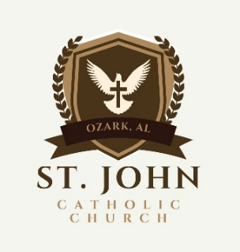
Today is the Third Sunday in Ordinary Time – January 25, 2026
Telephone: 334-774-6826 Email: stjozark@gmail.com
NEW Website: http://sjccozark.com/
FB: St. John the Evangelist Catholic Church – Ozark, AL
Mailing Address: P.O. Box 1008, Ozark, AL 36361
Address: 475 Camilla Ave., Ozark, AL 36360

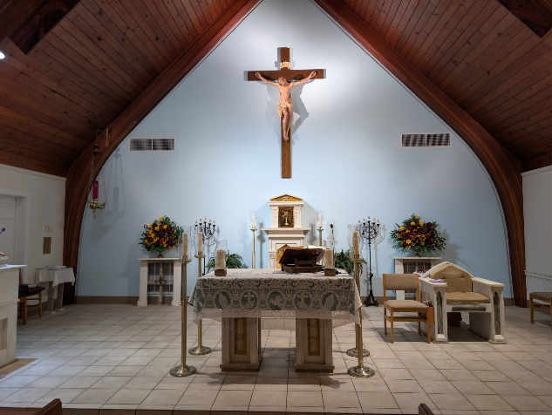
Parish News
Ways to Give to St. John
sjccozark.com
and click “Menu” in upper R corner
“online giving”
Or

QR Code linked to our online giving
Or
Text to Tithe - Text GIVE to 334-633-0906

Faith Formation
We will meet this Sunday.

Catholic Charities Appeal
“Today is Catholic Charities Appeal Sunday. It is our goal to have 100% participation. Please help us achieve this goal with a pledge that you can afford. The basic pledge is $56 a month or $672 for the year, and our parish goal is $ 36,000.00. Please return your envelope and save our Parish Chairs and Volunteer Team a phone call. If you are unable to give the basic pledge, please give what you can afford. No amount is too small or too large. The Catholic Charities Appeal supports more than 30 ministries in the southern half of Alabama. If you have not done so already, please complete one of the envelopes in the pews, mark it with your intended pledge, and place it in the collection basket today. God bless you for your generosity.”

Fr. Boutin will be on vacation
January 26-30. We will not have mass or reconciliation on Thursday, Jan. 29.

Gift Store News
Your Gift shop is going to continue with 25 cent ornaments sale and other gifts on sale!

Women's Club Scholarship
The Women's Club is offering their annual
scholarship of $500 to those who will be attending post secondary education options for the 2026-2027 school year. Scholarship applications will be available on February 1. Scholarships can be obtained on the table at the back of the church OR can be requested by email at sjoladies@gmail.com. Applications and transcripts are due by March 1. For more information, contact JoAnn McCaffrey (334-237-2857) or joannmccaffrey@aol.com

Social Committee
If you are interested in serving on the new social committee that is being formed, please contact Amber Williams.
Text (334) 797-5202 or email
amberamusowilliams@gmail.com

Fun Facts
Our loose cash contributions (meaning, not attributed to anyone with envelopes) for 2025 were:
offertory $15,456.19
building fund $1005
2nd collections $1,245.12

Upgrades
Woohoo, looky at the upgrade in the church. Thank you, Rob Amuso, for organizing, Justin, Chris, Johnathon, Leroy and some soldiers from Ft. Rucker for taking down, and putting up our new Crucifix and wow, look at that new color. Thank you, Jan, for organizing the painter, Austin, with Imperial Painting and for the after cleaning. Please, we are always looking for volunteers.

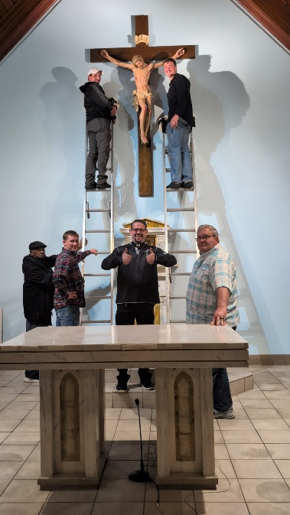
Blessings of Blankets
BURR!!! The weather is going to be chilly.
If you would like to donate a NEW lap blanket to be given to our homebound, sick, or those in need, please drop it in the basket at the entrance to the church or to Amber Williams or Janet Amuso.

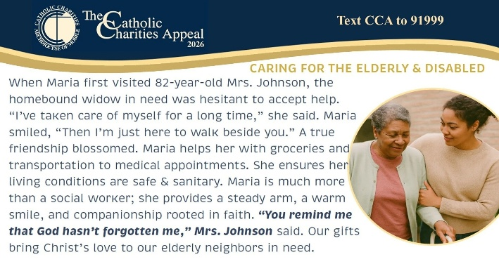

Check out SJCCOZARK.COM
Have you seen our updated website? Did you know that we have had 5 new folks have requested information on becoming a Catholic by using CONTACT US? Did you know that we have had specific donations to our food pantry through the website and our address located there? Did you know that the website is updated weekly and contains a calendar of the church events with times and places? The website is a good way to keep track of church happenings in addition to our facebook page. If you need to find out about an event or time, please know that the website can be a good place to check on what you may need. We are touching those in Ozark and around the world.

