‘Staff’

Pastor: Fr. Chris Boutin
cboutin@mobarch.org

Deacon: Pat Pattberg
334-774-3449

Secretary: Jackie Oakes
Bookkeeper 334-774-6826
stjozark@gmail.com

Faith Formation:
Amber Williams
Amberamusowilliams@gmail.com

Parish Council:
Tana Reed- President
Andy Kraeger
Sue Hayden
Bill Breeze
Amber Williams
Maria Conaway
Darcy Hamilton

Finance Council:
Rob Amuso – President
Johnathon Leazer
Matt Simechak

Gift Store: Harald Rambacher
Cindy & Ray Simmons

Penny’s Carolyn Thieme
Pantry: & many volunteers
(Food Pantry)

Please contact the office for communication with council members or other ‘staff’
Sunday Mass  8:30am  Facebook live @ 8:30  Confessions  Sunday @ 8:00am Thursday @ 5:00pm or by appointment | Communion Service  NO Services until further notice  Mass  Thursday @ 5:30p | Office Hours  Tues. 10:00a-2:00p  Thurs. 10:00a-2:00p  (If calling outside of office hours, please leave a message.) | New, interested in joining or reconnecting?  Please call the office to schedule an appointment.
Week At a Glance

Sunday
8:00a: Reconciliation
8:30a: Mass
9:45a: Bible Study (FF Building)
9:45a: OCIA

Monday
7:00p: Ladies Meeting

Tuesday
7:00p: AA (closed meeting)

Thursday
5:00p: Reconciliation
5:30p: Mass

Friday
7:00p: AA (closed meeting)

Sunday
8:00a: Reconciliation
8:30a: Mass
9:45a: Bible Study (FF Building)
9:45a: OCIA

Last Week’s Collections
General Collection - $2123
Building Fund - 250

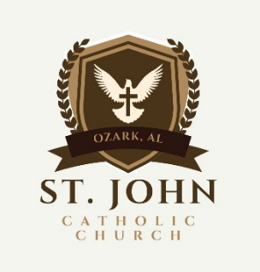
Today is the Fourth Sunday in Ordinary Time – February 1, 2026
Telephone: 334-774-6826 Email: stjozark@gmail.com
NEW Website: http://sjccozark.com/
FB: St. John the Evangelist Catholic Church – Ozark, AL
Mailing Address: P.O. Box 1008, Ozark, AL 36361
Address: 475 Camilla Ave., Ozark, AL 36360

When Jesus saw the crowds, he went up the mountain, and after he had sat down, his disciples came to him. He began to teach them. (Gospel)
liturgy.slu.edu
Fra Angelico, The sermon on the Mount, 1437-1445
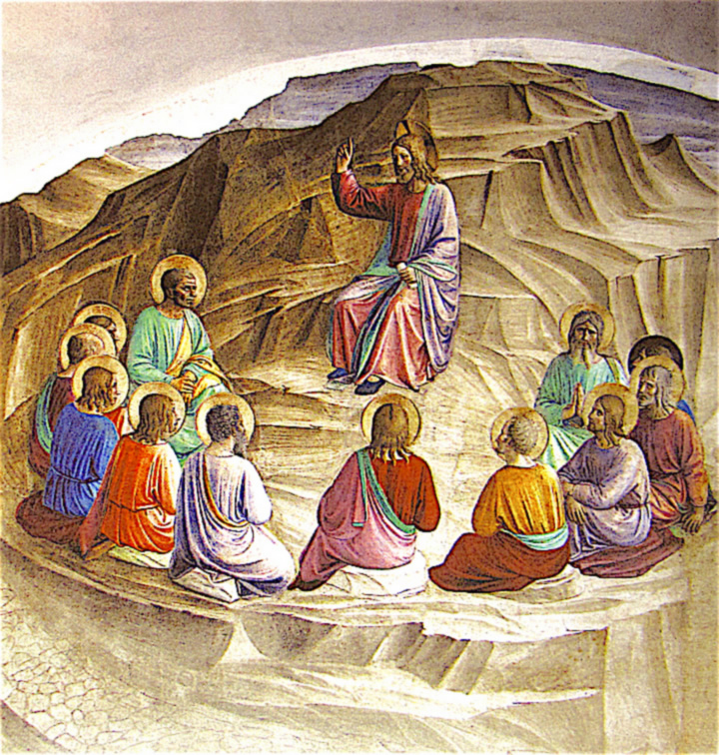
Parish News
Ways to Give to St. John
sjccozark.com
and click “Menu” in upper R corner
“online giving”
Or

QR Code linked to our online giving
Or
Text to Tithe - Text GIVE to 334-633-0906

Catholic Charities Appeal
“ We are in the final weeks of the Catholic Charities Appeal, we are about half way to achieving our parish goal of $36,000.00 Presently, we have 26 Pledges for $16,166.15 in our parish. If you have not returned your Catholic Charities pledge envelope, take a few minutes now to complete one. There are plenty in the pews, or raise your hand, and an usher will bring one to you. Please return your envelope and save our Parish Chair a phone call. If you are unable to give the basic pledge, please give what you can afford. We ask that everyone complete a pledge card so that our database can be updated. The Catholic Charities results will be reported in the Catholic Week very soon. Please help us reach 100% participation! God bless you for your generosity.”

Gift Store News
Your Gift shop is going to continue with 25 cent ornaments sale and other gifts on sale!

Blessings of Blankets
BURR!!! The weather is going to be chilly.
If you would like to donate a NEW lap blanket to be given to our homebound, sick, or those in need, please drop it in the basket at the entrance to the church or to Amber Williams or Janet Amuso.

Women's Club Scholarship
The Women's Club is offering their annual
scholarship of $500 to those who will be attending post secondary education options for the 2026-2027 school year. Scholarship applications will be available on February 1. Scholarships can be obtained on the table at the back of the church OR can be requested by email at sjoladies@gmail.com. Applications and transcripts are due by March 1. For more information, contact JoAnn McCaffrey (334-237-2857) or joannmccaffrey@aol.com

Social Committee
If you are interested in serving on the new social committee that is being formed, please contact Amber Williams.
Text (334) 797-5202 or email
amberamusowilliams@gmail.com

Check out SJCCOZARK.COM
Have you seen our updated website? Did you know that we have had 5 new folks have requested information on becoming a Catholic by using CONTACT US? Did you know that we have had specific donations to our food pantry through the website and our address located there? Did you know that the website is updated weekly and contains a calendar of the church events with times and places? The website is a good way to keep track of church happenings in addition to our facebook page. If you need to find out about an event or time, please know that the website can be a good place to check on what you may need. We are touching those in Ozark and around the world.

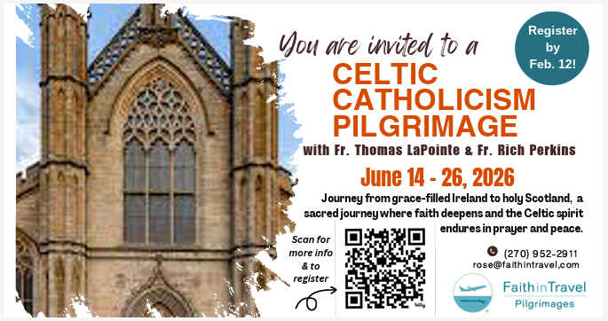

In remembrance of parishioners who passed in February
“The inspiration for this column came from seeing the monthly listing of Diocesan clergy in the Catholic Week.”
Sr. Penny

1 Dorothy “Dottie Woodham 2009
2 Mary Rose Yuskieivicz 1989
4 Calvin W. Shade 1997
5 Marie Darlene Robinson 1994
12 Anna Gromzer 2003
12 Peter Anthony Genovese 2011
12 Francis Paramore Watson 2012
12 George Simpson 2022
18 Pauline Stergenback 2005
19 Robert Thieme 2024
22 Jenell Thomas 2007
25 John Thornton 2022
27 Hilde Wilson 2013

