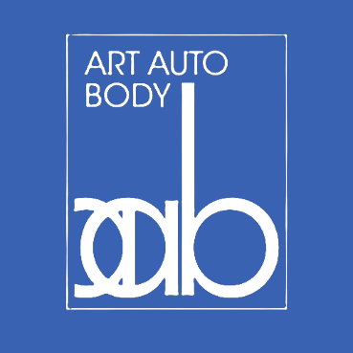
Art Auto Body AUTHORIZATION TO REPAIR & DIRECTION OF PAYMENT
REGISTRATION: 7098552
TAX ID: 22-2610832

I, _______________________hereby authorize _______________________Insurance Company

to pay art auto body for any collision repairs (original and supplemental) related to my

__________________________________, for claim#_______________________________________
(year/make/model)

also, i have chosen art auto body as my designated representative during my repair, as provided for in regulation 64 of the insurance department, state of New York, only as to my motor vehicle damage.

i also acknowledge that i will be responsible for my deductible/co-pay of (if applicable)

0.00 $250 $500 $1,000 na Other:_________________

I understand that art auto body will not be responsible for any personal items that i have left in my vehicle during repairs.

due to possible loss related advanced vehicle diagnostic calibrations, art auto body may have to fill at least ½ a tank of fuel in my vehicle, i acknowledge that i may have to incur those costs should the insurance company not reimburse art auto body.

vehicle fuel level at drop-off: e ¼ 1/3 ½ ¾ f (void if electric)

DATE:______________________________ SIGNATURE:_______________________________

BEST CONTACT NUMBER: ___________________________________________________________

