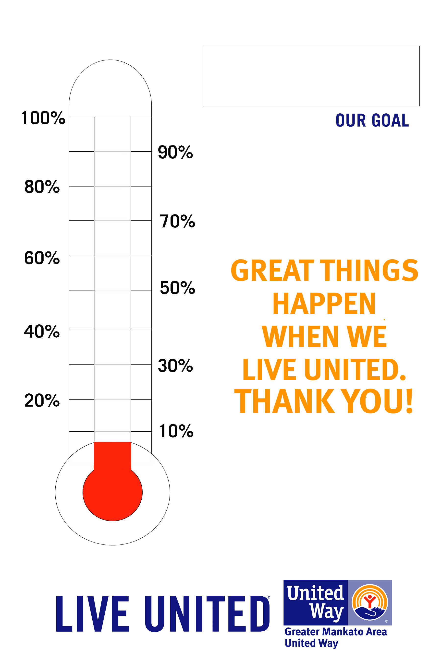

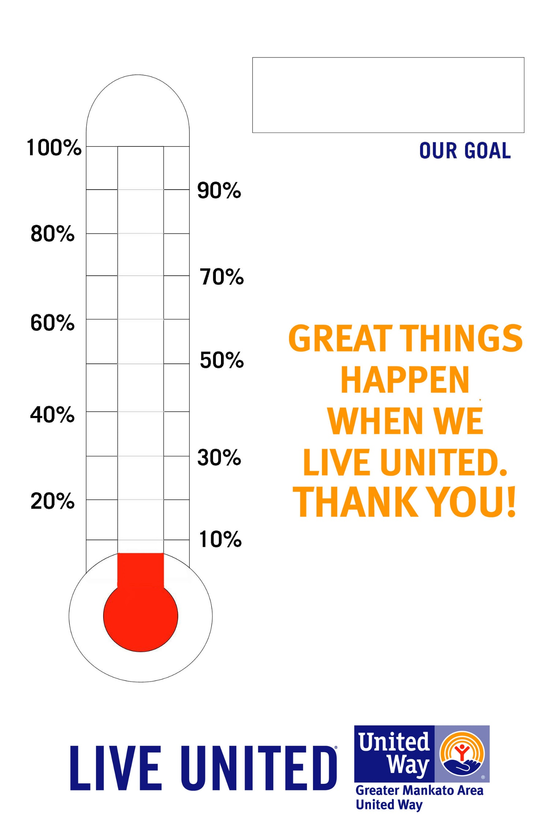

EVERY DOLLAR MATTERS.

JUST LIKE EVERY PERSON.