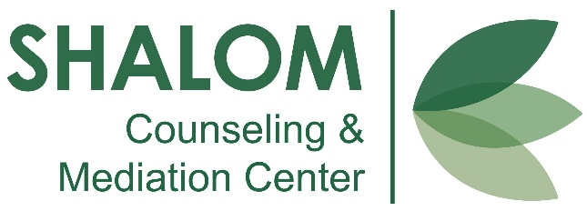
22nd ANNUAL
GOLF SCRAMBLE

SATURDAY - MAY 16, 2026
8:00am - SHOTGUN START
IRONWOOD GOLF COURSE
1015 W Leggett St. Wauseon, OH 43567

Name of Individual/Organization: _________________________________________________
(Please list name as you want it to appear on promotional information)

Contact Person (if different than above): _______________________________________________________________
Phone: _________________________ Email: __________________________________________
We are continuously grateful for your support and cannot wait to have you join us this year!

DEADLINE for SPONSORSHIP & REGISTRATION:
May 8th

***REGISTER EARLY!***
Space is limited
to 32 teams

Please make checks payable to:
Shalom Ministries
22251 State Route 2
Archbold, OH 43502

Phone: (419) 445-1552
Fax: (419) 445-1401
or email: info@shalomworks.org

Sponsoring and golfing? Select your sponsorship level here:
☐ $850 - Corporate Hole Sponsorship plus a 4-Member Team
Team Captain: ___________________ Phone#______________
Team Member 2 ________________________________
Team Member 3 ________________________________
Team Member 4 ________________________________

☐ $650 - VIP Hole Sponsorship plus a 4-Member Team
Team Captain: ___________________ Phone#______________
Team Member 2 ________________________________
Team Member 3 ________________________________
Team Member 4 ________________________________

☐ $550 – Gold Level Hole Sponsorship plus 4-Member Team
Team Captain: ___________________ Phone#_____________
Team Member 2 _______________________________
Team Member 3 _______________________________
Team Member 4 _______________________________

Golfing, but not sponsoring? Select your registration here:
☐ $350 – Four Member Team
Team Captain: ___________________ Phone#_____________
Team Member 2 _______________________________
Team Member 3 _______________________________
Team Member 4 _______________________________

☐ $100 – Individual Player ________________________________
Phone# _______________________________________

Sponsoring, but not golfing? Select your sponsorship level here:
☐ I would like to underwrite the entire event
☐ $550 – Corporate Level Hole Sponsor
☐ $350 – VIP Level Hole Sponsor
☐ $250 – Gold Level Hole Sponsor
☐ I would like to sponsor $_______towards the event/cause

