Gulf Swimming
Athlete Representative Guidebook



A detailed guide on what it takes and entails to be an Athlete Representative

By: Sami Johnson and Makayla Noe

2022 Edition
What is an Athlete Representative?

USA Swimming Definition:
An athlete representative is an athlete member of USA Swimming who serves in a formal governance position at an LSC, Zone, or National level.

How it relates to Gulf swimming:
Athlete representatives for Gulf Swimming work at the LSC level and are a part of the Gulf Swimming athlete committee. This means that athlete representatives are responsible for representing their team's interests at committee meetings, house of delegate meetings, board meetings, etc…

Importance:
Athlete representatives play a major role in all aspects of USA Swimming and Gulf Swimming governance. Without athlete representation there would be no athlete influence in the decisions made, meaning the athletes would have no control over their sport.

Athlete Rep responsibilities and expectations:
- Advocate on behalf of other athlete’s in the LSC
- Bring creative and original ideas to meetings
- Have strong communication skills
- Meet the required attendance for meetings
- Have the ability to compromise
- Understanding that what is discussed is for the good of the entire Gulf
- Build relationships with non- athlete members
- Reach out to experienced athlete reps when confused or have questions
- Contact information for athlete representatives on the board are under the athlete committee tab on the Gulf Swimming website

Benefits of being an Athlete Rep:
Throughout an athlete's terms they will learn many skills that will be beneficial to them throughout life.
These skills include:
- Respect towards others
- Ability to collaborate with others
- Ability to create relationships with mentors, adults, other athletes, non athletes, etc..
- Public speaking skills
- Time- management
- Ability to represent others without being bias

Additional Benefits include:
- Leadership opportunities (this may be useful to add to your college resume)
- Volunteer Opportunities
- Swag
- Relationships with swimmers from around the greater Houston area

Note: Although there are many expectations, the main point of being an athlete rep is to share one’s love for swimming through representing one’s team’s interests and through helping the Gulf community.

Terminology
HOD (House of Delegates):
Composed of coaches, athletes, officials, committee leaders, etc. HOD meetings include the BOD presenting legislation that is to be voted upon. HOD members cannot vote at BOD meetings.

The BOD (Board of Directors):
A select few who are voted into their respective positions to create new legislation. BOD members have the power to vote both in BOD and HOD meetings.

How is the Athlete committee organized?

The Athlete Committee Hierarchy
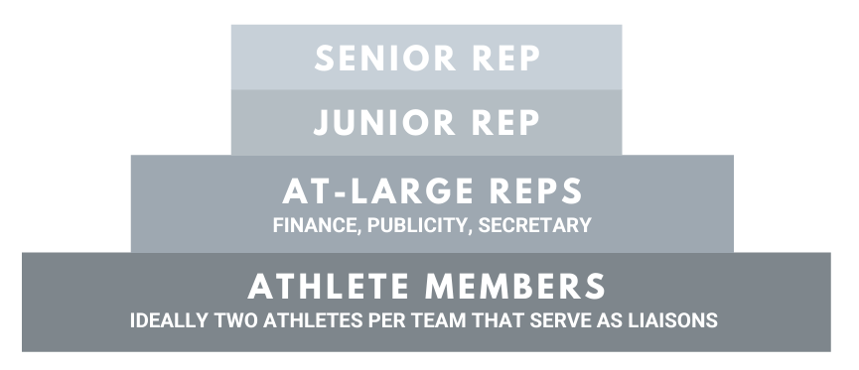

The Athlete committee is split into four tiers. The higher the tier the more voting power that athlete representative has.

Note: The athlete representatives who wish to be an At-Large rep, or junior rep must be voted into the position. All athlete representatives are expected to attend the athlete committee elections and vote for who they think will best perform in the chosen position. Elections are held in late August.

Athlete Members
Athlete members include all athlete representatives. They have the ability to vote in athlete committee meetings, however, they cannot vote in HOD or BOD meetings.

At-Large Representatives
Above the athlete members tier are the At-Large Reps. This tier contains three positions all of which have one year terms, are board members and have the power to vote in athlete committee meetings and HOD meetings. Although not all At-Large reps can vote in BOD meetings, it is still expected that they attend. The three At- Large positions include the At-Large communications, Finance Chair, and Programming & Events.

At-Large Communications:
This is the only position out of the three At- Large reps that has the ability to vote at board meetings. This position's main responsibility is to take minutes at every athlete committee meeting, as well as, keep the athlete committee tab on the website, the attendance tracker and contact information sheet up to date.

Finance Chair:
The Finance chair is responsible for handling the athlete committee budget, keeping track of receipts, and working with the finance committee. It is highly encouraged that the athlete running for this position either has financial knowledge or is highly interested in finance.

Programming & Events:
This athlete is responsible for answering emails, sending out notifications, managing social media and leading the publicity committee. They work with the Junior and Senior representatives to help plan and coordinate events and meetings.

Junior and Senior Representative
The top two tiers consist of the Junior and Senior representative. These two positions have the most voting power out of any athlete rep. They have the ability to vote in athlete committee meetings, HOD meetings, and BOD meetings. Both representatives are expected to attend all HOD and BOD meetings, as well as, run athlete committee meetings. The Junior and Senior rep work hand and hand with the BOD and the At-Large Representatives to plan projects and create agendas.

Junior Representative:
The Junior representative must be a rising junior to run for this position. This is because the junior representative automatically becomes the senior representative once their one year term has expired. The main responsibility this position has is to work closely with the senior representative to create agendas, organize projects, run meetings, etc…

Senior Representative:
The Senior Representative is the head of the athlete committee. They are responsible for working with the Board of Directors to create an effective athlete committee. They also are responsible for mentoring the junior representative, creating agendas, scheduling and running committee meetings, making sure all athlete rep input is accounted for, proposing projects to the BOD, etc…

Note: Both the Junior and Senior rep are also athlete representatives for the Southern Zone. This means that both positions are required to attend SZ meetings, which are mostly held through zoom.

How can athlete representatives who are not in an elected position become more involved?

Athlete representatives not only have the opportunity to be a part of the athlete committee, but they can also join many other committees including Technical Planning, Governance, Safe Sport, Diversity, Equity, and Inclusion, Programming and Events, Finance, Club Development, etc…

Technical Planning Committee:
The TPC is involved in all aspects of Gulf sanctioned swim meets. This includes, meet fees, sanction applications, scheduling championship meets, deck official, meet director financial reports, etc… Athlete representatives who are interested in helping plan the location and dates of championship meets are highly encouraged to join this committee.

Safe Sport Committee:
This committee creates and reviews policies that insure athlete, coach, and parent security. They also encourage athlete and non- athlete members of Gulf Swimming to participate in programs that educate behavioral boundaries.

Finance Committee:
The Finance committee works to find the best way to utilize available funds. Joining this committee involves helping track athlete committee expenses, as well as, gives athletes the opportunity to learn financial skills and what goes into creating a budget for a large organization.

Diversity, Equity, and Inclusion Committee:
The DEI committee ensures that the sport of swimming is an accessible and welcoming environment to all. In order to do this they work on policies that aid people who have less access to the sport (ex. those with disabilities or from low income backgrounds). Athlete representatives can propose and develop new initiatives, work with fellow board members on maintaining current programs, and offer input from their own personal experiences on the importance of DEI.

Governance Committee:
The governance committee is involved in determining how Gulf swimming as an organization functions. It ensures that the bylaws and policies are upholding the mission statement.

Programming & Development Committee:
This committee plans special events and workshops for coaches, officials, parents, and swimmers in Gulf Swimming. They not only discover potential event opportunities, but execute them to completion by working with partners/sponsors, managing sign ups, and discussing budgets (in conjunction with the finance committee). Athletes can help on this committee by offering input on which events would be especially helpful (or not) to swimmers and distributing info on upcoming programs to their respective team

Conclusion
Becoming an athlete representative is a large responsibility. It requires athletes to not only think about themselves, but what’s best for athletes around the LSC. Although this guide went into detail about what is required from an athlete representative, it is also important to note that being an athlete representative is a fun and rewarding opportunity that allows reps to create lasting relationships with other swimmers in the Gulf, attend and plan events, and become great leaders. Athletes should become athlete representatives for their love of the sport and passion for helping others around the community. It is vital that the athlete committee consists of athlete’s that genuinely want to help Gulf Swimming create an inclusive and structured LSC.

