Georgetown Youth Baseball Association
Protected Player Approval Form

Player Name: ____________________________________________

Parent Name: ____________________________________________

Age Division: ____________________________________________

Coach Name: ____________________________________________

I, the above-named parent, am giving my approval to the above-named coach, to be a protected player on their roster. I understand this is my agreement with the coach and is a requirement of GYBA to receive this form prior to the cut-off day to be effective.

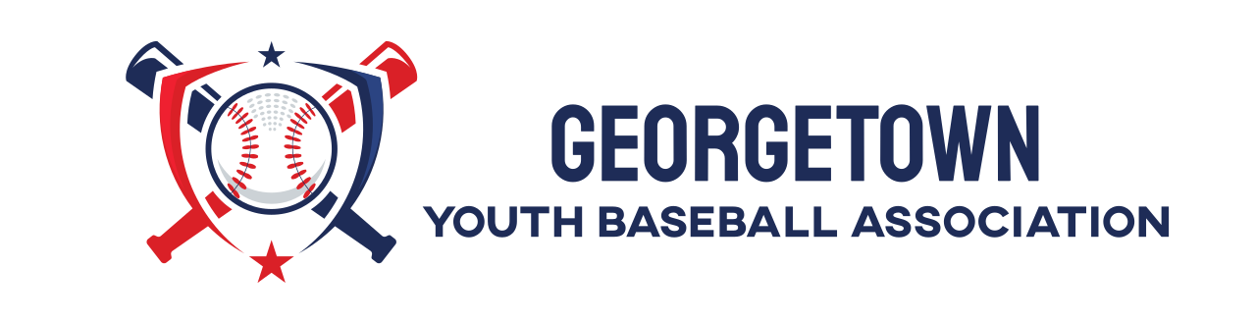
Signature & Date

