
Lifeline Global Ministries®
CERTIFICATE OF COMPLETION
awarded to
First Name Last Name

for successfully meeting the requirements of

Insert Book Name Here

at [Prison or Jail, City, State]
[Month date, year]

_______________________________________________________

Warden or Chaplain [type Name here)

________________________________________________________

[type Name here) Chaplain or Facilitator

_______________________________________________________

Dr, Romney Ruder, President Lifeline Global Ministries

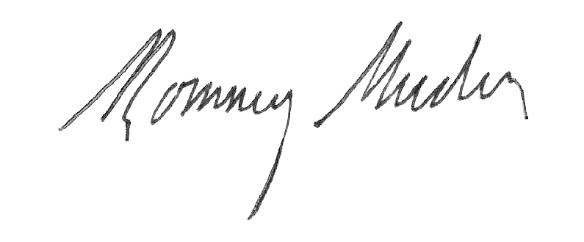

--

Dr. Romney Ruder, President Lifeline Global

And he will turn the hearts of the fathers to their children and the hearts of the children to their fathers…
Malachi 4:6 (ESV)

