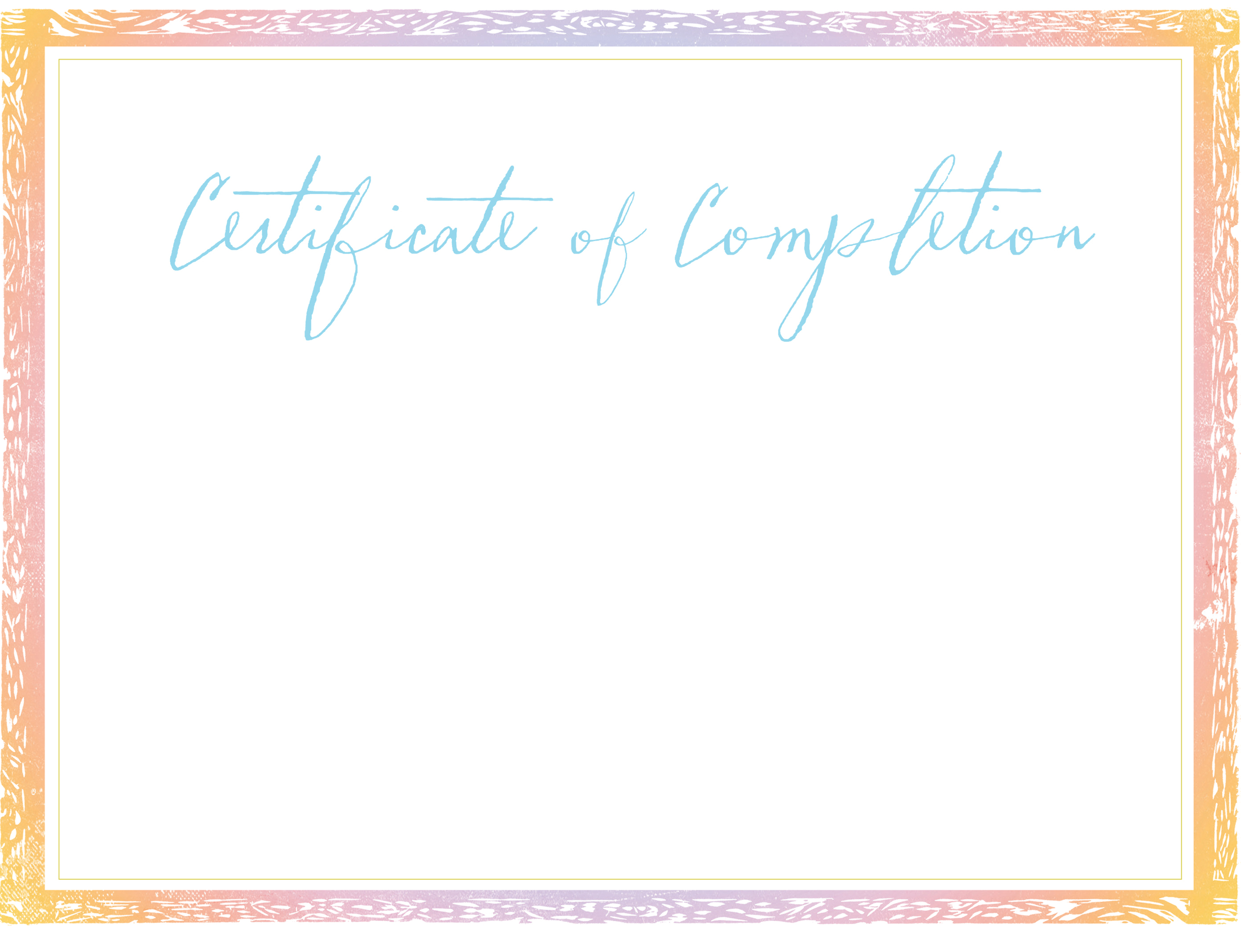
AWARDED TO
Type Name Here
in honor of her bible study completion and pledge memorization
at [Prison Name, City, State]
[Month, date, year]
Key verse
For this child I prayed, and the LORD has granted me my petition that I made to Him.
Therefore, I have lent him to the LORD. As long as he lives, he is lent to the LORD (1 Samuel 1:27-28).
Pledge
As a Hannah’s Gift mom, I acknowledge that my children are a gift from God.
I take hold of the call and responsibility as a mother and I seek God’s guidance on how to
best parent my child. I am growing into a wise and strong woman of faith and my greatest desire
is to leave behind a spiritual legacy carried on by my children to their children.
May my family prove to be a tower of strength built on the firm foundation I am laying in the power of Christ.
______________________________________________________________________________________________
mentor signature date
Lifeline Global Ministries®
HANNAH’S GIFT™

