MOJAVE CHAMBER OF COMMERCE PO BOX 935 MOJAVE, CA 93502

MEMBERSHIP APPLICATION

BUSINESS NAME : ______________________________________________________________

CONTACT/INDIVIDUAL NAME: _____________________________________________________

ADDRESS: ______________________________________________________________________

PHONE: ________________________________________________________________________

E-MAIL ADDRESS: _______________________________________________________________

MAY WE SHARE YOUR E-MAIL ADDRESS WITH A THIRD PARTY ___________YES__________NO

NUMBER OF EMPLOYEES: ____________

AMOUNT ENCLOSED: $ _________________

Local Business:
Employees Dues
1 to 5 $90.00
6 to 20 $180.00
21 & over $270.00

Out of Area Business: $90.00

Individuals (Not available for local business owners)
Senior Citizens (60 +) $25.00
Under 60 $30.00
Non-Profit Organizations: $35.00
PayPal
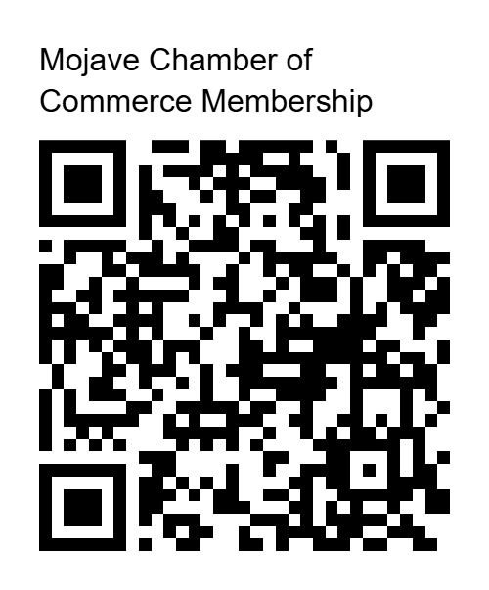
Thank you for your participation and help.

Ted Hodgkinson

Ted Hodgkinson
President Mojave Chamber of Commerce
mojavechamber@gmail.com 661-824-2481

