Model: U100 DRIVEBAY Summary
BUILDING DIMENSIONS  Width: 24' - 0"  Length: 30' - 0"  Height (Eave): 10' - 0"  Height (Apex): 13' - 0"  Area: 720.00 sqft  BUILDING OPTIONS  Roof: R-PANEL-PB KYNAR PAINTED 26 GA X 39 1/8 26G painted  Wall: R-PANEL-PB KYNAR PAINTED 26 GA X 39 1/8 26G painted  FRAME OUT DETAILS  (1) One - 10'x8' framed opening for Roll Up Door  (1) One - 3' - 4"x7' - 2" framed opening for Personnel Door  FOUNDATION  Type: 4" Slab  Sidewall Footing: : 1' - 0" - 1' - 0"  Endwall Footing: : 1' - 0" - 1' - 0"  BUILDING CODE/LOAD  Code: 2021 IBC  Occupancy: II  Snow: 5 psf ground snow load  Wind: 105 mph - Exposure ‘C’  Soil Bearing: 1500 psf  Heating: Unheated  Extra Roof Dead Load: 5 psf  Extra Wall Dead Load: N/A | 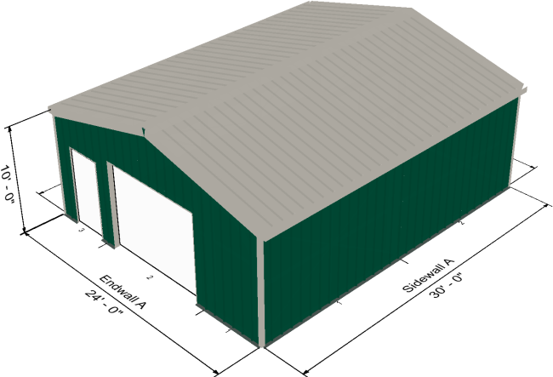  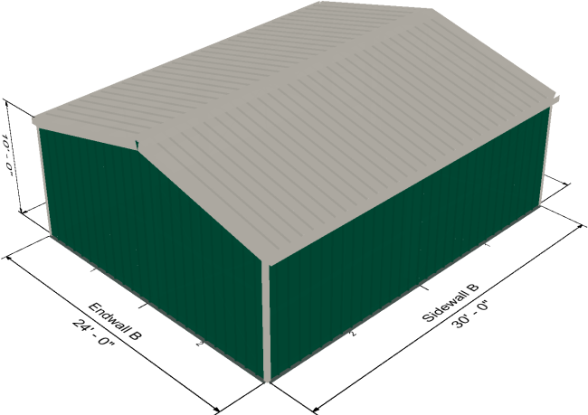  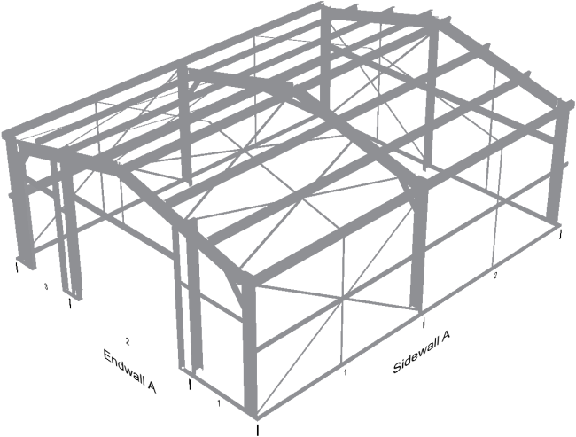

FLOOR PLAN
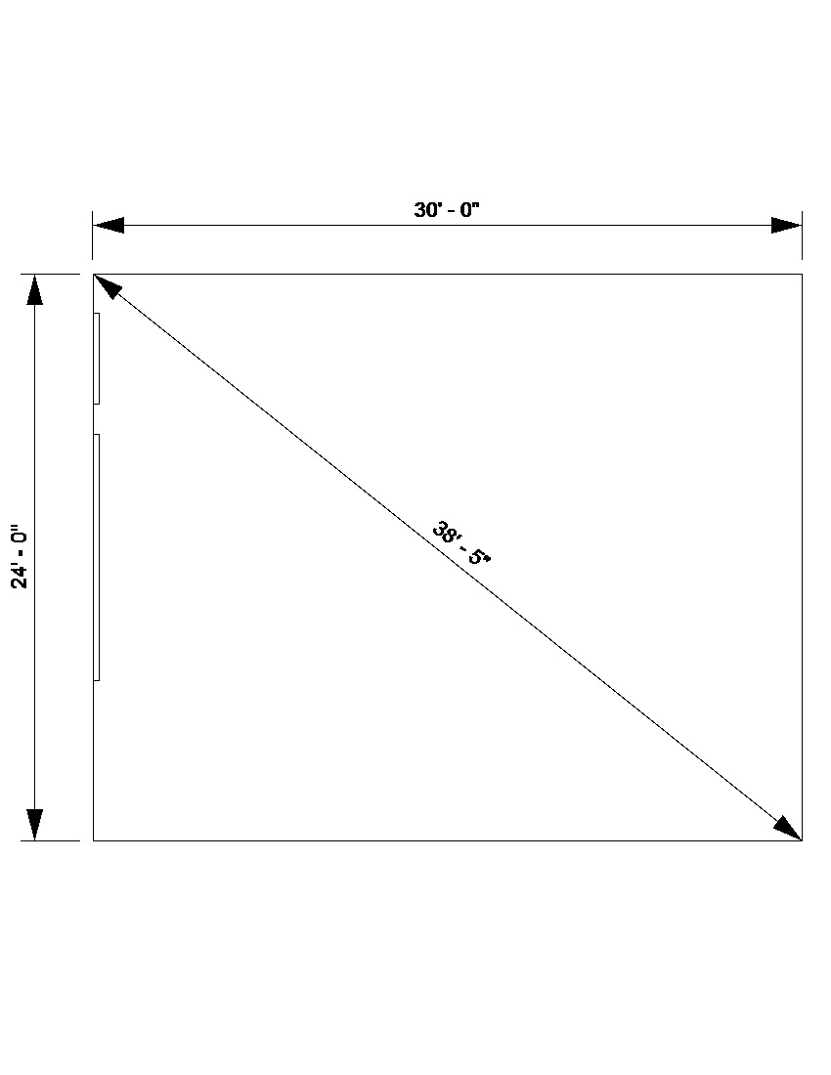

ELEVATIONS
FRONT | REAR
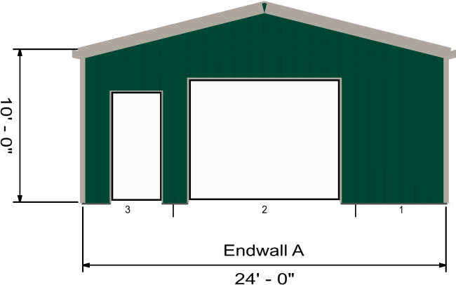 | 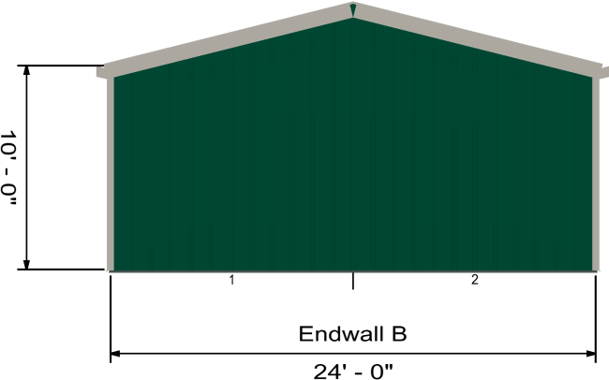
LEFT | RIGHT
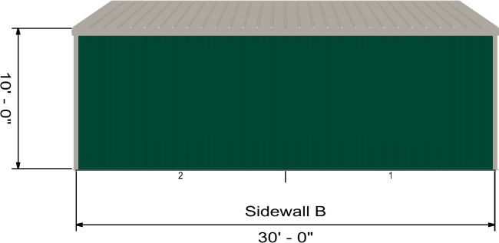 | 