Greater Manchester Magistrates Association
Magistrates In The Community
Report for AGM - 13th October 2026

A Successful and Busy Year for the Magistrates In The Community Team
It has been a very successful and busy year for the Magistrates In The Community Team, with significant growth and many new opportunities to engage with schools, partnership agencies and communities across the region.
Over the past year, we have visited many new primary schools, with engagement from this sector increasing substantially. It has been fantastic to see our work reaching more young people and to build new relationships with schools and local communities.
We have seen considerable growth across several areas: Stockport, Bolton, Trafford and Salford, reflecting the continued interest and value of the Magistrates In The Community Programme.
Please see our year in numbers below for 2025/26.
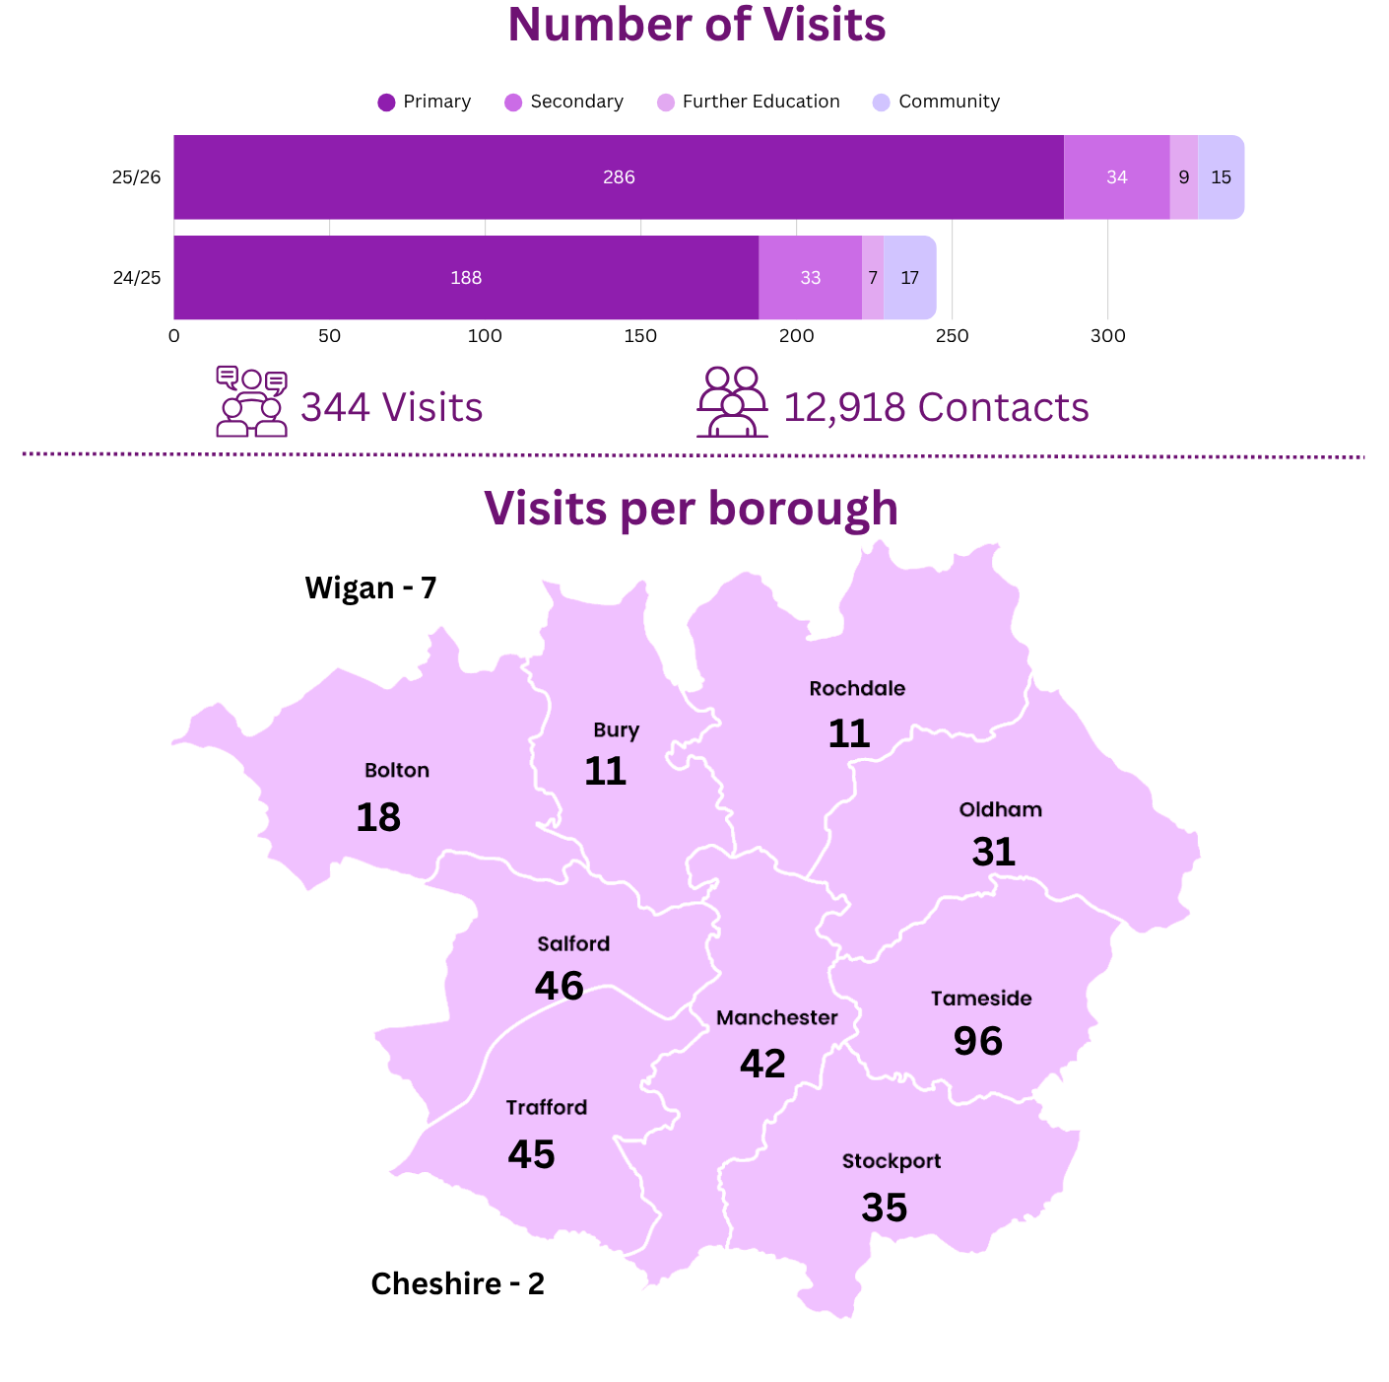
We have seen a 40% increase in our community outreach this academic year, which is phenomenal and clearly demonstrates the dedication of the GM MIC team.
This year, we have also taken small steps towards delivering workshops/presentations within Pupil Referral Units (PRUs) in Oldham, Tameside and Stockport. This is an area where there is a clear need for targeted support and engagement. Some pupils are already very aware of the Criminal Justice System, making this an opportunity to build on their existing awareness and provide meaningful support.
During the year, we welcomed 5 new members to the MIC Team: Ronald Marshall, John Lyne, Bridget Hardiman, Sally-Jo Mayo and Catherine Feeney, who have already been out in the community observing and delivering presentations.

General Update on MIC Activity and Community Initiatives for the Last Academic Year (September 2025 – August 2026)

Partnerships:
Child Safety Media (CSM): Crucial Crew and B Safe Salford:
We have built on our relationship with CSM and B Safe. Taking part in these initiatives has resulted in several new contacts and follow-up school visits:
Crucial Crew Trafford, January 2026:
- 540 year six children
- 10 schools from Trafford

Crucial Crew Wythenshawe, July 2026:
- 620 year 6 children
- 10 schools from Wythenshawe

B Safe:
- 960 year 6 children
- 16 sessions delivered throughout the academic year
- 22 schools from Salford

StreetDoctors (SD):
- funding has been secured to run a further 8 Joint MIC/SD Knives workshops to run in High Schools commencing December 2026, following a successful Pilot at Co-op Academy, Blackley in December 2025.

Greater Manchester Combined Authority (GMCA) and Violence Reduction Unit (VRU):
- This year, we have cemented our partnership with GMCA resulting in funding for our Mock Trial Competition and StreetDoctors joint working initiative for knife-related workshops.

- This year, we have worked with GMCA and VRU on knife crime initiatives, reacting to need, which has helped increase the number of our knife crime workshops in High Schools.

- Members of the MIC Team have attended and supported at two Sceptre Q&A Sessions in the last academic year. Sceptre is a national initiative aimed at reducing knife crime. This bi-annual week of action looks at community intervention, education and enforcement, a key focus of the VRU. We are very pleased to be continuing this partnership into 2026/27.

Annual Year 6 Mock Trial Competition
9 Local Heats took place between 24th February and 24th March 2026, totaling 58 Schools and 348 children. 16 schools made it through to the final.
The Final - an unforgettable day of learning, teamwork and achievement! 16 schools and 140 Year 6 students came together to take part in this year's Mock Trial Final, where our young participants impressed everyone with their confidence, professionalism and enthusiasm.
His Majesty's High Sheriff of Greater Manchester, Mr Mark Llewellin DL, handed out the awards. Every participating school celebrated success, with one pupil from each team receiving an Outstanding Performance Award, celebrating exceptional individual contributions throughout the day.
Congratulations to Stockport Grammar School, who were crowned this year's champions. Horwich Parish Primary proudly received the Runners-up Shield, with an incredibly close finish—just two points separated the top two schools, highlighting the exceptional standard of the competition.
We would like to thank all of the schools, students and partnership agencies who participated in making this year’s Mock Trial Competition a success. It was lovely to see the dedication and commitment of all those involved in creating a safe and educational environment for our young people to learn about key issues with real life professionals.
Partnership agencies in attendance this year were:
- Greater Manchester Police
- Oasis Navigators – a youth-focused, violence reduction project
- Greater Manchester Travel Safe – focusing on prevention and engagement
- Early Break – advocacy support for young people and families facing substance misuse challenges
- Greater Manchester Fire and Rescue Service – Broughton’s Blue Watch ran a water safety exercise in the yard with their fire engine
- British Transport Police – antisocial behaviour on the railways

We were delighted to welcome Granada Reports to the final, who spent the day filming the event. Their report was broadcast on Tuesday 30th June 26, showcasing the incredible enthusiasm, talent and dedication of all those involved.

If you haven’t yet seen it, please follow the link below to watch the report and celebrate this fantastic event with us.

- https://www.itv.com/watch/news/school-pupils-get-potentially-life-saving-legal-lessons-by-taking-part-in-a-mock-trial/vtmrm5m

Presentations/Workshops:

As a team, we are always looking at our resources and updating and adding to our portfolio in order to ensure that we are up-to-date on issues within our community and current legislation. With this in mind, we recently updated one of our ‘choices and consequences’ presentations, which focuses on drink and drug awareness relating to driving for students aged 16-18. The presentation was written by Rachel Medcalf.
This updated presentation was rolled out on Friday 7th November 2025 at Ashton Sixth Form College, with further presentations taking place at Stockport Grammar School and Poynton High School, all very well received.
On 6th March 2026, several MIC members met to reflect on the feedback received from schools and, as a result, we updated our Core Introductory and Quiz PowerPoint presentation, which was rolled out to schools from April 2026. Feedback regarding this new presentation will be sought in the 2026/27 academic year.

Lastly, a special thank you to our fantastic team of presenters for all their hard work, commitment and dedication throughout the last academic year.

Kirsty Hart JP
GM MIC Coordinator

