Inhouse
Firefighter I/II
Policies and Procedures

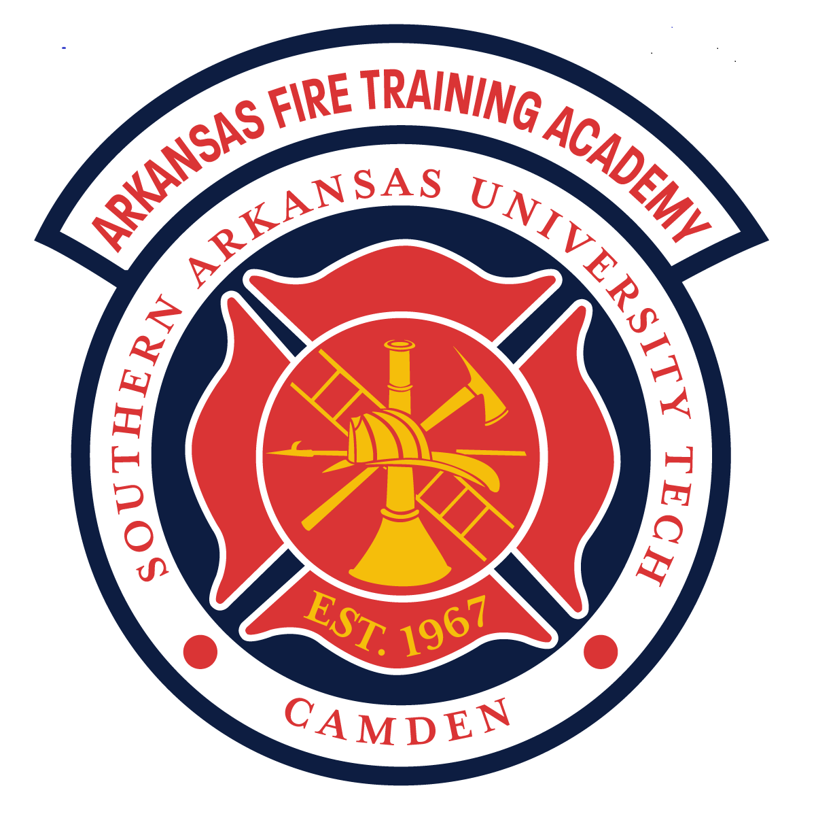

- Purpose

The purpose of the Arkansas Fire Training Academy’s In-House Fire Fighter 1 & 2 (FF1 & FF2) program is multi-faceted:
- Allow fire departments that meet the following standards to host an in house FF1 & FF2 program
- Eliminate some of the back log and wait time at the AFTA for Standards class
- Create locally trained people to enhance the departments needs

As participants of the FF1 & FF2, the Arkansas Fire Training Academy (AFTA) is permitting departments and students to have access to the training he/she needs to further their careers. This program will serve as a valuable means of recruiting and retaining future firefighters. This document provides an overview of the requirements for hosting the FF1 and FF2 program, curriculum, and courses at local fire stations. The goal is to help program leaders and administrators establish fire service training that complies with the rules and instructional objectives set forth by the Arkansas Fire Training Academy and the National Fire Protection Association (NFPA) 1010, Standard for Fire Fighter Professional Qualifications. This information is also intended to help ensure that the consistency and effectiveness of firefighter programs offered throughout the state meets the very high standard for training quality established by the Arkansas Fire Training Academy, that students are safe, and the integrity of all testing processes is constantly maintained.

II. Scope
This policy affects those involved in the implementation of the Firefighter 1&2 program: Arkansas Fire Training Academy staff, sponsoring fire departments, as well as the program instructor(s), and participating students.

III. Guidelines
A. Program Overview

1. Program Scheduling
A. Pre-approval is required for this program. The Chief of the Department or Training Officer wanting to host the class must contact the Deputy Director of the AFTA for approval prior to applying.
- Once approved, they must then apply for the course through normal class request channels.
- Once approved, a schedule of the class must be provided with dates and times of classes, burns, testing, etc.
  - Course schedule may be altered to accommodate severe weather. The AFTA shall be notified when this occurs to adjust the schedule and testing.
  - A list of instructors that will help out with the program need to be submitted along with the schedule of the course.

B. Program Disqualifiers

1.If a department does not have or have access to equipment and facilities, or only has very limited/minimal support and supplies from the fire department, they are not eligible to participate in this program. The department MUST have a minimum of 6 students to be considered.

a. Note: Each skill sheet in the AFTA curriculum includes a list of equipment and props needed in order to perform the specific type of training. Skill sheets may be found in the Firefighter Standards Student Handbook. Partnerships may provide access to equipment and burn facilities. Funding requests and needs are the responsibility of and at the department discretion.

2. Course Pathway

The program is designed to be completed in order with few options for students to deviate. The ideal pathway being as follows:

A. CPR
B. Hazardous Materials Awareness and Operations (IFSAC), Wildland Firefighting (8 hours)
C. Traffic Incident Management (TIMS) course
D. Firefighter I (current curriculum from the AFTA + Big basement + JPR exam + IFSAC written Certification Exam)
E. Firefighter II (current curriculum from the AFTA + FEATS test + JPR exam + IFSAC written Certification Exam)

3. Road Map for Firefighter 1
A. Prerequisites:
- CPR Healthcare Provider (Red Cross or AHA)
B. Requisites: (must be completed prior to testing for Firefighter I)
- Haz-Mat Awareness and Operations (IFSAC) from ADEM,
- Wildland Firefighter
- Traffic Incident Management (TIMS)
C. Firefighter 1 classes (current curriculum from the AFTA)
D. Firefighter 1 Testing requirements:
a. Basement exercise (administered at an approved AFTA Site) ICS 100, 200, 700, & 800, and Firefighter 1 IFSAC exam from AFTA
b. The basement exercise must be completed prior to sitting for the FF1 IFSAC accredited exam.
- The basement is designed to demonstrate that the student is competent and confident while wearing structural PPE and a SCBA in an environment with obscured vision and restrictive spaces. The student’s vision will be obscured by blacking out their SCBA mask. The student will encounter entanglements, movement through studded walls, and obstacles that will have to be climbed over or under. Student will be required to move through obstacles that require them to lay flat.
c. ICS 100, 200, 700, & 800 links are available on Resource One as homework
d. Chapter/Unit tests must be set up through the testing division at the AFTA on Resource One. Resource One is the online website we will use for Chapter/Unit testing. The website address is www.moodle.ifsta.org Each student that submits an application for the FF I/II Certification Program will need to enroll in Resource One at the start of the program. The email the student uses for that enrollment will need to be sent to AFTA for us to sign the students up for the course on Resource One. For further questions concerning Resource One, please contact AFTA Testing Division.
e. Rosters for the chapters requested will need to be filled out and signed by each student that attended and emailed to AFTA prior to requesting Resource One Chapter/Unit test. Make sure the dates for each chapter have the dates of the class on the roster and the instructor has signed at the bottom.
i. Failure of one of these tests will result in one (1) retest.
ii. Failure of the retest results in removal from the active roster
iii. Students who fail a retest may remain in class, at the discretion of the hosting department and will receive a Basic FF certificate upon completion. This will result in a separate roster being sent in for each class taught daily.
D. Firefighter 1 IFSAC/ Pro Board certification exam
a. Proctored by AFTA staff member
b. Scheduled at least two weeks in advance with the testing department to assure proper time to get materials sent out.
c. Retests shall be scheduled at least two weeks before the start of the Firefighter 2 program

4. Road map for Firefighter 2
A. Prerequisites:
a. Firefighter 1
B. Firefighter 2 classes (current curriculum from the AFTA)
C. Firefighter 2 testing requirements
a. FEATS test (administered at an approved AFTA site)
b. Chapter/Unit tests must be set up through testing department at AFTA on Resource One. Request for tests should be done at least 2-3 days prior to requested test date.
i. Failure of one of these tests will result in one (1) retest.
ii. Failure of the retest results in removal from the active roster
iii. Students who fail a retest may remain in class, at the discretion of the hosting department, and will receive an Advanced FF certificate upon completion. This will result in a separate roster being sent in for each class taught daily.
D. Firefighter 2 IFSAC/Pro Board Certification exam
a. Proctored by an AFTA staff member
b. Scheduled at least two weeks in advance with the testing department to assure proper time to get materials sent out.
c. Retests shall be scheduled at least two weeks in advance.

5.Course Eligibility Chart

New Hire Process/ AFTA | Fire Department/ AFTA Roster
Firefighter 1 | JPR’s + Big Basement + Written Certification Exam (IFSAC/Pro Board)
Firefighter 2 | JPR’s + FEATS test + Written Certification Exam (IFSAC/Pro Board)

A. This program will require coursework to include some combination of; Wildland Firefighter, Traffic Incident Management (TIMS), Hazardous Materials Awareness (HMA), Hazardous Materials Operations (HMO), Firefighter I and Firefighter II. EMT may be added to the course schedule if requested. These curriculum materials must be acquired from the AFTA. Any supplemental learning materials instructors wish to use in their courses should be material from which curriculum is based
- Questions of permissibility should be directed to AFTA

6. Course Design & Structure
A. The exact duration of the Firefighter I and Firefighter II courses will vary, depending on the seat time required to fulfill the requirements for AFTA, including the academic and practical skills testing. The minimum hours for completion of the Firefighter 1 & 2 program is 320 hours. The cognitive portions of the training are delivered in a traditional classroom setting. The departments Instructor-in-Charge should determine the most appropriate teaching method and time schedule for their particular program. The class schedule and syllabus can be adjusted accordingly. Depending on the schedule chosen, an occasional Saturday lecture, or skill training session may be needed in order to provide enough class time to meet the overall course requirements and ensure positive student outcomes. Once a schedule has been determined by the instructor-in-charge, a copy SHALL be provided to AFTA testing division and Deputy Director.

7. Class Size & Instructor Ratio
A. Class size shall be a minimum of six (6) and is limited to twenty-five (25) students maximum, any number of students over 25 must get approval from the Deputy Director or Director. Larger classes may be approved if facilities and staffing are shown to be sufficient. Proof of instructor availability must be shown for additional students. Additional instructors must assist with moderate/high risk activities, such as live burns, extrication etc. and be certified to do so; usually a 1:5 instructor/student ratio is required for these evolutions. Exercises involving live fire must be in compliance with the current edition of NFPA 1403. Firefighters from the host fire department(s) are strongly encouraged to assist with classroom and fire ground training activities. Each skill sheet in the AFTA curriculum specifies the need for additional instructors as required.

8. Facilities & Equipment
A. The fire department(s) must provide bunker gear, SCBA, PASS devices, cylinders, tools, equipment, apparatus, training props, and any other tools needed to complete the training. All equipment must meet applicable NFPA requirements and safety standards. Needed equipment may be found in the individual skill sheets found in the Firefighter Standards Student Handbook.

9. Equipment
A. Each student shall have:
- A full set of NFPA compliant bunker gear – turnout coat and pants, hood, structural firefighting boots, gloves, a helmet with safety glasses or goggles and a properly fitting SCBA facemask
- Stethoscope (for daily blood pressure checks)
B. Each student shall have access to:
  - Self-Contained breathing apparatus (SCBA)
  - Pumper, ladder and other necessary apparatus
  - Extinguishers, ladders, nozzles, tools, appliances and other hand equipment
  - Blood pressure cuff

10. Facilities
A. Classroom and training facilities should be comfortable for students with plenty of space. Burn facilities must be in compliance with NFPA 1402 and NFPA 1403
a. Adequate lighting, HVAC, plumbing, ventilation and seating
b. Visual presentation equipment (TV, projector, etc.) will be required for classroom presentation
B. Facilities and equipment required for conducting fire training typically include, but are not limited to, the following types of items:
- A multiple-story tower-type structure, where students can use ladders, advance hose lines, connect to a standpipe, perform simulated rescues and hoist equipment.
- Structures and training devices that allow for forcible entry and ventilation drills on doors, windows, roofs, floors, ceilings and partitions.
c. Hydrant and/or drafting facilities.
d. Facilities for live fire training that will, when required, permit the use of breathing apparatus in an enclosed structure, and props that will enable students to practice extinguishing flammable liquid, propane and natural gas and vehicle fires. These facilities must be NFPA 1402 compliant.

11. Program Credit
A. AFTA Credit
a. Successfully passing all examinations, including chapter/unit tests, certification exams, and chapter job performance requirements, with a 70% or higher, and passing all JPR skills testing with 100% accuracy, will allow a student to receive Arkansas Fire Training Academy credit for Firefighter I and II, Hazardous Materials Awareness and Operations – as well as International Fire Service Accreditation Congress (IFSAC) and Pro Board Seals. Successful completion of the Emergency Medical Technician curriculum will permit the student to participate in the National Registry Examination.
b. All end-of-course exams, FFI and II, Hazardous Materials Awareness and Operations are administered on-site by AFTA personnel. In course chapter/unit tests are administered by in person proctors.

B. College Credit
a. AFTA is a division of SAU Tech. All certification courses successfully completed during the FF1 & FF2 program may be submitted to SAU Tech for a one-time portfolio fee, and are eligible to earn college credit. Credit is available according to the following scale:
i. Firefighter I – 3 credit hours
ii. Firefighter II – 3 credit hours
iii. Hazardous Materials Aws and Ops – 3 credit hours
iv. Emergency Medical Technician – 6 credit hours

12. Retesting
A. Retesting in this program follows the AFTA Retesting Policy.
a. Chapter/Unit tests- you are allowed one retest
b. Certification Exams- you are allowed two retests, only one of which may be immediately following the grading of the initial exam. A date must be set with the AFTA testing division for the third attempt and must be completed within one year of initial test.

13. Program Fee
A. AFTA requires a registration and/or seal fee for each student’s enrollment per course listed below:
a. EMT- $250.00 per student
b. Firefighter 1- $25.00 seal fee
c. Firefighter 2- $25.00 seal fee
d. Haz-Mat Awareness- $25.00 seal fee
e. Hazmat Operations- $25.00 seal fee

14. Students
A. Students who are not formally enrolled in a FF1 or FF2 program will not receive credit for the course and may not participate in the examination process.
B. To train to the level of Firefighter I, students must:
- Be at least 18 years of age
- Be a full-time employee or member of the sponsoring department???
- Meet the pre-requisites listed above prior to testing
- Provide proof of personal insurance or worker’s comp insurance. Copies maintained by the department.
- Complete a certified fit test
- Before the course begins, disclose information about a physical or learning disability that could potentially affect classroom or fire ground performance or safety. Written documentation from the student’s primary care physician (PCP) must accompany any claims to learning disabilities or other documented medical conditions.
- Obtain a FEMA Student ID www.cdp.dhs.gov
- Complete and submit the AFTA new student application
- Comply with class attendance requirements throughout the duration of the course
- It is recommended that students pass a physical exam that includes clearance for using SCBA. Requirement for the physical will be made by the local AHJ, this will be the hosting department. If a physical is required, a copy MUST be provided to the AFTA
i. Physical requirement: a physical that meets the intent of NFPA 1582
C. These job requirements should be shared with the licensed medical practitioner who performs the students’ exams.

15. Stakeholder Responsibilities
A. Program Instructors
        - The classroom instructor must receive/maintain minimum of Instructor I certification from AFTA or teacher certification from the State of Arkansas. Any instruction involving increased hazards must have a person that is trained to the level of Instructor II as the lead instructor. The instructor must hold certification in the course they are teaching (such as Firefighter I, Firefighter II, or other courses being taught). AFTA will provide assistance to instructors to help them complete the appropriate training.
        - EMT Instructors MUST be certified through the Arkansas Department of Health and aligned with AFTA. They may be aligned with and use other local colleges if they so choose for the EMR and EMT portions ONLY.
        - An EMT class requires extensive documentation prior to course delivery. Department representatives must contact the AFTA 60 days prior to the course to ensure required information is received and processed.
        - As part of course evaluations and as a means to improve the course delivery and structure, students may be asked to complete confidential questionnaires concerning their opinion of assignments and activities, the textbook and other components of the curriculum. No opinions should be reported as coming from any individual without proper consent.

16. Additional Responsibilities
A. To make sure all of those involved are fully informed, instructors should provide a packet that includes the following types of information:
a. Letter from the department head as to expectations of the course.
b. An overview of the NFPA standards on which courses are based (NFPA 1010)
c. A description of the course and course syllabus
d. Location of off-campus sites where training will be conducted
e. Grooming and clothing requirements
f. Prerequisites for training
g. Physical training expectations during the course
h. Explanation of possible risks of injury associated with fire suppression and other training activities
i. Expectations for class grades, personal conduct, class assignments, attendance and daily preparation
j. Computer and internet access requirements
k. Required physician’s physical for the respiratory evaluation for SCBA use
l. Checklist of required forms, documents and prerequisite tasks
m. Written permission for use of photos on web pages, social media and printed publications of students engaged in classroom and skill activities.

17. Sponsoring Fire Departments
A. Sponsoring departments or entities accept any and all responsibilities for injury during the training process.
B. Firefighters from local departments may serve as classroom and fire ground teaching assistants.

AFTA Inclement Weather policy

Less than 90 degree (heat Index) – regular operations

Between 90 – 94 (Heat Index) – Students are permitted to work outside in PPE for 20 minutes at a time followed by 20 minutes of rehab

Between 95 – 100 (Heat Index) – Students are permitted to work in a covered environment in PPE for 20 minutes at a time followed by 20 minutes of rehab

Greater than 100 degree (Heat Index) – Students are permitted to work in a covered environment (No PPE) for 20 minutes at a time followed by 20 minutes of rehab

Lightning Policy
If lightning is seen or registered on your local weather app as being within ten (10) miles of your facility, all outside evolutions shall be suspended.
Evolutions shall be suspended until there has been no lightning strikes indicated for a minimum of thirty (30) minutes. If a strike is indicated the timer starts over.

