WECAN
WORKFORCE EQUIPPED CERTFICATIONS ACHIEVED NOW

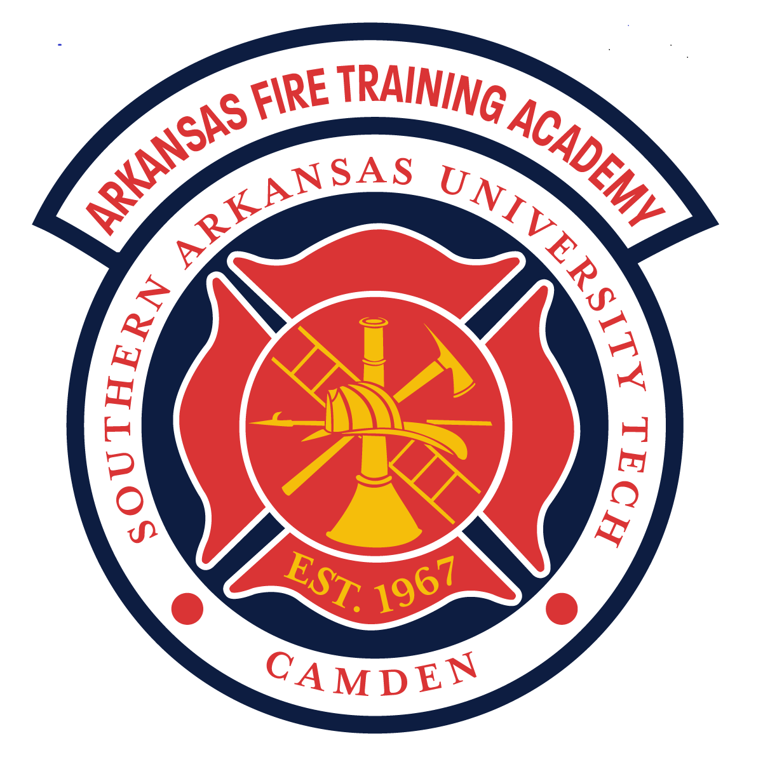

THE ARKANSAS DEPARTMENT OF EDUCATION AND THE ARKANSAS FIRE TRAINING ACADEMY

I. Purpose
The purpose of the Arkansas Fire Training Academy’s Workforce Equipped Certifications Achieved Now (WECAN) program is multi-faceted:
- Prepare high school students for immediate entry into the workforce
- Reduce the time needed for fire departments to put newly hired firefighters in service
- Create locally trained people to enhance participation in volunteer fire departments
As participants of the WECAN program, the Arkansas Fire Training Academy (AFTA) is permitting Arkansas high school students under the standard age of 18 to engage in this training endeavor. This program will serve as a valuable means of recruiting and retaining future volunteer and career firefighters. This document provides an overview of the requirements for hosting the WECAN program curriculum courses at Arkansas high school and career academies. The goal is to help program leaders and administrators establish fire service training that complies with the rules and instructional objectives set forth by the Arkansas Fire Training Academy and the National Fire Protection Association (NFPA) 1010, Standard for Fire Fighter Professional Qualifications, chapters 6 and 7. This information is also intended to help ensure that the consistency and effectiveness of firefighter programs offered throughout the state meets the very high standard for training quality established by the AFTA, that students are safe, and the integrity of all testing processes is constantly maintained.
II. Scope
This policy affects those involved in the implementation of the WECAN program: the staff, sponsoring fire departments and hosting school districts, as well as the program instructor(s), participating students and their parents/guardians.
III. Guidelines
A. Program Overview
1. Program Scheduling
During the appropriate curriculum selection timeframe, selecting Firefighter I will prompt the Arkansas Department of Education (ADE) to inform the school district to notify the AFTA of the intent to teach a course
- Schools are required to complete a course request form with the AFTA
- A Firefighter Pathway Sponsor Form must be filled out and sent to the Deputy Director of the AFTA
- Participating schools need to notify the AFTA on an annual basis on their intent to continue with the WECAN program.

B. Program Disqualifiers

1. If a school does not have access to equipment and facilities or only has limited/minimal support from a fire department, they are not eligible to participate in this program. Local fire department support is required to begin. A memorandum of understanding between the school and local fire department must be submitted to the Deputy Director of the AFTA for approval

C. Course Pathway(s)
1. The program is designed to be completed in order with few options for students from ninth grade to twelfth grade. The following are a few examples:
Option #1:
- Ninth/Tenth/Eleventh/Twelfth
  - Introduction to Emergency Services
    - Hazardous Materials Awareness (Arkansas Division of Emergency Management – ADEM)
    - Hazardous Materials Operations (Arkansas Division of Emergency Management – ADEM)
    - Wildland Firefighting (Arkansas Dept. of Agriculture – Forestry)
    - ICS 100, 200, 700, 800 (Resource One or training.fema.gov)
Copies of certificates will be required by AFTA to verify completion of the above training.
* All hazardous materials training must be conducted through the Arkansas Division of Emergency Management (ADEM) and tested through the AFTA
** Wildland Firefighting is conducted through the Arkansas Department of Agriculture: Forestry Division
- Tenth/Eleventh/Twelfth
  - Firefighter I (222 hrs)
- Eleventh/Twelfth
  - Firefighter II (82 hrs)
2. Emergency Medical Technician (EMT) may be taken through your local community college. If they will not sponsor your class, or you do not have one available contact the AFTA and we will try to assist you with this matter

**Students may enter the program at any year of the four-year program; however, they must begin with Introduction to Emergency Services as their first year of study.
Here are the options of when students may take classes and who schools may offer them to
Course | Eligible Year
Introduction to Emergency Services | 9, 10, 11, 12
Firefighter I | 10, 11, 12
Firefighter II | 11, 12
EMT | 12
This program will require coursework to include some combination of; CPR and first aid, Hazardous Materials Awareness (HMA), Hazardous Materials Operations (HMO), Wildland Firefighter, Firefighter I, and Firefighter II. These curriculum materials must be acquired from the AFTA. Any supplemental learning materials instructors wish to use in their courses should be material from which curriculum is based
a. Questions of permissibility should be directed to the AFTA Deputy Director
3. Course Design & Structure
The exact duration of the Firefighter I and Firefighter II courses will vary, depending on the seat time required to fulfill the requirements for AFTA, including the academic and practical skills testing. The cognitive portions of the training are delivered in a traditional classroom setting.
School leaders should determine the most appropriate teaching method and time schedule for their particular program. The class schedule and syllabus can be adjusted accordingly. Depending on the schedule chosen, weekend lectures, skill training sessions or field trips may be required in order to provide enough class time to meet the overall course requirements and ensure positive student outcomes.
4. Prerequisites
Before beginning a Firefighter 1 course, students must successfully complete the following prerequisites. If students do not have the prerequisites before entering the Firefighter 1 program they cannot participate.
A. CPR
B. Wildland Firefighting
c. Hazardous Materials Awareness and Operations
During Firefighter 1 class and before certification testing is allowed, students must complete:
a. All skills and training associated with NFPA 1010, chapter 6
b. Big Basement or equivalent. The scope of the Big Basement may be found in the Firefighter Standards Handbook.

Before beginning a Firefighter II course, students must successfully complete the Firefighter 1 program. If students do not have the prerequisite before entering the Firefighter II program, they cannot participate.
Before Firefighter II certification testing, the student is required to complete a Firefighter Encounter Agility Test (FEAT). A description of the FEAT may be found in the Firefighter Standards Handbook.
5. Class Size & Instructor Ratio
Minimum class size is ten students. Class size should be limited to 25 students, according to the AFTA requirements. Any class size below ten students or above 25 students requires a written approval from the Deputy Director of the AFTA. Additional instructors must assist with moderate/high risk activities, such as live burns; and be certified to do so; usually a 1:5 instructor/student ratio. Firefighters from the host fire department are strongly encouraged to assist with classroom and fire ground training activities.
Each skill sheet in the AFTA curriculum specifies the need for additional instructors as required. Skill sheets may be found in the AFTA Firefighter Standards Student Handbook.
B. Facilities & Equipment
Any facility or equipment item available to the training program may be used. The host fire department may loan bunker gear, SCBA and PASS devices, cylinders, tools, equipment, apparatus and other items not owned by the school. However, ALL equipment must meet applicable NFPA requirements and safety standards. Funding for this may be provided via grants and is the responsibility of the school.
1. Equipment
Each student should have:
- A full set of bunker gear – turnout coat and pants, hood, structural firefighting boots, gloves, a helmet with shield, safety glasses or goggles and a properly fitting SCBA facemask. All equipment must be within its 10 yr. service date set by NFPA 1970.
Each student should have access to:
  - Self-Contained breathing apparatus
  - Pumper, ladder and other necessary apparatus
  - Extinguishers, ladders, nozzles, tools, appliances and other hand equipment
1. Facilities
Classroom and training facilities should be comfortable for students with plenty of space. Burn facilities must be NFPA compliant and inspected by the AFTA. The use of the AFTA mobile burn trailer may be an option.
Facilities and equipment required for conducting fire training typically include, but are not limited to, the following types of items:
- A multiple-story tower-type structure, where students can use ladders, advance hose lines, perform simulated rescues and hoist equipment.
- Structures and training devices that allow for forcible entry and ventilation drills on doors, windows, roofs, floors, ceilings and partitions.
- Hydrant and/or drafting facilities.
- Facilities for live fire training that will, when required, permit the use of breathing apparatus in an enclosed structure.
- Facilities that will enable students to practice extinguishing flammable liquid, propane and natural gas and vehicle fires.
If a school does not have access to equipment and facilities or only has very limited/minimal support from a fire department, they are not eligible to participate in this program. Local fire department support is required to begin.
Note: The above lists provide an overview of equipment needs and is not intended as a complete purchase list. Each skill sheet in the AFTA curriculum includes a list of equipment and props needed in order to perform the specific type of training as well as guidance documents provided by the ADE. Grants or other funding obtained through various organizations may be available to purchase equipment for school firefighter programs; while the fire department partnership may provide access as well. Funding requests and needs are the responsibility of and at the discretion of the school district.
7. Program Credit
a. School Program Credit
Academic testing and school credit requirements should be established by the school system and the course coordinator. Successful completion of the WECAN program allows a student to receive high school transcript credit.
b. AFTA Credit
Successfully passing all examinations, including unit exams, certification exams, chapter job performance requirements, and skills testing for certification, will allow a student to receive Arkansas Fire Training Academy credit for Firefighter I and II, Hazardous Materials Awareness and Operations – as well as International Fire Service Accreditation Congress (IFSAC) and Pro Board Seals. Successful completion of the Emergency Medical Technician curriculum will permit the student to participate in the National Registry Examination.
All end-of-course exams, FF I and II, Hazardous Materials Awareness and Operations are administered by AFTA personnel. In course quizzes and tests are administered by AFTA or third-party school personnel.
c. College Credit
AFTA is a division of SAU Tech. All certification courses successfully completed during the WECAN program may be submitted to SAU Tech for a one-time portfolio fee, and are eligible to earn college credit. Credit is available according to the following scale:
Firefighter I – 3 credit hours
Firefighter II – 3 credit hours
Hazardous Materials Awareness-1 credit hours
Hazardous Materials Operations – 2 credit hours
Emergency Medical Technician – 6 credit hours (if chosen)

8. Retesting
Retesting in this program follows the AFTA Retesting Policy. The following is brief information concerning the AFTA testing policy is not all inclusive:
- Students must score a 70% on all written test to pass
- Students are allowed one retest on the unit tests. A second failure results in removal from the course
- Students are allowed one (1) retest on all practical tests, this also includes the Big Basement and FEATs
- Students are allowed two (2) retests on the final tests for IFSAC and ProBoard seals.
9. Program Fee
AFTA requires a $200 certification fee for each student’s annual enrollment per course
This fee covers the dual IFSAC and Pro Board accreditations associated with all of these courses, testing fees, proctor fees as well as administrative fees.

10. Students
Students who are not formally enrolled in the WECAN program may not participate in any activities in the course.
To train to the level of Firefighter I, WECAN students must:
- Obtain a FEMA Student ID (www.cdp.dhs.gov/FEMASID, select register for a FEMA SID)
- Complete and submit the AFTA new student application
- Be at least 15 years of age
- Be enrolled in an Arkansas Career Academy, high school or a similarly qualified academic institution
- Meet the grade requirements of their school and remain in good academic standing while in the course
- Provide proof of personal insurance. Copies maintained by the school
- Complete a certified fit test
- Before the course begins, disclose information about a physical, medical, or learning disability that could potentially affect classroom or fire ground performance or safety
- Comply with class attendance requirements throughout the duration of the course
- It is required that students pass a physical exam that includes clearance for using SCBA
  - Minimum recommended: Sports Exam
  - Recommended requirement: A physical that meets the intent of NFPA 1582**
**These job requirements should be shared with the licensed medical practitioner who performs the students’ exams. **

C. Stakeholder Responsibilities
- Program Instructors
        - The classroom instructor must receive/maintain minimum of Instructor I certification from AFTA or teacher certification from the State of Arkansas.
        - The instructor must hold current certification in the course they are teaching (such as Firefighter I, Firefighter II, or other courses being taught). AFTA will provide assistance to WECAN instructors to help them complete the appropriate training. This may be achieved through regular training sessions at AFTA or local fire departments, instructor orientation workshops, or a customized process arranged by AFTA and the school district. Instructors will be required to maintain certification with AFTA.
        - EMT Instructors MUST be certified through the Arkansas Department of Health via AFTA.
          - Contact AFTA to begin this process
        - EMT Class requires extensive documentation prior to course delivery. School representatives should work with AFTA well ahead of the course to ensure required information is received and processed.
        - All Hazardous Materials training must be coordinated through the Arkansas Division of Emergency Management.
        - Qualified AFTA instructors may also choose to complete one of the alternative pathways if they wish to pursue state teacher certification. For more information, contact the ADE.
        - As part of course evaluations and as a means to improve the course delivery and structure, students may be asked to complete confidential questionnaires concerning their opinion of assignments and activities, the textbook and other components of the curriculum. No opinions should be reported as coming from any individual without the consent of the student and parent.
        - Before the beginning of a Firefighter 1 or 2 course, it is required that instructors hold a meeting for students and their parents/guardians. Participants in the course will be exposed to physical and mental stress beyond those experienced in a typical classroom
setting. Instructors should ensure parents are aware of the nature of the course.
        - To make sure all of those involved are fully informed, instructors should provide a packet that includes the following types of information:
- Letter from the school’s top administrator and/or the course coordinator or department head
- An overview of the NFPA standards on which courses are based (NFPA 1010)
- A description of the course and course syllabus
- Location of off-campus sites where training will be conducted
- Grooming and clothing requirements. This may be found in the AFTA Student Manual and the AFTA Fire Standards Student Manual.
- Prerequisites for training
- Physical training expectations during the course
- Explanation of possible risks of injury associated with fire suppression and other training activities
- Expectations for class grades, personal conduct, class assignments, attendance and daily preparation
- Computer and internet access requirements
- Proof of insurance
- Physician’s physical release for the respiratory evaluation for SCBA use
- Checklist of required forms, documents and prerequisite tasks
- Written permission for use of photos on web pages, social media and printed publications of students engaged in classroom and skill activities.
2. Sponsoring Fire Departments
In addition to AFTA, ADE, and the school, WECAN programs must be affiliated with or sponsored by a fire department or qualified fire agency. A relationship between the fire instructor or program leader and the sponsoring fire department/agency must be maintained to ensure the active involvement of fire department members in the mentoring of students, facilitating student career development and assisting with classroom instruction, skills training and field trips.
Firefighters from local departments may serve as classroom and fire ground teaching assistants.
3. Guidance Counselors
Guidance/career counselors should understand the physical requirements and nature of the course before enrolling students in fire service training. They should also understand that the required textbooks are written at the college level. While firefighting is a physical activity, it also requires a high level of cognitive work and testing. Students with disabilities who are admitted to the program should have an individualized education plan (IEP) for them to complete the course. The program instructor of the WECAN program may meet with the special education teachers to develop a student’s IEP. While reasonable accommodations for a student with special needs must be made so they can complete the course in some sort of achievable fashion, a student cannot qualify to take an exam for AFTA transcript credit or IFSAC/Pro Board certificate if he/she is unable to meet the full requirements for becoming a firefighter as stated in NFPA 1010.
Students will be enrolled in this program on a voluntary basis. Students will not be enrolled in this program based on the needs of the school.
IV. Attachments
- Firefighter 1 JPRs
- Firefighter 2 JPRs
- FEAT test

Attachment 1 – Firefighter I Job Performance Requirements
NFPA 1010, 2024 ed.

Number | 1010 Reference | Task
1 | 6.1.2 | Don PPE
2 | 6.2.1 | Initiate response to 911 call, receive 911 call
3 | 6.2.2 | Transmit and receive communications
4 | 6.2.3 | MAYDAY Call
5 | 6.3.1 | Don SCBA
6 | 6.3.2 | Respond on apparatus to emergency scene
7 | 6.3.3 | Establish work area at emergency scene
8 | 6.3.4 | Forcible entry
9 | 6.3.5 | Exit hazardous area
10 | 6.3.6 | Ground ladders
11 | 6.3.7 | Vehicle fire
12 | 6.3.8 | Class A fire, exterior
13 | 6.3.9 | Search and rescue, including ladders
14 | 6.3.10 | Interior fire
15 | 6.3.11 | Horizontal ventilation
16 | 6.3.12 | Vertical ventilation
17 | 6.3.13 | Overhaul
18 | 6.3.14 | Salvage/Sprinklers
19 | 6.3.15 | Hydrant
20 | 6.3.16 | Fire extinguishers
21 | 6.3.17 | Lighting/Generator
22 | 6.3.18 | Utilities
23 | 6.3.19 | Ground cover fire
24 | 6.3.20 | Knots/Hoisting
25 | 6.3.21 | Air-monitoring
26 | 6.5.1 | Clean/inspect equipment
27 | 6.5.2 | Clean/inspect fire hose

Attachment 2 – Firefighter II Job Performance Requirements
NFPA 1001, 2019 ed.

Number | 1010 Reference | Task
1 | 7.1.2 | Command/ICS
2 | 7.2.1 | Incident report
3 | 7.2.2 | Request team assistance
4 | 7.3.1 | Extinguish Class B, liquid fire
5 | 7.3.2 | Coordinate an interior attack
6 | 7.3.3 | Thermal imaging camera (TIC)
7 | 7.3.4 | Flammable gas cylinder fire
8 | 7.3.5 | Protect evidence
9 | 7.4.1 | Vehicle extrication
10 | 7.4.2 | Technical rescue, assist team
11 | 7.5.1 | Fire safety survey
12 | 7.5.2 | Present PSA
13 | 7.5.3 | Pre-incident survey/pre-incident plan
14 | 7.5.4 | Maintain power tools
15 | 7.5.5 | Test fire hose

Attachment 3 – Firefighter Encounter Agility Test (FEAT)

Procedure:
In order to complete the Firefighter II program, students are required to complete the FEATS agility course within 12 minutes.
Prior to beginning and after the test each student will have vitals taken and recorded. The student must perform the course while properly wearing full protective clothing and SCBA.
If the student fails to complete the course in the allotted time, runs out of air or removes any PPE, he/she will have a second chance to retake the FEATS test at least 24 hours after first attempt.
If the student passes the course on the second attempt, the time will be posted as 11:59.
If after 2 attempts the student cannot pass the Feats test, he/she will be dismissed from the course.

Course:
All portions of the course must be completed and in the proper order.
Time will begin when the participant breaks the starting point plane.
Station 1 – Hose drag
Participant will drag 100’ of 2.5” hose a distance of 100’. At the end of the hose drag, the participant will attach a nozzle and then remove the nozzle. The nozzle must be screwed on until the threads bottom out. Participant will then remove the nozzle and place back on the ground.
Station 2 – Hose roll
Participant will straight roll a 50’ section of 2.5” hose. The hose will not be rolled by dragging the hose towards the participant. The hose will be rolled until the hose roll contacts the female coupling. The participant will tamp the hose roll with their hands to provide a suitable bundle for storage. The hose will then be unrolled in a controlled manner. The hose will not be thrown or bowled out. At the completion, the hose will be in a relatively straight line and ready for the next participant.
Station 3 – Hose move
The participant will move three sections of 2.5” hose to three different locations. The participant will move section one from point A to point B. The participant will then move section two from point A to point B. The participant will next move section three from point A to point C. Participant will move section two from point B to point C. Finally, participant will section one from point B to point C. Hoses will be neatly stacked within the circle at each point. Participant will carry the hose with two hands in a flat carry manner. The participant will not carry the hose by the coupling or the banding material. Hose will be placed in a controlled manner; it will not be thrown or dropped.
Station 4 – Ladder raise / Leg lock
The participant will raise a 14’ ladder using an approved technique of their choice. Participant will obtain the ladder, place the foot of the ladder into the ground and base of the building in a controlled manner. Participant will climb the ladder, touch the roof, execute a proper leg lock and then release their hands. After demonstrating the leg lock, participant will grasp the ladder, remove the leg lock and descend the ladder. Once on the ground, participant will lower the ladder using an approved technique of their choice and replace the ladder in the original location.
Participant must maintain control of the ladder at all times. If the participant drops the ladder, hits themselves in the head, excessive bouncing of the ladder against the ground or building or other indicators that suggest the participant has lost control of the ladder, the participant will be disqualified.
Station 5 – Attic simulator
The participant will ascend to the attic simulator. The participant will crawl through the attic simulator on their hands and knees. While exiting the attic simulator steps, the participant will descend feet first, on their knees or butt. Participant will sound each step as they descend. Participant will not stand until they reach the ground.
Station 6 – Stair climb / Hose hoist
At the base of the exterior stairs to the tower, the participant will pick up a 2.5” hose bundle and carry it to the fourth floor. At the fourth-floor landing, the participant will put down the hose bundle.
The participant will then hoist a 2.5” hose bundle to the fourth floor. The participant will then reach over the top rail and touch the hose bundle. Participant will then lower the hose bundle to the ground. The lowering will be in a controlled manner, the hose will not be allowed to freely slide through the hands at any time. When the hose is on the ground, the rope will be straight without any knots in it. The participant will then pick up the 2.5” hose bundle and descend the stairway.
The participant may skip steps while ascending the stairs. When descending the stairs, the participant must hit every step. It is required that participants use the handrail while ascending/descending the stairs.
Station 7 – Dummy drag
The participant will position at the head of the dummy and pull the dummy backwards 30’. The participant must drag the dummy around a cone and then back to the starting point. The feet of the dummy must cross the starting the line. If the dummy is in a SKED, the entire SKED must cross the line.
Station 8 – Walk to finish
The student then proceeds to the finish line. It is across the street. Once the participant crosses the curb into the grass, the course is complete. Removal of any PPE prior to crossing the finish line is a disqualification.
Notes
- All PPE and SCBA must be worn properly during the entire test
- This is an individual event. Any outside interference (physical, verbal, or other) will result in disqualification of the participant.
- People are encouraged to motivate others that are testing.
- Running is not permitted on the course.

