January 12, 2026

Dear Notre Dame of Bethlehem Parishioner,

Our 18th Annual Notre Dame Tricky Tray is March 28 – 29. This year’s theme is “Stairway to Heaven” with all fundraising going toward replacement of the Church steps facing Catasauqua Road.

Last year, we raised over $98,000 for renovation of the school bathrooms. The bathroom project was completed before students returned for this school year, and the bathrooms look amazing!

Winners took home over 450 prizes last year including the Disney Platinum Prize and a 50/50 that reached $12,000. This year’s Tricky Tray will, once again, be filled with beautiful baskets, great prizes, a 50/50 raffle, a Platinum prize, baked goods, and lots of fun!

Enclosed you will find two forms. The gold form explains how you can help through donations for this wonderful event. The white form contains information about how to purchase Tricky Tray raffle tickets in advance. Tickets may always be purchased at the door, but we encourage you to buy in advance. You avoid the crowds and can begin browsing all the wonderful prizes sooner. Deadline to purchase tickets in advance is Sunday, March 22. You will receive 1 free sheet (that’s 26 extra chances to win) of basket tickets for every 4 sheets of basket tickets purchased before the deadline.

If you have any questions, please contact Wendy or Brian Kalamar at (610) 653-0989 or at wendykalamar@outlook.com.

Yours in Christ,

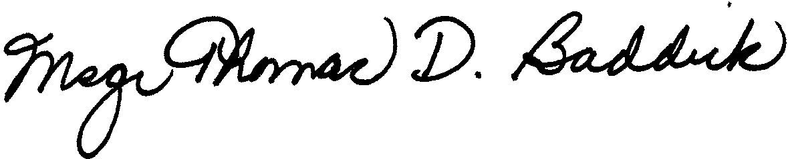

Rev. Msgr. Thomas D. Baddick, Pastor

