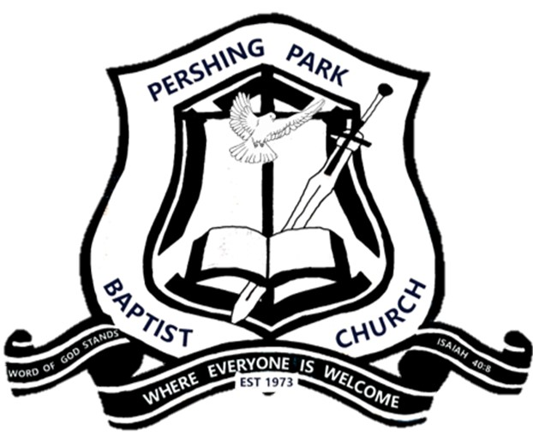
Pershing Park Baptist Church Communications Request Form
• Requests must be submitted by Wednesday at 12:00 noon for inclusion in the following Sunday's announcements.
• Please submit all flyers, logos, and graphics with this form.
• The Church Office reserves the right to edit announcements for clarity, length, and consistency.

REQUEST TYPE
☐ New Announcement ☐ Update Existing Announcement
☐ Sunday Announcement Slides ☐ Church Website ☐ Facebook ☐ Email Blast

REQUEST INFORMATION

Requested By Name and Ministry
__________________________________________________________________________________________

Phone Number or Email Address
__________________________________________________________________________________________

ANNOUNCEMENT DETAILS

Title of Announcement
_________________________________________________________________________________________

Announcement Description (Exactly as you would like presented or provide flyer)
_________________________________________________________________________________________
_________________________________________________________________________________________
_________________________________________________________________________________________

EVENT INFORMATION

Event Date, Time and Location
_________________________________________________________________________________________

TARGET AUDIENCE
☐ Entire Church ☐ Men ☐ Women ☐ Youth ☐ Parents ☐ Ministry Members

PHOTOS OR FLYERS
Will artwork be provided? ☐ Yes ☐ No
If yes, attach:
☐ Flyer ☐ Logo ☐ Picture ☐ QR Code

OFFICE USE ONLY
Date Received: ______________________
Approved: ☐ Yes ☐ No
Announcement Scheduled: ☐ Yes ☐ No
Slides Created: ☐ Yes ☐ No
Video Script Completed: ☐ Yes ☐ No
Website Posted: ☐ Yes ☐ No
Facebook Posted: ☐ Yes ☐ No
Notes:
______________________________________________________________________________________________

