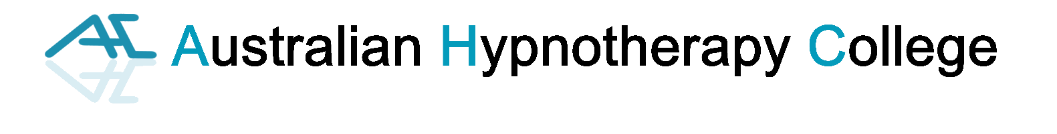
EMDR Student Application Form
***Please type details, save as word document and email back ***
EMDR Course will be held live via zoom Saturday 4th and Sunday 5th July, 9am to 4pm and
Monday 6th July, 7.30pm – 9.30pm plus readings and assessments (50 hours of training (10CPD) and 6 hours supervision)
Student Full Name
(as it will be on your Certificate)
Address
(including state, p/code)
Date of Birth |  |  | First Nation Person? Y/N
Email

Phone contact

Any Disability
All attendees must be a trained therapist (Counsellor, Hypnosis, RTT, etc) |  |  |  | Year Obtained
Name of qualification/s

Membership Association

Membership Number/s

Direct deposit payment to be made to: Credit Card Payment details:
Name: AustralianHypnoCollege | Name on card:
BSB: 112 879 | Number:
Account: 495 954 649 | Expiry:
Reference: Your surname and year of birth | CVV: | Amt: $
Credit card payments incur a 1.5% processing fee
Cost of EMDR course - $1,695 (AHC)
(Please print your full name):
(sign or type name for signature)

Signed: Date:

10 CPD points allocated – AHA, CHA, GoAH, HNZ, CPCA, ASCH, ACA, PACFA
Please email completed form to admin@atccourses.com.au

