
The Bible In 365 Days!

In honor of Pope Francis’ declaration that the third Sunday in Ordinary time be called Sunday of Word of God, St. Mary is inviting every parishioner to participate in a systematic Scripture plan to read the entire Bible in one year. The plan provides three Bible excerpts daily that can be read in 15 minutes so that after 365 days, every parishioner will have read the entire Bible!
The Scripture plan we are using was created in 2014 and released on the Held in His Pierced Hands website. Rather than reading the Bible in order, the three daily excerpts are taken from different parts of the Bible. For example, Day 1 invites us to read 1 John 1:1-3:10, Psalm 1, and Matthew 1:1-17. This means we start by reading the first letter of John, Chapter 1, verses 1 through 3:10. Then we read the first Psalm and after that an excerpt from the Gospel of Matthew, chapter 1, verses 1-17.
Each day presents a new set of three readings. Pope Francis wrote that “the relationship between the risen Lord, the community of believers and Sacred Scripture is essential to our identity as Christians.” By giving God fifteen minutes each day to read His Word, we will be living our Christian identity..
Starting January 26, every parishioner is asked to set aside 15 minutes each day to read the three short Biblical excerpts. The full schedule of readings is available on the St. Mary website along with a Bible timeline. The readings for the first thirty days are printed on the back of this sheet. A new Bulletin insert with the next set of readings will be in the Bulletin every month, with the next set coming February 23.
Each day, before you start, say a prayer to quiet and open your heart. One possible prayer is printed below or you can make up your own! Join us as we work our way through Sacred Scripture and open our hearts to God’s holy Word!

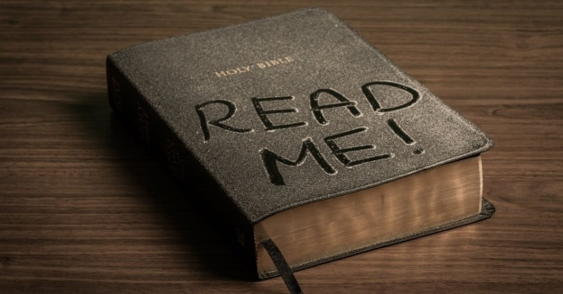
Prayer Before Spiritual Reading
Come Holy Spirit, fill the hearts of your faithful and enkindle in them the fire of your love. Send forth your Spirit, and they shall be created.
R. And You shall renew the face of the earth.
Let us pray.
O God who has taught the hearts of the faithful by the light of the Holy Spirit, grant that by the gift of the same Spirit we may be always truly wise and ever rejoice in his consolation. Through Christ Our Lord. R. Amen.

