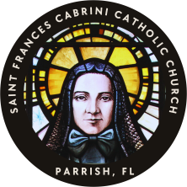
ST. FRANCES CABRINI CATHOLIC CHURCH
12001 69TH Street E., Parrish, FL 34219
CERTIFICATE OF ELIGIBILITY FOR CONFIRMATION SPONSORSHIP
Name of Candidate: _________________________________________
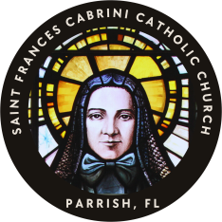
Eligibility Requirements for Confirmation Sponsors. Please read the following carefully: The Church asks certain requirements of those who aspire to be Sponsor for Confirmation. In accordance to Church Law, canons 872, 874, 892, and 893, to be a sponsor for Confirmation, the person must:
- Be a person suitable for this role, selected by the candidate or family and having the intention of fulfilling the responsibility.
- Be at least 17 years of age, , received the sacraments of Baptism, First Communion and Confirmation in the Roman Catholic faith.
- Be a Catholic who lives his/her faith, with weekly attendance at Mass, reception of the Eucharist and Penance on a regular basis and is a suitable person for this responsibility as a sponsor.
- Not be a parent of the one to be baptized. (May act as proxy for one who cannot attend.)
- Be in conformity with all laws of the Catholic Church concerning marriage.
- Must provide copy of your updated Baptismal Certificate (Parish of Baptism)
- Provide a letter from the pastor of your current parish of attendance stating you are registered (for 6 months) and are in good standing. Complete and return this form. It MUST be signed and dated by the Pastor of the
Sponsor’s current parish where they have attended at least 6 months. The Parish Seal MUST be affixed below.

Sponsor Information

Sponsor’s Name __________________________________________________________________________

Sponsor’s Date of Birth_______________________________/_____________/_______________________

Sponsor’s Address ________________________________________________________________________

City____________________________________________ State__________________ Zip______________

Phone________________________________ Email_____________________________________________

Please read the following carefully, initial next to each box to confirm eligibility requirements, and sign below:
_____ I am a baptized and confirmed Catholic 17 years or older. I believe in Jesus Christ and the Catholic Church. I am striving to live the Gospel message in my daily life by setting a good example to others. Please provide copy of your updated Baptismal Certificate.
_____ I weekly attend Sunday Mass and receive Holy Communion. I regularly approach the Sacrament of Penance (Confession). Please provide proof of your Catholic Church Registration, signed within 6 months.
_____ I understand the responsibility I am undertaking, and I will do all in my power to assist the Catholic development of the person I intend to sponsor by the Catholic example of my own life, by my sincere prayers for him/her, and by fostering his/her continued growth in living and l earning the Catholic Faith.
_____ I am not a parent of the Baptismal Candidate, and I am Single ______ Married ______
_____ If married, I am validly married in the Catholic Church and/or my marriage has been Convalidated (blessed by the Church). Please provide copy of your Catholic Marriage Certificate.
I am registered at the following parish:__________________________________________________________________
Parish Address:_______________________________________ City__________________ State_______ Zip_________
_____________________________________________________________ _________________
Sponsor Signature Date
(Affix Parish Seal)
__________________________________ _______________________________ __________
Printed Name of Priest Priest Signature Date

