

Heroes for Healthcare Application
General Aid Wis-MAC

Name: Date:
(First) (Middle) (Last)
Date of Birth: Male Female Branch: Rank: Current/Past MOS(s): Years in service: Active Reserve National Guard
Currently Enlisted No longer enlisted (include last day of service):
Race: White Black/African American American Indian/Alaska Native
Asian Native Hawaiian/Pacific Islander Prefer Not to Answer
Ethnicity: Hispanic or Latino or Spanish Origin Not Hispanic or Latino or Spanish Origin
Current Address, City, State, zip:

Primary Phone Number: Email:
Contact Preference? Phone Email Both
What year did you graduate high school or obtain your GED?
What type of healthcare career would you want to pursue?

(RN) Registered Nurse | Occupational Therapist | Physician | Dentist/Orthodontist | OR Tech
(PT) Physical Therapist | Nurse Practitioner | Radiologist | Medical Assistant | Other
How did you hear about Heroes for Healthcare?
Are you a Medic, Corpsemen or Medical Technician that has performed patient care in a clinic or field setting within the past 12 months? Yes No
If yes, please explain:

Have you used any special medical machines or equipment? Yes No
If yes, please explain:

Please list jobs you have held prior to the military (Job Title, Company, months/years worked in position, date of last employed day of position)
1.
2.
3.
Do you have any physical limitations that would prevent you from being a caregiver? Yes No
If yes, please explain:
Can you lift, push, pull or move 50 pounds or more throughout the day? Yes No Are you able to continuously walk or stand for 8+ hours? Yes No
Are you currently enrolled in a higher education program? Yes No
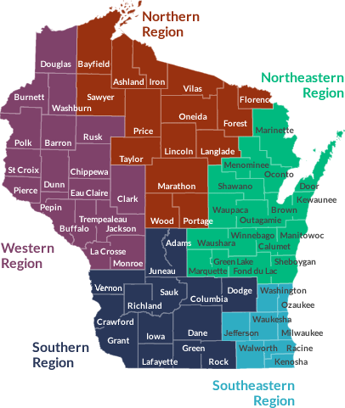
If yes, list title of program and location:

Preferred Wisconsin Geographic:
Northern Region
Northeastern Region
Western Region
Southern Region
Southeastern Region
Preferred County or city/town:

State preference to work in healthcare: Rural Urban
Type of facility: Acute Care Long-term care Community Health Center Tribal Health
What do you need to be successful continuing your education?

Do you need assistance? GI Bill Assistance Financial Support (Uniforms, shoes, stethoscope, laptop)

Required Information and Documents
Number of people in your household: Household yearly income:
List and Attach Certifications:
Please attach: Resume JST Discharge Papers (DD214) Immunization Records Please visit heroesforhealthcare.org for more information. For additional questions, please email
info@heroesforhealthcare.org or call 866-456-3864.

