

113 South 6th Street, Milbank SD 57252

Parent & Student Handbook
2026-2027


Find us online:
Follow us on Facebook: St. Lawrence School - Milbank, SD

www.stlawrenceschoolmilbank.org

Welcome to St. Lawrence Catholic School
Page
Welcome 3
Staff 4
Mission Statement 5
Accreditation 5
Catholic Religious Practices 5
Admissions 6
Tuition 7
Academic Policies 7-9
Attendance Policy 9-10
Student Records 10-11
School Lunch 11
Parties 11
Health Services 11-13

Table of Contents
Page
Transportation 13
LIFE (PTO)/Fundraising 13
Dress Code 14
Conduct at School Functions 14
Discipline & Conduct 14-15
Electronic Devices 15
Anti-Bullying Policy 15-17
Weapons Policy 17-18
Conflict Resolution 18-19
School Advisory Council 19
OST (Out of School Time) 19
Standard Response Protocol 20-21
Prayers to Know 22-25
Parental Covenant 25

______________________________________________________
Dear St. Lawrence School Families,
Welcome back to a new school year! We are thrilled to have you join us as we begin another year of nurturing our students' minds, bodies, and spirits within our vibrant Catholic community. At St. Lawrence Catholic School, we are dedicated to providing a faith-filled environment where students can grow in knowledge, character, and a deep understanding of their Catholic faith.
We believe that parents are the primary educators, and we are honored to partner with you in guiding your children on their educational journey. We encourage you to reach out to us with any questions or concerns, and we look forward to seeing you at our upcoming events throughout the year.
Together, we will foster a love of learning, cultivate a strong moral compass, and empower our students to become compassionate leaders and contributing members of our community and the world.
May God bless you and your families, and may this be a year filled with grace, growth, and joyful discovery.
Sincerely,
Brenda Anderson
Principal

St. Lawrence School Staff
Pastor/Superintendent: Fr. Tom Hartman frthomashartman@sfcatholic.org
Parochial Vicar: Fr. John Helmueller frjohnhelmueller@sfcatholic.org
Principal: Brenda Anderson Brenda.Anderson@k12.sd.us
Administrative Assistants: Deanne Dockter, JoAnn Tillman stlawrence.school@k12.sd.us
Preschool: Brittany Bray Brittany.Bray@k12.sd.us
Preschool Paraprofessional: Matti Scott Mattison.Scott@k12.sd.us
Kindergarten: Ella Kasuske Ella.Kasuske@k12.sd.us
First Grade: Andrea Wiese Andrea.Wiese@k12.sd.us
Second Grade: Sarah Whipkey Sarah.Whipkey@k12.sd.us
Third Grade: Dolly Lenards Dolly.Lenards@k12.sd.us
Fourth Grade: Sara Johnson Sara.J.Johnson@k12.sd.us
Fifth Grade: Candee Cloos Candee.Cloos@k12.sd.us
Sixth Grade: Natasha Karels Natasha.Karels@k12.sd.us
Paul Dhaemers Paul.Dhaemers@k12.sd.us
Music: Kristy Tostenson Kristy.Tostenson@k12.sd.us
Computer/Student Council Advisor: Susie Wendland Susie.Wendland@k12.sd.us
Custodial: Kim Wittrock
Mary Sarah Schacherer
Maintenance: Ken Vanorny
OST Director: Brenda Anderson Brenda.Anderson@k12.sd.us
OST Lead Teacher: Paul Dhaemers Paul.Dhaemers@k12.sd.us
______________________________________________________________________________________

School Office: 605-432-5673 stlawrence.school@k12.sd.us
OST Director, Brenda Anderson: 605-432-5673 Brenda.Anderson@k12.sd.us

Mission Statement
Through the intercession of St. Lawrence, we support our families in their mission as the first educators of the Catholic faith. St. Lawrence Catholic School is committed to develop in our students a love for Christ and all that is true, good, and beautiful in accordance with the Catholic faith. Our mission is to educate our students in the Catholic Tradition to be productive, responsible, and authentic witnesses of Jesus Christ in the world as they work to attain sanctification of souls and the glory of God.
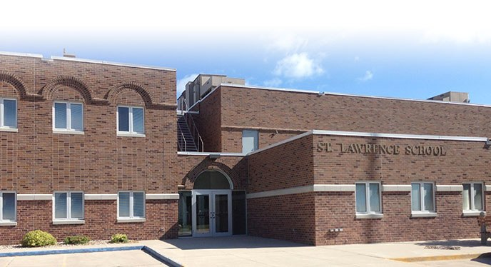

Accreditation
St. Lawrence Catholic School is a fully accredited elementary school. The school goes through a full accreditation review every five years with the South Dakota State Department of Education.

Catholic Religious Practices
Ever mindful of the fact that St. Lawrence is a Catholic School, our students will be surrounded by the beauty of the Church’s tradition, history, teachings, and prayers each day. Our Catholic identity is interwoven throughout the students’ daily lives by placing an emphasis on and participating in communal prayer throughout the day at St. Lawrence School.

  - All students will learn basic prayers and pray them each day.
  - Students will also attend and participate in Mass weekly, typically on Fridays at 8:30 am.
  - Students participate in many other types of prayer and liturgical services throughout the year, such as the Rosary in October and May, Stations of the Cross during Lent, and the Chaplet of Divine Mercy throughout the year.

Admissions Policy
Considering and adhering to the Non-Discrimination Policy Statement as set by the Diocese of Sioux Falls, St. Lawrence School grants all rights, privileges, and programs and activities generally accorded or made available to its students. Every effort is made to provide each qualifying student the opportunity to attend St. Lawrence School regardless of the financial situation of the family.

Reasonable accommodation is made for students with special needs, as the resources and capabilities will reasonably permit. St. Lawrence School reserves the right to decline admission or impose reasonable conditions and requirements for attendance.

- For all admissions, the necessary forms and certificates are required:
- Completed registration packet
- Copy of a certified birth certificate
- Copy of current immunization records or immunization exemption

- Registration Guidelines: Families will be accepted in the following order:
- Parish and Pastorate Families
- Non-parish/pastorate families and children currently registered in our school
- Families from surrounding parishes who do not have children currently enrolled
- Families of other faiths who do not have children currently enrolled

- General Registration
- Preschool and kindergarten student registration at St. Lawrence School opens the first Monday in February. To enter kindergarten, a student must be five (5) years of age by the first of September of the calendar year. Any child who transfers from another state may proceed in a continuous educational program without interruption. Students entering 3-year-old preschool and 4-year-old preschool, must turn 3 or 4 respectively before September 1 of the calendar year. Registration is generally communicated in the local newspaper, school newsletter, and on school social media.
- Reregistration is only required when students move into kindergarten. Reregistration is not required after a student has registered in any grade K-6 as they are considered a continuing student until they graduate from sixth grade.

- Admission of Students of Other Faiths

St. Lawrence School’s primary purpose is the imparting of the Catholic faith to its students as a religious school. We exist for the purpose of formation in the authentic Catholic Faith for the community of students and their families who come to our school. St. Lawrence offers a complete Catholic religious education program and makes every effort to develop the faith-life within its students so that they may be fully alive in Christ.

Students of other faiths may be admitted to St. Lawrence School under the following conditions:

- Adequate facilities and space are available – without denying the admission of eligible Catholic students.
- The parents/guardians agree to permit their child(ren) to attend Catholic religion
classes and religious functions that are offered as part of the school programming.
- The parents/guardians will commit themselves to accept and to promote the
philosophy, goals, objectives, and regulations of St. Lawrence School.
- The parents/guardians agree, in writing, to assume responsibility for financial
obligations.

St. Lawrence School Tuition Rates for 2025-2026
KINDERGARTEN--$1,800 PRESCHOOL:
FIRST GRADE--$1,900 3-YR-OLDS Tues./Thurs. $90.00 per month - $810/year
GRADES 2-6 --$2,000 4-YR-OLDS Mon./Wed./Fri. $115.00 per month - $1,040/year
FAMILY CAP--$4,300 *There is a $40 non-refundable registration fee for all preschoolers
Non-parish families - NO family caps.
Academic Policies
All students of St. Lawrence School are responsible for proper preparation for class, completing all class assignments, participation, and homework. Daily performance of students is assessed by the teacher. Grades on tests and quizzes should be commensurate with the student's ability.

All Students at St. Lawrence School are expected to:
- Give attention and show respect to the teacher(s) at all times.
- Show Christian concern, self-control and respect towards other students by demonstrating a willingness to share and to take turns.
- Actively participate in class by responding orally or in writing.
HOMEWORK
Homework refers to an assignment made by a teacher that will positively reinforce a concept presented in class. Homework includes reading, written, and study assignments that should be done by the student independently if possible. Students in kindergarten – second grade may need assistance. Although St. Lawrence does not discourage parental help on occasion, students’ assignments should be completed without undue parental assistance whenever possible.

Educational research indicates that homework improves student scores, stimulates independent learning, fosters self-discipline, and teaches responsibility. Homework also lets parents know what is being taught; therefore, a reasonable amount of homework is encouraged and expected. The amount of homework varies at different grade levels. The grading term includes how homework assignments are completed: for neatness, completeness of work, accuracy in content, and for students’ original thought in the work. Incomplete homework assignments in grades 3-6 will result in detention after the third occurrence. The objective is not time, but the extension of personal learning acquisition that goes beyond the classroom.
NOTE: Parents/Guardians are asked to check Take Home folders and assignment notebooks on a daily basis for homework.

PROGRESS REPORTS
Progress reports may be issued in support of quarterly reporting for any of the flowing reasons:

- Neglect of written work or personal study
- Student not working up to ability
- Failure to listen and follow directions after repeated warnings
- Lack of personal responsibility in handing in homework on time or failure to return test paper(s) signed by parents/guardians
- Absence work not made up after a reasonable amount of time
- Repeated careless or incomplete homework assignments

Students in fourth, fifth, and sixth grades will receive mid-terms each quarter to communicate grades to parents to give students the opportunity to improve their grades.

TITLE I
Title I is a support program for students who require additional support in math and/or reading. It is available for students K-2. Parents/guardians will be notified when a student is placed in the Title I program and will grant permission for Title I staff to work with your child.

MUSIC
St. Lawrence School provides music education for preschool through sixth grade. Band is also offered for students in fifth and sixth grades who have interest in this activity.

STANDARDIZED TESTING
English language arts and math state testing is administered to students in third through sixth grades in the spring. The results are communicated to parents and are utilized for curriculum planning and school improvement.

All fifth grade students will take the state science test required in the spring. The results are shared with parents and are used to drive science instruction.

PARENT-TEACHER CONFERENCES
Parent-Teacher conferences are held twice during the school year according to the Milbank Public School calendar. Teachers will schedule parent conference times, and will notify school administration of these times. A teacher may wish to schedule an additional special conference if the need arises.

REPORT CARDS
Learning not only cultivates intellectual skills but also personal responsibility for one’s actions and choices. St. Lawrence School will issue a report card quarterly for academic achievement. Grading and learning at St. Lawrence School are to help students strive to reach their fullest potential in academic, spiritual, emotional, social, and moral areas.

Grading is as follows:
Kindergarten: Standards based report cards are used for all students in kindergarten. Students will receive a proficiency number indicating their performance on each skill.

Grades 1-2:
H – Highly Satisfactory Progress H+ = 100%
S – Satisfactory Progress H = 94%-99%
N – Needs Improvement H- = 92%-93%
U – Unsatisfactory Progress S+ = 89%-91%
P – Participates in Class Activity S = 79%-88%
I – Improving S- = 75%-78%
N = 70%-74%
U = 69% and below

Grades 3-6:
A – Excellent 94%-100% H – Highly Satisfactory Progress
B – Above Average 86%-93% S – Satisfactory Progress
C – Average 75%-85% N – Needs Improvement
D – Below Average 70%-74% U – Unsatisfactory Progress
F – Failing 69% and below I – Incomplete
P – Pass

Character Development Grades 1-6:
[X] – Indicates Commendable Performance
[ ] – Indicates Satisfactory Performance
[√] – Indicates Improvement Needed
[S] – Indicates Showing Improvement

PROMOTION AND RETENTION
When evaluating a student's need for retention, the principal, parents, and involved teachers shall make use of all available information including standardized and classroom assessments, as well as teacher observation of student performance.

At the end of the first quarter report card period, the parent/guardian is informed of the student’s academic, social, and emotional progress. At the end of the second quarter, the teacher will contact the parent/guardian of the student who continues to experience difficulty, to discuss the possibility of retention and support services.

By the end of March, the teacher will schedule a follow-up meeting with the parent(s)/guardian(s) presenting the recommendations for the student.

Promotion or retention is at the discretion of the administration in consultation with the teacher and the parent.

GRADUATION
Sixth grade students who have completed the prescribed course of study are eligible for graduation. Procedures for graduation are determined by the school administration and teaching staff of St. Lawrence School.

Attendance Policy
Regular attendance in school is vital to your child’s progress. In-person participation, group discussion, and hands-on activities are crucial to your child and cannot be replicated. Consistent, regular attendance is imperative to successful school performance. Persistent absences will affect students’ academic achievement and evaluations.

Therefore, according to South Dakota law, excessive absences are cause for great concern and require immediate intervention by the school and local law enforcement personnel in cases of potential truancy. When a student has reached ten days of unexcused absences, the parent will be notified through a letter from the school office making them aware of the number of absences. If the student reaches 20 days of unexcused absences, a parent meeting will be scheduled with administrators to discuss continued attendance. If absences continue thereafter, law enforcement will be asked to intervene.

ABSENCES
Excessive absence from school is defined as ten or more days unexcused absence and/or ten or more unexcused late arrivals. At ten days of unexcused absences and/or ten late unexcused arrivals, parents will receive a letter indicating the total days absent and the total number of late arrivals recorded. At 15 days of unexcused absence and/or 15 late unexcused arrivals, parents will receive a second letter indicating the total days absent and the total number of late arrivals recorded.

The school office must be notified by 8:30 a.m. if a student is unable to attend school due to illness or emergency. Please feel free to leave a voice mail if no one is available to answer the phone.

Should it be necessary for a child to be absent for a reason other than illness, arrangements must be made with the teacher or principal in advance. We strongly encourage you to schedule medical and dental appointments during non-school days or after school hours, as this contributes to unnecessary absence from school.

MAKE-UP WORK POLICY
In order to arrange for pick-up of student’s homework assignments due to illness, kindly call the school office. Homework may be picked up by a parent/guardian in the school office. School work missed because of an absence must be made up.

VACATION POLICY
Family vacations are encouraged to be taken over school breaks. In the event that a child is absent while school is in session, all work must be made up. These will be counted as absences on their student record.

ARRIVAL TIMES
Students must not arrive at school earlier than 7:45 a.m. Upon arrival students are to drop off their backpacks, coats, etc. in their respective classrooms and then proceed directly to the school gymnasium until dismissed at 8:10 a.m. Parents are not allowed to leave their child at school alone or before 7:45 a.m. unless special arrangements have been made with the school office. For the safety of all students, adult supervision is required at all times.

TARDINESS
A student who arrives late to school (after 8:10 a.m.) must report to the school office. It may be required that unexplained tardiness will require a written explanation from a parent/guardian explaining the reason for tardiness. Remember that tardiness affects the attendance record and the student’s learning.

DISMISSAL
Students are dismissed from their classrooms at 3:05 p.m. No student may leave the school building without the direction of their teacher or principal. If a student is to be dismissed early, a phone call or a note signed by the parent/guardian must be brought to the school office prior to dismissal. No student will be dismissed until the parent/guardian arrives at the school office.

EARLY DISMISSAL
St. Lawrence School follows the Milbank Public School schedule for early dismissal. A notification will be given prior to the dismissal day via newsletter, email, note, or phone call.

CANCELLATION OF SCHOOL
In case of severe weather or other school emergency, the official announcement for school closing will be sent via the Remind app as a text message or email. St. Lawrence follows the calendar and emergency weather closing coordinated with the Milbank Public Schools. Parents/guardians will also be notified by the Milbank Public School phone call system. You may sign up for this notification at Open House.

Student Records

CONFIDENTIALITY
- All records and information on any student is held in the strictest confidence by all school personnel.
- Teachers shall keep confidential all personal, educational, and psycho-social information regarding the students entrusted to them at St. Lawrence School.
- No files, permanent records, letters should be left open anywhere in the school building.
- Any written messages concerning the student(s) being sent to other professional staff members by a teacher should be stapled or sealed shut.
- Parents/ legal guardians may have access to a student’s records.

LEGAL CUSTODY ISSUES
Accurate custodial information is collected through the application for acceptance process and is on file in the office. St. Lawrence School abides by the provisions of the Buckley Amendment with respect to the rights of non-custodial parents. In the absence of a court order to the contrary, the school will provide the non-custodial parent with access to academic records and other school information regarding his/her child. If there is a court order specifying that no information be given, it is the custodial parent's responsibility to provide the school with a court-certified copy of the court order.

School Lunch Program
The Milbank Public School provides a well-balanced nutritional hot lunch each day.
- Price and Payment: Checks are made out to Milbank Public School. Prices change yearly, so please be aware.
- Free or Reduced Lunches: For those who qualify, an application may be picked up at the school office.
- Special Diets: Students with allergies or special dietary needs must submit an annual medical statement signed by a licensed physician each year.
- Parents/Guardians for Lunch: You are welcome to join the children for lunch. Please notify the office by 8:30 a.m. so we add you to the lunch count. Please arrive by 10:55 to eat with your child. We cannot guarantee a lunch for anyone who has not called ahead or is late. Bringing siblings that are smaller children and not a current student is the parent’s/guardian’s responsibility. Correct payment for meal(s) is required at lunch time.
- Cold Lunches: To help instill healthy choices in all children, lunches from home should contain a balanced meal. Pop and candy are prohibited.
- Lunch Out of the Building: If a parent/guardian wishes for their child to leave school during the lunchtime period, prior arrangements must be made with the school office. We ask that you notify the office by 8:30 a.m. that day. Meals are prohibited from being eaten in the lunchroom if they are brought in from local restaurants.

Parties
Room parties are Fall parties, Christmas, and Valentine's Day. Personal party invitations (such as birthday), birthday gifts, etc., should not be sent to school unless all children in the class are included. Please be conscious of allergies within the classroom before sending treats to share with the class.

Health Services
IMMUNIZATIONS & BIRTH CERTIFICATES
State law requires all students to have a certified copy of their birth certificate and immunization records or immunization exemption on file at school. Students will not be allowed to start school if either the birth certificate or immunization records are not on file.

MEDICATION ADMINISTRATON POLICY
For medical treatment and drug administration, St. Lawrence collects information from parents/guardians for first aid treatment or administration of FDA approved medications for their students. All medicines are kept in a locked cabinet to be administered by qualified personnel. It is the responsibility of parents/guardians to provide the medication and will agree to pick up any and all expired and unused medication within one week of notification by staff.

MEDICAL PERMISSION FORM
When registering a child, parents/guardians are required to have completed and signed the Medical Permission Form. Its completion will direct and assist the school as to the type of medical treatment required, and in case of an emergency, how medical services shall be rendered.

The Medical Permission Form includes pertinent personal information on the student, contact information of parent/guardian, as well as the name of the doctor, phone number, and name of family health insurance carrier. Where this form is missing, and a necessary treatment is required, standard first aid will be administered until parent/guardian is contacted (example – severe injury).

The Medical Permission Form delineates the Over-the-Counter (OTC) medications to be administered for simple conditions such as cuts, bumps, bee stings, sore throat, cough, fever, or headache.
Note: Medications are kept in the locked cabinet located in the nurse’s room in the school office.

MEDICAL ADMINISTRATION
Students who depend on a particular prescription medication in order to stay in school must adhere to the following procedures:

a. The Medication Administration and Authorization Form is completed, signed by parent/guardian, and is on file;

b. The prescribed medication must be in a container provided by the pharmacy with a label that includes the student’s name, age, dosage, doctor’s name, and the phone number;

c. If the medication is an OTC (over the counter) medicine, it must be in a container or zip-lock bag with a label that includes the date, student’s name, parent/guardian name, phone number, and dosage.

IN CASES OF INJURY, ILLNESS & ACCIDENT
A parent/guardian will be notified if a child is seriously injured or becomes ill. A child running a temperature is sick and must be removed from school as soon as possible.

Students who are afflicted with a communicable, contagious, and/or infectious disease, or who are infected with communicable parasites, or who are liable to transmit such a disease or parasite will be excluded from school attendance.

A determination of whether an infected student be excluded from the classroom or school activities shall be made on a case-by-case basis under the direction of the child’s doctor.

In the cases of:

- Strep Throat - may return to school after having been on antibiotic medication for at least 24 hours and having been fever free for 24 hours without fever reducing medications.
- Chicken Pox - may return to school 7 days after onset and sores have crusted over.
- Impetigo - may return to school when treatment has begun and sores are covered.
- Ring Worm - may return to school when treatment has begun.
- Pink Eye - may return to school 24 hours after being treated and eyes are no longer weeping.
- Head Lice – may return to school after being treated.
- Covid 19 – may return with doctor recommendation.
- Hand, Foot and Mouth – may return when blisters have cleared up and having been fever free for 24 hours without fever reducing medications.

Any questions can be brought to the attention of the principal.

PEANUT FREE ENVIRONMENT
In the case of a diagnosed peanut allergy, St. Lawrence School will become a peanut-free environment.

Transportation
BUS
The Milbank School District provides bus transportation for students who reside at a distance greater than one (1) mile from the school. All students on the bus are expected to behave in a safe, obedient, and orderly manner. Failure to comply may result in denied privilege to ride the bus. DeFea Bus Services may be contacted at 605-432-4836 for inquiries.

CAR PICK-UP and DROP-OFF
All cars are to ENTER the parking lot at the southeast entrance on Huron Street in single file order, picking up the student(s), and moving towards the west exit. Please do not get out of your car to visit with others or to come to the school doors to pick up your child while in the pick-up/drop-off line. The school personnel on duty will get your child to you.

L.I.F.E. (Living in Faith & Education) & Fundraising
LIFE is our parent/teacher organization. It is essential for parents to understand that their involvement in fundraising directly contributes to the school's ability to maintain the high educational standards offered at St. Lawrence Catholic School. By fostering a culture of gratitude and acknowledging parents' contributions, we can strengthen the partnership between families and the educational mission of our school. Parents of Catholic school students play a vital role in fundraising efforts, which are crucial for the school's financial stability. Fundraising bridges the gap between tuition fees and the true cost of education. Specific expectations are:
- Financial contributions: Directly donating to the school's fundraising campaigns, such as the St. Lawrence School Gala or the St. Lawrence School Endowment.

- Participation in fundraising events: Attending and supporting events organized by the school or LIFE Group such as the St. Lawrence School Golf Tournament, School Store, the Mystery Dinner Theater, greenery sales, Catholic United Financial raffle, Mardi Gras, and the St. Lawrence School Gala and silent auction.

- Volunteering time and skills: Parents are encouraged to contribute their time to various school activities and fundraising initiatives. This includes assisting in chaperoning field trips, helping with event organization, or offering professional skills that would fall in line with the mission of our school.

- Promoting fundraisers: Spreading awareness about fundraising activities among their networks, encouraging others to participate and donate, and utilizing online platforms like social media to amplify the reach are various ways in which parents can promote fundraising.

At St. Lawrence School we are blessed to offer affordable tuition to our families. In order to continue to offer affordable tuition, we require parents to acknowledge their responsibility in participating in these fundraising efforts. Families are required to help in fulfilling the percentage of their child’s cost of education that falls under the fundraising umbrella. When parents do their part, it relieves the heavy burden that is placed on the parish which is currently budgeted to subsidize 50% of your child’s cost of education.

Dress Code
The Letter to Timothy 2:9 states this requirement nicely:
"Dress modestly and with decency."

REGULAR SCHOOL DAY
Tops:
- Must have a sleeve; wide-strap tank tops may be worn in August, September and May
- Must completely cover torso while hands are raised
- Slogans must have a positive message

Shorts/Pants/Shoes:
- Shorts may only be worn through September 30 and again starting May 1
- Length of shorts and skirts must be as long as fingertips
- No holes or ripped pants
- No writing or designs extending across the seat of the pants
- No flip flops/sandals must have a strap around back of ankle
- Wear sturdy shoes only – no heels

ATTIRE ON MASS DAYS
Students are to dress in the appropriate school attire for Mass: St. Lawrence School shirt WITH LOGO along with khaki pants, shorts (when shorts are permissible), or khaki skirts, jumpers and dresses

VIOLATION OF DRESS CODE
If a student is found to be in violation of the dress code policy, one or all of the following may apply:
- A note will be sent home
- Student may be asked to exchange his/her t-shirt, pants, etc. with one from the office and will wash and return it on the next day
- A parent may be called to provide a change of clothing

Please monitor your child’s clothing prior to leaving the house as this is a difficult way to start the morning.

Conduct at School Functions
Students are expected to act responsibly and to show respect for themselves and others while attending activities at St. Lawrence School and Milbank Public School. Conduct unbecoming of a student will constitute unacceptable behavior and corrective measures will be taken.

Discipline & Conduct Code
Students will be informed of and taught the rules on the opening days of school. At this time, the teacher will establish and explain the consequences for behaviors that adversely affect the smooth running of the classroom, the learning process, or welfare of others. Moreover, St. Lawrence School encourages and supports good choice-making; students learn to live and work with others according to the tenets of the Catholic faith and also the acceptable standards of society so as to be good citizens now and later.

Consequences of the misbehavior, depending upon severity and degree, may include:
- Losing privileges (i.e. free play, group work, etc.)
- Missing recess
- Visiting with the principal
- Child calling parents to inform them of their behavior
- Staying after school

Electronic Devices
Students may not have in their possession personal cell phones or any personal handheld electronic device while school is in session. Students may wear electronic watches; any unauthorized communication using the watch during school hours will lead to confiscation by the principal and will be picked up by the parent.

Infractions of having electronic devices by students while at school will necessitate immediate confiscation of the item to be held in the principal’s office; it will be placed in a locked cabinet. The electronic device may be claimed after school by the parent/guardian. Note: St. Lawrence School is not responsible for broken or damaged electronic devices.

ELECTRONIC MEDIA & INFORMATIONAL TECHNOLOGY POLICY
The use of computers is a privilege. Teachers will be responsible for maintaining control so that computers are used exclusively for acquisition of knowledge, study, and the mastery of critical thinking skills by the students. All students and parents/guardians will sign the Acceptable Internet Use Policy Agreement – sent home with them the first week of school or signed during registration.

INTERNET MONITORING & SUPERVISION
St. Lawrence School teachers and other authorized personnel will monitor the use of informational technology and its resources to help ensure that student-users are secure and in conformity with Diocesan and St. Lawrence School policies.

The school administration reserves the right to examine, use and disclose any data found on school networks, i.e. computers, laptops, and classroom materials, that in anyway endanger the health, safety, discipline, or security of any person employed by St. Lawrence or any student of the school. This information may be part of disciplinary action and may also be used as evidence by law enforcement agencies.

Anti-Bullying Policy
St. Lawrence School has a ‘Zero-tolerance policy’ for bullying and cyber-bullying. These kinds of behaviors always generate a conduct referral.

PROHIBITION OF HARASSMENT, INTIMIDATION, AND BULLYING
St. Lawrence School is committed to maintaining a constructive, safe school climate that is conducive to student learning and fostering an environment in which all students are treated with respect and dignity. Persistent bullying can severely inhibit a student's ability to learn and may have lasting negative effects on a student's life. The bullying of students by students, staff, or third parties is strictly prohibited and will not be tolerated.

Bullying consists of repeated physical, verbal, non-verbal, written, electronic, or any conduct directed toward a student that is so pervasive, severe, and objectively offensive that it:
  - Has the purpose of creating or resulting in an intimidating, hostile, or offensive academic environment; or
  - Has the purpose or effect of substantially or unreasonably interfering with a student's academic performance which deprives the student access to educational opportunities.

Any staff member observing or suspecting bullying toward another individual is required to report the issue to the principal.

This policy is in effect while students are on school property; are in school-operated vehicles; and while students are attending or engaged in school-sponsored activities.
The school will act to investigate all complaints (formal or informal, verbal or written) of bullying. A formal complaint may be submitted to the principal. Anonymous reports may be given to the principal for further investigation, and name of reporter shall remain confidential. Any student engaging in an act of bullying is subject to discipline pursuant to the St. Lawrence School student discipline procedure. This policy may not be interpreted to prohibit civil exchange of opinions or debate protected under the state or federal constitutions if the opinion expressed does not otherwise materially or substantially disrupt the education process or intrude upon the rights of others. Source: SL 2012, ch 96, § 6.

DEFINITION OF BULLYING
Bullying is defined as: A pattern of repeated conduct that causes physical hurt or psychological distress on one or more students that may include threats, intimidation, stalking, physical violence, theft, destruction of property, any threatening use of data or computer software, written or verbal communication, or conduct directed against a student that:
- Places a student in reasonable fear of harm to his or her person or damage to his or her property; and either:
- Substantially interferes with a student’s educational performance: or
- Substantially disrupts the orderly operation of a school.

For the purpose of §§ 13-32-14 to 13-32-19, inclusive, bullying also includes retaliation against a student for asserting or alleging an act of bullying.

Incidents Involving Electronic Devices
Neither the physical location nor the time of day of any incident involving the use of computers or other electronic devices is a defense to any disciplinary action taken by a school district for conduct determined to meet the definition of bullying in § 13-32-15. Source: SL 2012, ch 96, § 5.

ACTION PLAN
- If bullying is alleged or suspected a written record is begun.
- St. Lawrence School Administration will talk to the alleged victim, and the alleged bully (or bullies) separately, and any or all witnesses.
- This “talk” will include in writing the following information: what happened; clarifying the ‘who, where, when and how’ of the incident(s).

St. Lawrence School will report to individual parents/guardians the situation of the students involved without releasing names of other students.

Disciplinary Steps:
- Student(s) will be warned verbally to end the observed bullying behavior; this verbal warning must be recorded in the anti-bullying record which is kept in the locked file in the school office.
- When determined necessary, a separate parent/guardian conference will be called for the individual students involved.
- The purpose of the meeting is:
  - To state the problem and/or behavior to parents;
  - To explain actions taken to ensure safety and security for all students;
  - To problem solve the situation and to create a just and fair solution together for the betterment of students involved;
  - To offer assistance, or counseling agency if required, that will be used for prevention of bullying.
- Regarding the students involved in bullying behaviors: Separate follow-up meetings with those involved may be arranged in order to explain the resolution made and the procedures to be carried out. Forgiveness and Christian tolerance is the goal. This can have a therapeutic effect of reconciliation and restorative justice for everyone involved.
- Some creative solutions to bullying may include:
- Exclusion from break/lunch times for a specific number of days
- Loss of specific privileges as appropriate.
- Escorting their child to and from school.
- Participation in parent/student anti-bullying initiatives where counseling and/or therapeutic behavior planning may be utilized
- Each individual record, of all incidents of bullying and the subsequent investigation, will record the outcome and the course of action taken.

NOTE: Even after parent conferences and resolutions have been made, if the student(s) continue to offend by bullying, the result may be recommendation for a fixed period of suspension from school not to exceed three (3) school days. In cases in which the bullying continues after suspension, the student may be removed from St. Lawrence School.

OTHER SERIOUS VIOLATIONS TO THE CONDUCT AND DISCIPLINE POLICY
There may be other occasions in which violations to the St. Lawrence School Discipline and Conduct Code is seriously violated with situations that go beyond the simple classroom difficulties or infractions. In such cases these are of a serious nature and will result in the potential suspension, dismissal, or removal from school. This is not an all-inclusive list of possible, serious misconduct or discipline violations.
Here are some examples:

- Truancy;
- Violent behavior - fighting and physical contact that causes injury to others or
being involved in a fight;
- Repeated use of profanity and obscene language or gestures;
- Intimidation or harassment of any kind;
- Insubordination;
- Blatant disrespect to teachers, school personnel, volunteers, parents and other
students;
- Forgery, plagiarism, cheating and theft of school/church property or other’s property;
- Destruction or vandalism to property belonging to staff, school, parish, or others;
- Severe and repeated violation of dress code;
- Possession of firearms, knives or any instruments that may present a danger to others;
- Bomb scare or triggering a false alarm in the building/church.
These categories do not cover every possible situation. All serious violations result in immediate contact with parent or guardian.

Anyone acting on behalf of students to dissuade them from properly following the student discipline or education practices of St. Lawrence School (i.e. siblings or other students) may cause an immediate disciplinary action including, but not limited to, immediate suspension. The principal will determine if the infraction is considered severe and warranting further action.

Weapons Policy
St. Lawrence School strictly prohibits any student, parent, guardian, staff, faculty, or visitor from possessing a weapon on school property. School property includes the school parking lot. The superintendent will, in writing, permit possession on an individual basis to the following:

- Any person, other than law enforcement officer or as otherwise approved in writing by the superintendent, who intentionally carries, possesses, stores, keeps, leaves, places, or puts into the possession of another person, any dangerous weapon, firearm, or air gun, (collectively, “weapons”) whether or not the weapon is designed, adapted, used, or intended to be used primarily for imitative or noisemaking purposes, on or in any elementary school premises, vehicle, or building, or on or in any premises, vehicle or building used or leased for elementary school functions (collectively, “school premises”), whether or not any person is endangered by any action under this section, is in violation of this policy. The provisions of this section do not apply to:
  - Any firearm or air gun at a supervised school or session for training in the use of firearms; or ceremonial presence of unloaded weapons at color guard ceremonies.

St. Lawrence School will not tolerate weapons on school premises. Compliance with this policy by all persons is a strict condition for a person’s explicit or implicit invitation to, and lawful presence on, school premises. Violation of this policy is a criminal trespass and is punishable pursuant to South Dakota Codified Law 22-35-5. Without prejudice towards all available criminal and civil remedies, violation of this policy in any manner by a student will result in an expulsion recommendation to the superintendent. Without prejudice towards all available criminal and civil remedies, violation of this policy in any manner by a parent, guardian, staff, faculty, or visitor will result in a prohibition from entry onto school premises.

This policy defines the term “dangerous weapon” to include: “any firearm, knife or device, instrument, material, or substance, whether animate or inanimate, which is calculated or designed to inflict death or serious bodily harm, or by the manner in which it is used is likely to inflict death or serious bodily injury.”

St. Lawrence School Conflict Resolution Policy
FOR PARENTS & STAFF
Purpose
To resolve concerns fairly, respectfully, and at the lowest level possible—while upholding our values of confidentiality, cooperation, and Christian kindness.

CORE PRINCIPLES
• Start with Dialogue: Address issues directly with the person involved.
• Keep It Local: Prevent issues from spreading and affecting others.
• Act Promptly: Address concerns as soon as possible.
• Protect Privacy: Keep discussions and outcomes confidential.
• Understand the Process: Everyone has the right to raise concerns without fear of retaliation.
• Support Allowed: An advocate may accompany a parent or employee ONLY with
prior written consent from the Pastor.

STEPS FOR RESOLVING CONFLICT
Level 1 – Direct Discussion
Begin by discussing the issue privately with the person involved (e.g., parent-to teacher or employee-to-employee).
Level 2 – Principal Involvement
If the conflict remains unresolved, the concern should be brought to the principal. The principal will review the matter, facilitate further discussion, and guide the parties toward a resolution. If the matter involves the principal, it should be brought to the pastor. If it involves the pastor, the matter should be brought to the St. Lawrence Advisory Council Chairperson or his/her designee.
Level 4 – Pastor or Committee Review
Should the issue persist after principal involvement, either party may submit a written request for review to the pastor.

If the matter involves the pastor, the request for review should be submitted to the Sioux Falls Diocesan Chancellor or his/her designee.

The written request must specify which agreement, contract, policy, rule, practice, or procedure of St. Lawrence School has been violated, misinterpreted, and/or inequitably applied. Specifics about the alleged incident or pattern of conduct must also be included with the written statement.

The Chancellor or his/her designee will investigate the matter, render and communicate a written decision to the aggrieved person. This decision shall be final. Under normal circumstances, this process should be completed within 20 school days.

GUIDELINES FOR ALL PARTICIPANTS
• Maintain Respect: All parties are expected to treat one another with courtesy, patience, and understanding throughout the process.
• Confidentiality: Information shared during conflict resolution must not be disclosed to those not directly involved.
• No Retaliation: Retaliation against anyone raising or addressing a concern is strictly prohibited and may be subject to further action.
• Timeliness: Address all stages promptly to avoid lingering concerns.
• Employment decisions are not subject to conflict resolution policy.

RECORDKEEPING
The school will keep confidential records of concerns raised, steps taken, and outcomes reached. These records are maintained to ensure accountability and to support a fair, transparent process.

By following this policy, St. Lawrence School seeks to ensure all members of our community feel heard, respected, and supported while upholding our shared values.

School Advisory Council
The School Advisory Council is established to assist the school administration in the interest of students, staff, and parents/guardians for the programs and policies of St. Lawrence School. It is an advisory council and holds no legal or binding decision-making power.

OST (Out of School Time)
St. Lawrence School OST is a licensed South Dakota childcare program that offers after-school care for children 5-12 years of age. Hours during the school year are 3:05-5:30 p.m. on scheduled school days and from 7:30-5:30 in the summer. We are closed on non-school days and holidays. Parents are asked to register their child(ren) and pick up the OST Parent Handbook in the school office for further information.

Standard Response Protocol (SRP)

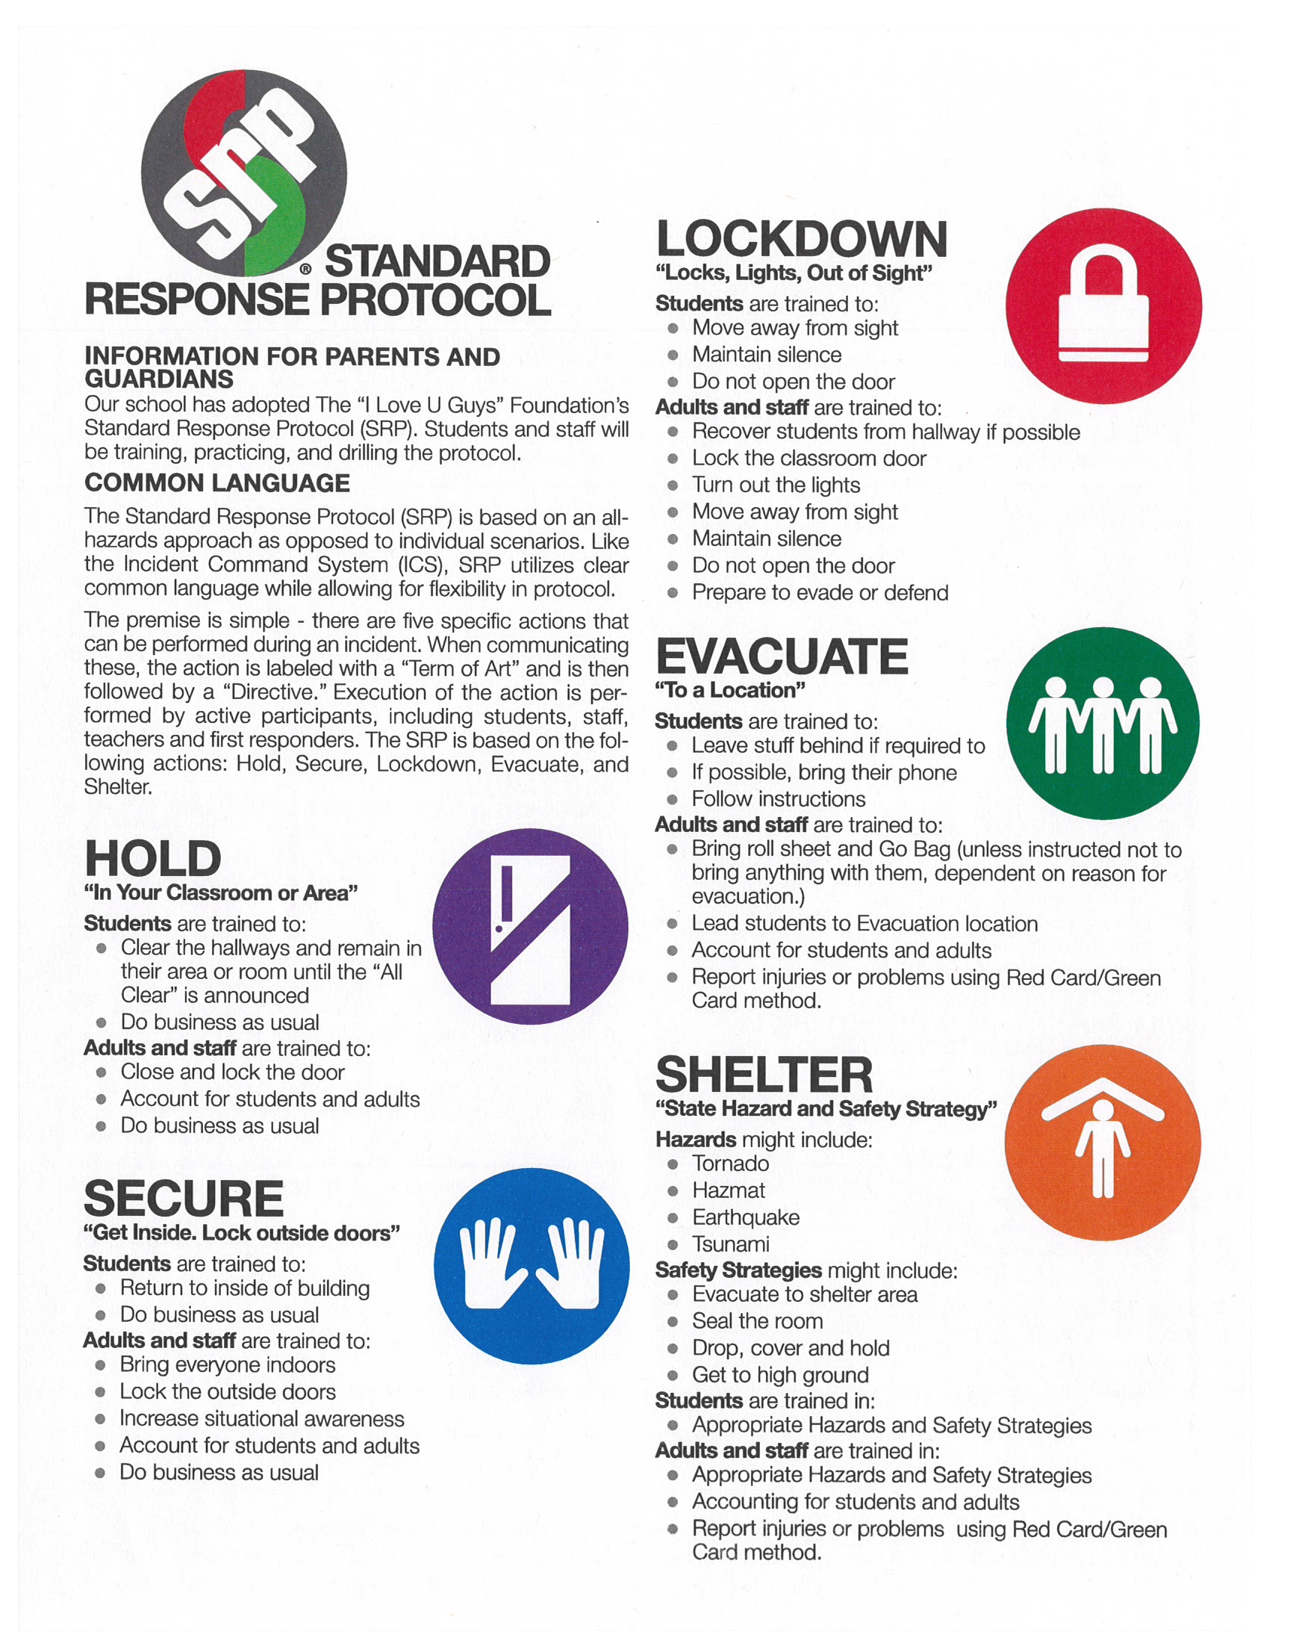

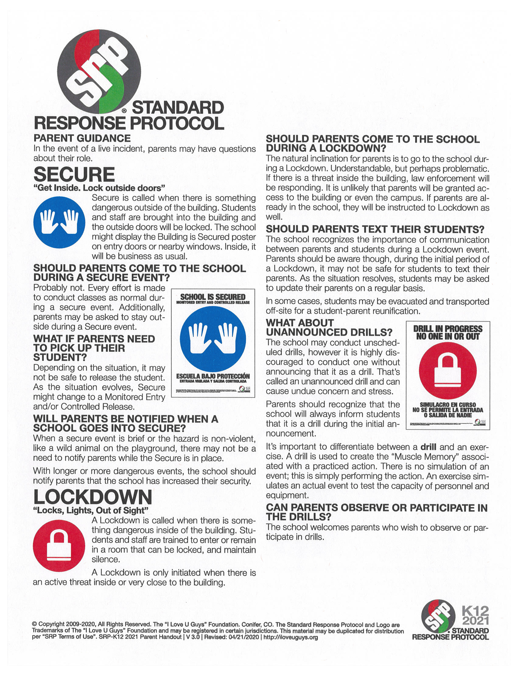
Prayers to Know
Kindergarten: Sign of the Cross, Before and After Meal Prayer, Our Father, Glory Be, Hail Mary, Angel of God

1st Grade: Sign of the Cross, Before and After Meal Prayer, Our Father, Glory Be, Hail Mary, Angel of God

2nd Grade: Sign of the Cross, Before and After Meal Prayer, Our Father, Glory Be, Hail Mary, Angel of God, Act of Contrition

3rd Grade: Sign of the Cross, Before and After Meal Prayer, Our Father, Glory Be, Hail Mary, Angel of God, Act of Contrition, The Apostles Creed

4th Grade: Sign of the Cross, Before and After Meal Prayer, Our Father, Glory Be, Hail Mary, Angel of God, Act of Contrition, The Apostles Creed, Morning Offering, Hail Holy Queen, The Angelus, Acts of Love, Hope, and Faith, Mysteries of the Rosary

5th Grade: Sign of the Cross, Before and After Meal Prayer, Our Father, Glory Be, Hail Mary, Angel of God, Act of Contrition, The Apostles Creed, Nicene Creed, Morning Offering, Mysteries of the Rosary, Hail Holy Queen, The Angelus, Acts of Love, Hope, and Faith, The Memorare, Come Holy Spirit

6th Grade: Sign of the Cross, Before and After Meal Prayer, Our Father, Glory Be, Hail Mary, Angel of God, Act of Contrition, The Apostles Creed, Nicene Creed, Morning Offering, Mysteries of the Rosary, Hail Holy Queen, The Angelus, Acts of Love, Hope, and Faith, The Memorare, Come Holy Spirit

Sign of the Cross  In the name of the Father, and of the Son, and of the Holy Spirit.  Amen. | Before Meal Prayer  Bless us, Oh Lord,  and these thy gifts,  which we are about to receive,  from thy bounty,  through Christ, Our Lord.  Amen. | After Meal Prayer  We give you thanks, almighty God, for all thy benefits which we have received from thy bounty. Through Christ our Lord.  Amen. | Angel of God  Angel of God, my guardian dear, to who God’s love commits me here. Ever this day be at my side, to light, to guard, to rule and guide.  Amen.
Glory Be  Glory be to the Father  and to the Son  and to the Holy Spirit,  as it was in the beginning  is now, and ever shall be  world without end.  Amen. | Our Father  Our Father, who art in Heaven, hallowed be Thy Name. Thy kingdom come, thy will be done on Earth as it is in Heaven. Give us this day our daily bread and forgive us our trespasses as we forgive those who trespass against us and lead us not into temptation but deliver us from evil.  Amen. | Hail Mary  Hail Mary, full of grace, the Lord is with thee. Blessed are you among women and Blessed the fruit of your womb, Jesus.  Holy Mary, Mother of God, Pray for us sinners now and at the hour of death.  Amen. | Morning Offering  O Jesus, through the Immaculate Heart of Mary, I offer you my prayers, works, joys, and sufferings of this day in union with the Holy Sacrifice of the Mass throughout the world.  I offer them for all the intentions of Your Sacred Heart:  The salvation of souls, reparation for sin, and the reunion of all Christians. I offer them for the intentions of our bishops and of all Apostles of Prayer, and in particular for those recommended by our Holy Father this month.  Amen.
Act of Contrition  O my God, I am heartily sorry for having offended You, and I detest all my sins, because I dread the loss of Heaven and the pains of hell. But most of all because I have offended You, my God, who are all good and deserving of all my love. I firmly resolve with the help of Your grace, to confess my sins, to do penance and to amend my life.  Amen. | Acts of Faith  O my God, I firmly believe that You are one God, in three Divine Persons, the Father, the Son and the Holy Spirit; I believe that Your Divine Son became man and died for our sins and that He will come to judge the living and the dead. I believe these and all the truths which the holy Catholic Church teaches, because You have revealed them, Who can neither deceive nor be deceived.  Amen. | Acts of Hope  O My God, relying on Your infinite goodness and promises, I hope to obtain pardon of my sins, the help of You r grace and life everlasting, through the merits of Jesus Christ, my Lord and Redeemer.  Amen. | Acts of Love  O my God, I love You above all things with my whole heart and soul, because You are all good and worthy of all love. I love my neighbor as myself for love of You. I forgive all who have injured me, and I ask pardon for all whom I have injured.  Amen.
The Apostles Creed  I believe in God,  the Father almighty,  Creator of heaven and earth,  and in Jesus Christ, his only Son, our Lord,  who was conceived by the Holy Spirit,  born of the Virgin Mary,  suffered under Pontius Pilate,  was crucified, died and was buried;  he descended into hell;  on the third day he rose again from the dead;  he ascended into heaven,  and is seated at the right hand of God the Father almighty;  from there he will come to judge the living and the dead.  I believe in the Holy Spirit,  the holy catholic Church,  the communion of saints,  the forgiveness of sins,  the resurrection of the body,  and life everlasting.  Amen. | Nicene Creed  I believe in one God,  the Father almighty,  maker of heaven and earth,  of all things visible and invisible.  I believe in one Lord Jesus Christ,  the Only Begotten Son of God,  born of the Father before all ages.  God from God, Light from Light,  true God from true God,  begotten, not made, consubstantial with the Father;  through him all things were made.  For us men and for our salvation  he came down from heaven,  and by the Holy Spirit was incarnate of the Virgin Mary,  and became man.  For our sake he was crucified under Pontius Pilate,  he suffered death and was buried,  and rose again on the third day  in accordance with the Scriptures.  He ascended into heaven  and is seated at the right hand of the Father.  He will come again in glory  to judge the living and the dead  and his kingdom will have no end.  I believe in the Holy Spirit, the Lord, the giver of life,  who proceeds from the Father and the Son,  who with the Father and the Son is adored and glorified,  who has spoken through the prophets.  I believe in one, holy, catholic and apostolic Church.  I confess one Baptism for the forgiveness of sins  and I look forward to the resurrection of the dead  and the life of the world to come. Amen. | Hail Holy Queen  Hail, Holy Queen, Mother of Mercy, hail,  our life, our sweetness and our hope.  To thee do we cry,  poor banished children of Eve.  To thee do we send up our sighs,  mourning and weeping in this valley of tears.  Turn then, most gracious advocate,  thine eyes of mercy toward us,  and after this our exile  show unto us the blessed fruit of thy womb, Jesus.  O clement, O loving,  O sweet Virgin Mary.  V. Pray for us O Holy Mother of God.  R. That we may be made worthy of the promises of Christ. | The Angelus  V. The Angel of the Lord declared unto Mary.  R. And she conceived of the Holy Spirit.  Hail, Mary, full of grace,  the Lord is with thee.  Blessed art thou among women  and blessed is the fruit of thy womb, Jesus.  Holy Mary, Mother of God,  pray for us sinners,  now and at the hour of our death.  Amen.  V. Behold the handmaid of the Lord.  R. Be it done unto me according to thy word.  Hail Mary...  V. And the Word was made flesh.  R. And dwelt among us.  Hail Mary...  Let us pray:  Pour forth, we beseech thee, O Lord, thy grace into our hearts; that we, to whom the Incarnation of Christ, thy Son, was made known by the message of an angel, may by his Passion and Cross be brought to the glory of his Resurrection. Through the same Christ, our Lord.  Amen.
Come Holy Spirit  Come Holy Spirit,  fill the hearts of your faithful and kindle in them the fire of your love.  Send forth your Spirit and they shall be created.  And You shall renew the face of the earth.  O, God, who by the light of the Holy Spirit,  did instruct the hearts of the faithful,  grant that by the same Holy Spirit we may be truly wise and ever enjoy His consolations,  Through Christ Our Lord, Amen. | The Memorare  Remember, O most gracious Virgin Mary, that never was it known that anyone who fled to thy protection, implored thy help, or sought thy intercession, was left unaided.  Inspired by this confidence I fly unto thee, O Virgin of virgins, my Mother.  To thee do I come, before thee I stand, sinful and sorrowful.  O Mother of the Word Incarnate, despise not my petitions, but in thy mercy hear and answer me.  Amen. | Fatima Prayer  Oh my Jesus, forgive us our sins, save us from the fires of hell, and lead all souls to heaven. Especially those who have most need of thy mercy.

Diocese of Sioux Falls Parental Covenant

Since as parents we are the primary educators of our children, we will participate in the education of our children by:

…recognizing that all that we are and have is a gift from God
…attending Mass on weekends and holy days with our children (Catholics)
…participating in the sacramental life of the church regularly (Catholics)
…promoting positive attitudes toward school at home and in the community
…bringing concerns about our child directly to the teacher
…showing respect for the teacher as a professional person working for the well-being of our child
…following the policies of the school
…promoting family prayer and faith traditions at home
…encouraging my child in his/her call to holiness and vocational discernment
…volunteering and giving service to the school and parish (place of worship)
…witnessing Gospel values in our everyday life
…practicing the virtues of our Catholic faith in our everyday life
…agreeing to not knowingly supply or assist any student in obtaining or using drugs or alcohol

As a Diocese of Sioux Falls Catholic School, parents can expect:

…an authentic Catholic education
…a positive, professional relationship with students, characterized by mutual respect, warmth, and good will
…regular parent communication regarding their child’s progress
…standards of student behavior enforced in a fair, firm, compassionate, and educationally sound manner

