Processing Electronic Correspondance - Healthmail

Purpose
To provide a clear and consistent approach for the processing of emails received on Healthmail

Scope
Due to the nature of the confidential information contained in correspondence received into and sent out of the practice, all correspondence is to be processed confidentially and in an efficient timely manner.

Healthmail is a secure email service used in Ireland by healthcare providers (like GPs and pharmacists) to share patient-identifiable clinical information securely. It allows for the safe exchange of sensitive health data between clinicians in primary and secondary care, ensuring compliance with data protection regulations

Responsibilities
- The reception team is responsible for reviewing all Healthmail accounts linked to the practice, and scanning/attaching any documentation received to the correct patient chart and tagging the relevant GP for their review.

Protocol Steps
- Every morning log into the practice Healthmail – castlebarfamilypractice.gp@healthmail.ie - and the Healthmail accounts of the HCPs linked to the practice. See appendix A for logging onto Healthmail
- Open up each individual email and print email contents and attachments. To save paper please print as a PDF and save to you Desktop.
- Scan or attach the email/document to the correct patient chart.
- Tag the newly scanned/attached document for relevant HCP to review.

Scanning to Socrates
- My Control Panel, Document Management System
- Batch Scan

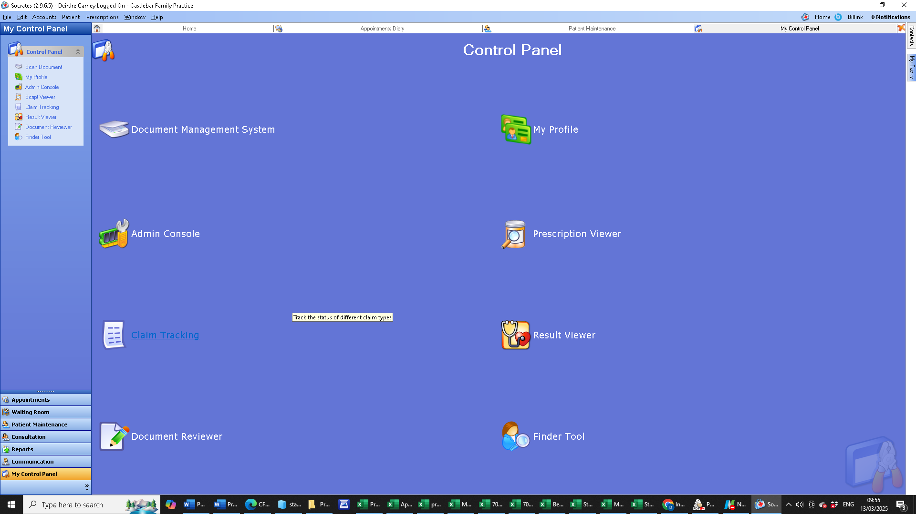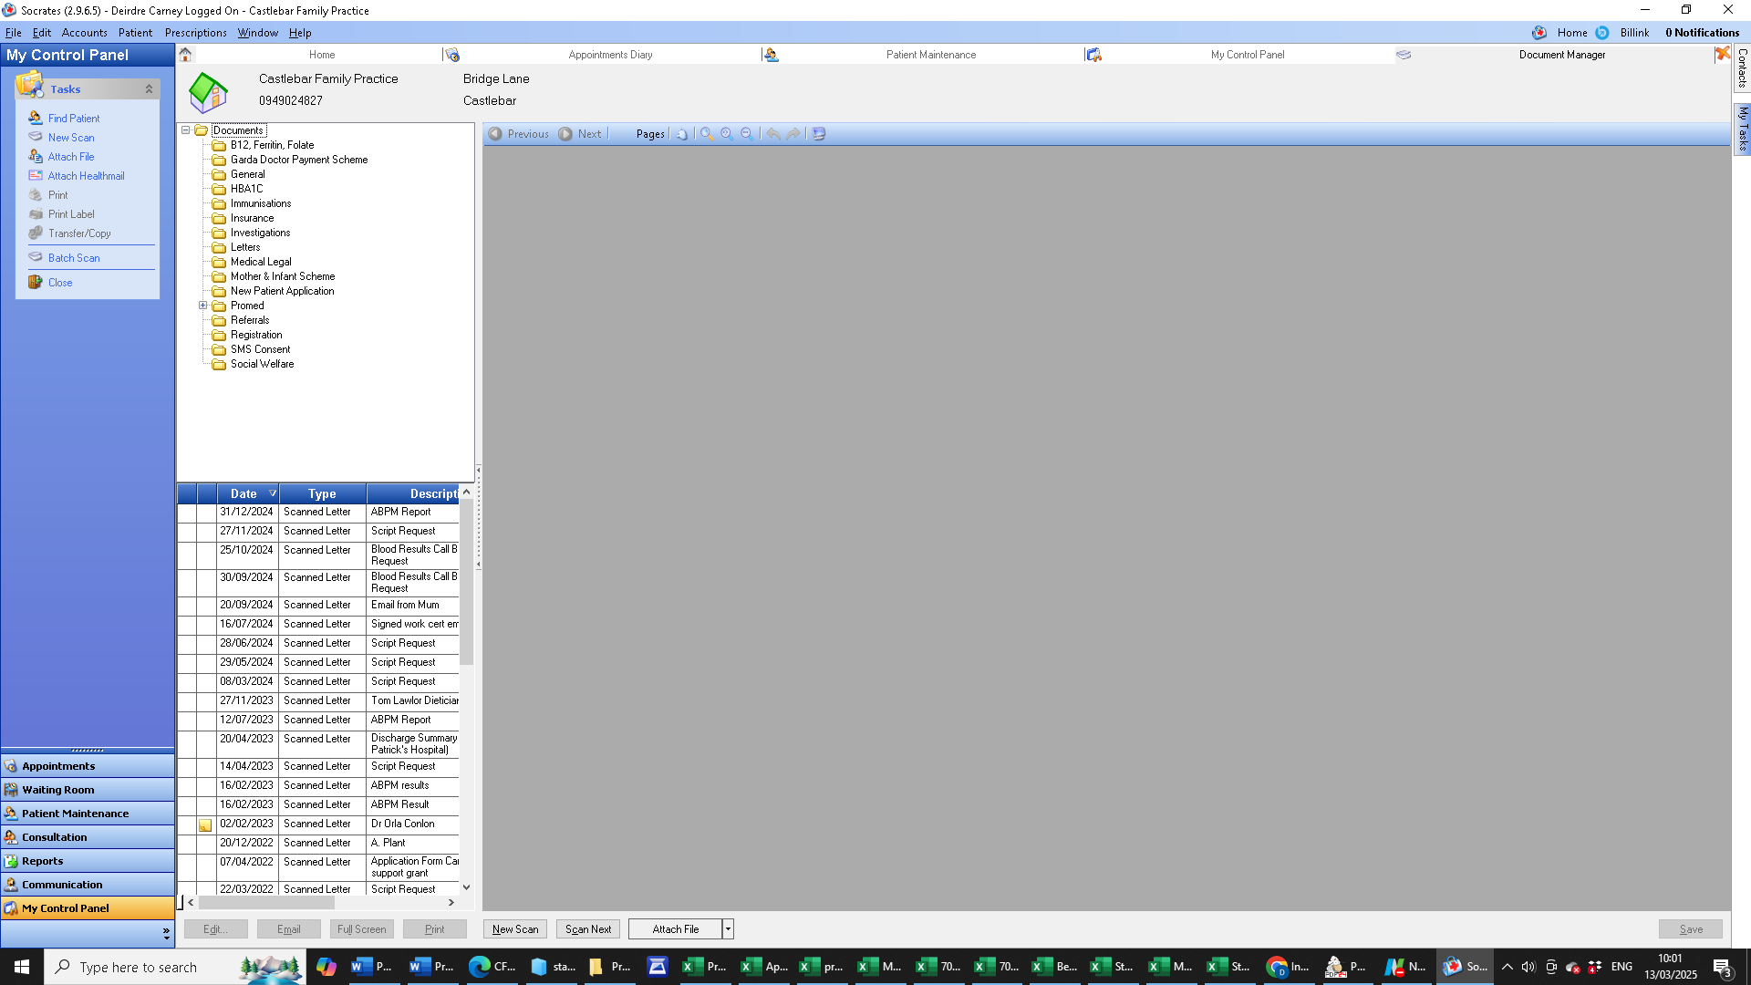

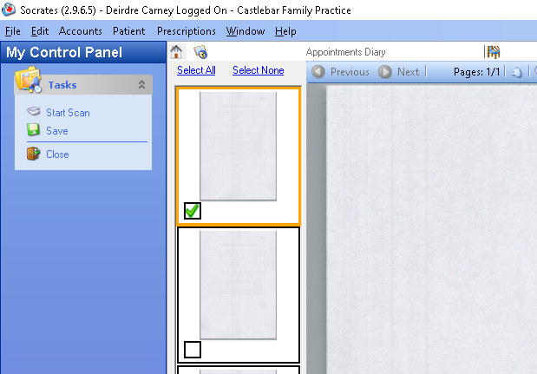
- Tick the scanned document
- Selected the Save button on the bottom right of the screen
- Select the patient the letter refers to
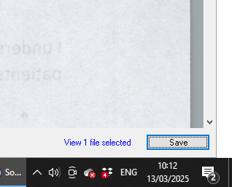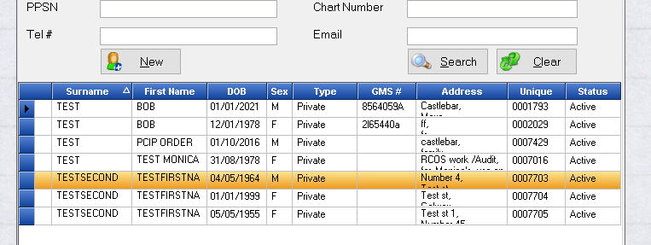
- Save the letter with the name of the Consultant and the discipline they are working in.
- Put all scanned documents in the Confidential Shredding Bin.

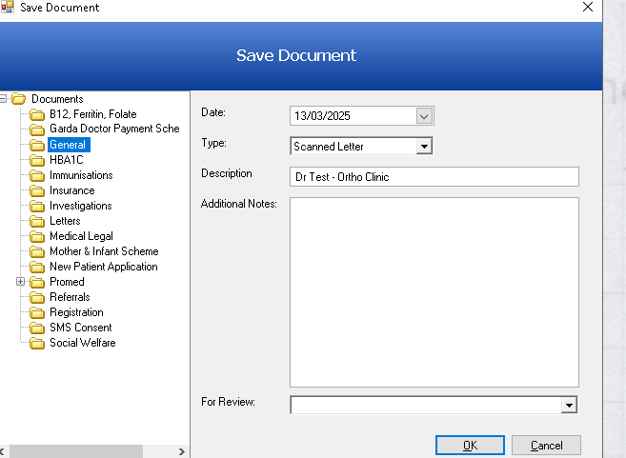

Attaching a File to Patient Chart in Socrates
- Download the attachment received on the Healthmail and save as a PDF to your desktop.
- My Control Panel, Document Management System, Attach File
- Your Desktop file explorer will open, double clink in the file you saved
- Name the letter of the clinic and flag to the relevant GP

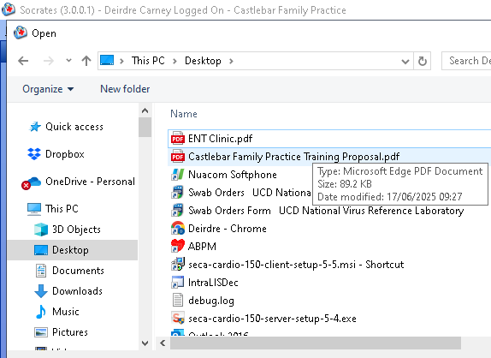
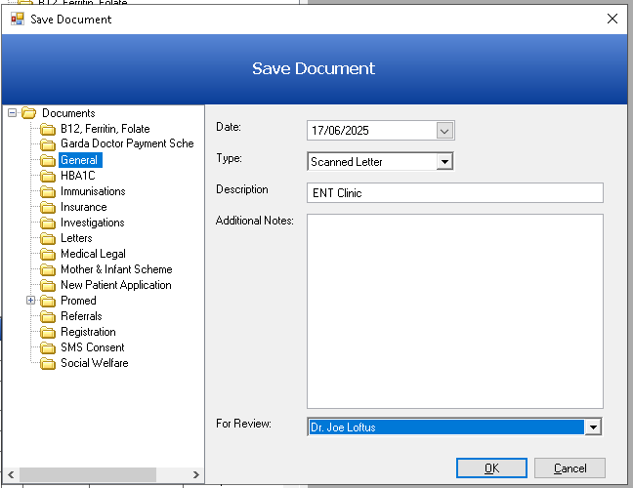

- Delete the file that was saved to your Desktop and Delete the email from Healthmail.

Review Schedule
This protocol will be reviewed biennially or in response to significate changes in the procedure or clinical guidelines.

Approved by:

_______________________ _____________________
Dr Joe Loftus Dr Tommy Carney
Date:13th March 2025 Date: 31th March 2025

Next Review Date: March 2027

