Posting of Cervical Check Samples

Purpose
To provide a clear and consistent approach for posting of Cervical Check Samples

Scope
All Cervical Check samples must be posted within the time frame outlined by Cervical Check, detailed below, to allow for samples to be processed on time and to prevent any repeat sample collection for retesting due to the age of the sample.

Responsibilities
- The reception team is responsible for posting the Cervical Samples.
- The sample taker (practice nurse) will leave all samples to be posted in the required Cervical Check transport box along with all relevant paperwork.
- The sample taker (practice nurse) will have logged all samples to be posted in the Cervical Check Log Book.
- The reception team will cross check paperwork against the log book and will update log book with date samples were posted and initial.

Protocol Steps

Cross Checking Samples against Log Book

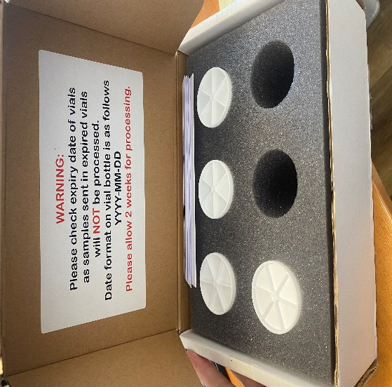
- Open transport box and count the number of sample vials to be posted.
- Take out paper work in the transport box and cross check these documents against what has been input into the log book. Ensure the CSPID has been included on the document.
- If all details agree, return the paperwork to the transport box and seal it with Sellotape.
- Update log book with number of vials posted, date of posting and initial of person who posted.
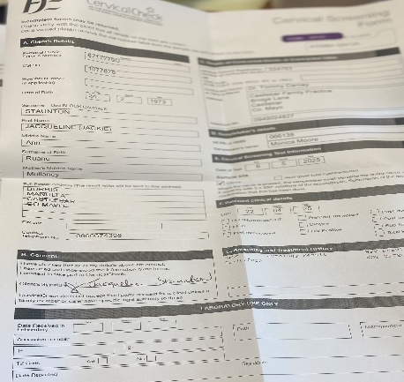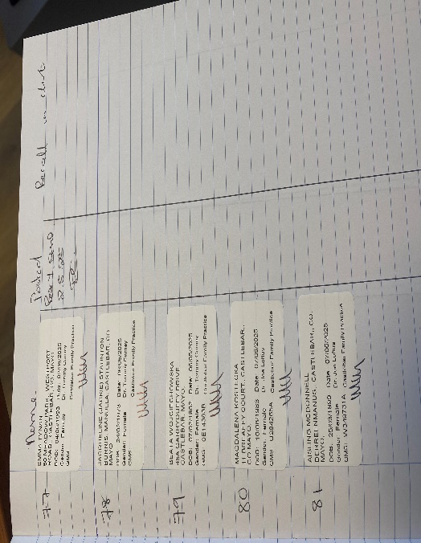

Cross Checking Log Book against Socrates
- Open up Claim Tracking in Socrates and go to Forms and sort by Form Type:
My Control Panel/Claim Tracking/Forms
- The patient names listed on Socrates should corrolate to the list of patient names in the log book, which in turn should agree with the paperwork and number of sample vials in the trasport box that are due to be posted.
- Highlight all names that have been checked against the log book and tick the Sent box to the bottom left of the screen and update with the date of posting which should be the date reflected in the log book.
- If Socrates is showing a form has been printed for a patient, but there is no corresponding paper work, no entry in the log book or no vial in the box, open up the patient chart and read the Cosultation note. Often times the sample will not have been take for clinical reasons decided by the nurse. In those instances, please tick the recject button to the bottom left and update with the date of the original appointment.

If there are any discrepancies at any stage in the process, please highlight these to the practice manager or the practice nurse.

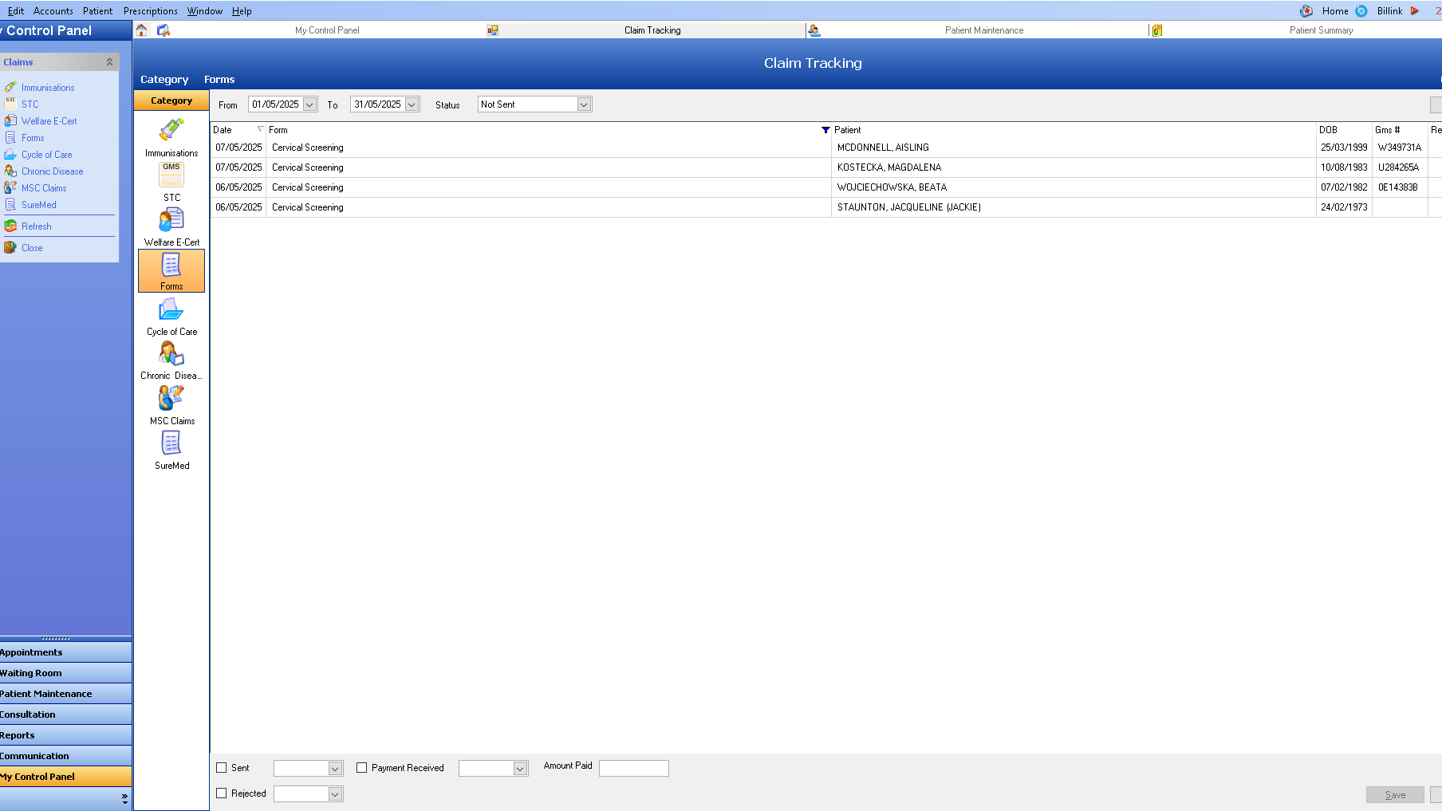

Review Schedule
This protocol will be reviewed annually or in response to significant changes in
procedures or clinical guidelines.

Approved by:
_______________________ _____________________
Dr Joe Loftus Dr Tommy Carney
Date:08th May 2025 Date: 08th May 2025

Next Review Date: March 2027

