Patient Check-In

Purpose
To provide a clear and consistent approach to managing the appointment diary for all clinicians of the practice

Scope
To ensure all reception team members have a standard approach to the checking-in of patients to the waiting room.

Responsibilities
The reception team is responsible for the management of the appointment diary on a day-to-day basis. The checking-in of patients to the waiting room is part of that.
The check in window is the main priority of the team member who is assigned to the window that day. Although, you may also be processing paperwork while at the window, when a patient approaches, all other activities should be stopped and your attention should turn the patient in front of you.

Protocol Steps
Open the Waiting Room on Socrates and go to the Patients Expected Queue.
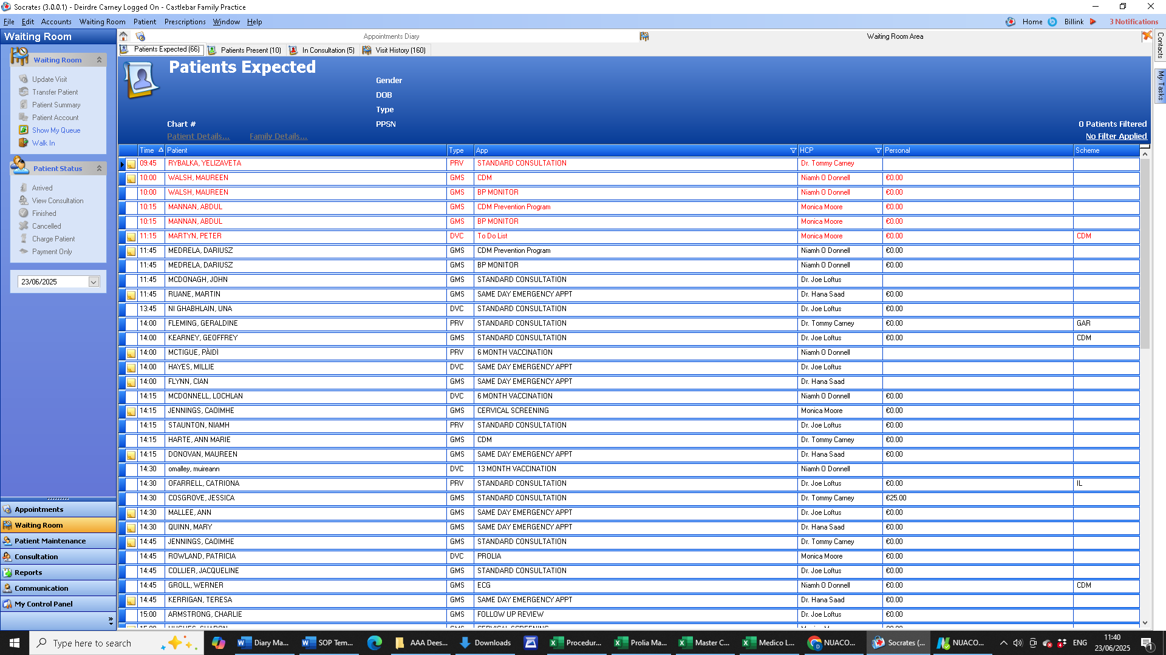
Greet the patient with a smile and “Hello/Hi There/ How are you?”
As the patient’s name, if they have not volunteered it, search the list of expected patients. Once you have found the patient’s name double click on it, and ask the patient to take a seat.
If the patient is over 30 mins late for their appointment, have not contacted the practice to advise they are running late, and the GP is already running behind, reschedule the patient for the next available time slot.
If the patient has arrived too early for their appointment, asked them to retune closer to the time, there are a limited number of seats available in the waiting room.

Review Schedule
This protocol will be reviewed biennially or in response to significate changes in the procedure or clinical guidelines.

Next Review Date: March 2027

