24 Hour ABPM

Purpose
To provide a clear and consistent approach to downloading the information from the 24 Hours ABPM’s returned by patients

Scope
This procedure details the downloading the report from ABPM monitors that are retuned by patients.
Monitors are fitted by the practice nurse or practice assistant on Day 1. The patient returns the monitor on the morning or Day 2. Reports are downloaded from the monitor and uploaded to the patient chart for the GP to review.

Responsibilities
- The practice nurse or practice assistant are responsible for the fitting of the ABPM to the patient. They ensure the monitors are fitted correct and working.
- Reception are responsible for following up on all Day 2 monitors that have not been returned.
- Reception are responsible for downloading the report from the monitor, uploading to the patient chart for the GP to review.

Protocol Steps

Downloading the report from the monitor
- Connect the monitor to your PC via the USB cable.
- Navigate to the ABPM icon on the PC desktop, and double click to open it. 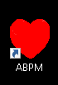
- Double click on the download icon on the top left - indicated below
- Select the Use USB option and say OK.

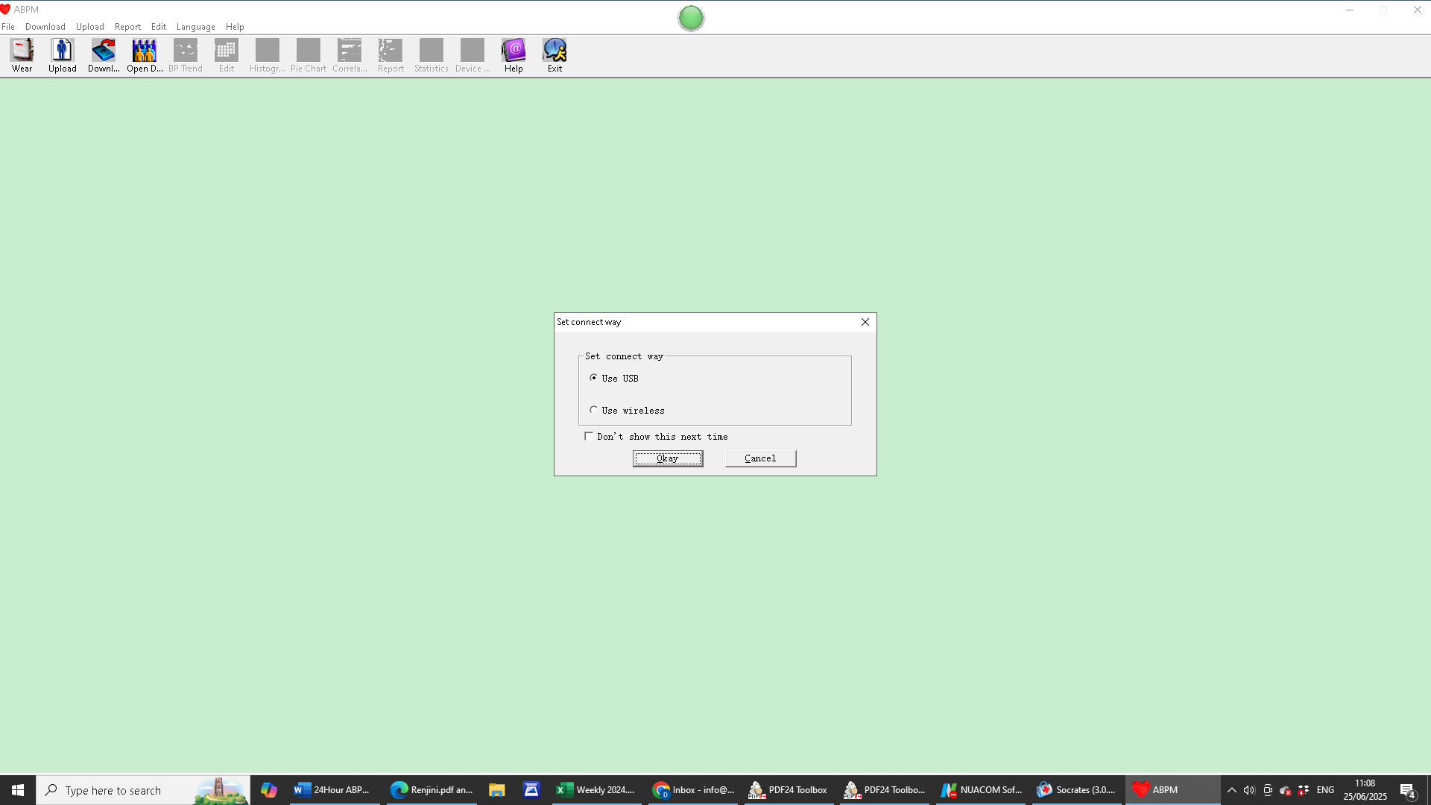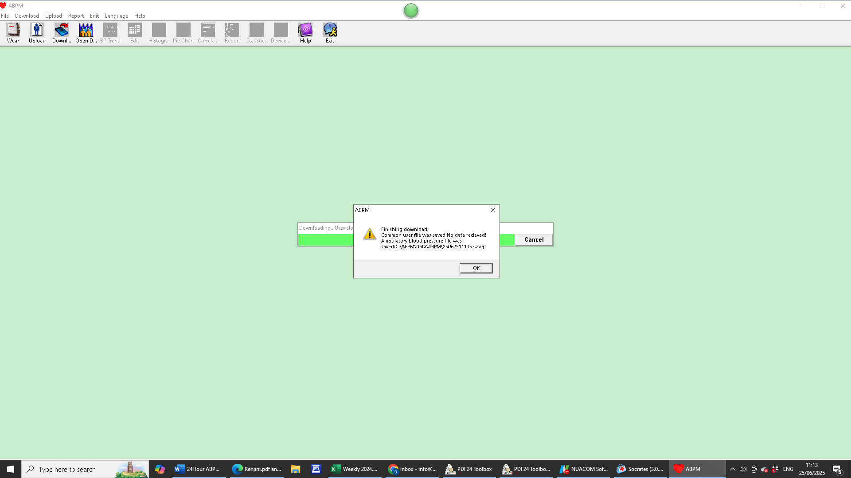

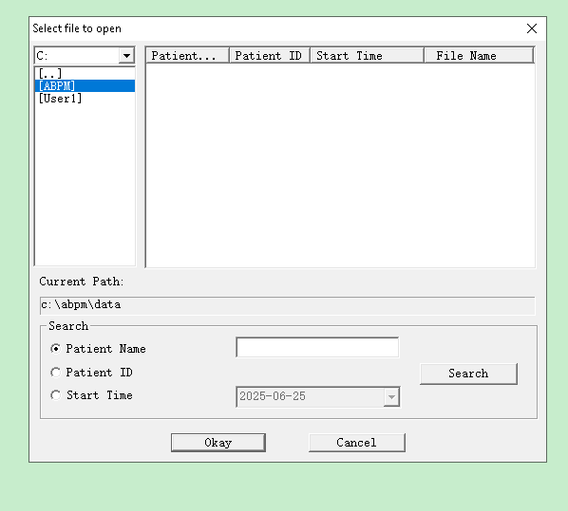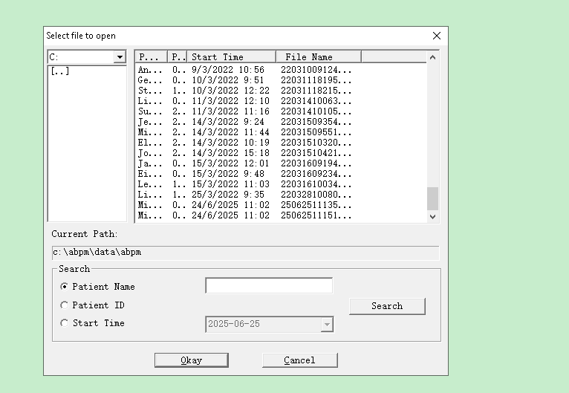

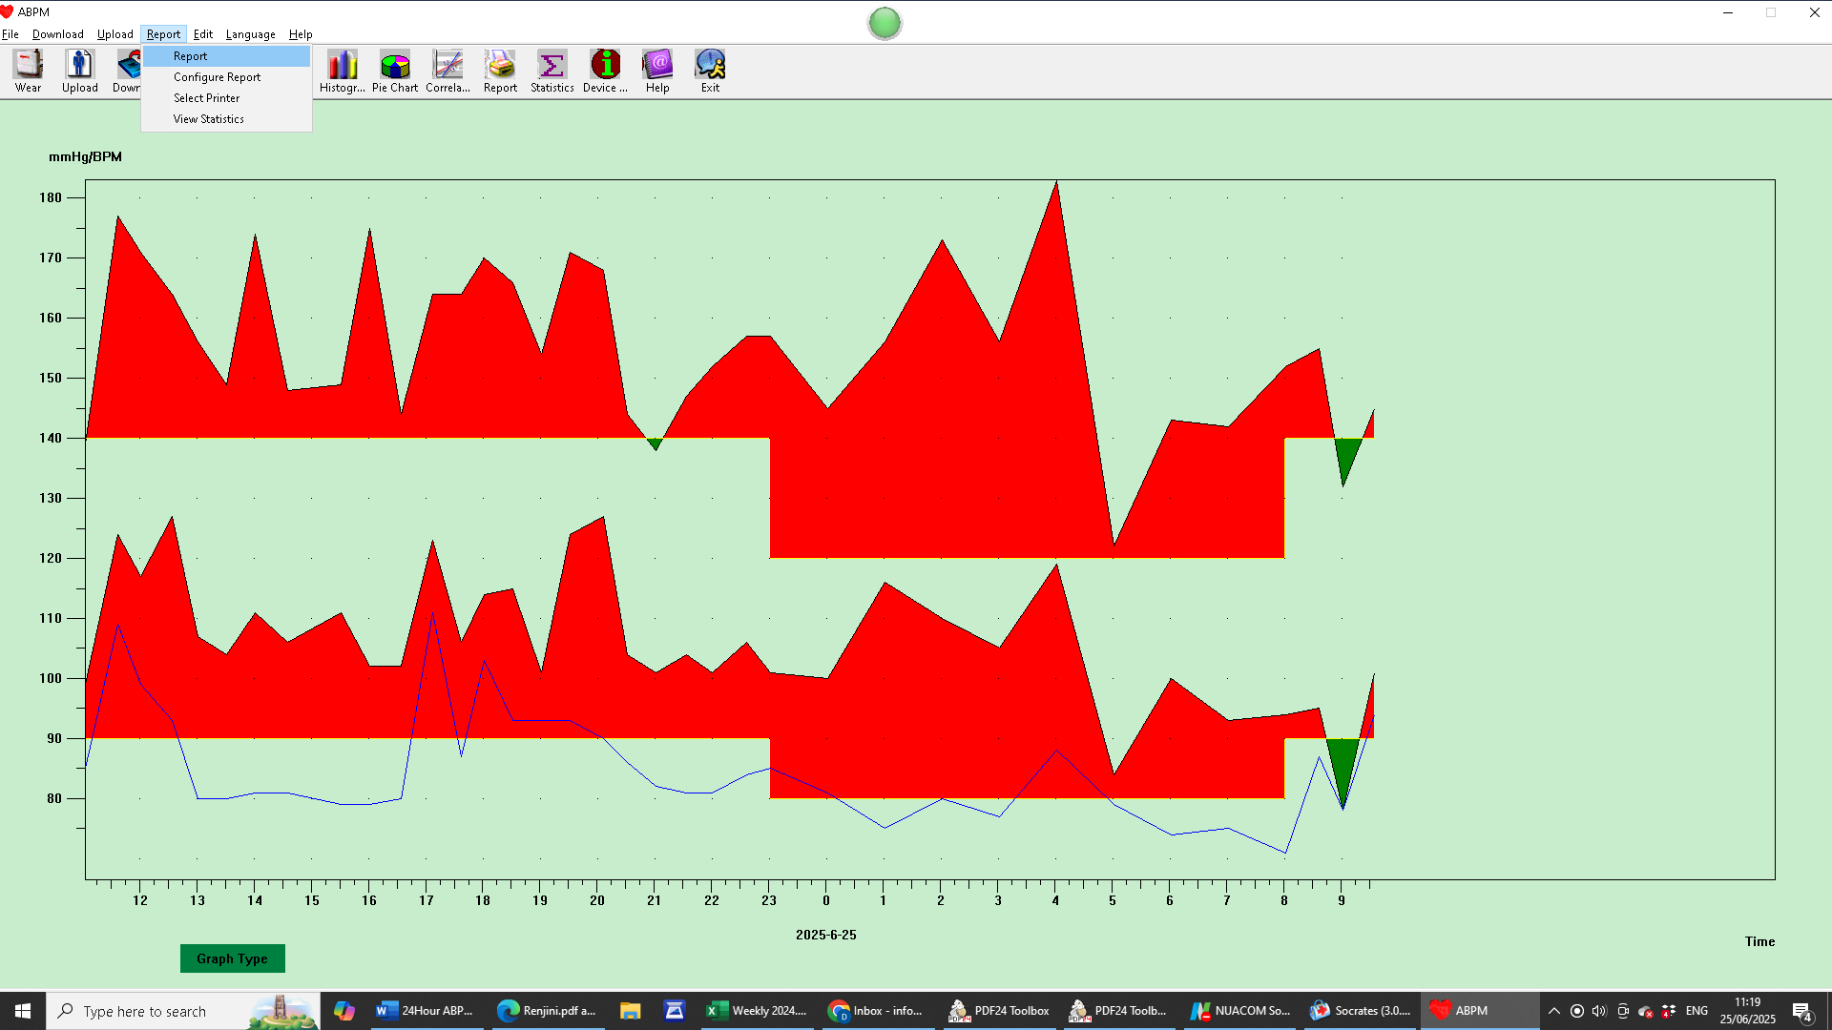
Double on ABPM
The last patient on the list will be the most recent report.
Print report, save to PDF and attach to patient chart.

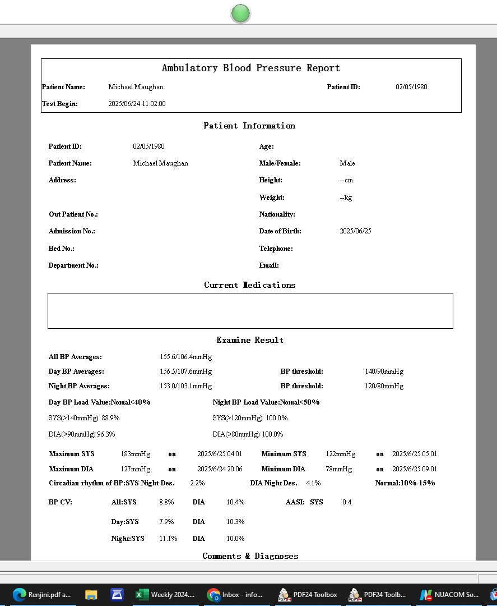

Copy and paste this complete template into an email and send it to
gskvaccines@united-drug.com
- A payment link will be sent back to the originating email address – typically info@castlebarfamilypractice.com
- Make payment by entering in the practice card details.
- Receipt of payment will be sent by email. Print and give to practice manager for end of year accounts.
- Vaccines typically arrive on the next business day if ordered before 3PM.
- Vaccines should not be ordered on Wednesday as Thursday is the practice half day. GSK will not deliver as the cannot guarantee the vaccines will be delivered before the practice closes for the afternoon.

Next Review Date: March 2027

