

Saturday, September 19 All Parish Celebration
4 pm Mass ~ 5 pm Spaghetti Dinner and Event in the Mary Center

All cultures and parishioners are invited to participate in 1 or more ways:

- Traditional Dress: all are invited to wear cultural attire to Mass & Event
- Procession of Nations: 1 person to carry the flag of your country in the opening before Mass. We will provide the flag. Must arrive by 3:40 pm.
- Cultural Displays: Decorate 1 display table in the Mary Center with symbols of your country, Patron Saint & faith, traditional items. See pictures on reverse for ideas.
- International Desserts. Provide 60 or more bite-sized treats from your country – may be made or purchased. Share recipe/ingredient list.
- Silent Auction. Donate a gift basket featuring items from your country. Baskets will be auctioned that evening; proceeds support parish ministry.
- Music! Share 3 pieces of party/dance music from your culture to be included in the evening’s playlist.
- Volunteer! Many hands are needed to set-up, cook, serve, assist with activities, clean-up. Signup at mmotc.org/onefaith

Use page 2 of this packet to sign up for items related to country/cultures.
Questions? Roxanne Tozier, rtozier@mmotc.org, 952-890-0045 ext 247

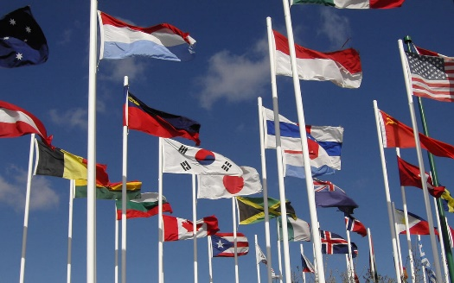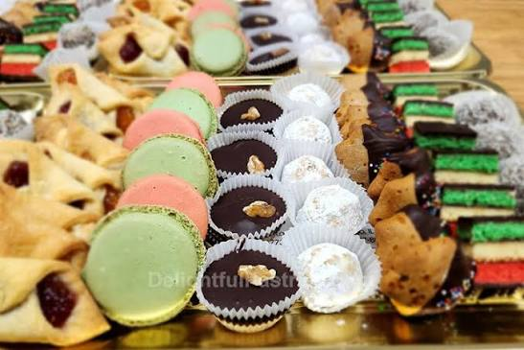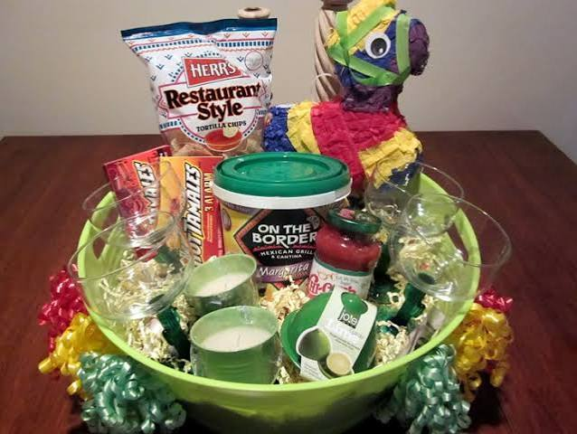
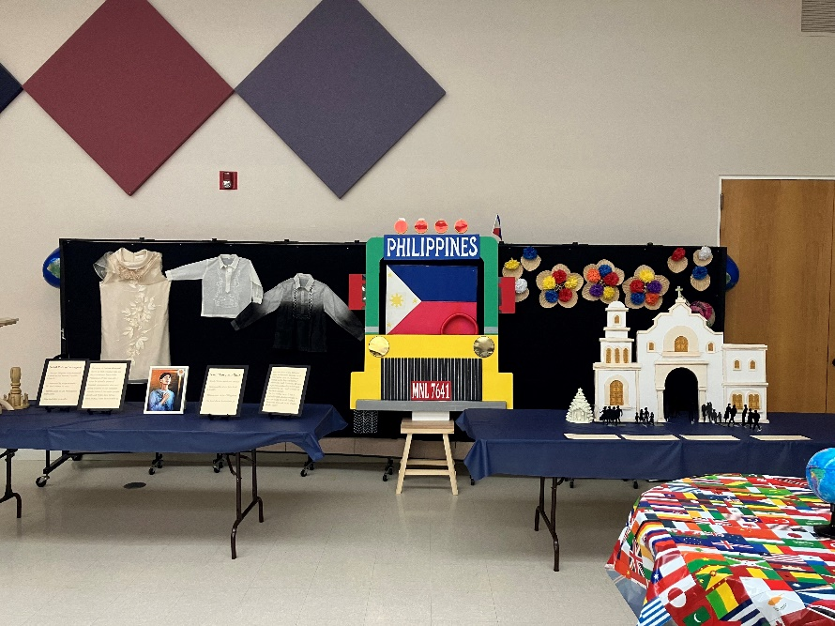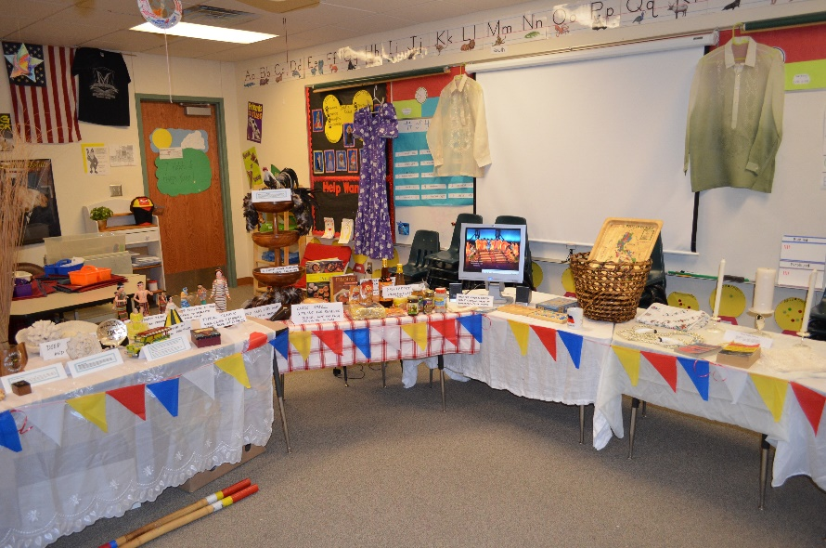

The Church will provide one 8’ table. We have limited electrical outlets. We can provide a backdrop board if requested. The 2 photos are just examples.

Possible items to showcase: Faith tradition – Patron Saint, Nativity Set. Clothing, crafts, traditional items. Have some present at your table to share in person.

Consider having a laptop playing a loop of pictures or a video showcasing your country/culture.

Reserve your space by August 17. Set-up your display table on Saturday, September 19 between 1 and 3 pm in the Mary Center.


Participation Sign-up for September 19 Event
Country:______________________
Name: _______________________
Email: _______________________
Cell: _______________________
Yes! I would like to: (check all that apply – deadline Aug 17)
___ Carry my country’s flag in a procession before the 4 pm Mass on Sept 19. Arrive by 3:40 pm to Atrium.
___ Prepare a cultural display table; set up Sept 19, 1-3 pm
___ Prepare a dessert – at least 60 bite sized pieces, include recipe card with list of ingredients; deliver between 1-3 pm to Mary Center.
What will you bring: _________________
___ Silent Auction – prepare a basket with purchased food/other items from your country. Bring prepared basket to Atrium table 9/5-9/6 or 9/12-9/13
___ Music. Email 3 pieces of dance/party music from your country for the event playlist. cesar.y.nocon@gmail.com
___ Many volunteers are needed! See mmotc.org/onefaith
By August 17, return this sign-up to the Atrium table or to Roxanne Tozier – rtozier@mmotc.org

