Summary annual report
Breckinridge-Grayson Programs, Inc.

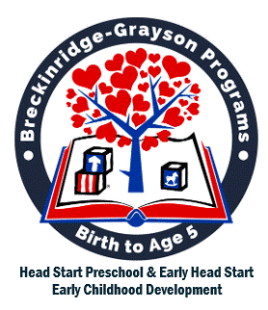
2025

Table of Contents

Table of Contents 1
Our Vision 2
Our Mission 2
What We Do 3
History of the Head Start Program 4
Local Services 7
School Readiness - Preparing Children for Kindergarten 9
Parent Engagement Activities 12
Summary of Head Start Preschool Services Provided Juke 1, 2024 to May 31, 2025
Summary of Early Head Start Services Provided June 1, 2024 to May 31, 2025 14
Child and Adult Food Care Program (CAFCP) through USDA 15
CLASS® Scores 16
School Readiness Report 17
Budget 18
Reporting 20
Non-federal Share – In-Kind 20
Board of Directors 21
Policy Council Members 21
Agency Contacts 22
Center Locations 23

Our Vision

Empowering children and staff to ensure school readiness
and lifelong success for every child.

Our Mission

Promote the growth and development of children by
strengthening families.

Serving children and families since 1965
Breckinridge-Grayson Programs, Inc. would like to take this opportunity to express our gratitude and thankfulness for all the support and encouragement the community has shown to program throughout our 50+ years of service to children and families. Community partnerships have been a great asset to our program, and we look forward to strengthening these partnerships over the next 50 years.

What We Do
Breckinridge-Grayson Programs, Inc. (BGP) was incorporated in 1975 in the state of Kentucky as a nonprofit, limited purpose corporation. BGP is the local grantee for the Head Start and Early Head Start programs. Funds are awarded by the Department of Health and Human Services, Administration for Children and Families to serve children and families in the counties of Breckinridge and Grayson.
Head Start was enacted in 1965 as a federal program to assist with the needs of at-risk children from four to five years of age. In 1995, the Early Head Start program was established to serve children from birth to three years of age. The programs now provide services to children and families to promote school readiness by enhancing the social and cognitive development of children through the provision of educational, health, nutritional, social, and other services.
The Agency provides comprehensive child development services to children and families, including children with significant disabilities, with a special focus on helping preschoolers develop the early reading and math skills they need to be successful in school. Parents are engaged in their children's learning. Parents are assisted and encouraged in making progress toward their own educational, literacy, and employment goals. Significant emphasis is placed on the involvement of parents in the administration and governance of the programs through Policy Council participation.

History of the Head Start Program
In January of 1964, President Lyndon B. Johnson declared “The War on Poverty” in his State of the Union speech. Shortly thereafter, Robert Sargent Shriver, Jr. took the lead in assembling a panel of experts to develop a comprehensive child development program that would help communities by meeting the needs of disadvantaged preschool children. Among these experts were Dr. Robert Cooke, a pediatrician at John Hopkins University, and Dr. Edward Zigler, a professor of psychology and director of the Child Study Center at Yale University.
At that time, part of the thinking was influenced by new research on the effects of poverty on families and the impact on education. This research indicated an obligation to help disadvantaged groups, compensating for inequality in social or economic conditions. Head Start was designed to provide preschool children of low-income families with a comprehensive program to meet their emotional, social, health, nutritional and psychological needs to prepare them for lifelong success. A key tenet of the program established that it be culturally responsive to the communities served, and that the communities have an investment in its success through the contribution of volunteer hours and other donations as nonfederal share.
In the summers of 1965 and 1966, the Office of Economic Opportunity launched the eight-week Project Head Start program. In 1969, under the Nixon administration, Head Start was transferred from the Office of Economic Opportunity to the Office of Child Development in the U.S. Department of Health, Education, and Welfare. Dr. Edward Zigler, who had served on the planning committee to launch Project Head Start, was appointed Director of the Office of Child Development.
In 1977, under the Carter administration, Head Start began bilingual and bicultural programs in about 21 states. Seven years later, in October 1984 under the Reagan administration, Head Start's national budget exceeded $1 billion. In September of 1995, under the Clinton administration, the first Early Head Start grants were awarded to programs, and in October of 1998, Head Start was reauthorized to provide more hours of service to children.
Head Start was most recently reauthorized again in 2007, under the George W. Bush administration, with several provisions to strengthen Head Start quality. These include alignment of Head Start school readiness goals with state early learning standards, higher qualifications for the Head Start teaching workforce, State Advisory Councils on Early Care and Education in every state, and increased program monitoring, including a review of child outcomes and annual financial audits. In 2009, under the Obama administration, the American Reinvestment and Recovery Act added more than 64,000 slots for Early Head Start and Head Start programs. In 2017, BGP was awarded Head Start funding to extend the hours of service for 46 children. In 2019, BGP received funding to extend hours for 16 additional children, for a total of 62 children attending five days per week instead of the prior four-day model.
Head Start is administered by the Administration for Children and Families (ACF) in the Department of Health and Human Services. Head Start serves over a million children and their families each year in urban and rural areas in all 50 states, the District of Columbia, Puerto Rico and the U.S. territories, including American Indian, Alaska Native, and Migrant and Seasonal communities.
Currently, Head Start programs promote school readiness of children to age five from low-income families by providing comprehensive services to focus on the whole child. Head Start and Early Head Start programs offer a variety of service models, depending on the needs of the local community. Many Head Start and Early Head Start programs are based in centers and schools. Other programs are in childcare centers and family childcare homes. Some programs offer home-based services that assign dedicated staff who conduct weekly visits to children in their own home and work with the parent as the child's primary teacher.
Today, children three and four years old make up more than 80% of the children served by Head Start programs each year. Early Head Start (EHS) was created to serve pregnant women, infants, and toddlers. EHS programs are open to the family until the child turns three and is ready to transition into Head Start or another pre-K program. Recently, many EHS programs have been funded to partner directly with existing infant and toddler childcare programs, resulting in higher quality services to all children enrolled in the childcare program.
Head Start programs support children's growth and development in a positive learning environment through a variety of services, which include:
- Early Learning: Children's readiness for school and beyond is fostered through individualized learning experiences. Through relationships with adults, play, and planned and spontaneous instruction, children grow in many aspects of development. Children progress in social skills and emotional well-being, along with language and literacy learning, and concept development.
- Health: Each child's perceptual, motor, and physical development is supported to permit them to fully explore and function in their environment. All children receive health and development screenings, nutritious meals, oral health, and mental health support. Programs connect families with medical, dental, and mental health services to ensure that children are receiving the services they need.
- Family well-being: Parents and families are supported in achieving their own goals, such as housing stability, continued education, and financial security. Programs support and strengthen parent-child relationships and engage families around children's learning and development.
Delivered through more than 1,600 agencies in local communities, Head Start and Early Head Start programs provide services to over a million children every year, in every U.S. state and territory, in farm-worker camps, and in more than 155 tribal communities. Head Start programming is responsive to the ethnic, cultural, and linguistic heritage of each child and family.

Local Services
BGP began serving Head Start children from age three to five in 1965 in Grayson and a portion of Breckinridge Counties. Years later, the agency identified Grayson County as its service area and relinquished enrollment for Breckinridge County to the Breckinridge County Public School System. Around 1967, the agency began serving children age birth to three in the federally funded Parent-Child Center program in both Grayson and Breckinridge counties. This program operated on a two-day per week schedule for families attending, Monday-Tuesday and Wednesday-Thursday. Teachers planned and received training on Friday. Parents were required to attend with their child(ren) and offered a variety of learning opportunities. Home-based services were provided for some Head Start families during the ‘80s.
In 1996, (Bill Clinton, President) BGP successfully opened an Early Head Start Program during Wave I funding. This program replaced the Parent-Child Center concept and supported the federal government’s initiative known as “Welfare-to-Work.” Parents of enrolled children were expected to seek further education or job skill training and seek employment. At this time the Breckinridge-Grayson Parent-Child Center was closed, and enrolled families transitioned into the agency’s first Early Head Start home-based program. In 1998, revised Head Start Program Performance Standards were implemented. A requirement of the revision was the collection and aggregation of child outcomes data.
Under President George W. Bush’s administration, the “Improving Head Start for School Readiness Act of 2007” was implemented. Within the Act, governing bodies’ responsibilities were clarified, and program staff qualifications were included among other requirements. Teacher requirements were addressed to include a minimum of an associate degree in early childhood education by 2011 and that 50% of Head Start Teachers nationwide would hold a baccalaureate degree in or relative to an Early Childhood Degree. The Obama administration implemented new Head Start Program Performance Standards in September 2016 that continue to support school readiness and requires programs to provide at least 1,380 hours of service for Early Head children, and 1,020 hours of service for 45% of Head Start children.
Today, BGP provides center-based Early Head Start in both counties and Head Start in Grayson County. Also, Early Head Start is provided through the home-based option in both counties. The program uses data collected from various sources to demonstrate service outcomes and to guide program options and services. During BGP’s 50 plus years we have had the opportunity and privilege to embrace, educate and encourage over 7,000 children and their families in Breckinridge and Grayson Counties.
BGP employs 77 full-time staff, 1 part-time staff, and 11 variable positions for bus monitors, drivers, and substitutes. The Agency’s standard business hours for the Leitchfield center are from 7:00 a.m. to 4:00 p.m. The Hardinsburg center operates from 7:00 a.m. to 3:00 p.m. Both of BGP’s centers have been given a KY ALLSTARS quality rating of FIVE Stars, with five being the highest rating possible.

School Readiness - Preparing Children for Kindergarten
Head Start: Getting young children and their families ready for school and ready for life.
Head Start’s primary goal is to prepare children and families for kindergarten and lifelong success. To enter kindergarten, children should show some of the following skills.
- Language and Literacy Development
  - Demonstrates the ability to listen, understand and use complex and varied vocabulary and participate in stories, songs, and poems.
  - Discriminates, identifies and matches sounds in words, hears and demonstrates phonological awareness, has book knowledge and appreciation, tells stories, engages in reading activities, prints names, letters and numbers, has good concept of a word as a unit of print and words put together can tell a story, early writing is understood as communication, draws pictures to tell a story and uses a variety of writing tools.

- Mathematics - Understands the concept of numbers, rote and object count, identify basic shapes, repeat patterns, measures and matches.

- Science - Observes and discusses differences and comparisons of objects, can collect, predict outcomes, especially in the natural world of materials.

- Creative Skills - Learns to express experiences through music, art, movement, and dramatic play.

- Social Emotional Development - Understands self-concept, has self-control, is cooperative, progresses in caring for self and others in social relationships.

- Approaches to Learning - Learns to make independent choices, use imagination and inventiveness, can engage and be persistent in tasks, and can reason and solve tasks or problems.

- Physical Health and Development - Shows strength and control in using tools for writing and creating, hand-eye coordination skills to enable play with blocks, complete puzzles and use scissors, gross motor abilities reflect balance, control, and ability to participate in moderate to vigorous activities, self-help and personal care needs are met.
The quality classroom environments provided in our programs give children the foundation needed to be successful. To guide learning, comprehensive research-based curricula are used. BGP uses the following curricula.
- Creative Curriculum® by Teaching Strategies® is a comprehensive curriculum with a clear organizational structure and focus on routines and experiences.
- Florida State University Partners for a Healthy Baby is a two generational curriculum that addresses the needs of both the parent and the child used in home-based services for infants, toddlers, and pregnant women.
Along with the curricula mentioned above, comprehensive research-based assessment tools are used. BGP uses an ongoing, observation-based assessment system, Teaching Strategies GOLD, to collect, record and aggregate each child’s developmental progress. Teaching Strategies GOLD allows parents to access their children’s assessment data and communicate with teachers.
The Office of Head Start requires programs to use an observation tool to measure teacher and child interactions to further assure quality classroom and home visiting experiences. Breckinridge-Grayson uses the following teacher-child interaction observation tools.
- CLASS® (Classroom Assessment Scoring System) by Teachstone® uses research-driven insights to improve how teachers interact with children every day to cultivate supportive, structured, and engaging classroom experiences.

- HOVRS (Home Visitor Rating Scale) created by Lori A. Roggman at Utah State University is designed for practitioners and supervisors seeking a high level of excellence in home visiting practices in programs aiming to help parents to support the early development of their infants and young children.

Other resources used in classrooms include Conscious Discipline® and Flip It®.
- Conscious Discipline® by Dr. Becky Bailey provides social-emotional learning and classroom management tools.

- Flip It® from Devereaux Advanced Behavioral Health Center for Resilient Children provides strategies for working with children with challenging behaviors.

When children are ready to transition to kindergarten or another setting, BGP partners with the parents and schools to assist by involving and supporting the parents before, during and after the transition so they gain increased confidence in their child’s ability to succeed in a new setting and enhance their own ability to effectively influence education, care and service delivery.
- Transition Activities
- Obtain parental consent to begin transitioning into a new setting.
- Children will have activities planned in the dining room to prepare for dining in elementary school.
- Plan experiences for children that provide continuity between settings such as home learning ideas and using familiar routines.
- Children will take a field trip to their new school. While there, children will visit the kindergarten classrooms, lunchroom, library, gym, music and all offices.
- Children will take home educational materials from the school along with a transition booklet that includes pictures of elementary school staff where they will be attending.
- Parents will receive tips and advice on appropriately effective talking to their child’s teacher, or other school personnel regarding concerns, wants, and needs.
- Families of children with disabilities are invited to participate in a Transition ARC meeting at their new school.
- Principals and counselors from public schools are invited to attend Transition Celebration at the end of the school year for children going to public school.

Parent Engagement Activities
Breckinridge-Grayson has a strong partnership with families, offering a variety of parent engagement opportunities.
- Volunteer Job Training Programs

    - Bus Monitors
    - Substitutes
    - Clerical Skills
    - Resume Writing
    - Application Completion
    - Dressing for Success
    - Interviewing Skills
    - Service Area Substitutes

- Parent-Teacher Conferences Conversations

- Parent-Committee Meetings

- Parent Café’s

- Parent Training opportunities:

Pedestrian Safety
Father/Male Involvement
Smoke Free Homes Campaign
Family Art Activities
Healthy Lifestyle opportunities Healthy Child Discipline Techniques
Nutrition
Healthy Food Choices Budgeting

Summary of Head Start Preschool Services Provided from June 1, 2024, to May 31, 2025
- Funded enrollment - 100
- Total children served – 120
- Total families served - 110
- Average monthly enrollment-100 (100% of funded enrollment)
- 24 of children served were income eligible-under 100% federal poverty level
- 66 of children served were eligible due to receipt of public assistance
- 13 of children served were eligible due to being foster children
- 3 of children served were eligible due to being homeless
- 11 of children were eligible at the 101-130% of the federal poverty level
- 3 of children served were over income at 130% or higher federal poverty level
- 95% of children received medical exams
- 99% of children received dental exams

Summary of Early Head Start Services Provided June 1, 2024, to May 31, 2025
- Funded enrollment - 100
- Total children served - 134
- Total families served -113
- Average monthly enrollment- 100 (100% of funded enrollment)
- 32 of children served were income eligible-under 100% federal poverty level
- 82 of children served were eligible due to receipt of public assistance
- 11 of children served were eligible due to being foster children
- 2 of children served were eligible due to being homeless
- 5 of children served were eligible at the 101-130% federal poverty level
- 2 of children served were over income at 130% or higher federal poverty level
- 96% of children received medical exams
- 51% of children are up to date on dental exams

Child and Adult Food Care Program (CAFCP) through USDA
Program Facts:
- Providing nutritious meals to children is a fundamental Head Start Service.
- All meals are nutritionally balanced in accordance with USDA guidelines.
- Menus are approved by a registered dietician.
- The Agency is reimbursed by USDA for the costs of food.
- All classrooms participate in hands-on nutrition activities at least twice per month.
- Head Start Preschool/Early Head Start serves meals that are high in nutrients and low in sugars and salts.
Impact:
- Each day, children receive nutritious meals and snacks.
- An estimated 1,748 breakfasts, 1,780 lunches, and 1,700 snacks are prepared for children per month.
- All Head Start Preschool and Early Head Start children are served through the CACFP program at no cost to children and families.

CLASS® Scores
CLASS® Data (School Year 2024-20245)
Agency staff and educators stay committed to providing the highest quality services to low-income families, so children can, regardless of circumstances and/or environment, have an equal chance to succeed in school and life.
The Classroom Assessment Scoring System® (CLASS®) is a critical tool used to measure the quality of adult-child interactions in all classrooms. High CLASS® scores directly correlate to higher child outcomes. Currently, the program has five staff members that are CLASS® Inter-Rater Reliable.

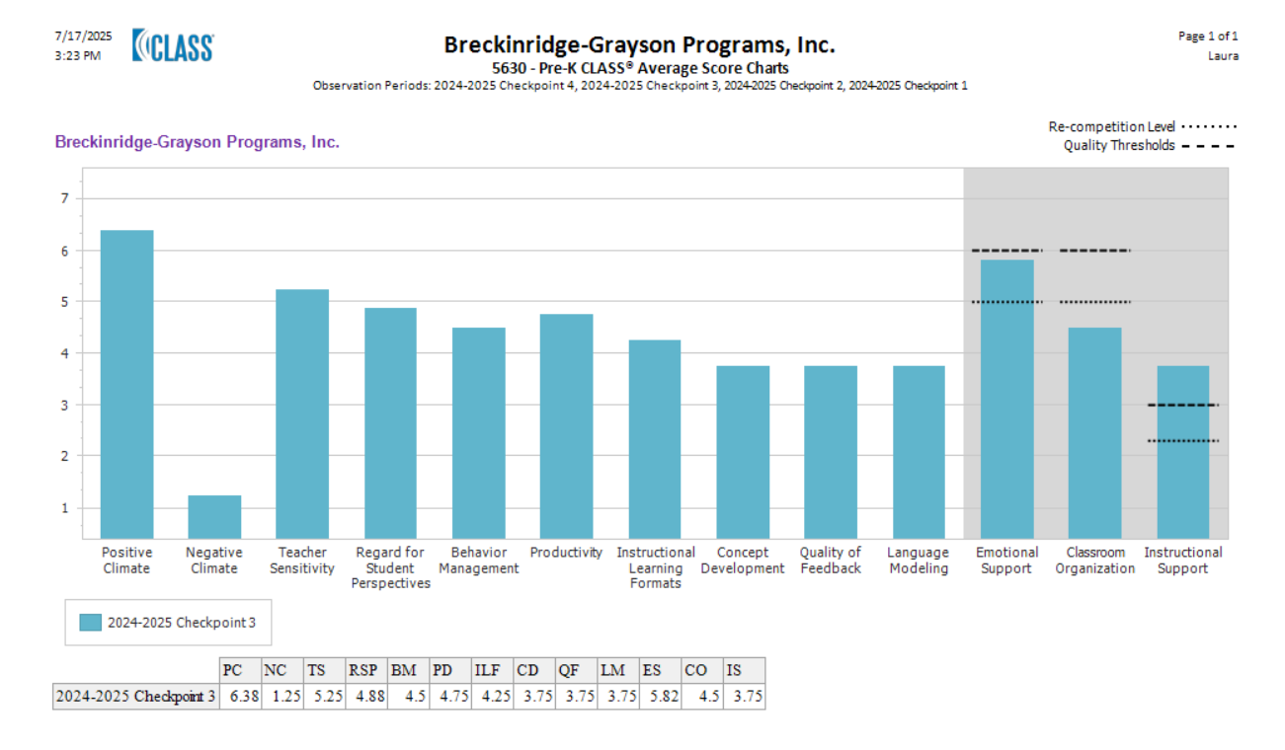

School Readiness Report

School Readiness Reports (School Year 2024-2025)
Ongoing assessment data is collected three times per program year from Teaching Strategies GOLD® to measure progress from the beginning of the year to the end of the year for children. Progress toward all goals may vary from year to year. However, it is the expectation that levels of average achievement (regardless of classroom makeup) can be calculated.

2024-2025 School Readiness Data Analysis
Data collected from Teaching Strategies Gold (SmartTeach) highlights variations in skill development across age groups.
Early Head Start (EHS) Areas for Improvement:
Uses an expanding expressive vocabulary (5% below standard)
Engages in conversations (7% below standard)
Uses social rules of language (11% below standard)
Head Start (HS) Areas for Improvement:
Notices and discriminates rhyme (15% below standard)
Identifies and names letters (15% below standard)
Quantifies (16% below standard)

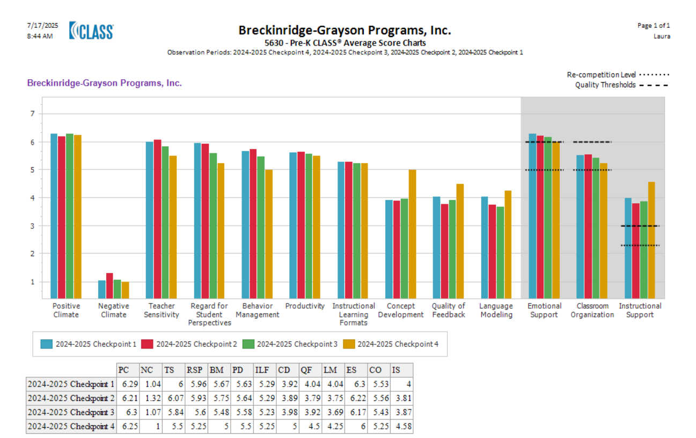

Action Plan for Improvement:

Enhance literacy & mathematics instruction through targeted professional development.

Strengthen classroom support strategies for Classroom Organization.

Implement differentiated learning for underperforming skills across age groups.

Integrate parent engagement initiatives to reinforce learning at home.

Budget
Audited Revenue and Expenditure Statement June 1, 2024 to May 31, 2025

Revenue
Office of Head Start-Program Year 6/1/2024 to 5/31/202 $ 6,082,130
USDA Revenue 181,235
Other Revenue 1,184,223
Total Revenue $ 7,447,588
Expenses
Personnel 3,192,359
Fringe 579,465
Travel 830
Supplies 54,146
Contractual services 7,068 Occupancy 250,037
Transportation 103,745
Nutrition 158,457
Child Consulting Services 950
Parent services 5,956
Training and Staff Development 66,139
Other 1,614,036
Total Expenses $ 6,033,188

Current Fiscal Year Budget (June 1, 2025, to May 31, 2026)

Revenue
Office of Head Start-Program Year 6/1/2025 to 5/31/2026 $ 4, 213,804
USDA Reimbursement 140,000
Other Revenue 500
Non-Federal Share Revenue-Grantee contributions 1,053451
Total Revenue $ 5,407,755
Expenses
Personnel 2,784,213
Fringe 860, 850
Travel 1,877
Supplies 72,860
Contractual services 28,448 Occupancy 198,344
Transportation 104,594
Nutrition 148,100
Child Consulting Services 4,583
Parent services 8,540
Training and Staff Development 55,590
Other 86,305
Non-Federal Share Expenses-Grantee contributions 1,053,451
Total Expenses $5,407,755

Reporting
Annual Audit Report
The annual audit report for the year ending May 31, 2025, was presented to the Board of Directors at the January 2026 meeting. The report did not contain any findings.
Federal Review Report
The most recent Federal Review was conducted on January 27, 2025. There was one area of concern regarding Child Health and Oral Health Status and Care. The grant recipient should improve its efforts to obtain medical and oral health determinations from a health care professional for all children within the prescribed timeframe. This report can be found online at: https://eclkc.ohs.acf.hhs.gov/grantee-profiles/breckinridge-grayson-programs-inc-ky.

Non-federal Share – In-Kind
As a condition of our federal grant, BGP must match federal dollars received with local contributions, in a 4 (federal) to 1 (local) ratio. This match is called non-federal share. These contributions may be cash donations or in-kind donations. In-kind can consist of supplies we may need for our classroom or facility, but in-kind can also be volunteer hours. We have some wonderful volunteers in our facility each and every day; however, we are always in need of more. If you would be interested in visiting our wonderful facility to learn more about our program, and potentially become a volunteer, we would be more than happy to talk with you!

Board of Directors
Member Title
Barbara Carden Board Chairperson
Carolyn Thomason Vice-Chairperson
Mary Hunt Secretary/Retired Early Head Start Home Visitor
Linda Day Retired Special Education Teacher
Alexus Snyder Policy Council Chairperson
Elisha Clark Former Parent

Policy Council Members
Parent Representatives Community Representatives
Alexus Snyder Linda Day
Christina Rubio Elisha Clark
Dinisha Cummins
Sara Young

Agency Contacts
Valeria Hayes, Chief Executive Officer valeria.hayes@breckgrayson.org
Julie Cox, Chief Financial Officer julie.cox@breckgrayson.org

Center Locations

Breckinridge County Grayson County

228 Tules Creek Road 201 East Walnut Street
Hardinsburg, Kentucky 40413 Leitchfield, Kentucky 42754
270-756-0560 270-259-4054
270-756-0114 fax 270-259-4055 fax

