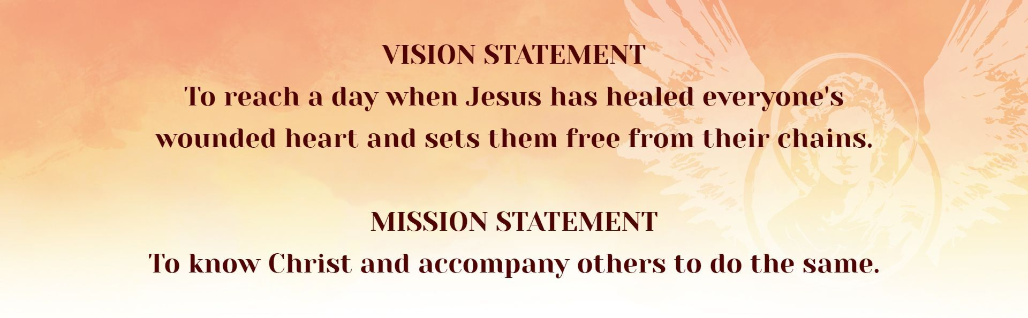
St. Gabriel the Archangel Family of Parishes

St. Gabriel Family of Parishes (SGFP) Children’s Faith Formation Policies:
- Students and volunteers will not be discriminated against on the basis of race, gender, or national origin.
- Tuition for SGFP Religious Education classes is $25.00 per student for one academic year. Refunds will only be offered to those withdrawing before attending any sessions.
- Employees and volunteer Catechists (teachers) of the religious education classes are required to be in compliance with the Archdiocese of Cincinnati Decree on Children Protection and SafeParish. Anyone can read and access the Decree at this link: Archdiocese of Cincinnati Decree on Child Protection. Additional resources can be found at Archdiocese of Cincinnati Safe Environment Resource Page
- Employees and volunteer catechists (teachers) are expected to be in compliance with the Archdiocese of Cincinnati Youth Religious Education Policies for Parishes.
- Religious Education students will not be expected to complete homework; however, they may be encouraged and/or given a faith based “challenge” to complete between classes.
- Parents/Guardians of students who can foresee a series of absences (for example due to a sporting practice conflict) can ask the Director of Children’s Faith Formation for materials to do parent/guardian-led homeschool during the span of the absences. When the reason for absences is over, the student can return to in-person classes.
- Communication to parents/guardians will be via email from both the Director of Children’s Faith Formation and the child’s catechist. The email address used will be the one provided by the parent/guardian on the registration form.
- Parents/Guardians wanting to communicate with the Children’s Faith Formation office and its volunteers can use the parish email or parish phone number of the Director of Children’s Faith Formation.
- Parents/Guardians with concerns should first contact the Director of Children's Faith Formation. If the parent’s concern is not satisfied, the parent should email the parish Chief Operating Officer.
- Children in the second grade or older can be prepared to receive the Sacraments of First Communion and First Reconciliation.
- Youth in the eighth grade or older can be prepared to receive the Sacrament of Confirmation
- All children and youth receiving the Sacraments of First Communion, First Reconciliation, and Confirmation must have been baptized or received in the Roman Catholic Church.
- Serious infractions of respect to others, the Church and/or the facilities by a student will be made known to the parent/guardian of the child along with a discussion between the Director of Children’s Faith Formation and parent/guardian about the appropriate course action. The course of action may include the child’s departure from the program if needed.
- If a child becomes injured or ill during a religious education class, the parent/guardian will be notified immediately using the phone number provided on the child’s registration form for serious illnesses and injuries or notified when the child is picked up for minor illnesses and injuries.
- Medicine will not administered to a child during a religious education class. The exception is if the parent/guardian and Director of Children’s Faith Formation have a discussion about the special need for medicine during class time. If there is an event that is longer than a religious education class, such as a retreat, and medicine is needed, the medicine should be put in a zip sealed bag with clear labels, instructions and the name of child. The medicine should be handed over to the Director of Children’s Faith Formation or the appointed adult volunteer in charge and administered by that adult.
- Snacks in the religious education classroom must be nut free.

St. Gabriel the Archangel Family of Parishes
Children’s Faith Formation and Sacraments
Serving children and families in Pre-K through 5th grade
Director of Children’s Faith Formation: Elise Sas
esas@sgfp.org
937-898-3542 ext. 302

