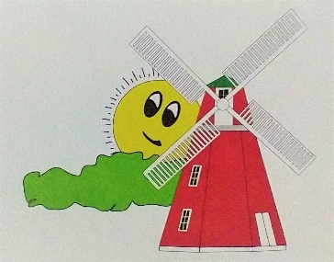
Grove City Windmill Days - August 15 & 16, 2025
Dear Sponsor,
Grove City Windmill Days 2025 is approaching quickly. In the past, the success of this event is credited largely to our sponsors who lend their name and financial support to the event. The money we raise helps promote Grove City, its businesses, clubs, and organizations. Thank you in advance for your generous donation as we help give back to the community to better enhance our place to live, work, and retire.
By participating as a sponsor, your organization will benefit from extended exposure through advertising campaigns and promotional efforts directed toward the support of the Grove City Windmill Days.
We have different levels of sponsorship packages, as detailed at the bottom of the page. You can select the level that best meets your needs.
We are counting on your support and would be happy to answer any questions that you may have. Please email Mail@grovecitymn.com or call 320-857-2322 for any questions, comments, and concerns. Please return your sponsorship information to: Betsy Ammermann, C/O Grove City Windmill Days, PO BOX 98, Grove City, MN 56243. Please make check payable to: City of Grove City EDA. Thank you in advance for your support of Grove City Windmill Days. Please enclose a business card so that we have the correct spelling of your business/organization and logo if needed.
*Deadline* July 25, 2025.
***Sponsorships after the deadline may not be able to be on the banners and in the advertiser for the current year but will still be recognized in 2025. ***
Sincerely,
Grove City Economic Development Authority
Windmill Days Planning Committee

Levels of Sponsorship:
Bronze $100.00: Your business/organization appears on the Windmill Days flyer and Grove City WMD’s webpage and social media.

Silver $200.00: Your business/organization appears on a 48” x 48” banner in addition to webpage and social media.

Gold $300.00: Your business/organization appears on a 48” x 96” banner in addition to webpage and social media.

