Sinclair Tour and Travel 5494 5083
Murray River Meander
Departs Thursday 30th April – 6 days
$3,850 per person twin share. Single $495

Day One Thursday 30th April
After pick up from your door as usual, you’ll be transferred to the Brisbane airport for your flight to Adelaide. Here, you’ll be met by our driver. Let’s go down to Glenelg for some free time for lunch (own expense) and shopping. Walk along the waterfront and enjoy the lovely sea breezes. Then, we’re off to Murray Bridge – our home for 2 nights. With great views of the Mighty Murray River, you’ll enjoy our stay here. Dinner at our Hotel tonight (D)
Bridgeport Hotel (08) 8532 2002

Day Two Friday 1st May
After a delicious brekky at our hotel, we’re off to historic Strathalbyn for free time to wander and go shopping. Strathalbyn is a charming, historic town with 19th-century buildings, settled by Scottish pioneers, and is one of Australia's prettiest town. Then we’re in for a real treat.
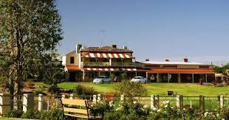
You’ll LOVE our Horse-drawn Tram ride at Victor Harbour. These magnificent Clydesdale horses pull the tram along the causeway from the coastal town of Victor Harbor to the stunning Granite Island.
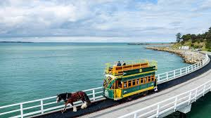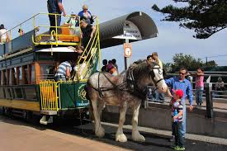
Our Murray River adventure continues…. Welcome to Storm Boy Country, on an unforgettable half-day experience with Spirit of the Coorong. This 3.5-hour cruise introduces you to the natural wonder that is the Coorong National Park. Offering stunning scenery, memorable wildlife encounters, and rich cultural insights, making it an ideal trip for nature enthusiasts and adventurers. Explore this vast wetland ecosystem that consists of ocean beach, freshwater lakes, estuaries, saline lagoon and the Murray River mouth.
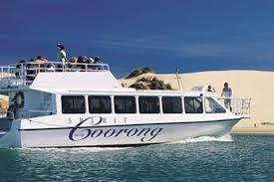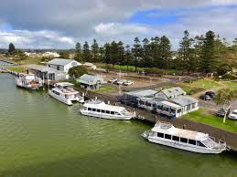
You’ll cruise from Goolwa along historic sites; Goolwa Barrage & Lock - Transit between fresh & brackish waters through the lock & enjoy watching Fur Seals bask in the sun. Unique Wildlife Viewing - Spot fur seals, diverse birdlife, learn the ‘Pipi-Shuffle’ at 90 Mile Beach the longest beach in Australia. Guided Shore Experience – you may wish to Take an optional guided walk through the dunes, Indigenous sites and learn about flora, fauna & bushfoods. Picturesque Landscapes - Marvel at the stunning Coorong scenery, including Storm Boy filming locations and towering dunes. Relaxing Return Journey, meandering back to Goolwa. Dinner at our Hotel tonight. (B)(D)
Bridgeport Hotel (08) 8532 2002

Day Three Saturday 2nd May
After another great brekky at our Hotel, we’re off to Mildura. On our meander, we’ll visit the town of Mannum, an historic river port, birthplace of the first paddle steamer, the first car, and the houseboat capital of Australia. Then, on to /Swan Reach, famous for its towering cliffs.
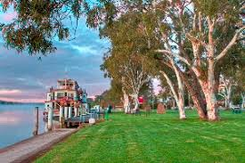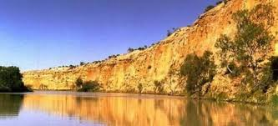

Blanchetown Lock will be our next stop. Officially known as Lock and Weir No. 1, Blanchetown's lock was named for William R. Randell, the Murray's pioneer captain, who first navigated the river in 1853.
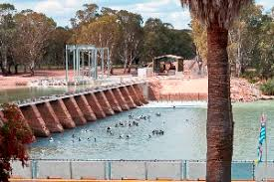. 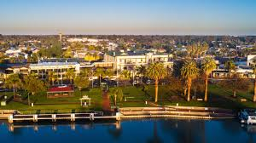
Set in the heart of the Riverland just over three hours’ drive from Adelaide, Renmark sits majestically on the flourishing banks of the River Murray. This historic town established in 1887 is the largest in the Riverland with impressive ochre-coloured cliff tops and wetlands brimming with birdlife
You’ll love the Silo Art at Paringa. The paintings tell the story of the concept of irrigation in the area in 1887. Also tells the tale of Captain Pearl Wallace, a famous female riverboat Captain.
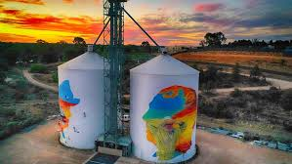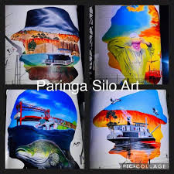
We’ll also visit the Murray-Darling Junction. The junction of Australia's two longest rivers, the Murray and the Darling - an iconic Australian 'must-see'! Climb the viewing tower and see the confluence of the Murray and Darling Rivers, which, combined, is the fourth largest river system in the world. When the Darling is in flow, a surprise awaits - as the two rivers are marked by a distinct colour difference visible from the tower. The Darling is a clay-based river; its milky appearance contrasts starkly to that of the mighty Murray. Truly one of Australia's iconic 'must-see' attractions.
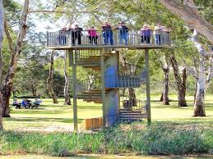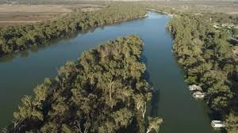
Our overnight destination is Mildura. Perched on the edge of the wild Australian outback, Mildura is an oasis on the Murray River boasting Mediterranean-style sunshine and a laid-back outdoor lifestyle.
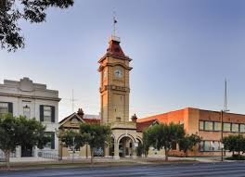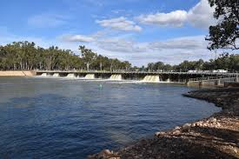
Dinner at our Hotel tonight. (B)(D)
Mercure Mildura Hotel (03) 5051 2500

Day Four Sunday 3rd May
After breakfast at our Hotel, we’ll visit the Swan Hill Pioneer Settlement. Set on three hectares of land on the banks of the Little Murray River, the Pioneer Settlement lets you experience Australian history firsthand.
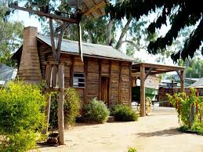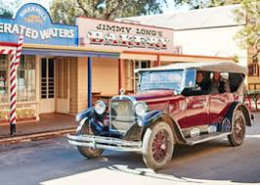
You will find real-life Mallee cottages, a hotel, schools and shops, plus our enormous collection of working tractors and machinery – sourced mostly from the local area. You can feel the heat in the blacksmith shop, listen to the sounds of the old Pianola or take a ride through our Mallee township on a horse and cart.
As you wander the site, you can also chat to staff and volunteers, all looking the part in costumes of the period. The Pioneer Settlement opened in 1966 after a joint community and government effort to recognise the unique history of our Murray Mallee region. By the 1970s, the Pioneer Settlement was one of the most popular tourism destinations in Victoria, if not Australia, and the concept has been emulated around the country. The Settlement is now introducing more ground-breaking tourism concepts to complement the historical Mallee townships. Take the opportunity for some lunch here (own expense) before we travel on to Echuca.
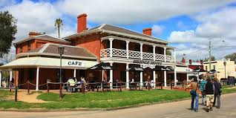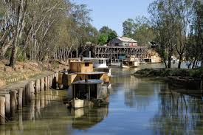
The Port of Echuca invites you to come walk the path of Echuca's river pioneers. Explore the legend of Australia's pioneering spirit and learn how Australia's inland river system connected a fledgling colony to its growing cities and the outside world. The iconic Port of Echuca, located two and a half hours north of Melbourne on the banks of the Mighty Murray River, is one of Australia's premier regional tourist destinations. Discover Echuca Moama's unique paddle steamer history through the living breathing vessels that still captivate the imagination of visitors today. Free time to walk the waterfront and enjoy the many shops/cafes in the area before checking in to our home for the night. (B)(D)
Mercure Port of Echuca (03) 5482 5666

Day Five Monday 4th May
After brekky at our Hotel, we will indeed discover the paddle steamer history as we step aboard the remarkable PS Pevensey, names after a sheep property on the Murrumbidgee River called Pevensey Station. This vessel is an authentic paddle steamer with its original steam engine. It’s known to people all over the world for its role as “Philadelphia” in the Australian mini-series “All the Rivers Run”, made in Echuca 1982-1983. Relish the elegance and nostalgia of a bygone era as you cruise along the majestic Murray River.
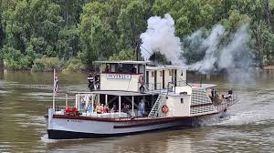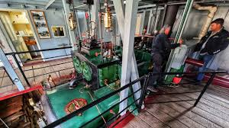
During this 1-hour cruise, take in the tranquil beauty of the Murray River's landscapes, where nature's serenity blends seamlessly with the historic allure of the steamboat era. Captivating views and photo opportunities abound as you peacefully drift along the water. Let’s enjoy some more wonderful Silo Art when we visit Rochester, Devenish and Goorambat.
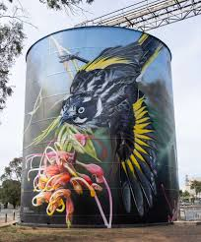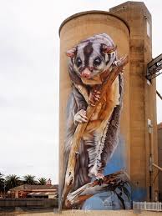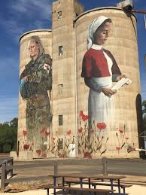

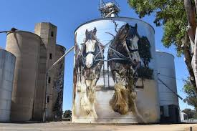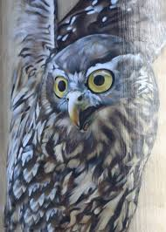
We’ll overnight in Albury – our last stop on the Mighty Murray River. Mixing heritage with modern culture, Albury Wodonga blends country pace and city lifestyle with its offerings of historical buildings, cultural events, vibrant shopping precincts and tree-lined gardens.
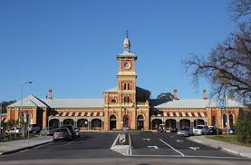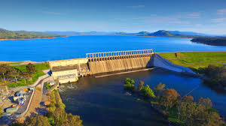
Straddling the state line that separates Victoria and New South Wales, Albury Wodonga is united by the Murray River that winds its way between the two cities. Once a busy trade route for paddle steamers, the river now serves as a backdrop to the cities' parklands, walking trails, golf courses and cultural events. Dinner at our Hotel tonight. (B) (D)
Siesta Resort Albury (02) 6025 4555

Day Six Tuesday 5th May
Sadly, this is our last breakfast together. How hard will it be to go back to tea and toast? After a scenic drive around Albury and Lake Hune, we’ll fly back to Brisbane from Albury today. Here, you’ll be met by a representative from Sinclair Tour and Travel and taken back to your front door. We do hope you’ve enjoyed our Murray River Meander Tour. Please tell your friends. That’s how our business grows. We look forward to travelling with you again really soon. (B)

TERMS AND CONDITIONS

These terms and conditions apply to bookings you make with us. These terms and conditions govern our relationship with you.

Please read the following terms and conditions carefully. You must not make any booking unless you are 18 years of age or older and understand and agree with the following terms and conditions. We will rely on the authority of the person making the booking to act on behalf of any other person on the booking and the person making the booking will bind all other persons on the booking to these and conditions.

BOOKINGS, DEPOSITS AND PAYMENTS

In order to secure your booking, we require a deposit, per person, within 7 days of making your booking. Deposit amounts are outlined in each itinerary. $1,000 deposit required for this Murray River Meander Tour
When making a booking for yourself you warrant that you are 18 years of age or older. If you are making a booking on behalf of another person/s or thirds parties, you warrant that you have their authority to do so and have conveyed these terms and conditions to them, and they are properly informed. You agree to indemnify us and the Supplier against any claims from any person/s or third parties who you made the booking for if they have not in been properly informed in regard to these terms and conditions.
If you are making a booking on behalf of a minor/s you warrant that you are their parent or legal guardian and take full responsibility for said minor/s and will not hold us or a Supplier responsible for any breach of these term and condition by any minor under your control.

When making a booking for yourself or on behalf of another person or on behalf of a minor, you warrant that all information provided by you is true and correct. We take no responsibility for any errors or incorrect information provided by you and will not be held responsible for costs, fees, penalties or payments incurred for errors or incorrect information provided by you.

All deposits are non-refundable for changes of mind or cancellations by you (subject to your rights under the Australian Consumer Law).

You are required to pay the balance payment at least 60 days prior to the tour date. For tour bookings made within 60 of the tour date full payment is required on booking.

Failure to make payment by the due date may result in your booking being cancelled and deposits forfeited.

Payments made by direct deposit may take up to three business days to process. If you are paying by this method, you will need to make the payment at least three business days prior to the actual due date. You must notify us once your payment has been made.

Payments made by personal cheque (excluding bank cheques) require five business days to process. If you are paying by this method, you will need to make the payment at least five business days prior to the actual due date. You agree not to stop payment of the cheque even when you cancel a booking. You agree that we may apply the proceeds of the cheque to satisfy any liability you have to us or to a Supplier, including any liability in respect of cancellation fees, before refunding the balance to you.

CHANGE AND CANCELLATION FEES

Please be aware that some confirmed bookings are not refundable if cancelled and may not be transferable to another date or otherwise changed. Alternatively, a change may only be permissible subject to payment of an additional fee or charge. Changes and cancellations of confirmed bookings may incur fees from Suppliers. It is your responsibility to check if a booking is non-refundable or will incur charges for changing it before placing the booking.

If you cancel your booking, we reserve our right to charge you cancelation fees on the following basis: -
- Bookings cancelled more than 60 days from the tour date will not incur a fee subject to any additional non-refundable fees or charges from Suppliers.
- Bookings cancelled not more than 59 days but not less than 15 days from the tour date will incur a fee which is 50% of the Tour Price subject to any additional non-refundable fees or charges from Suppliers.
- Bookings cancelled not more than 14 days but not less than 8 days from the tour date will incur a fee which is 75% of the Tour Price subject to any additional non-refundable fees or charges from Suppliers.
- Bookings cancelled within 8 days from the tour date will be required to pay for 100% of the Tour Price.
- Bookings cancelled after the tour date will be required to pay for 100% of the Tour Price.

Please be advised that a $100 administration fee (per person) will be charged on ALL cancellations regardless of the number of days’ notice given.

To cover cancellations as a result of illness or loss of baggage, we strongly encourage passengers to arrange travel insurance. We now sell Covermore travel insurance and just need your date of birth to be able to provide you with a quote.

REFUNDS
Your entitlement to a refund for cancelled bookings is subject to the relevant Supplier’s terms and conditions, and our cancelation fees as outlined described above.
If you are entitled to a refund then, subject to the Supplier’s terms and conditions, we will arrange for it to be supplied to us on your behalf, unless we expressly agree with you otherwise.
If we are managing or arranging a refund for a cancelled booking on your behalf it will not be paid to you until the Supplier provides the refund to us, and we will not be liable for any delay on the part of the Supplier. Be aware that typically airlines will take between 60-90 days to process a refund.
Please note that if we are entitled to a service fee for placing a booking, we will remain entitled to this fee if you cancel the booking or the Supplier fails to provide you with the Product for any reason (other than our default), including in an event of Force Majeure. We will be entitled to deduct our service fee from any refund we receive on your behalf before remitting the balance to you.

SUMMARY

Please read all of the terms and conditions, the following is a summary of our terms and conditions: -

- Prices, including, in some cases, of confirmed bookings, may be subject to change.

- Some confirmed bookings are non-refundable if cancelled by you and it is your responsibility to check if this applies.

- We will be entitled to retain our service fees even if a booking is cancelled or does not proceed for any reason which is not our fault.

- It is your responsibility to make yourself aware of all information relevant to your travel plans, including but not limited to visa requirements and health precautions.

- We are not liable for the accuracy of any published Supplier content including websites and brochures.

SUMMARY OF OBLIGATIONS
Before making a booking, it is important that you meet the following requirements:
- You are over the age of eighteen (18) and have sufficient funds to pay for the travel services.
- You have read our terms and conditions and if booking for third parties warrant that you have their authority to do so and have conveyed these terms and conditions to them. You agree to indemnify us and the Supplier against any claims from third parties who have not in fact been properly informed.
- You have read the terms and conditions of any applicable Suppliers and agree to be bound by those.
- You are responsible for checking the accuracy of all documents provided to you.
- You are responsible for confirming departure times of any booked services at least 24 hours prior to travel.
- You warrant and acknowledge that you have accessed the Smartraveller website http://smartraveller.gov.au for any specific information in relation to your intended destination.
- You accept that passports, visas and other required identification documents are your responsibility.

PRICES, TAXES, FEES AND SURCHARGES

All prices that we quote are in Australian Dollars. Quoted prices are subject to change at the discretion of the Supplier prior to booking. Price changes may occur after booking because of matters outside our control which may increase the cost of the Product. Such factors include but are not limited to currency fluctuations, fuel surcharges, taxes and airfare increases. Please contact us for up-to-date prices. Even when paid in full, prices may change because of matters outside our control.
In the event there is an increase in cost incurred by us we reserve our right to alter our prices and charge a surcharge. If we require a surcharge to be paid due to increases in costs, this will be requested in writing. If you do not pay this surcharge, your action will be regarded as a cancellation by you and cancellation charges will apply
Prices include all applicable taxes requiring payment prior to departure and may be subject to adjustment in the event of an increase in those taxes. On other occasions, you may be liable for taxes in addition to the quoted price of the Product. For example, there may be a local tax charged at some airports or resorts.

You agree to pay fees and surcharges incurred by us on your behalf, which include but are not limited to booking or reservation fees, cancellation and amendment fees, credit card merchant fees, insurance claim processing fees or fees for ad-hoc services performed as required.
You authorise us to charge all monies payable by you in relation to any booking we make on your behalf or other services we have procured or provided to the credit card or debit card designated by you. If payment is not received from the card issuer or its agents for any reason, you agree to pay us all amounts due immediately on demand. Please not surcharges in relation to credit and debit card payments are non-refundable and we accept no responsibility for an inappropriate surcharge being applied if the correct card type has not been advised.

PRODUCTS

All tours and Products that we quote on are subject to availability and may be withdrawn or varied by us or the Supplier without notice.
MISCELLANEOUS
It is your responsibility to make yourself aware of all information that it is necessary or desirable to know in order to make optimum use of the tour, Products and to undertake travel generally.
It is your responsibility to ensure you have the necessary passports, visas, documents and vaccinations for international travel.
It is your responsibility to obtain medical advice prior to your booking to ensure it is safe for you to undertake the tour, participate in activities and are aware of the associated risks.
It is your responsibility to further investigate and confirm any matters that are applicable to you.
SPECIAL REQUIREMENTS
You must inform us regarding any special requirements you may have for your travel arrangements such as special meal and seating requests, room type or disabled access prior to making a booking. If you do not specifically inform us, we will assume that you do not have any such requirements, and the booking will be made on that basis.

We require that you are able to walk unaided and able to have full control of your own luggage.
FREQUENT FLYER AND LOYALTY PROGRAMS
When booking with us, it is your responsibility to let us know your frequent flyer membership details (or other applicable loyalty program details) for inclusion in your booking. Notwithstanding that your details may be included in the booking; we cannot guarantee that the Supplier will credit you with points for your booking.
AGENCY

In order for us to facilitate tours we may need to act as an agent for and sell various travel related products as an agent on behalf of numerous transports, accommodation and other service providers, such as airlines, coach, rail and cruise line operators, as well as travel wholesalers (“Suppliers”). Any brochures provided by us to you are supplied by Suppliers or are prepared by us based on content supplied by Suppliers, and we accept no liability for errors in that material. Your oral or written instructions to us are authority for us to make travel bookings on your behalf and to arrange relevant contracts between you and the applicable Supplier. Notwithstanding this authority, we are not your agent and do not have any fiduciary duty to you. We exercise care in the selection of reputable Suppliers; however, we have no control over, or liability for, the Products provided by the Suppliers, who are third parties. All bookings are made on your behalf subject to the terms and conditions, including conditions of carriage and limitations of liability, imposed by the Supplier. We recommend that you read them before finalising the transaction and we can provide you with copies of the relevant terms and conditions on request.

Your legal rights and remedies in connection with the provision of Products are against the Supplier and, except to the extent a problem is directly and primarily caused by fault on our part, are not against us. Specifically, if for any reason (excluding fault on our part) any Supplier is unable to provide the Product for which you have contracted either at all, or to the requisite standard, your remedies are against that Supplier and not against us.
LIABILITY

To the extent permitted by law, we do not accept any liability in contract, tort or otherwise for any injury, damage, loss (including consequential loss), delay, additional expense or inconvenience caused directly or indirectly by the acts, omissions or default, whether negligent or otherwise, of third party providers over whom we have no direct control, an event of Force Majeure affecting you, us or a Supplier or any other event which is beyond our control or which is not preventable by reasonable diligence on our part. Under circumstances where our liability cannot be excluded and where liability may be lawfully limited, such liability is limited to the remedies required of us under applicable law (including the Australian Consumer Law). In particular, we disclaim any liability for any consequential loss, including loss of enjoyment or amenity. This liability clause is subject to your rights under the Australian Consumer Law and nothing in these terms and conditions is intended to limit any rights you may have under the Competition and Consumer Act 2010 (Cth).

Without limitation of the disclaimer of liability in the previous paragraph, any obligation we have to you will be suspended during the time and to the extent that we are prevented from, or delayed in, complying with that obligation by an event of Force Majeure.

Your rights with respect to a confirmed booking affected by an event of Force Majeure will be subject to the terms and conditions of the relevant Supplier

GOVERNING LAW

If any dispute arises between you and us, the laws applicable in Queensland will apply. You irrevocably and unconditionally submit to the exclusive jurisdiction of the courts of Queensland and waive any right that you may have to object to an action being brought in those courts.

DEFINITIONS
- "we" and "us" means Sinclair Tour & Travel.

- “you” means the person and the people who make a booking for a tour or Product with us and use our services.

- "Supplier” means a third-party company or person who provides Products, including a wholesaler of such Products.

- "Product" means travel and holiday related products and services including accommodation, leisure activities and various forms of transport, including packaged combinations thereof.

- “Travel documents” means any document (whether in electronic form or otherwise) used to confirm an arrangement with a Supplier, including (without limitation) airline tickets, hotel vouchers and tour vouchers.

- “Force Majeure" means an act of God, peril of the sea, accident of navigation, war (including civil war), sabotage, riot, insurrection, civil commotion, coup d’état, national emergency, martial law, fire (including wildfire), explosion, lightning, flood, tsunami, cyclone, hurricane, tornado or other major weather event, earthquake, landslide, volcanic eruption or other natural catastrophe, epidemic, pandemic, quarantine, outbreaks of infectious disease or any other public health crisis, radiation or radioactive contamination, national strike or other major lack of availability of labour, raw materials or energy beyond the control of the affected party. For the avoidance of doubt, the inability of a party to make a profit or avoid a financial loss, changes in market prices or conditions, or a party’s inability to perform its obligations due to insufficiency of finance does not in itself constitute Force Majeure

