Sinclair Tour and Travel - 5494 5083

Norfolk Island Foundation Day Tour

Departs Tuesday 3rd March 2026 8 days

$4,999 per person twin share. Single $650
(same price as 2024 & 2025!)

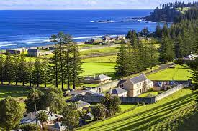

Tour Inclusions.

Door to door transfers
Return flights Brisbane/Norfolk Island
Tour leader with hire car
Half Day Island Tour
Barney Duffy BBQ
Cyclorama
Sound and Light Convict Show
Glass Bottom Boat
Bounty Folk Museum
Wonderland by Night
Island Culture Tour
Over the Cattlestops Tour
Indulgence Tour – Scenic highlights
Progressive Dinner at Island Homes
Island Fish Fry Dinner Tour
Foundation Day Re-enactment/Lunch Tour
7 breakfasts, 1 lunch, 7 dinners.

Brisbane – Norfolk Island.

Day One. Tuesday 3rd March

After your early morning pick up from your door, we make our way to Brisbane International Airport. Welcome to the start of your Norfolk Island Holiday. Following is your itinerary giving times and descriptions of all the wonderful tours and excursions you will be undertaking while visiting this beautiful Island. Di will assist you to the Check-in Counter at the Brisbane International Airport by 7.00 am to check in for your Qantas flight QF183 and will take approximately 2 hours to Norfolk Island. During the flight you will be served a light lunch. Touch down & welcome to Norfolk Island! After clearing customs at the airport, you will be met by a representative of Pinetree Tours who will assist you with your luggage and transfer you to your accommodation at Castaway Hotel. Free time this afternoon to rest or explore, or hit the shops.. Dinner at our Hotel tonight. (B) (D)

Day Two. Wednesday 4th March.

This morning your breakfast will be served at your hotel. Then at 8.30 am, we’ll enjoy an overview of this wonderful Island. Di and Peter will join you for the Half-Day Island Tour. This tour is a must for all visitors and will introduce you to Norfolk’s beautiful scenery, rich history, heritage and way of life that is enjoyed today. Your Guide will keep you informed and entertained as you journey around Norfolk taking in some of the impressive sights it has to offer. We’ll even visit the local markets. Visit historic Kingston and see the most popular beach on Norfolk, Emily Bay, plus the famous convict buildings. Marvel at the Melanesian Chapel with its beautiful stained-glass windows, enjoy the views from Cascade and Anson Bay and finish the tour with morning tea ORN DA CLIFF.

Remember, we have a hire car and can take you anywhere on the island you’d like to see. We’ll take you to the top of Mt Pitt for stunning views of one of the most beautiful islands on earth.

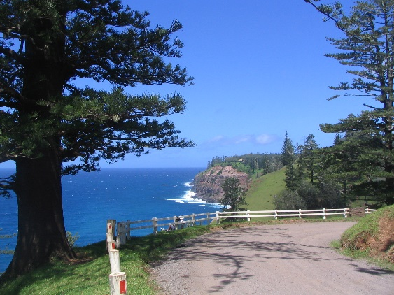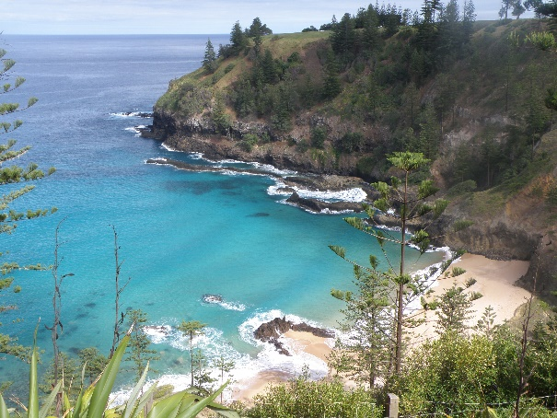

Our Progressive Dinner is a real treat tonight. We will be met at our hotel at 6pm by Pinetree Tours for this evening’s Progressive Dinner to Island Homes. Tonight, is going to be a feast not to be forgotten, with plenty to go around. This 3-course meal will take you to Island homes, each course at a different venue, welcomed into the homes of your friendly hosts for a touch of true Island living and hospitality. (Duration 3.5 hours) (B) (D)

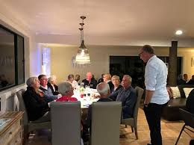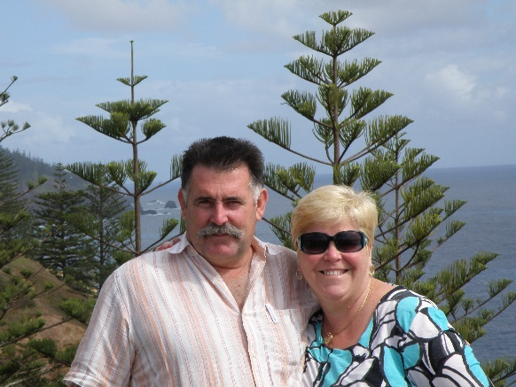

Day Three. Thursday 5th March.

Brekky at the Hotel before our Over the Cattlestops Tour. We’ll be picked up at 8.30 am. To explore the heart and soul of Norfolk Island on our captivating tour. We’ll discover the hidden gems of Norfolk’s local industries. We’ll meet the skilled artisans and entrepreneurs behind the island’s thriving businesses as they show their unique crafts and specialities. From hand-crafter pottery to locally made soft drinks, we’ll have the chance to taste and purchase some of the finest local-made products. Along the way, we’ll stop at a stunning scenic spot for morning tea where we can soak up the breathtaking natural beauty of the island. Let’s not miss this chance to connect with the island’s thriving community and see the magic in action.

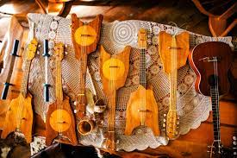

At 1pm, we’ll pick be picked up for our Indulgence Tour. This is a perfect way to see all the places you haven’t seen so far. The lovely Pinetree Driver will take us off the beaten track to see some out of the way places – including a lovely afternoon tea.

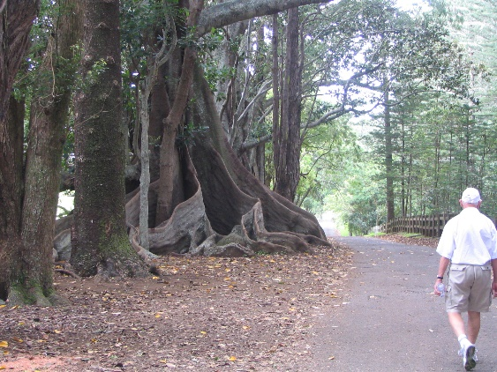 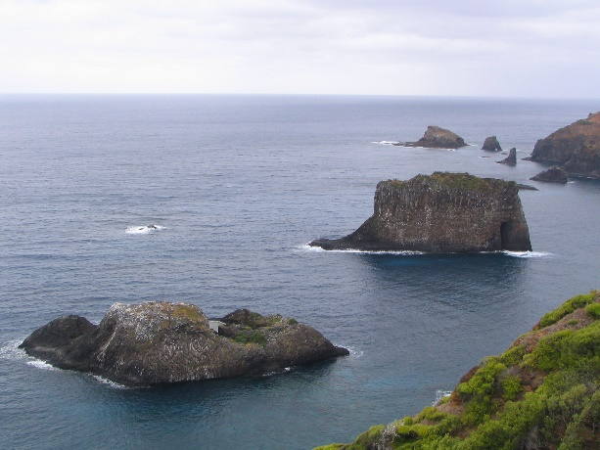.
This evening’s events will begin with Pinetree Tours meeting you at your hotel at 5.45pm Tonight enjoy an eye catching, taste bud tantalising feast at scenic ORN DA CLIFF. The Island style Fish Fry takes place perched on top of one of Norfolk’s majestic cliff tops surrounded by stately Norfolk Pines, watch the sea birds coming in for the night and the sun setting out in the Pacific Ocean. Enjoy a feast of Island dishes, salads, homemade bread and fresh fried fish, followed by Island desserts and tea/coffee. (Duration 2 hours) (B)(D)

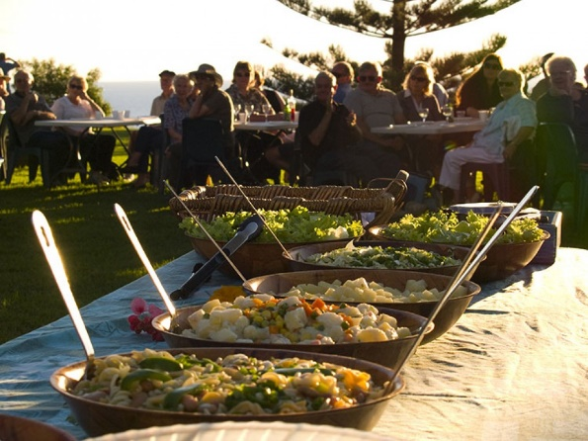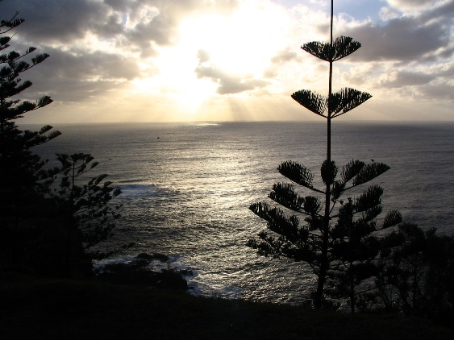

Day Four. Friday 6th March.

We’re in for a real treat today as we celebrate Foundation Day. We’ll be picked up at 9.00am and be transported for the term of Foundation Day morning to Kingston to enjoy a re-enactment of the first landing of Convicts on Norfolk Island. Afterwards, we’ll enjoy a sumptuous lunch of meats, fish, salads, roast veggies and traditional bread, served with wine, champagne and orange juice followed by a spread of delicious desserts.

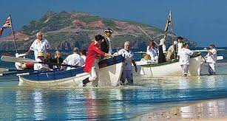

Then free time this afternoon to go exploring. It’s a public holiday so it may be time for a WELL-EARNED REST. Dinner at our Hotel tonight. (B) (L) (D)

Day Five. Saturday 7th March.

Free time after brekky at our Hotel. Rest or explore before we’re picked up at 1pm to visit one of Norfolk Island’s favourite attractions, The Cyclorama. Produced by local artists over a period of 15 months, The Cyclorama presents Norfolk Island’s history in a unique and fascinating way. Step into another time and place as you become a part of this magnificent artwork. After the Cyclorama, you may like to pop into Guava Gallery and view some artwork by talented local artists.

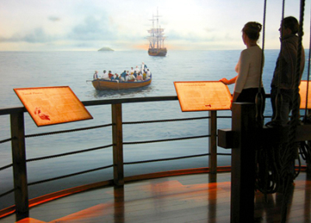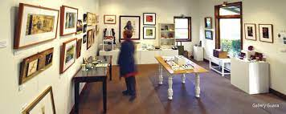

Pinetree Tours will meet you at your hotel tonight at 5.45pm . Get ready for a great night of fun with Norfolk’s longest running theme night, Night as a Convict. Uniforms for this evening will be delivered to your rooms during the day so you can prepare for an epic night of laughter, games and convict mayhem. After tonight you will know why this is the most popular feature dinner on the Island. A fun night out for all ages! Dress as a convict & join with the commandant for an evening of gaiety, feasting, singing & dancing. Great food! Great fun! (Duration: 3.5 hours) (B) (D)

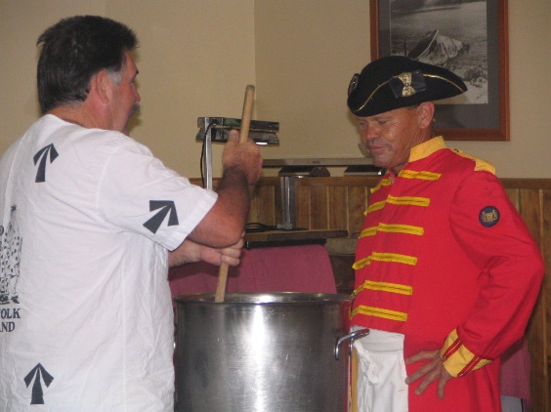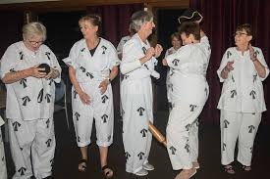

Day Six Sunday 8th March

After brekky at our Hotel, we’ll take anyone who’d like to go to the markets this morning. At 1.15pm, we’re off to the Bounty Folk Museum, a treasure chest of history, an Aladdin's cave full of fantastic collections, excellent learning resources and inspiring information. The Bounty Folk Museum tells the strange and startling history of Norfolk Island, from the harrowing tales of ill-fated convicts brought here, to the against-the-odds survival of the Bounty mutineers and their Tahitian wives.
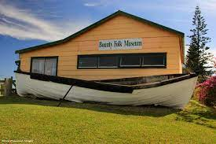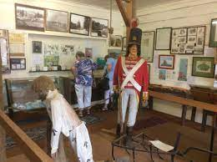
Though small in size, the museum is wide in scope, with lots of artefacts to pore over. Discover Bounty memorabilia, early photographs of Pitcairn settlers, old weapons and some frankly quite terrifying antique medical instruments. Browse handwritten research books and get lost in the page-turning plot of Norfolk Island’s past. You’ll also get a good sense of the day-to-day life on the island, not just the key historical events
During your free time on any day, you may wish to hire a car and explore on your own or, you may also like to book an optional tour to see something else on the island – Convict Settlement Tour, Green Finger Tour, Behind the Hedges Tour or a Fishing Trip.
Dinner at the fabulous Bounty Bar and Grill tonight . (B)(D)

Day Seven Monday 9th March
After another delicious brekky at our Hotel, we’ll be picked up at 8.30 for our Island Culture Tour. Experience the culture and heritage of our forebears! The arts of weaving, cooking, dancing and our Norfolk Language were inherited from our mutineer ancestors and their Tahitian wives. Join us for a cooking demonstration, a taste of traditional dishes, Tahitian dancing, and learn some of the Norf’k language we are so proud of.
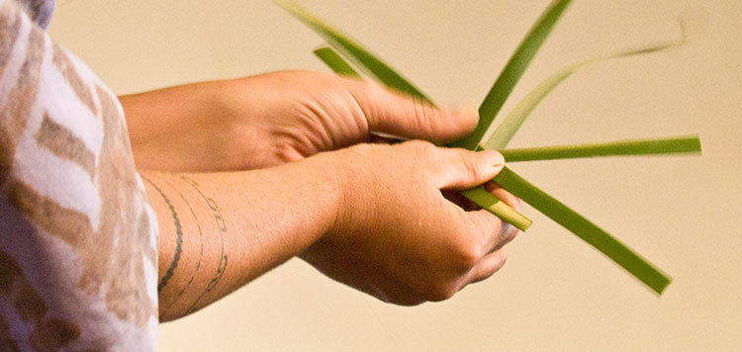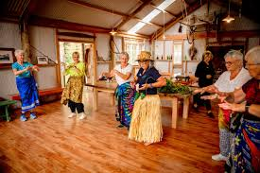
At 1pm, we’ll be picked up at the Hotel for our Glass Bottom Boat Tour. Your guide is Don & George who are 7th generation descendants of HMAS Bounty. Beautiful marine life abounds in this eco-system that only takes 1 minute to start viewing. The trip takes approx 1 hour. Boarding the boat is simple as our trailers convert to a small jetty right on the beach so no wet shoes. Discover life under the water with a cruise through the calm waters within the reef. See exotic colourful fish in one of the world's most southern coral reefs. Large glass viewing area.

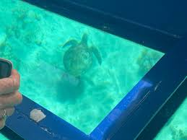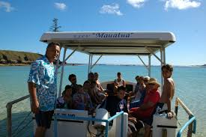

After dinner, we’re in for a treat as we visit Wonderland by Night, a magical and enchanting experience under the stars. As you WALK through a wooded Norfolk Forest, thousands of fairy lights arch overhead, illuminating towering Norfolk Pines and creating a truly fairy-tale-like atmosphere. This tour celebrates the history and stories of Norfolk Island with a collection of Old Time Island Stories written by Archie Bigg. You’ll hear humorous and poignant tales of family life and hear the Norf’k language spoken and translated. The hour-long tour ends with a cuppa and a chance to share stories in “the shed”. (B)(D)

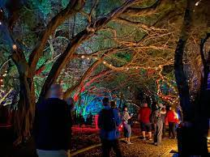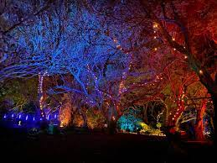

Day Eight. Tuesday 10th March.

After our final brekky at our hotel, we’ll check out of our Hotel and bring our luggage down to the foyer. Then join us at 11.45 am as we enjoy our last lunch together at Hilli’s Restaurant before being picked up at approximately 2.00pm and transferred to the airport for our return Qantas flight QF184. Please be sure to have your ticket handy for check in. Then you’ll have time for a coffee at the airport while we’re waiting to board our flight. Your return flight will land at Brisbane International terminal, and you will be delivered to your door from Brisbane airport. We do hope you enjoyed your tour and hope you’ll travel with us again really soon. Please tell your friends. That’s how our business grows! (B)

SEE YORLYE GANE – See you Again!

Helpful Information:

- Your hotel contact numbers are Ph: 0011 6723 22625

- Average temperatures on the island at this time of year ranges from approximately 20 min to 24 max degrees (though it can be very humid). We suggest some light casual clothing making sure you pack a couple of warm items for the evenings, together with a warm all-weather jacket.

- Norfolk Electricity is 240 volts.

- VERY IMPORTANT: Please pack your prescription medication into your hand luggage in case your check baggage is delayed.

- Norfolk time is 2 HOURS AHEAD of BRISBANE. Same as Sydney Daylight Saving Time.

- Foodstuffs – Most Fresh fruit and vegetables are prohibited imports into Norfolk Island.

- Banks – Commonwealth have on-line branches on Norfolk Island.
The Australian Dollar is the official currency. You can use your EFTPOS card at most stores. Credit Cards – Most are widely accepted.

- You may play golf any day except please note, Wednesdays and Saturdays are club days, so the golf course is busier so best to avoid these days

- It is recommended you take a small flashlight with you.
TERMS AND CONDITIONS
These terms and conditions apply to bookings you make with us. These terms and conditions govern our relationship with you.
Please read the following terms and conditions carefully. You must not make any booking unless you are 18 years of age or older and understand and agree with the following terms and conditions. We will rely on the authority of the person making the booking to act on behalf of any other person on the booking and the person making the booking will bind all other persons on the booking to these and conditions.

BOOKINGS, DEPOSITS AND PAYMENTS

In order to secure your booking, we require a deposit, per person, within 7 days of making your booking. Deposit amounts are outlined in each itinerary. $1,500 deposit required for this Norfolk Island tour
.
When making a booking for yourself you warrant that you are 18 years of age or older. If you are making a booking on behalf of another person/s or thirds parties, you warrant that you have their authority to do so and have conveyed these terms and conditions to them and they are properly informed. You agree to indemnify us and the Supplier against any claims from any person/s or third parties who you made the booking for if they have not in been properly informed in regard to these terms and conditions.

If you are making a booking on behalf of a minor/s you warrant that you are their parent or legal guardian and take full responsibility for said minor/s and will not hold us or a Supplier responsible for any breach of these term and condition by any minor under your control.

When making a booking for yourself or on behalf of another person or on behalf of a minor, you warrant that all information provided by you is true and correct. We take no responsibility for any errors or incorrect information provided by you and will not be held responsible for costs, fees, penalties or payments incurred for errors or incorrect information provided by you.

All deposits are non-refundable for changes of mind or cancellations by you (subject to your rights under the Australian Consumer Law).
You are required to pay the balance payment at least 60 days prior to the tour date. For tour bookings made within 60 of the tour date full payment is required on booking.
Failure to make payment by the due date may result in your booking being cancelled and deposits forfeited.
Payments made by direct deposit may take up to three business days to process. If you are paying by this method, you will need to make the payment at least three business days prior to the actual due date. You must notify us once your payment has been made.

Payments made by personal cheque (excluding bank cheques) require five business days to process. If you are paying by this method, you will need to make the payment at least five business days prior to the actual due date. You agree not to stop payment of the cheque even when you cancel a booking. You agree that we may apply the proceeds of the cheque to satisfy any liability you have to us or to a Supplier, including any liability in respect of cancellation fees, before refunding the balance to you

CHANGE AND CANCELLATION FEES

Please be aware that some confirmed bookings are not refundable if cancelled and may not be transferable to another date or otherwise changed. Alternatively, a change may only be permissible subject to payment of an additional fee or charge. Changes and cancellations of confirmed bookings may incur fees from Suppliers. It is your responsibility to check if a booking is non-refundable or will incur charges for changing it before placing the booking.

If you cancel your booking, we reserve our right to charge you cancelation fees on the following basis: -
- Bookings cancelled more than 60 days from the tour date will not incur a fee subject to any additional non-refundable fees or charges from Suppliers.
- Bookings cancelled not more than 59 days but not less than 15 days from the tour date will incur a fee which is 50% of the Tour Price subject to any additional non-refundable fees or charges from Suppliers.
- Bookings cancelled not more than 14 days but not less than 8 days from the tour date will incur a fee which is 75% of the Tour Price subject to any additional non-refundable fees or charges from Suppliers.
- Bookings cancelled within 8 days from the tour date will be required to pay for 100% of the Tour Price.
- Bookings cancelled after the tour date will be required to pay for 100% of the Tour Price.

Please be advised that a $50 administration fee (per person) will be charged on ALL cancellations regardless of the number of days’ notice given.
To cover cancellations as a result of illness or loss of baggage, we strongly encourage passengers to arrange travel insurance. We now sell Covermore travel insurance and just need your date of birth to be able to provide you with a quote.

REFUNDS

Your entitlement to a refund for cancelled bookings is subject to the relevant Supplier’s terms and conditions, and our cancelation fees as outlined described above.

If you are entitled to a refund then, subject to the Supplier’s terms and conditions, we will arrange for it to be supplied to us on your behalf, unless we expressly agree with you otherwise.
If we are managing or arranging a refund for a cancelled booking on your behalf it will not be paid to you until the Supplier provides the refund to us, and we will not be liable for any delay on the part of the Supplier. Be aware that typically airlines will take between 60-90 days to process a refund.

SUMMARY

Please read all of the terms and conditions, the following is a summary of our terms and conditions: -

- Prices, including, in some cases, of confirmed bookings, may be subject to change.

- Some confirmed bookings are non-refundable if cancelled by you and it is your responsibility to check if this applies.

- We will be entitled to retain our service fees even if a booking is cancelled or does not proceed for any reason which is not our fault.

- It is your responsibility to make yourself aware of all information relevant to your travel plans, including but not limited to visa requirements and health precautions.

- We are not liable for the accuracy of any published Supplier content including websites and brochures

SUMMARY OF OBLIGATIONS

Before making a booking, it is important that you meet the following requirements:
- You are over the age of eighteen (18) and have sufficient funds to pay for the travel services.
- You have read our terms and conditions and if booking for third parties warrant that you have their authority to do so and have conveyed these terms and conditions to them. You agree to indemnify us and the Supplier against any claims from third parties who have not in fact been properly informed.
- You have read the terms and conditions of any applicable Suppliers and agree to be bound by those.
- You are responsible for checking the accuracy of all documents provided to you.
- You are responsible for confirming departure times of any booked services at least 24 hours prior to travel.
- You warrant and acknowledge that you have accessed the Smartraveller website http://smartraveller.gov.au for any specific information in relation to your intended destination.
- You accept that passports, visas and other required identification documents are your responsibility.

PRICES, TAXES, FEES AND SURCHARGES

All prices that we quote are in Australian Dollars. Quoted prices are subject to change at the discretion of the Supplier prior to booking. Price changes may occur after booking because of matters outside our control which may increase the cost of the Product. Such factors include but are not limited to currency fluctuations, fuel surcharges, taxes and airfare increases. Please contact us for up-to-date prices. Even when paid in full, prices may change because of matters outside our control.

In the event there is an increase in cost incurred by us we reserve our right to alter our prices and charge a surcharge. If we require a surcharge to be paid due to increases in costs, this will be requested in writing. If you do not pay this surcharge, your action will be regarded as a cancellation by you and cancellation charges will apply.

Prices include all applicable taxes requiring payment prior to departure and may be subject to adjustment in the event of an increase in those taxes. On other occasions, you may be liable for taxes in addition to the quoted price of the Product. For example, there may be a local tax charged at some airports or resorts.

You agree to pay fees and surcharges incurred by us on your behalf, which include but are not limited to booking or reservation fees, cancellation and amendment fees, credit card merchant fees, insurance claim processing fees or fees for ad-hoc services performed as required.

You authorise us to charge all monies payable by you in relation to any booking we make on your behalf or other services we have procured or provided to the credit card or debit card designated by you. If payment is not received from the card issuer or its agents for any reason, you agree to pay us all amounts due immediately on demand. Please not surcharges in relation to credit and debit card payments are non-refundable and we accept no responsibility for an inappropriate surcharge being applied if the correct card type has not been advised

PRODUCTS

All tours and Products that we quote on are subject to availability and may be withdrawn or varied by us or the Supplier without notice.

MISCELLANEOUS

It is your responsibility to make yourself aware of all information that it is necessary or desirable to know in order to make optimum use of the tour, Products and to undertake travel generally.
It is your responsibility to ensure you have the necessary passports, visas, documents and vaccinations for international travel.
It is your responsibility to obtain medical advice prior to your booking to ensure it is safe for you to undertake the tour, participate in activities and are aware of the associated risks.
It is your responsibility to further investigate and confirm any matters that are applicable to you

SPECIAL REQUIREMENTS

You must inform us regarding any special requirements you may have for your travel arrangements such as special meal and seating requests, room type or disabled access prior to making a booking. If you do not specifically inform us, we will assume that you do not have any such requirements, and the booking will be made on that basis.
We require that you are able to walk unaided and able to have full control of your own luggage.

FREQUENT FLYER AND LOYALTY PROGRAMS

When booking with us, it is your responsibility to let us know your frequent flyer membership details (or other applicable loyalty program details) for inclusion in your booking. Notwithstanding that your details may be included in the booking; we cannot guarantee that the Supplier will credit you with points for your booking.

AGENCY

In order for us to facilitate tours we may need to act as an agent for and sell various travel related products as an agent on behalf of numerous transports, accommodation and other service providers, such as airlines, coach, rail and cruise line operators, as well as travel wholesalers (“Suppliers”). Any brochures provided by us to you are supplied by Suppliers or are prepared by us based on content supplied by Suppliers, and we accept no liability for errors in that material. Your oral or written instructions to us are authority for us to make travel bookings on your behalf and to arrange relevant contracts between you and the applicable Supplier. Notwithstanding this authority, we are not your agent and do not have any fiduciary duty to you. We exercise care in the selection of reputable Suppliers; however, we have no control over, or liability for, the Products provided by the Suppliers, who are third parties. All bookings are made on your behalf subject to the terms and conditions, including conditions of carriage and limitations of liability, imposed by the Supplier. We recommend that you read them before finalising the transaction and we can provide you with copies of the relevant terms and conditions on request.
Your legal rights and remedies in connection with the provision of Products are against the Supplier and, except to the extent a problem is directly and primarily caused by fault on our part, are not against us. Specifically, if for any reason (excluding fault on our part) any Supplier is unable to provide the Product for which you have contracted either at all, or to the requisite standard, your remedies are against that Supplier and not against us

LIABILITY

To the extent permitted by law, we do not accept any liability in contract, tort or otherwise for any injury, damage, loss (including consequential loss), delay, additional expense or inconvenience caused directly or indirectly by the acts, omissions or default, whether negligent or otherwise, of third party providers over whom we have no direct control, an event of Force Majeure affecting you, us or a Supplier or any other event which is beyond our control or which is not preventable by reasonable diligence on our part. Under circumstances where our liability cannot be excluded and where liability may be lawfully limited, such liability is limited to the remedies required of us under applicable law (including the Australian Consumer Law). In particular, we disclaim any liability for any consequential loss, including loss of enjoyment or amenity. This liability clause is subject to your rights under the Australian Consumer Law and nothing in these terms and conditions is intended to limit any rights you may have under the Competition and Consumer Act 2010 (Cth).
Without limitation of the disclaimer of liability in the previous paragraph, any obligation we have to you will be suspended during the time and to the extent that we are prevented from, or delayed in, complying with that obligation by an event of Force Majeure.

Your rights with respect to a confirmed booking affected by an event of Force Majeure will be subject to the terms and conditions of the relevant Supplier

GOVERNING LAW

If any dispute arises between you and us, the laws applicable in Queensland will apply. You irrevocably and unconditionally submit to the exclusive jurisdiction of the courts of Queensland and waive any right that you may have to object to an action being brought in those courts.

DEFINITIONS

- "we" and "us" means Sinclair Tour & Travel.

- “you” means the person and the people who make a booking for a tour or Product with us and use our services.

- "Supplier” means a third-party company or person who provides Products, including a wholesaler of such Products.

- "Product" means travel and holiday related products and services including accommodation, leisure activities and various forms of transport, including packaged combinations thereof.

- “Travel documents” means any document (whether in electronic form or otherwise) used to confirm an arrangement with a Supplier, including (without limitation) airline tickets, hotel vouchers and tour vouchers.

- “Force Majeure" means an act of God, peril of the sea, accident of navigation, war (including civil war), sabotage, riot, insurrection, civil commotion, coup d’état, national emergency, martial law, fire (including wildfire), explosion, lightning, flood, tsunami, cyclone, hurricane, tornado or other major weather event, earthquake, landslide, volcanic eruption or other natural catastrophe, epidemic, pandemic, quarantine, outbreaks of infectious disease or any other public health crisis, radiation or radioactive contamination, national strike or other major lack of availability of labour, raw materials or energy beyond the control of the affected party. For the avoidance of doubt, the inability of a party to make a profit or avoid a financial loss, changes in market prices or conditions, or a party’s inability to perform its obligations due to insufficiency of finance does not in itself constitute Force Majeure.

