Sinclair Tour and Travel 5494 5083
Treasures of the Top End
Departs Saturday 27th June 2026 – 7 days
$6,550 per person twin share. Single $ 985

Tour Inclusions

Return flights from Brisbane to Darwin
Royal Flying Doctors Service Darwin
Bombing of Darwin Experience
Army Truck Tour – Darwin’s War History
Full day Tiwi Islands by Design Tour
Nitmiluk (Katherine) Gorge cruise
Helicopter Flight Nitmiluk (Katherine) Gorge
Yellow Water Cruise Kakadu National Park
Museum/Art Gallery Northern Territory

Day One Saturday 27th June

After pick up from your door as usual, you’ll be transferred to Brisbane airport for your flight to Darwin. Here, your driver will meet you at the luggage carousel and your Treasures of the Top End Tour begins. Our first stop is the Museum and Art Gallery of the Northern Territory. Set in a scenic location overlooking Fannie Bay, MAGNT Darwin is home to internationally renowned artistic, cultural and scientific collections and research programs. You’ll love the display about Cyclone Tracy. Learn about the day that changed the urban landscape and the lives of Darwin’s residents forever. Light lunch at the Saltwater@Bundilla Café (included).

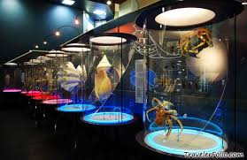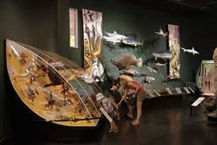
Rest up once we’ve checked in to our Hotel – our home for 3 nights. Meet your fellow travelers for a pre-dinner drink. Dinner at our Hotel tonight. (L)(D)
Rydges Palmerston (08) 8983 666

Day Two Sunday 28th June

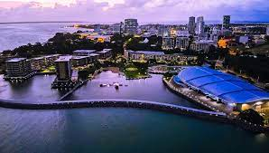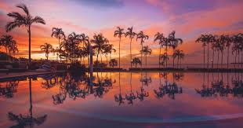
Darwin is the capital of the Northern Territory, a tropical paradise with an endless summer. Darwin is the multicultural hub of the NT. While a gateway to some of Australia’s most stunning natural wonders, Darwin itself is a place to indulge in the top End’s laid-back lifestyle. Darwin City has been transformed in recent years to become a vibrant centre for street art, bars and restaurants. The city has grown into an unexpected foodie paradise.

Our first stop, after a delicious brekky at our Hotel, is the Royal Flying doctor Service Tourist Facility at Stokes Wharf. The first iconic story is the Royal Flying Doctor Service, affectionately known throughout Australia as the RFDS. Founded by the Reverend John Flynn, it began its aero medical operations in the Northern Territory in 1939. Enjoy the heroic tales of the birth and growth of the RFDS. Learn about the history and the activities of the RFDS’s pilots, engineers, doctors and nurses, and the experiences of the patients that are carried and cared for each day. See, experience & learn through the wonder of technology as this facility brings history to life.
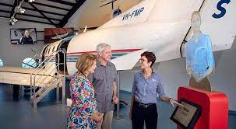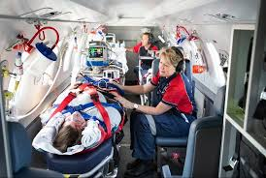
Relive the drama of the Bombing of Darwin Harbour that rocked Australia in 1942. The bombing of the harbour brought destruction to the city of Darwin, & many of the experiences & stories of what happened that day are learnt through the modern and exciting technology.
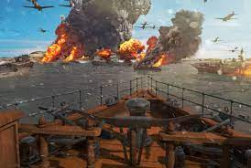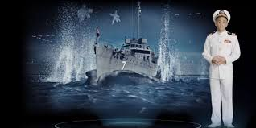
Free time in town to explore and buy some lunch (own expense) before a real treat. Join us on a journey back through time in a genuine WW2 army truck to relive Darwin’s exciting and historic past. We will discover, relive, learn and explore Darwin’s exciting and historic past!
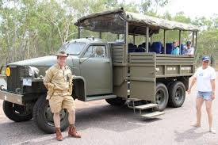
We’ll See historic sites such as Government House, Fort hill Wharf & Harbour, Parliament House, Charles Darwin National Park, Ammunitions storage bunkers, East Point Gun Battery & Military precinct, Anti-aircraft gun emplacements, and a 1934 QANTAS hangar.
We’ll Learn about Pre-war Darwin, The WW2 bombing of Darwin, The devastation of cyclone Tracy and the colourful characters of the past that made Darwin what it is today.
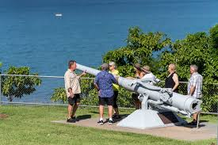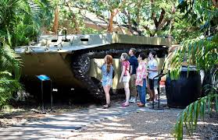
Dinner at our Hotel tonight. (B) (D)
Rydges Palmerston (08) 8983 666

Day Three Monday 29th June
After a delicious brekky at our Hotel, we’re in for a real treat as we venture to a place that not many of you would have visited – the Tiwi Islands. Feel your cheeks hurt from so much smiling as you discover the beautiful Tiwi Islands, the ‘Island of Smiles’. We’ll take a trip across the water from Darwin to find a unique haven. With a thriving Aboriginal arts culture, fishing lodges, coastal landscapes with breathtaking sunsets, the Tiwi Islands promises to be a destination like no other.
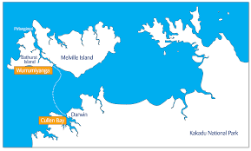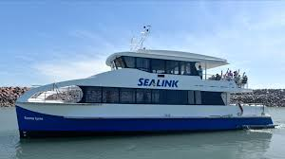
The Tiwi Islands comprise of two main islands – Bathurst and Melville, which are 80 kilometres north of Darwin. Most of the residents are of Aboriginal descent and you’ll meet some of them on our cultural tour.
The people on Tiwi Islands are famous for their traditional lifestyle, stunning artworks, vibrant fabrics and textiles, plus an exuberant passion for football. A highly personalised cultural experience, ‘Tiwi By Design’ is an opportunity to immerse yourself in the busy day of one of the oldest and most artistically diverse art centres in Australia.
After disembarking in the Aboriginal community of Wurrumiyanga on Bathurst Island, meet your Tiwi guide who will escort you to Tiwi Design Art Centre where local artists and dancers will perform a traditional Welcome to Country with a smoking ceremony and totem dances.
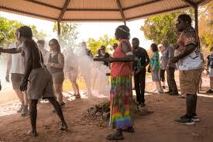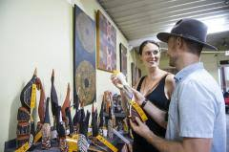
Enjoy a typical Tiwi morning tea of damper and a cuppa whilst getting to know some of the Tiwi Island community members. A walking tour with your guide will take in some of the local painted buildings and the historic mission precinct where you will see the beautiful wooden Catholic church that featured in the 'Top End Wedding' movie. You’ll learn of the Tiwi Creation Story through a mural in the art centre & there's some free time to browse the carvings, paintings & fabric, your best opportunity to purchase authentic Tiwi pieces at Island prices.
After a rest and lunch in the shade, you’ll get to participate in an exclusive ‘behind-the-scenes’ screen printing workshop. Choose from contemporary or traditional Tiwi design to print onto a take-home t-shirt, tea towel or fabric – a wonderful souvenir of your Tiwi visit.
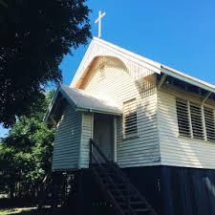
This is a leisurely day of absorbing the workings of a busy Indigenous art centre – you may see art pieces destined for international exhibitions, talk to artists who are carving or painting, and sometimes the ladies will be there weaving and chatting. It is always loud and busy with Tiwi people coming and going, Ngarukuruwala music playing on repeat. Take the time to connect, share where you’re from and which footy team you support, ask about the stories you see on the paintings, or ask the artists there to show you their work.
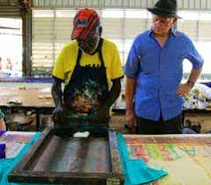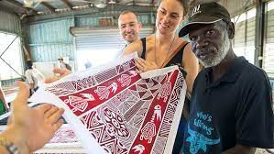
You leave the Tiwi Islands feeling so lucky to have visited. It’s a place like no other. You’ll love it. (B)(L)(D)
Rydges Palmerston (08) 8983 666

Day Four Tuesday 30th June.
Our last brekky in Palmerston before heading off to visit Katherine. No visit to the Northern Territory is complete without visiting the spectacular Nitmiluk National Park, a region of rugged beauty, history and culture with the breathtaking 'Nitmiluk (Katherine) Gorge' as the centrepiece. The Nitmiluk Gorge is made up of 13 separate gorges and you’ll simply love our Nit Nit Tour through two spectacular gorges. This maze of waterways has been sculpted from the sandstone over countless millennia by the Katherine River. Short walks between the gorges allow you to see more of the landscape. Hear from your informative guide about the wildlife and Aboriginal people of this land, the Jawoyn. Lunch (own expense) at the Café and Visitor Centre.
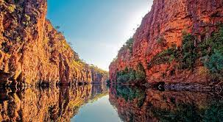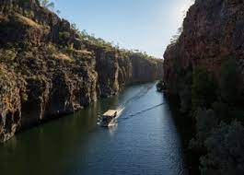
Dinner at our Hotel tonight. (B)(D)
Contour Hotel Katherine (08) 8972 1744

Day Five Wednesday 1st July. (Happy Territory Day!)
After brekky, we’ll experience the grandeur of the gorges from the air. Prepare to have your senses awakened as we lift from the Nitmiluk Gorge helipad and first fly past the Nitmiluk Visitor Information Centre and campgrounds before climbing over the mouth and entering the majestic Katherine Gorge. The sheer magnitude of this ancient formation will stay with you forever. There really is no better way to see it than from above.
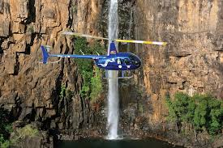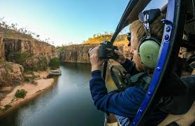
Once over the Gorge mouth and with a bird’s eye view, our track will follow - Baruwei Lookout Platform, Southern Rockhole, Jeddas Rock, Butterfly Gorge, Lillyponds and Smitt Rock. Finally, overhead the cascading 8th gorge we turn for home following the stunning canyons back to our base.
Some free time in Katherine for lunch (own expense) Then we drive through Pine Creek, the Gold Heritage Capital of the Northern Territory. Pine Creek is the only original mining town remaining in the Top End from the gold rush era of the 1870s. The National Trust Museum building is the oldest surviving prefabricated structure in the Northern Territory. A browse through the building and its contents sheds light on the gold rush, local Chinese history, buffalo hunters and the Overland Telegraph Line.
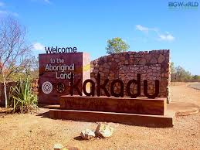

We drive through the magnificent Kakadu National Park to reach our overnight destination. People aren’t exaggerating when they refer to Kakadu as a world-class destination – only a few dozen sites around the globe appear on the World Heritage List for both their natural and cultural significance (and only four places in Australia). The park is a living cultural landscape. Its archaeological sites record the skills and way of life of Aboriginal people over tens of thousands of years. Kakadu’s rock art documents Indigenous creation stories and makes up one of the longest historical records of any group of people in the world.

Kakadu’s ancient escarpment and stone country spans more than two billion years of geological history. It’s rivers and coastal floodplains are more dynamic environments, shaped by changing sea levels and big floods every tropical summer. Dinner at our Hotel tonight. (B)(D)
Cooinda Lodge (08) 8979 1500

Day Six Thursday 2nd July

You’ll LOVE our Yellow Water Cruise on the Alligator River. The Indigenous-owned Yellow Water Cruises takes you on a discovery tour through the rich wildlife, dramatic scenery and ever-changing landscape of world-famous Yellow Water Billabong. Sunrise to sunset, the cruise winds its way through distinct ecosystems of Yellow Water Billabong and tributaries of the South Alligator River.

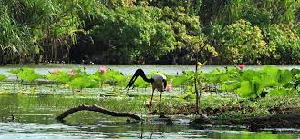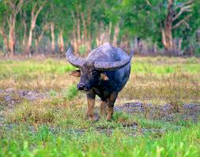
About one third of Australia's bird species are represented in Kakadu National Park, with at least 60 species found in the wetlands. Whistling Ducks and Magpie Geese are the most abundant. Eagles can be seen hovering searching for prey, and at times you will see distinctive Jabirus and may even get to see Brolgas dancing. There are plenty of crocodiles in their natural habitat and buffalo on the floodplains.
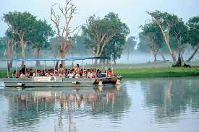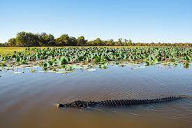
After our cruise, we’ll enjoy breakfast back at our Hotel – then check out of our Hotel. On our way back to Darwin, we’ll travel through Jabiru and enjoy lunch at the Bark Hut Inn.

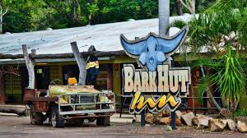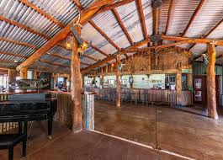

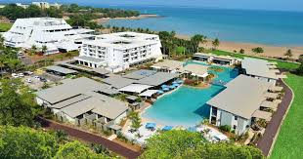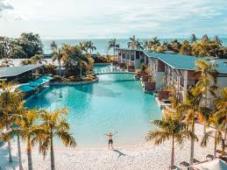

Our Darwin Hotel will blow you away. Mindil Beach Casino Resort is Darwin's only beachfront hotel and resort, complete with 152 stylish appointed rooms, lagoon pool with swim up bar and topical spa retreat. After checking in to our Hotel, go and enjoy the fun of the fair at the Mindil Beach Markets. Grab some amazing food from the many food trucks on site. Mindil Beach Sunset Market has been a Territory icon for nearly 40 years; providing an extraordinary event that is the multicultural ‘melting pot’ and truly reflective of the Darwin community and lifestyle!
Mindil Beach Sunset Markets is an integral part of the local community. Hosting charity-based stalls and free community-led events that entertain, educate and raise funds for the benefit of all Territorians. It remains a place to gather, connect, engage and plays a vital role in nurturing local talent from all walks of life.
(B)(L)

Mindil Beach Casino Resort (08) 8943 8888

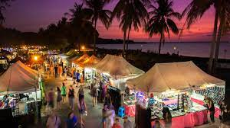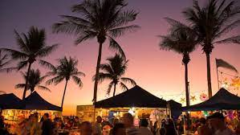

Day Seven Wednesday 3rd July
Sadly, this is our last breakfast together. How hard will it be to go back to tea and toast? After a drive around Darwin this morning, Peter will take you to the airport for your flight back to Brisbane. Here, a representative of Sinclair Tour and Travel will meet you at the luggage carousel and take you back to your front door. We do hope you’ve enjoyed your tour with Sinclair Tour and Travel. Please tell your friends. That’s how our business grows. We look forward to travelling with you again really soon. (B)

TERMS AND CONDITIONS
These terms and conditions apply to bookings you make with us. These terms and conditions govern our relationship with you.
Please read the following terms and conditions carefully. You must not make any booking unless you are 18 years of age or older and understand and agree with the following terms and conditions. We will rely on the authority of the person making the booking to act on behalf of any other person on the booking and the person making the booking will bind all other persons on the booking to these and conditions.

BOOKINGS, DEPOSITS AND PAYMENTS
In order to secure your booking, we require a deposit, per person, within 7 days of making your booking. Deposit amounts are outlined in each itinerary. $2,000 deposit required for this Treasures of the Top End Tour

When making a booking for yourself you warrant that you are 18 years of age or older. If you are making a booking on behalf of another person/s or thirds parties, you warrant that you have their authority to do so and have conveyed these terms and conditions to them, and they are properly informed. You agree to indemnify us and the Supplier against any claims from any person/s or third parties who you made the booking for if they have not in been properly informed in regard to these terms and conditions.
If you are making a booking on behalf of a minor/s you warrant that you are their parent or legal guardian and take full responsibility for said minor/s and will not hold us or a Supplier responsible for any breach of these term and condition by any minor under your control.
When making a booking for yourself or on behalf of another person or on behalf of a minor, you warrant that all information provided by you is true and correct. We take no responsibility for any errors or incorrect information provided by you and will not be held responsible for costs, fees, penalties or payments incurred for errors or incorrect information provided by you
All deposits are non-refundable for changes of mind or cancellations by you (subject to your rights under the Australian Consumer Law).
You are required to pay the balance payment at least 60 days prior to the tour date. For tour bookings made within 60 of the tour date full payment is required on booking
Failure to make payment by the due date may result in your booking being cancelled and deposits forfeited.

Payments made by direct deposit may take up to three business days to process. If you are paying by this method, you will need to make the payment at least three business days prior to the actual due date. You must notify us once your payment has been made.
Payments made by personal cheque (excluding bank cheques) require five business days to process. If you are paying by this method, you will need to make the payment at least five business days prior to the actual due date. You agree not to stop payment of the cheque even when you cancel a booking. You agree that we may apply the proceeds of the cheque to satisfy any liability you have to us or to a Supplier, including any liability in respect of cancellation fees, before refunding the balance to you
CHANGE AND CANCELLATION FEES
Please be aware that some confirmed bookings are not refundable if cancelled and may not be transferable to another date or otherwise changed. Alternatively, a change may only be permissible subject to payment of an additional fee or charge. Changes and cancellations of confirmed bookings may incur fees from Suppliers. It is your responsibility to check if a booking is non-refundable or will incur charges for changing it before placing the booking.
If you cancel your booking, we reserve our right to charge you cancelation fees on the following basis: -
- Bookings cancelled more than 90 days from the tour date will not incur a fee subject to any additional non-refundable fees or charges from Suppliers.
- Bookings cancelled not more than 89 days but not less than 15 days from the tour date will incur a fee which is 50% of the Tour Price subject to any additional non-refundable fees or charges from Suppliers.
- Bookings cancelled not more than 14 days but not less than 8 days from the tour date will incur a fee which is 75% of the Tour Price subject to any additional non-refundable fees or charges from Suppliers.
- Bookings cancelled within 8 days from the tour date will be required to pay for 100% of the Tour Price.
- Bookings cancelled after the tour date will be required to pay for 100% of the Tour Price.

Please be advised that a $100 administration fee (per person) will be charged on ALL cancellations regardless of the number of days’ notice given.
To cover cancellations as a result of illness or loss of baggage, we strongly encourage passengers to arrange travel insurance. We now sell Covermore travel insurance and just need your date of birth to be able to provide you with a quote.

REFUNDS
Your entitlement to a refund for cancelled bookings is subject to the relevant Supplier’s terms and conditions, and our cancelation fees as outlined described above. If you are entitled to a refund then, subject to the Supplier’s terms and conditions, we will arrange for it to be supplied to us on your behalf, unless we expressly agree with you otherwise.
If we are managing or arranging a refund for a cancelled booking on your behalf it will not be paid to you until the Supplier provides the refund to us, and we will not be liable for any delay on the part of the Supplier. Be aware that typically airlines will take between 60-90 days to process a refund.
Please note that if we are entitled to a service fee for placing a booking, we will remain entitled to this fee if you cancel the booking or the Supplier fails to provide you with the Product for any reason (other than our default), including in an event of Force Majeure. We will be entitled to deduct our service fee from any refund we receive on your behalf before remitting the balance to you.
SUMMARY
Please read all of the terms and conditions, the following is a summary of our terms and conditions: -
- Prices, including, in some cases, of confirmed bookings, may be subject to change.

- Some confirmed bookings are non-refundable if cancelled by you and it is your responsibility to check if this applies.

- We will be entitled to retain our service fees even if a booking is cancelled or does not proceed for any reason which is not our fault.

- It is your responsibility to make yourself aware of all information relevant to your travel plans, including but not limited to visa requirements and health precautions.

- We are not liable for the accuracy of any published Supplier content including websites and brochures

SUMMARY OF OBLIGATIONS
Before making a booking, it is important that you meet the following requirements:
- You are over the age of eighteen (18) and have sufficient funds to pay for the travel services.
- You have read our terms and conditions and if booking for third parties warrant that you have their authority to do so and have conveyed these terms and conditions to them. You agree to indemnify us and the Supplier against any claims from third parties who have not in fact been properly informed.
- You have read the terms and conditions of any applicable Suppliers and agree to be bound by those.
- You are responsible for checking the accuracy of all documents provided to you.
- You are responsible for confirming departure times of any booked services at least 24 hours prior to travel.
- You warrant and acknowledge that you have accessed the Smartraveller website http://smartraveller.gov.au for any specific information in relation to your intended destination.
- You accept that passports, visas and other required identification documents are your responsibility

PRICES, TAXES, FEES AND SURCHARGES
All prices that we quote are in Australian Dollars. Quoted prices are subject to change at the discretion of the Supplier prior to booking. Price changes may occur after booking because of matters outside our control which may increase the cost of the Product. Such factors include but are not limited to currency fluctuations, fuel surcharges, taxes and airfare increases. Please contact us for up-to-date prices. Even when paid in full, prices may change because of matters outside our control.
In the event there is an increase in cost incurred by us we reserve our right to alter our prices and charge a surcharge. If we require a surcharge to be paid due to increases in costs, this will be requested in writing. If you do not pay this surcharge, your action will be regarded as a cancellation by you and cancellation charges will apply.
Prices include all applicable taxes requiring payment prior to departure and may be subject to adjustment in the event of an increase in those taxes. On other occasions, you may be liable for taxes in addition to the quoted price of the Product. For example, there may be a local tax charged at some airports or resorts.

You agree to pay fees and surcharges incurred by us on your behalf, which include but are not limited to booking or reservation fees, cancellation and amendment fees, credit card merchant fees, insurance claim processing fees or fees for ad-hoc services performed as required.
You authorise us to charge all monies payable by you in relation to any booking we make on your behalf or other services we have procured or provided to the credit card or debit card designated by you. If payment is not received from the card issuer or its agents for any reason, you agree to pay us all amounts due immediately on demand. Please not surcharges in relation to credit and debit card payments are non-refundable and we accept no responsibility for an inappropriate surcharge being applied if the correct card type has not been advised.

PRODUCTS
All tours and Products that we quote on are subject to availability and may be withdrawn or varied by us or the Supplier without notice.

MISCELLANEOUS
It is your responsibility to make yourself aware of all information that it is necessary or desirable to know in order to make optimum use of the tour, Products and to undertake travel generally.

It is your responsibility to ensure you have the necessary passports, visas, documents and vaccinations for international travel.

It is your responsibility to obtain medical advice prior to your booking to ensure it is safe for you to undertake the tour, participate in activities and are aware of the associated risks.

It is your responsibility to further investigate and confirm any matters that are applicable to you.

SPECIAL REQUIREMENTS
You must inform us regarding any special requirements you may have for your travel arrangements such as special meal and seating requests; room type or disabled access prior to making a booking. If you do not specifically inform us, we will assume that you do not have any such requirements, and the booking will be made on that basis.

We require that you are able to walk unaided and able to have full control of your own luggage.

FREQUENT FLYER AND LOYALTY PROGRAMS

When booking with us, it is your responsibility to let us know your frequent flyer membership details (or other applicable loyalty program details) for inclusion in your booking. Notwithstanding that your details may be included in the booking; we cannot guarantee that the Supplier will credit you with points for your booking.
AGENCY
In order for us to facilitate tours we may need to act as an agent for and sell various travel related products as an agent on behalf of numerous transports, accommodation and other service providers, such as airlines, coach, rail and cruise line operators, as well as travel wholesalers (“Suppliers”). Any brochures provided by us to you are supplied by Suppliers or are prepared by us based on content supplied by Suppliers, and we accept no liability for errors in that material. Your oral or written instructions to us are authority for us to make travel bookings on your behalf and to arrange relevant contracts between you and the applicable Supplier. Notwithstanding this authority, we are not your agent and do not have any fiduciary duty to you. We exercise care in the selection of reputable Suppliers; however, we have no control over, or liability for, the Products provided by the Suppliers, who are third parties. All bookings are made on your behalf subject to the terms and conditions, including conditions of carriage and limitations of liability, imposed by the Supplier. We recommend that you read them before finalising the transaction and we can provide you with copies of the relevant terms and conditions on request.
Your legal rights and remedies in connection with the provision of Products are against the Supplier and, except to the extent a problem is directly and primarily caused by fault on our part, are not against us. Specifically, if for any reason (excluding fault on our part) any Supplier is unable to provide the Product for which you have contracted either at all, or to the requisite standard, your remedies are against that Supplier and not against us
LIABILITY
To the extent permitted by law, we do not accept any liability in contract, tort or otherwise for any injury, damage, loss (including consequential loss), delay, additional expense or inconvenience caused directly or indirectly by the acts, omissions or default, whether negligent or otherwise, of third party providers over whom we have no direct control, an event of Force Majeure affecting you, us or a Supplier or any other event which is beyond our control or which is not preventable by reasonable diligence on our part. Under circumstances where our liability cannot be excluded and where liability may be lawfully limited, such liability is limited to the remedies required of us under applicable law (including the Australian Consumer Law). In particular, we disclaim any liability for any consequential loss, including loss of enjoyment or amenity. This liability clause is subject to your rights under the Australian Consumer Law and nothing in these terms and conditions is intended to limit any rights you may have under the Competition and Consumer Act 2010 (Cth).

Without limitation of the disclaimer of liability in the previous paragraph, any obligation we have to you will be suspended during the time and to the extent that we are prevented from, or delayed in, complying with that obligation by an event of Force Majeure.
Your rights with respect to a confirmed booking affected by an event of Force Majeure will be subject to the terms and conditions of the relevant Supplier.

GOVERNING LAW
If any dispute arises between you and us, the laws applicable in Queensland will apply. You irrevocably and unconditionally submit to the exclusive jurisdiction of the courts of Queensland and waive any right that you may have to object to an action being brought in those courts.

DEFINITIONS
- "we" and "us" means Sinclair Tour & Travel.

- “you” means the person and the people who make a booking for a tour or Product with us and use our services.

- "Supplier” means a third-party company or person who provides Products, including a wholesaler of such Products.

- "Product" means travel and holiday related products and services including accommodation, leisure activities and various forms of transport, including packaged combinations thereof.

- “Travel documents” means any document (whether in electronic form or otherwise) used to confirm an arrangement with a Supplier, including (without limitation) airline tickets, hotel vouchers and tour vouchers.

- “Force Majeure" means an act of God, peril of the sea, accident of navigation, war (including civil war), sabotage, riot, insurrection, civil commotion, coup d’état, national emergency, martial law, fire (including wildfire), explosion, lightning, flood, tsunami, cyclone, hurricane, tornado or other major weather event, earthquake, landslide, volcanic eruption or other natural catastrophe, epidemic, pandemic, quarantine, outbreaks of infectious disease or any other public health crisis, radiation or radioactive contamination, national strike or other major lack of availability of labour, raw materials or energy beyond the control of the affected party. For the avoidance of doubt, the inability of a party to make a profit or avoid a financial loss, changes in market prices or conditions, or a party’s inability to perform its obligations due to insufficiency of finance does not in itself constitute Force Majeure.

